​
​
UNITED STATES
SECURITIES AND EXCHANGE COMMISSION
Washington, D.C. 20549
_______________________________________________________________________________
FORM 8-K
​
CURRENT REPORT
Pursuant to Section 13 or 15(d) of the Securities Exchange Act of 1934
​
Date of Report (Date of earliest event reported): July 30, 2026
_______________________________________________________________________________
Safehold Inc.
(Exact name of registrant as specified in its charter)
​

​ | ​ | ​ | ​ | ​
Maryland | ​ ​ ​ | 001-15371 | ​ ​ ​ | 95-6881527
(State or other jurisdiction of  incorporation) | ​ | (Commission File  Number) | ​ | (IRS Employer  Identification Number)
​
​

​ | ​
One Penn Plaza | ​
51st Floor | ​
New York , NY | 10119
(Address of principal executive offices) | (Zip Code)
​
Registrant’s telephone number, including area code: (212) 930-9400
_______________________________________________________________________________
​
N/A
(Former name or former address, if changed since last report.)
​
Check the appropriate box below if the Form 8-K filing is intended to simultaneously satisfy the filing obligation of the registrant under any of the following provisions (see General Instruction A.2. below):
​
☐ Written communications pursuant to Rule 425 under the Securities Act (17 CFR 230.425)
​
☐ Soliciting material pursuant to Rule 14a-12 under the Exchange Act (17 CFR 240.14a-12)
​
☐ Pre-commencement communications pursuant to Rule 14d-2(b) under the Exchange Act (17 CFR 240.14d-2(b))
​
☐ Pre-commencement communications pursuant to Rule 13e-4(c) under the Exchange Act (17 CFR 240.13e-4(c))
​
Indicate by check mark whether the registrant is an emerging growth company as defined in Rule 405 of the Securities Act of 1933 (§230.405 of this chapter) or Rule 12b-2 of the Securities Exchange Act of 1934 (§240.12b-2 of this chapter).
​
Emerging growth company ☐
​
If an emerging growth company, indicate by check mark if the registrant has elected not to use the extended transition period for complying with any new or revised financial accounting standards provided pursuant to Section 13(a) of the Exchange Act. ☐
​
Securities registered pursuant to Section 12(b) of the Act:
​

​ | ​ | ​ | ​ | ​
Title of each class | ​ ​ ​ | Trading Symbol(s) | ​ ​ ​ | Name of each exchange on which registered
Common Stock |  | SAFE |  | NYSE
​
​
​
​
​
​
Item 2.02Results of Operations and Financial Condition.
On July 30, 2026, Safehold Inc. issued an earnings release and made available on its website an earnings presentation for the quarter ended June 30, 2026. A copy of the earnings release and earnings presentation are attached as Exhibit 99.1 and Exhibit 99.2, respectively, hereto and incorporated herein by reference.
The information in this Current Report, including the exhibits hereto, is being furnished and shall not be deemed “filed” for purposes of Section 18 of the Securities Exchange Act of 1934, as amended, or otherwise subject to the liabilities of that Section. The information in this Current Report shall not be incorporated by reference into any registration statement or other document pursuant to the Securities Act of 1933, as amended, unless it is specifically incorporated by reference therein.
Item 7.01Regulation FD Disclosure.
On July 30, 2026, Safehold Inc. made available on its website an earnings presentation for the quarter ended June 30, 2026. A copy of the earnings presentation is attached as Exhibit 99.2 hereto and incorporated by reference.
The earnings presentation, including Exhibit 99.2 hereto, is being furnished and shall not be deemed “filed” for purposes of Section 18 of the Securities Exchange Act of 1934, as amended, or otherwise subject to the liabilities of that Section. The information in this Current Report shall not be incorporated by reference into any registration statement or other document pursuant to the Securities Act of 1933, as amended, unless it is specifically incorporated by reference therein.
Item 9.01Financial Statements and Exhibits.
Exhibit 99.1Earnings Release.
Exhibit 99.2Earnings Presentation.
Exhibit 104Inline XBRL for the cover page of this Current Report on Form 8-K.
​
​
SIGNATURE
Pursuant to the requirements of the Securities Exchange Act of 1934, the registrant has duly caused this report to be signed on its behalf by the undersigned, thereunto duly authorized.
​ | ​ | ​ | ​
​ |  | Safehold Inc.
​ |  | ​
Date: | July 30, 2026 | By: | /s/ BRETT ASNAS
​ |  | ​ | Brett Asnas
​ |  | ​ | Chief Financial Officer  ​
​
​
​
​
Exhibit 99.1
 | 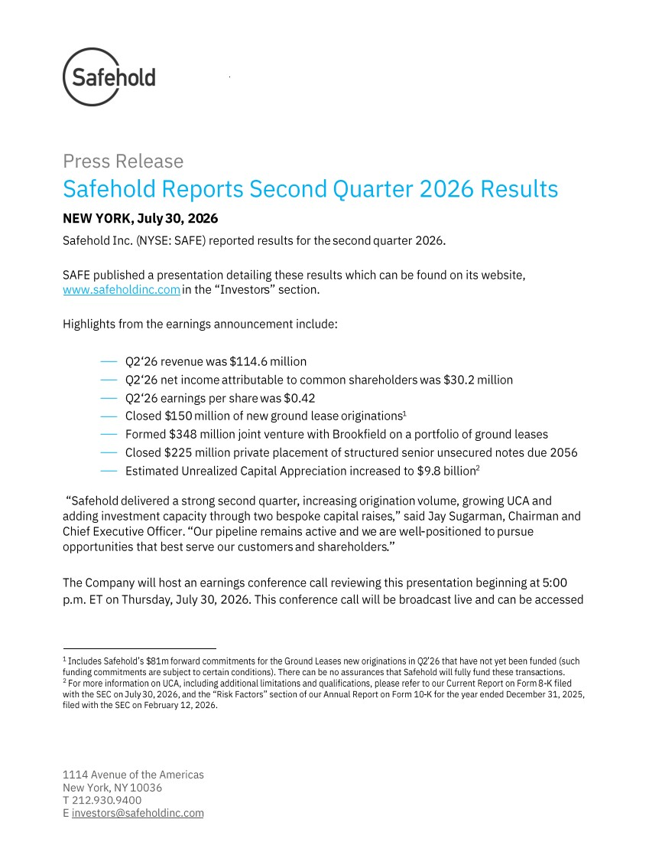 | 1114 Avenue of the Americas New York , NY 10036 T 212 .930 .9400 E investors@safeholdinc.com Press Release Safehold Reports Second Quarter 20 26 Results NEW YORK, July 30 , 20 26 Safehold Inc. ( NYSE: SAFE) reported results for the second quarter 20 26. SAFE published a presentation detailing these results which can be found on its website, www.safeholdinc.com in the “Investor s” section. Highlights from the earnings announcement include: ⎯ Q2‘26 revenue was $11 4.6 million ⎯ Q2‘26 net income attributable to common shareholders was $30.2 million ⎯ Q2‘26 earnings per share was $0. 42 ⎯ Closed $ 150 million of new ground lease originations 1 ⎯ Formed $348 million joint venture with Brookfield on a portfolio of ground leases ⎯ Closed $225 million private placement of structured senior unsecured notes due 2056 ⎯ Estimated Unrealized Capital Appreciation increased to $9. 8 billion 2 “Safehold delivered a strong second quarter , increasing origination volume , growing UCA and adding investment capacity through two bespoke capital raises ,” said Jay Sugarman, Chairman and Chief Executive Officer. “Our pipeline remains active and w e are well -positioned to pursue opportunities that best serve our customers and shareholders .” The Company will host an earnings conference call reviewing this presentation beginning at 5:00 p.m. ET on Thursday , July 30 , 202 6. This conference call will be broadcast live and can be accessed 1 Includes Safehold’s $ 81 m forward commitments for the Ground Leases new originations in Q 2’26 that have not yet been funded (such funding commitments are subject to certain conditions). There can be no assurances that Safehold will fully fund these transa ctions. 2 For more information on UCA, including additional limitations and qualifications, please refer to our Current Report on Form 8-K filed with the SEC on July 30, 2026, and the “Risk Factors” section of our Annual Report on Form 10 -K for the year ended December 31, 2025, filed with the SEC on February 12, 2026.
 | 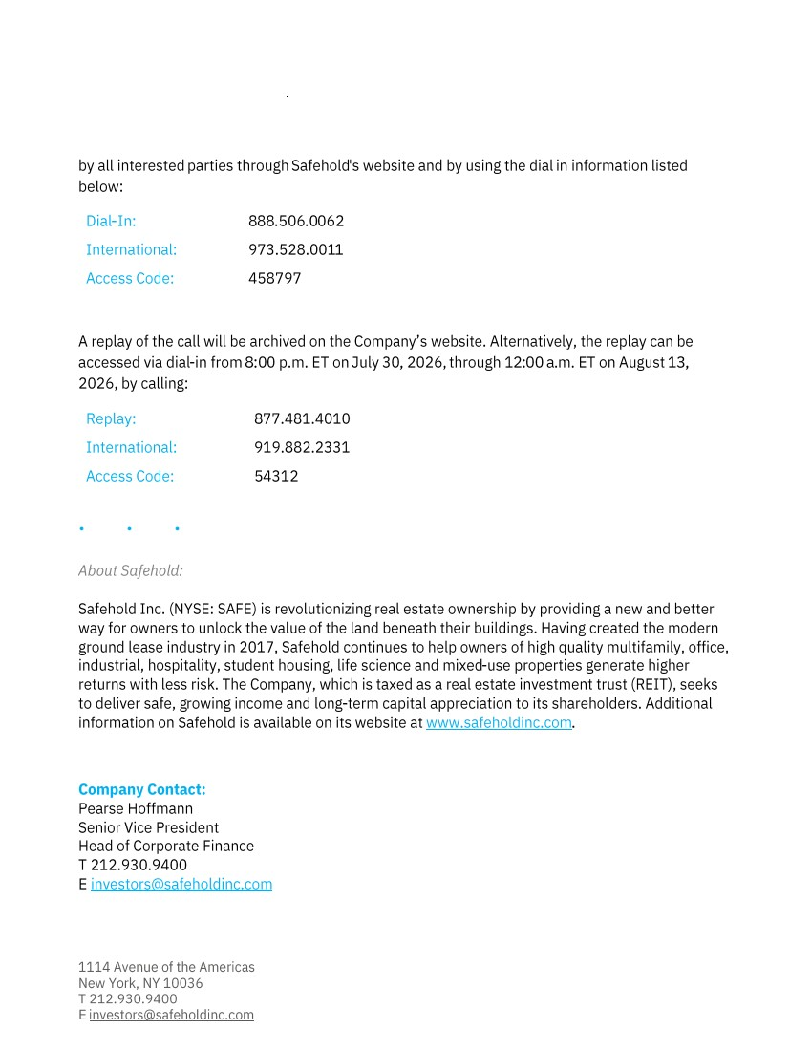 | 1114 Avenue of the Americas New York, NY 10036 T 212.930.9400 E investors@safeholdinc.com by all interested parties through Safehold 's website and by using the dial in information listed below: Dial -In: 888 .506 .0062 International: 973.528.001 1 Access Code: 458797 A replay of the call will be archived on the Company’s website. Alternatively, the replay can be accessed via dial -in from 8:00 p.m. ET on July 30 , 2026, through 1 2:00 a.m. ET on August 13, 2026, by calling: Replay: 877.481.4010 International: 919.882.2331 Access Code: 54312 • • • About Safehold: Safehold Inc. (NYSE: SAFE) is revolutionizing real estate ownership by providing a new and better way for owners to unlock the value of the land beneath their buildings. Having created the modern ground lease industry in 2017, Safehold continues to help ow ners of high quality multifamily, office, industrial, hospitality, student housing, life science and mixed -use properties generate higher returns with less risk. The Company, which is taxed as a real estate investment trust (REIT), seeks to deliver safe, g rowing income and long -term capital appreciation to its shareholders. Additional information on Safehold is available on its website at www.safeholdinc.com . Company Contact: Pearse Hoffmann Senior Vice President Head of Corporate Finance T 212.930.9400 E investors@safeholdinc.com
Exhibit 99.2
 | 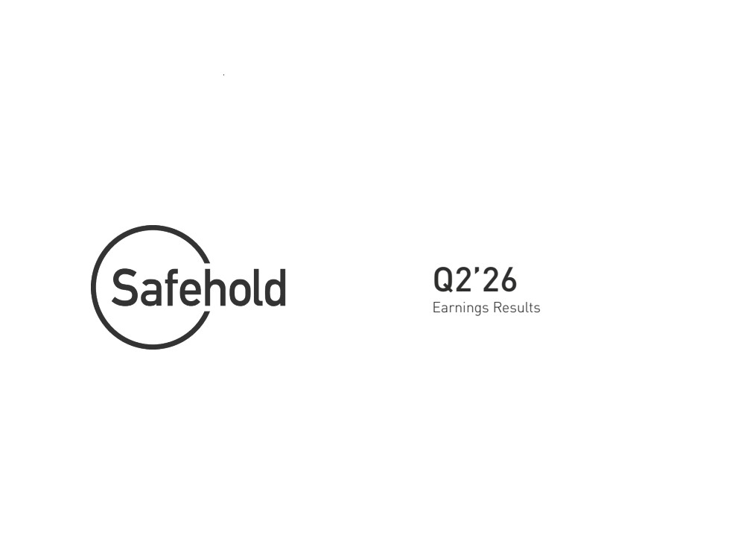 | Q2’26 Earnings Results
 | 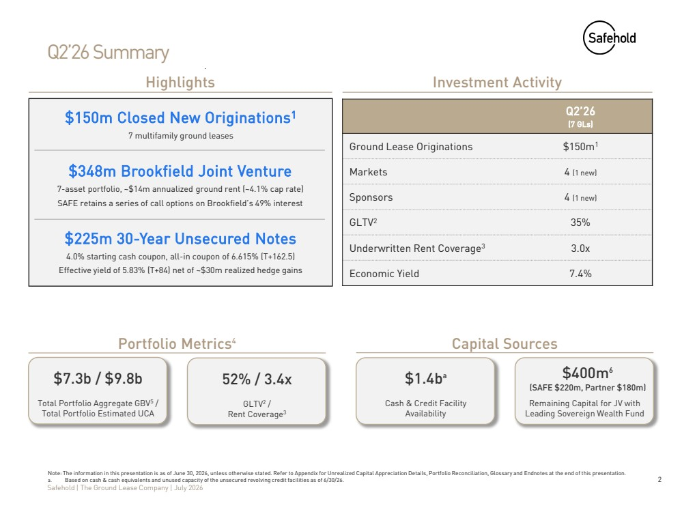 | 2 Safehold | The Ground Lease Company | July 2026 Q2’26 Summary Q2’26 (7 GLs) Ground Lease Originations $150m1 Markets 4 (1 new) Sponsors 4 (1 new) GLTV2 35% Underwritten Rent Coverage3 3.0x Economic Yield 7.4% Investment Activity Note: The information in this presentation is as of June 30, 2026, unless otherwise stated. Refer to Appendix for Unrealized Capital Appreciation Details, Portfolio Reconciliation, Glossary and Endnotes at the end of this presentation. a. Based on cash & cash equivalents and unused capacity of the unsecured revolving credit facilities as of 6/30/26. $7.3b / $9.8b Total Portfolio Aggregate GBV5 / Total Portfolio Estimated UCA Portfolio Metrics4 Capital Sources $1.4ba Cash & Credit Facility Availability 52% / 3.4x GLTV2 / Rent Coverage3 Remaining Capital for JV with Leading Sovereign Wealth Fund $400m6 (SAFE $220m, Partner $180m) Highlights $225m 30-Year Unsecured Notes 4.0% starting cash coupon, all-in coupon of 6.615% (T+162.5) Effective yield of 5.83% (T+84) net of ~$30m realized hedge gains $348m Brookfield Joint Venture 7-asset portfolio, ~$14m annualized ground rent (~4.1% cap rate) SAFE retains a series of call options on Brookfield’s 49% interest $150m Closed New Originations1 7 multifamily ground leases
 | 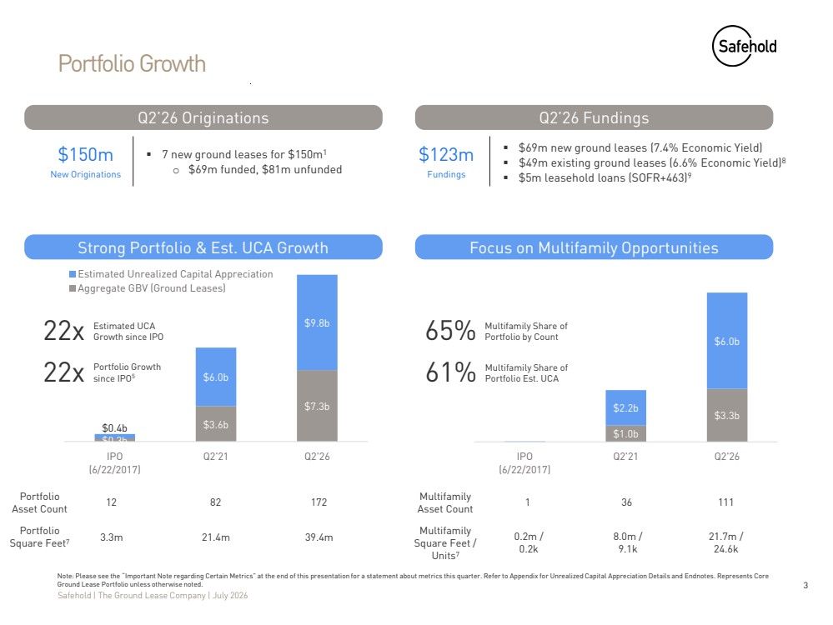 | 3 Safehold | The Ground Lease Company | July 2026 $1.0b $3.3b $2.2b $6.0b IPO (6/22/2017) Q2'21 Q2'26 Portfolio Growth Note: Please see the “Important Note regarding Certain Metrics” at the end of this presentation for a statement about metrics this quarter. Refer to Appendix for Unrealized Capital Appreciation Details and Endnotes. Represents Core Ground Lease Portfolio unless otherwise noted. Portfolio Asset Count 12 172 Multifamily Asset Count 82 1 36 111 Q2’26 Fundings $123m Fundings ▪ $69m new ground leases (7.4% Economic Yield) ▪ $49m existing ground leases (6.6% Economic Yield)8 ▪ $5m leasehold loans (SOFR+463)9 $150m New Originations ▪ 7 new ground leases for $150m1 o $69m funded, $81m unfunded Q2’26 Originations Portfolio Square Feet7 Multifamily Square Feet / Units7 Strong Portfolio & Est. UCA Growth Focus on Multifamily Opportunities 22x 22x Estimated UCA Growth since IPO Portfolio Growth since IPO5 3.3m 21.4m 39.4m 0.2m / 0.2k 21.7m / 24.6k 8.0m / 9.1k 65% Multifamily Share of Portfolio by Count 61% Multifamily Share of Portfolio Est. UCA $0.3b $3.6b $7.3b $0.4b $6.0b $9.8b IPO (6/22/2017) Q2'21 Q2'26 Estimated Unrealized Capital Appreciation Aggregate GBV (Ground Leases)
 | 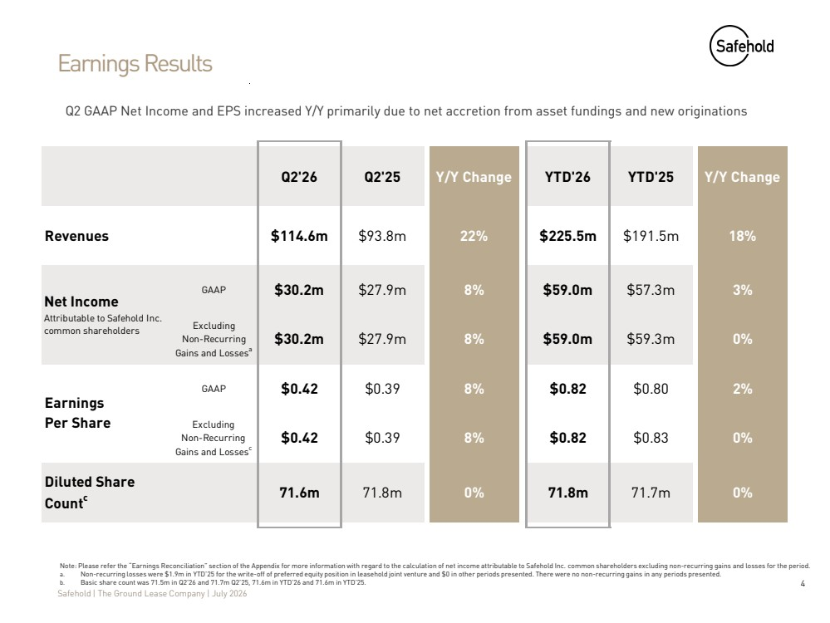 | 4 Safehold | The Ground Lease Company | July 2026 Earnings Results Note: Please refer the “Earnings Reconciliation” section of the Appendix for more information with regard to the calculation of net income attributable to Safehold Inc. common shareholders excluding non-recurring gains and losses for the period. a. Non-recurring losses were $1.9m in YTD’25 for the write-off of preferred equity position in leasehold joint venture and $0 in other periods presented. There were no non-recurring gains in any periods presented. b. Basic share count was 71.5m in Q2’26 and 71.7m Q2’25, 71.6m in YTD’26 and 71.6m in YTD’25. Q2 GAAP Net Income and EPS increased Y/Y primarily due to net accretion from asset fundings and new originations Q2'26 Q2'25 Y/Y Change YTD'26 YTD'25 Y/Y Change Revenues $114.6m $93.8m 22% $225.5m $191.5m 18% GAAP $30.2m $27.9m 8% $59.0m $57.3m 3% Excluding Non-Recurring Gains and Lossesa $30.2m $27.9m 8% $59.0m $59.3m 0% GAAP $0.42 $0.39 8% $0.82 $0.80 2% Excluding Non-Recurring Gains and Lossesc $0.42 $0.39 8% $0.82 $0.83 0% Diluted Share Countc 71.6m 71.8m 0% 71.8m 71.7m 0% Net Income Attributable to Safehold Inc. common shareholders Earnings Per Share
 | 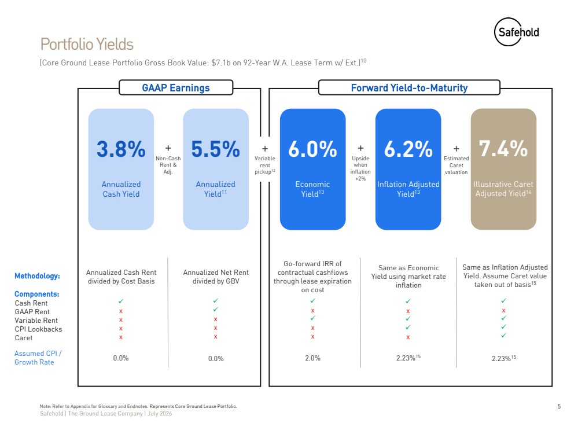 | 5 Safehold | The Ground Lease Company | July 2026 Assumed CPI / Growth Rate (Core Ground Lease Portfolio Gross Book Value: $7.1b on 92-Year W.A. Lease Term w/ Ext.)10 Portfolio Yields Note: Refer to Appendix for Glossary and Endnotes. Represents Core Ground Lease Portfolio. 3.8% Annualized Cash Yield 5.5% Annualized Yield11 6.0% Economic Yield13 6.2% Inflation Adjusted Yield13 7.4% Illustrative Caret Adjusted Yield14 Annualized Cash Rent divided by Cost Basis Annualized Net Rent divided by GBV Go-forward IRR of contractual cashflows through lease expiration on cost 0.0% 0.0% 2.0% 2.23%15 2.23%15 Methodology: + Non-Cash Rent & Adj. + Upside when inflation >2% + Estimated Caret valuation Same as Economic Yield using market rate inflation Same as Inflation Adjusted Yield. Assume Caret value taken out of basis15 + Variable rent pickup12 GAAP Earnings Cash Rent GAAP Rent Variable Rent CPI Lookbacks Caret ✓ x x x x ✓ ✓ x x x ✓ x ✓ x x ✓ x ✓ ✓ x ✓ x ✓ ✓ ✓ Forward Yield-to-Maturity Components:
 | 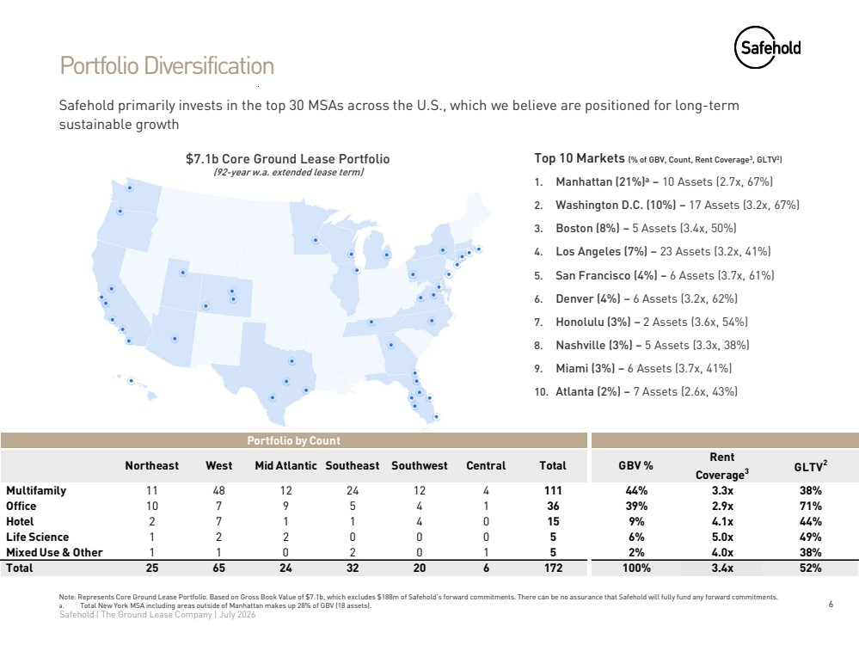 | 6 Safehold | The Ground Lease Company | July 2026 Portfolio Diversification Safehold primarily invests in the top 30 MSAs across the U.S., which we believe are positioned for long-term sustainable growth Top 10 Markets (% of GBV, Count, Rent Coverage3, GLTV2) 1. Manhattan (21%)a – 10 Assets (2.7x, 67%) 2. Washington D.C. (10%) – 17 Assets (3.2x, 67%) 3. Boston (8%) – 5 Assets (3.4x, 50%) 4. Los Angeles (7%) – 23 Assets (3.2x, 41%) 5. San Francisco (4%) – 6 Assets (3.7x, 61%) 6. Denver (4%) – 6 Assets (3.2x, 62%) 7. Honolulu (3%) – 2 Assets (3.6x, 54%) 8. Nashville (3%) – 5 Assets (3.3x, 38%) 9. Miami (3%) – 6 Assets (3.7x, 41%) 10. Atlanta (2%) – 7 Assets (2.6x, 43%) $7.1b Core Ground Lease Portfolio (92-year w.a. extended lease term) Note: Represents Core Ground Lease Portfolio. Based on Gross Book Value of $7.1b, which excludes $188m of Safehold’s forward commitments. There can be no assurance that Safehold will fully fund any forward commitments. a. Total New York MSA including areas outside of Manhattan makes up 28% of GBV (18 assets). Northeast West Mid Atlantic Southeast Southwest Central Total GBV % Rent Coverage3 GLTV2 Multifamily 11 48 12 24 12 4 111 44% 3.3x 38% Office 10 7 9 5 4 1 36 39% 2.9x 71% Hotel 2 7 1 1 4 0 15 9% 4.1x 44% Life Science 1 2 2 0 0 0 5 6% 5.0x 49% Mixed Use & Other 1 1 0 2 0 1 5 2% 4.0x 38% Total 25 65 24 32 20 6 172 100% 3.4x 52% Portfolio by Count
 | 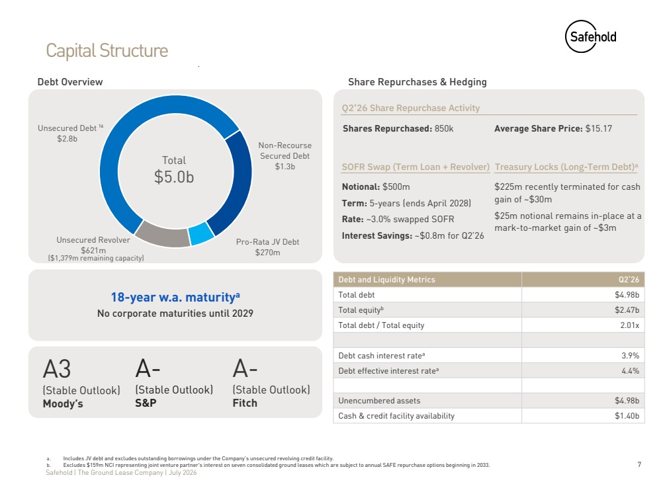 | 7 Safehold | The Ground Lease Company | July 2026 Capital Structure Debt Overview a. Includes JV debt and excludes outstanding borrowings under the Company’s unsecured revolving credit facility. b. Excludes $159m NCI representing joint venture partner's interest on seven consolidated ground leases which are subject to annual SAFE repurchase options beginning in 2033. ($1,379m remaining capacity) Total $5.0b Debt and Liquidity Metrics Q2‘26 Total debt $4.98b Total equityb $2.47b Total debt / Total equity 2.01x Debt cash interest ratea 3.9% Debt effective interest ratea 4.4% Unencumbered assets $4.98b Cash & credit facility availability $1.40b Share Repurchases & Hedging SOFR Swap (Term Loan + Revolver) Notional: $500m Term: 5-years (ends April 2028) Rate: ~3.0% swapped SOFR Interest Savings: ~$0.8m for Q2’26 Treasury Locks (Long-Term Debt)a $225m recently terminated for cash gain of ~$30m $25m notional remains in-place at a mark-to-market gain of ~$3m 18-year w.a. maturitya No corporate maturities until 2029 A3 (Stable Outlook) Moody’s A- (Stable Outlook) Fitch A- (Stable Outlook) S&P 16 Q2’26 Share Repurchase Activity Shares Repurchased: 850k Average Share Price: $15.17 Pro-Rata JV Debt $270m Unsecured Revolver $621m Unsecured Debt $2.8b Non-Recourse Secured Debt $1.3b
 | 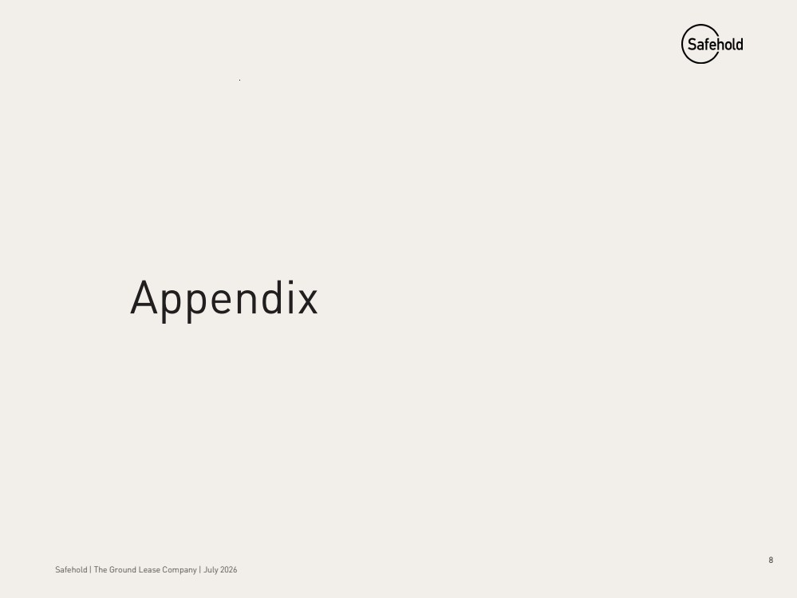 | 8 Safehold | The Ground Lease Company | July 2026 Appendix
 | 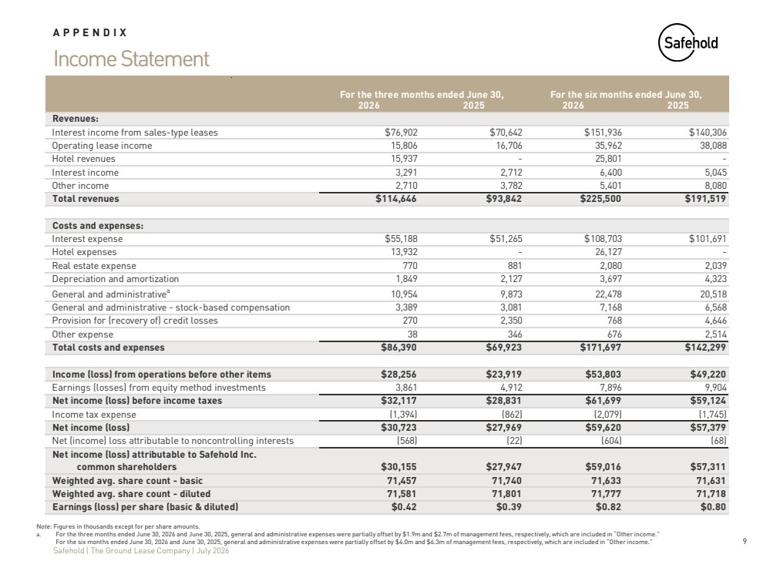 | 9 Safehold | The Ground Lease Company | July 2026 Income Statement APPENDIX Note: Figures in thousands except for per share amounts. a. For the three months ended June 30, 2026 and June 30, 2025, general and administrative expenses were partially offset by $1.9m and $2.7m of management fees, respectively, which are included in “Other income.” b. For the six months ended June 30, 2026 and June 30, 2025, general and administrative expenses were partially offset by $4.0m and $6.3m of management fees, respectively, which are included in “Other income.” 2026 2025 2026 2025 Revenues: Interest income from sales-type leases $76,902 $70,642 $151,936 $140,306 Operating lease income 15,806 16,706 35,962 38,088 Hotel revenues 15,937 - 25,801 - Interest income 3,291 2,712 6,400 5,045 Other income 2,710 3,782 5,401 8,080 Total revenues $114,646 $93,842 $225,500 $191,519 Costs and expenses: Interest expense $55,188 $51,265 $108,703 $101,691 Hotel expenses 13,932 - 26,127 - Real estate expense 770 881 2,080 2,039 Depreciation and amortization 1,849 2,127 3,697 4,323 General and administrativea 10,954 9,873 22,478 20,518 General and administrative - stock-based compensation 3,389 3,081 7,168 6,568 Provision for (recovery of) credit losses 270 2,350 768 4,646 Other expense 38 346 676 2,514 Total costs and expenses $86,390 $69,923 $171,697 $142,299 Income (loss) from operations before other items $28,256 $23,919 $53,803 $49,220 Earnings (losses) from equity method investments 3,861 4,912 7,896 9,904 Net income (loss) before income taxes $32,117 $28,831 $61,699 $59,124 Income tax expense (1,394) (862) (2,079) (1,745) Net income (loss) $30,723 $27,969 $59,620 $57,379 Net (income) loss attributable to noncontrolling interests (568) (22) (604) (68) Net income (loss) attributable to Safehold Inc. common shareholders $30,155 $27,947 $59,016 $57,311 Weighted avg. share count - basic 71,457 71,740 71,633 71,631 Weighted avg. share count - diluted 71,581 71,801 71,777 71,718 Earnings (loss) per share (basic & diluted) $0.42 $0.39 $0.82 $0.80 For the three months ended June 30, For the six months ended June 30,
 | 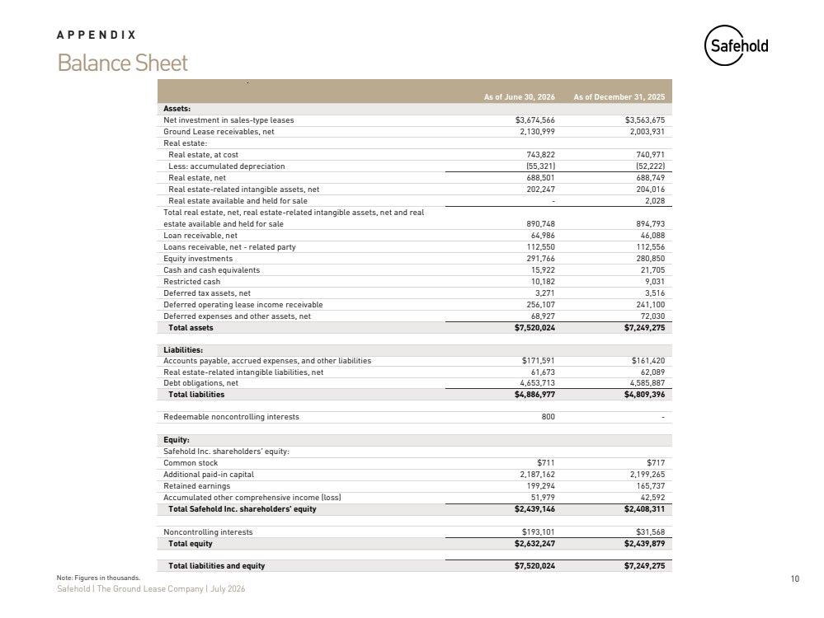 | 10 Safehold | The Ground Lease Company | July 2026 Balance Sheet APPENDIX Note: Figures in thousands. As of June 30, 2026 As of December 31, 2025 Assets: Net investment in sales-type leases $3,674,566 $3,563,675 Ground Lease receivables, net 2,130,999 2,003,931 Real estate: Real estate, at cost 743,822 740,971 Less: accumulated depreciation (55,321) (52,222) Real estate, net 688,501 688,749 Real estate-related intangible assets, net 202,247 204,016 Real estate available and held for sale - 2,028 Total real estate, net, real estate-related intangible assets, net and real estate available and held for sale 890,748 894,793 Loan receivable, net 64,986 46,088 Loans receivable, net - related party 112,550 112,556 Equity investments 291,766 280,850 Cash and cash equivalents 15,922 21,705 Restricted cash 10,182 9,031 Deferred tax assets, net 3,271 3,516 Deferred operating lease income receivable 256,107 241,100 Deferred expenses and other assets, net 68,927 72,030 Total assets $7,520,024 $7,249,275 Liabilities: Accounts payable, accrued expenses, and other liabilities $171,591 $161,420 Real estate-related intangible liabilities, net 61,673 62,089 Debt obligations, net 4,653,713 4,585,887 Total liabilities $4,886,977 $4,809,396 Redeemable noncontrolling interests 800 - Equity: Safehold Inc. shareholders' equity: Common stock $711 $717 Additional paid-in capital 2,187,162 2,199,265 Retained earnings 199,294 165,737 Accumulated other comprehensive income (loss) 51,979 42,592 Total Safehold Inc. shareholders' equity $2,439,146 $2,408,311 Noncontrolling interests $193,101 $31,568 Total equity $2,632,247 $2,439,879 Total liabilities and equity $7,520,024 $7,249,275
 | 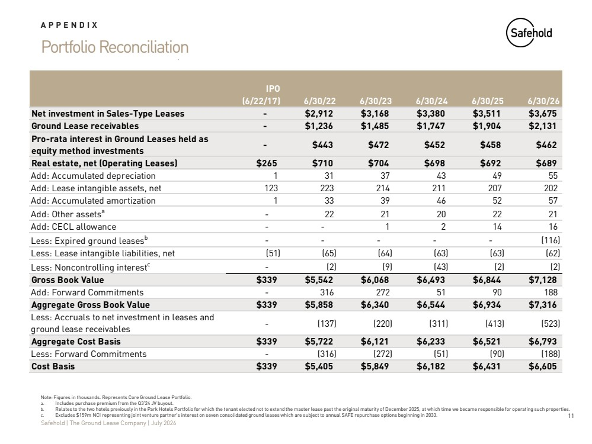 | 11 Safehold | The Ground Lease Company | July 2026 Portfolio Reconciliation APPENDIX Note: Figures in thousands. Represents Core Ground Lease Portfolio. a. Includes purchase premium from the Q3'24 JV buyout. b. Relates to the two hotels previously in the Park Hotels Portfolio for which the tenant elected not to extend the master lease past the original maturity of December 2025, at which time we became responsible for operating such properties. c. Excludes $159m NCI representing joint venture partner's interest on seven consolidated ground leases which are subject to annual SAFE repurchase options beginning in 2033. IPO (6/22/17) 6/30/22 6/30/23 6/30/24 6/30/25 6/30/26 Net investment in Sales-Type Leases - $2,912 $3,168 $3,380 $3,511 $3,675 Ground Lease receivables - $1,236 $1,485 $1,747 $1,904 $2,131 Pro-rata interest in Ground Leases held as equity method investments - $443 $472 $452 $458 $462 Real estate, net (Operating Leases) $265 $710 $704 $698 $692 $689 Add: Accumulated depreciation 1 31 37 43 49 55 Add: Lease intangible assets, net 123 223 214 211 207 202 Add: Accumulated amortization 1 33 39 46 52 57 Add: Other assetsa - 22 21 20 22 21 Add: CECL allowance - - 1 2 14 16 Less: Expired ground leasesb - - - - - (116) Less: Lease intangible liabilities, net (51) (65) (64) (63) (63) (62) Less: Noncontrolling interestc - (2) (9) (43) (2) (2) Gross Book Value $339 $5,542 $6,068 $6,493 $6,844 $7,128 Add: Forward Commitments - 316 272 51 90 188 Aggregate Gross Book Value $339 $5,858 $6,340 $6,544 $6,934 $7,316 Less: Accruals to net investment in leases and ground lease receivables - (137) (220) (311) (413) (523) Aggregate Cost Basis $339 $5,722 $6,121 $6,233 $6,521 $6,793 Less: Forward Commitments - (316) (272) (51) (90) (188) Cost Basis $339 $5,405 $5,849 $6,182 $6,431 $6,605
 | 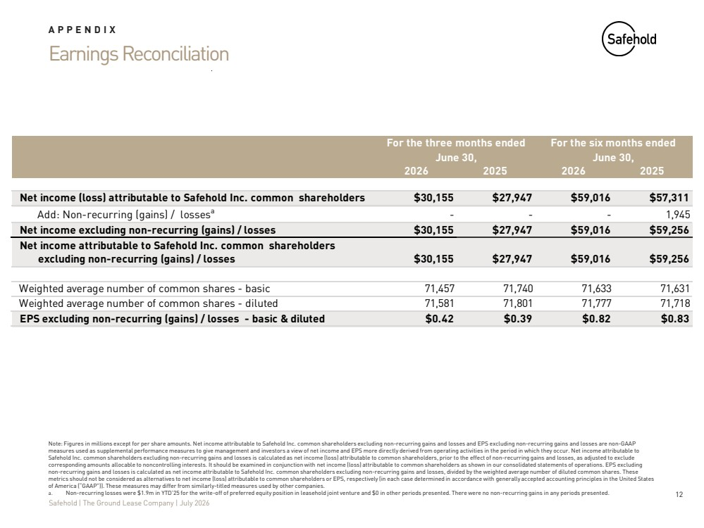 | 12 Safehold | The Ground Lease Company | July 2026 Earnings Reconciliation APPENDIX Note: Figures in millions except for per share amounts. Net income attributable to Safehold Inc. common shareholders excluding non-recurring gains and losses and EPS excluding non-recurring gains and losses are non-GAAP measures used as supplemental performance measures to give management and investors a view of net income and EPS more directly derived from operating activities in the period in which they occur. Net income attributable to Safehold Inc. common shareholders excluding non-recurring gains and losses is calculated as net income (loss) attributable to common shareholders, prior to the effect of non-recurring gains and losses, as adjusted to exclude corresponding amounts allocable to noncontrolling interests. It should be examined in conjunction with net income (loss) attributable to common shareholders as shown in our consolidated statements of operations. EPS excluding non-recurring gains and losses is calculated as net income attributable to Safehold Inc. common shareholders excluding non-recurring gains and losses, divided by the weighted average number of diluted common shares. These metrics should not be considered as alternatives to net income (loss) attributable to common shareholders or EPS, respectively (in each case determined in accordance with generally accepted accounting principles in the United States of America (“GAAP”)). These measures may differ from similarly-titled measures used by other companies. a. Non-recurring losses were $1.9m in YTD’25 for the write-off of preferred equity position in leasehold joint venture and $0 in other periods presented. There were no non-recurring gains in any periods presented. 2026 2025 2026 2025 Net income (loss) attributable to Safehold Inc. common shareholders $30,155 $27,947 $59,016 $57,311 Add: Non-recurring (gains) / lossesa - - - 1,945 Net income excluding non-recurring (gains) / losses $30,155 $27,947 $59,016 $59,256 Net income attributable to Safehold Inc. common shareholders excluding non-recurring (gains) / losses $30,155 $27,947 $59,016 $59,256 Weighted average number of common shares - basic 71,457 71,740 71,633 71,631 Weighted average number of common shares - diluted 71,581 71,801 71,777 71,718 EPS excluding non-recurring (gains) / losses - basic & diluted $0.42 $0.39 $0.82 $0.83 For the three months ended June 30, For the six months ended June 30,
 | 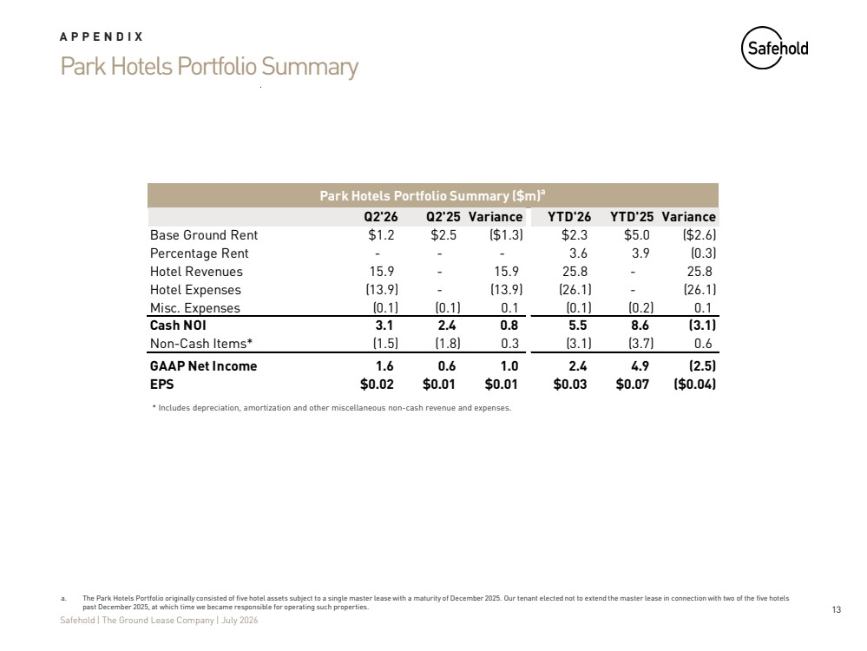 | 13 Safehold | The Ground Lease Company | July 2026 Park Hotels Portfolio Summary APPENDIX * Includes depreciation, amortization and other miscellaneous non-cash revenue and expenses. a. The Park Hotels Portfolio originally consisted of five hotel assets subject to a single master lease with a maturity of December 2025. Our tenant elected not to extend the master lease in connection with two of the five hotels past December 2025, at which time we became responsible for operating such properties. Q2'26 Q2'25 Variance YTD'26 YTD'25 Variance Base Ground Rent $1.2 $2.5 ($1.3) $2.3 $5.0 ($2.6) Percentage Rent - - - 3.6 3.9 (0.3) Hotel Revenues 15.9 - 15.9 25.8 - 25.8 Hotel Expenses (13.9) - (13.9) (26.1) - (26.1) Misc. Expenses (0.1) (0.1) 0.1 (0.1) (0.2) 0.1 Cash NOI 3.1 2.4 0.8 5.5 8.6 (3.1) Non-Cash Items* (1.5) (1.8) 0.3 (3.1) (3.7) 0.6 GAAP Net Income 1.6 0.6 1.0 2.4 4.9 (2.5) EPS $0.02 $0.01 $0.01 $0.03 $0.07 ($0.04) Park Hotels Portfolio Summary ($m)a
 | 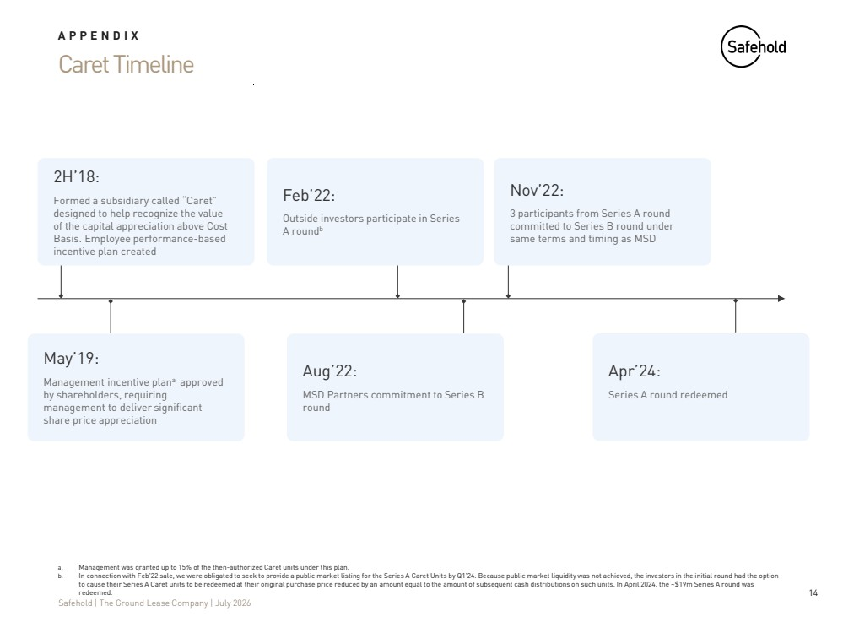 | 14 Safehold | The Ground Lease Company | July 2026 Caret Timeline APPENDIX a. Management was granted up to 15% of the then-authorized Caret units under this plan. b. In connection with Feb'22 sale, we were obligated to seek to provide a public market listing for the Series A Caret Units by Q1'24. Because public market liquidity was not achieved, the investors in the initial round had the option to cause their Series A Caret units to be redeemed at their original purchase price reduced by an amount equal to the amount of subsequent cash distributions on such units. In April 2024, the ~$19m Series A round was redeemed. 2H’18: Formed a subsidiary called “Caret” designed to help recognize the value of the capital appreciation above Cost Basis. Employee performance-based incentive plan created Feb’22: Outside investors participate in Series A roundb Nov’22: 3 participants from Series A round committed to Series B round under same terms and timing as MSD May’19: Management incentive plana approved by shareholders, requiring management to deliver significant share price appreciation Aug’22: MSD Partners commitment to Series B round Apr’24: Series A round redeemed
 | 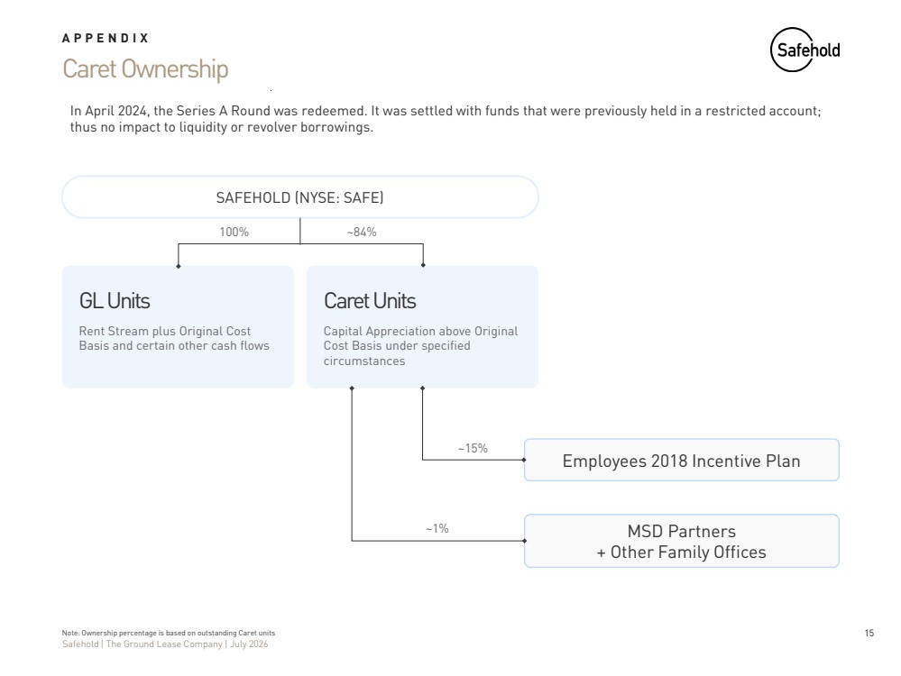 | 15 Safehold | The Ground Lease Company | July 2026 Caret Ownership Note: Ownership percentage is based on outstanding Caret units SAFEHOLD (NYSE: SAFE) GL Units Rent Stream plus Original Cost Basis and certain other cash flows Employees 2018 Incentive Plan Caret Units Capital Appreciation above Original Cost Basis under specified circumstances MSD Partners + Other Family Offices ~15% ~1% 100% ~84% APPENDIX In April 2024, the Series A Round was redeemed. It was settled with funds that were previously held in a restricted account; thus no impact to liquidity or revolver borrowings.
 | 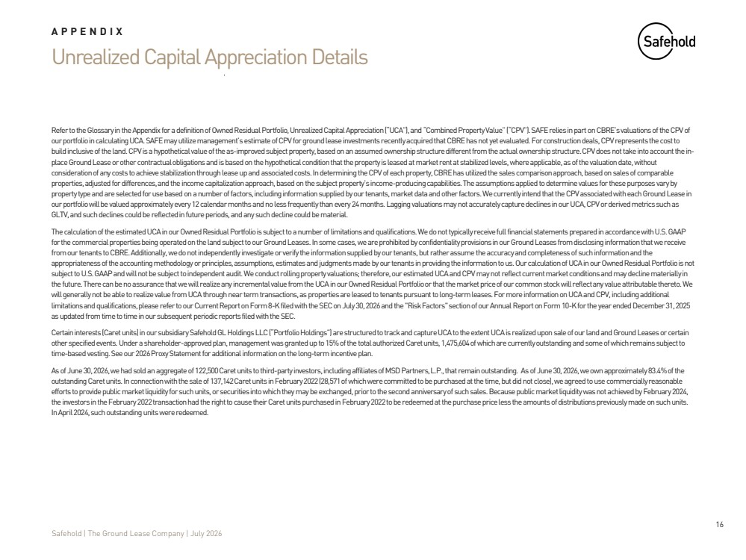 | 16 Safehold | The Ground Lease Company | July 2026 Unrealized Capital Appreciation Details APPENDIX Refer to the Glossary in the Appendix for a definition of Owned Residual Portfolio, Unrealized Capital Appreciation (“UCA”), and“Combined Property Value” (“CPV”). SAFE relies in part on CBRE’s valuations of the CPV of our portfolio in calculating UCA. SAFE may utilize management’s estimate of CPV for ground lease investments recently acquired that CBRE has not yet evaluated. For construction deals, CPV represents the cost to build inclusive of the land. CPV is a hypothetical value of the as-improved subject property, based on an assumed ownership structure different from the actual ownership structure. CPV does not take into account the in-place Ground Lease or other contractual obligations and is based on the hypothetical condition that the property is leased atmarket rent at stabilized levels, where applicable, as of the valuation date, without consideration of any costs to achieve stabilization through lease up and associated costs. In determining the CPV of each property, CBRE has utilized the sales comparison approach, based on sales of comparable properties, adjusted for differences, and the income capitalization approach, based on the subject property’s income-producing capabilities. The assumptions applied to determine values for these purposes vary by property type and are selected for use based on a number of factors, including information supplied by our tenants, market data and other factors. We currently intend that the CPV associated with each Ground Lease in our portfolio will be valued approximately every 12 calendar months and no less frequently than every 24 months. Lagging valuations may not accurately capture declines in our UCA, CPV or derived metrics such as GLTV, and such declines could be reflected in future periods, and any such decline could be material. The calculation of the estimated UCA in our Owned Residual Portfolio is subject to a number of limitations and qualifications. We do not typically receive full financial statements prepared in accordance with U.S. GAAP for the commercial properties being operated on the land subject to our Ground Leases. In some cases, we are prohibited by confidentiality provisions in our Ground Leases from disclosing information that we receive from our tenants to CBRE. Additionally, we do not independently investigate or verify the information supplied by our tenants, but rather assume the accuracy and completeness of such information and the appropriateness of the accounting methodology or principles, assumptions, estimates and judgments made by our tenants in providing the information to us. Our calculation of UCA in our Owned Residual Portfolio is not subject to U.S. GAAP and will not be subject to independent audit. We conduct rolling property valuations; therefore, our estimated UCA and CPV may not reflect current market conditions and may decline materially in the future. There can be no assurance that we will realize any incremental value from the UCA in our Owned Residual Portfolioor that the market price of our common stock will reflect any value attributable thereto. We will generally not be able to realize value from UCA through near term transactions, as properties are leased to tenants pursuant to long-term leases. For more information on UCA and CPV, including additional limitations and qualifications, please refer to our Current Report on Form 8-K filed with the SEC on July 30, 2026 and the "RiskFactors" section of our Annual Report on Form 10-K for the year ended December 31, 2025 as updated from time to time in our subsequent periodic reports filed with the SEC. Certain interests (Caret units) in our subsidiary Safehold GL Holdings LLC (“Portfolio Holdings”) are structured to track andcapture UCA to the extent UCA is realized upon sale of our land and Ground Leases or certain other specified events. Under a shareholder-approved plan, management was granted up to 15% of the total authorized Caret units,1,475,604 of which are currently outstanding and some of which remains subject to time-based vesting. See our 2026 Proxy Statement for additional information on the long-term incentive plan. As of June 30, 2026, we had sold an aggregate of 122,500 Caret units to third-party investors, including affiliates of MSD Partners, L.P., that remain outstanding. As of June 30, 2026, we own approximately 83.4% of the outstanding Caret units. In connection with the sale of 137,142 Caret units in February 2022 (28,571 of which were committed to be purchased at the time, but did not close), we agreed to use commercially reasonable efforts to provide public market liquidity for such units, or securities into which they may be exchanged, prior to the second anniversary of such sales. Because public market liquidity was not achieved by February 2024, the investors in the February 2022 transaction had the right to cause their Caret units purchased in February 2022 to be redeemed at the purchase price less the amounts of distributions previously made on such units. In April 2024, such outstanding units were redeemed.
 | 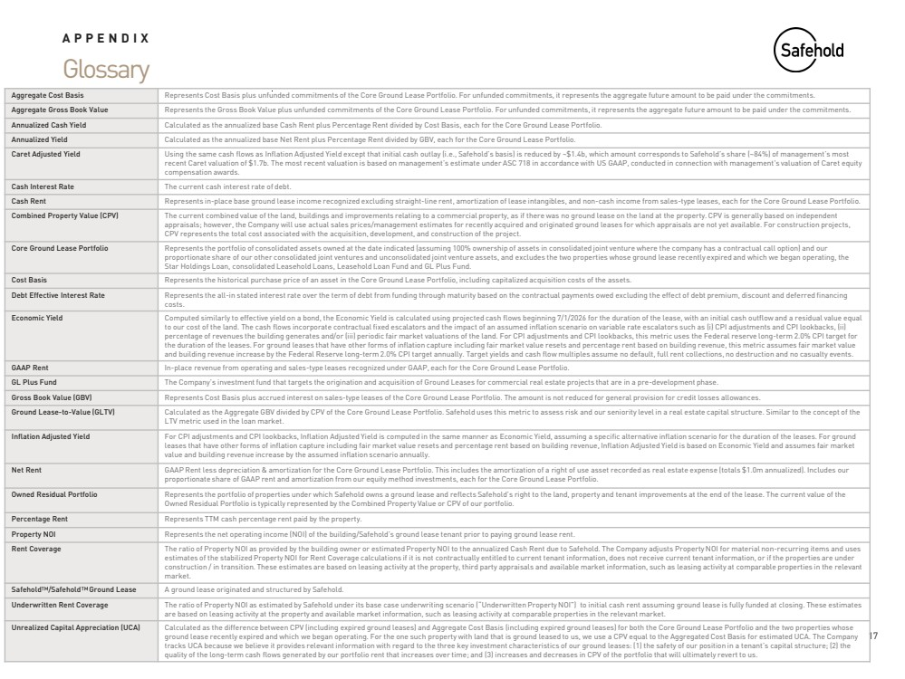 | 17 Safehold | The Ground Lease Company | July 2026 Glossary APPENDIX Aggregate Cost Basis Represents Cost Basis plus unfunded commitments of the Core Ground Lease Portfolio. For unfunded commitments, it represents the aggregate future amount to be paid under the commitments. Aggregate Gross Book Value Represents the Gross Book Value plus unfunded commitments of the Core Ground Lease Portfolio. For unfunded commitments, it represents the aggregate future amount to be paid under the commitments. Annualized Cash Yield Calculated as the annualized base Cash Rent plus Percentage Rent divided by Cost Basis, each for the Core Ground Lease Portfolio. Annualized Yield Calculated as the annualized base Net Rent plus Percentage Rent divided by GBV, each for the Core Ground Lease Portfolio. Caret Adjusted Yield Using the same cash flows as Inflation Adjusted Yield except that initial cash outlay (i.e., Safehold’s basis) is reduced by ~$1.4b, which amount corresponds to Safehold’s share (~84%) of management’s most recent Caret valuation of $1.7b. The most recent valuation is based on management’s estimate under ASC 718 in accordance with US GAAP, conducted in connection with management's valuation of Caret equity compensation awards. Cash Interest Rate The current cash interest rate of debt. Cash Rent Represents in-place base ground lease income recognized excluding straight-line rent, amortization of lease intangibles, and non-cash income from sales-type leases, each for the Core Ground Lease Portfolio. Combined Property Value (CPV) The current combined value of the land, buildings and improvements relating to a commercial property, as if there was no ground lease on the land at the property. CPV is generally based on independent appraisals; however, the Company will use actual sales prices/management estimates for recently acquired and originated ground leases for which appraisals are not yet available. For construction projects, CPV represents the total cost associated with the acquisition, development, and construction of the project. Core Ground Lease Portfolio Represents the portfolio of consolidated assets owned at the date indicated (assuming 100% ownership of assets in consolidated joint venture where the company has a contractual call option) and our proportionate share of our other consolidated joint ventures and unconsolidated joint venture assets, and excludes the two properties whose ground lease recently expired and which we began operating, the Star Holdings Loan, consolidated Leasehold Loans, Leasehold Loan Fund and GL Plus Fund. Cost Basis Represents the historical purchase price of an asset in the Core Ground Lease Portfolio, including capitalized acquisition costs of the assets. Debt Effective Interest Rate Represents the all-in stated interest rate over the term of debt from funding through maturity based on the contractual payments owed excluding the effect of debt premium, discount and deferred financing costs. Economic Yield Computed similarly to effective yield on a bond, the Economic Yield is calculated using projected cash flows beginning 7/1/2026 for the duration of the lease, with an initial cash outflow and a residual value equal to our cost of the land. The cash flows incorporate contractual fixed escalators and the impact of an assumed inflation scenario on variable rate escalators such as (i) CPI adjustments and CPI lookbacks, (ii) percentage of revenues the building generates and/or (iii) periodic fair market valuations of the land. For CPI adjustments and CPI lookbacks, this metric uses the Federal reserve long-term 2.0% CPI target for the duration of the leases. For ground leases that have other forms of inflation capture including fair market value resets and percentage rent based on building revenue, this metric assumes fair market value and building revenue increase by the Federal Reserve long-term 2.0% CPI target annually. Target yields and cash flow multiples assume no default, full rent collections, no destruction and no casualty events. GAAP Rent In-place revenue from operating and sales-type leases recognized under GAAP, each for the Core Ground Lease Portfolio. GL Plus Fund The Company’s investment fund that targets the origination and acquisition of Ground Leases for commercial real estate projects that are in a pre-development phase. Gross Book Value (GBV) Represents Cost Basis plus accrued interest on sales-type leases of the Core Ground Lease Portfolio. The amount is not reduced for general provision for credit losses allowances. Ground Lease-to-Value (GLTV) Calculated as the Aggregate GBV divided by CPV of the Core Ground Lease Portfolio. Safehold uses this metric to assess risk and our seniority level in a real estate capital structure. Similar to the concept of the LTV metric used in the loan market. Inflation Adjusted Yield For CPI adjustments and CPI lookbacks, Inflation Adjusted Yield is computed in the same manner as Economic Yield, assuming a specific alternative inflation scenario for the duration of the leases. For ground leases that have other forms of inflation capture including fair market value resets and percentage rent based on building revenue, Inflation Adjusted Yield is based on Economic Yield and assumes fair market value and building revenue increase by the assumed inflation scenario annually. Net Rent GAAP Rent less depreciation & amortization for the Core Ground Lease Portfolio. This includes the amortization of a right of use asset recorded as real estate expense (totals $1.0m annualized). Includes our proportionate share of GAAP rent and amortization from our equity method investments, each for the Core Ground Lease Portfolio. Owned Residual Portfolio Represents the portfolio of properties under which Safehold owns a ground lease and reflects Safehold’s right to the land, property and tenant improvements at the end of the lease. The current value of the Owned Residual Portfolio is typically represented by the Combined Property Value or CPV of our portfolio. Percentage Rent Represents TTM cash percentage rent paid by the property. Property NOI Represents the net operating income (NOI) of the building/Safehold’s ground lease tenant prior to paying ground lease rent. Rent Coverage The ratio of Property NOI as provided by the building owner or estimated Property NOI to the annualized Cash Rent due to Safehold. The Company adjusts Property NOI for material non-recurring items and uses estimates of the stabilized Property NOI for Rent Coverage calculations if it is not contractually entitled to current tenant information, does not receive current tenant information, or if the properties are under construction / in transition. These estimates are based on leasing activity at the property, third party appraisals and available market information, such as leasing activity at comparable properties in the relevant market. Safehold /Safehold Ground Lease A ground lease originated and structured by Safehold. Underwritten Rent Coverage The ratio of Property NOI as estimated by Safehold under its base case underwriting scenario (“Underwritten Property NOI”) to initial cash rent assuming ground lease is fully funded at closing. These estimates are based on leasing activity at the property and available market information, such as leasing activity at comparable properties in the relevant market. Unrealized Capital Appreciation (UCA) Calculated as the difference between CPV (including expired ground leases) and Aggregate Cost Basis (including expired ground leases) for both the Core Ground Lease Portfolio and the two properties whose ground lease recently expired and which we began operating. For the one such property with land that is ground leased to us, we use a CPV equal to the Aggregated Cost Basis for estimated UCA. The Company tracks UCA because we believe it provides relevant information with regard to the three key investment characteristics of our ground leases: (1) the safety of our position in a tenant’s capital structure; (2) the quality of the long-term cash flows generated by our portfolio rent that increases over time; and (3) increases and decreases in CPV of the portfolio that will ultimately revert to us.
 | 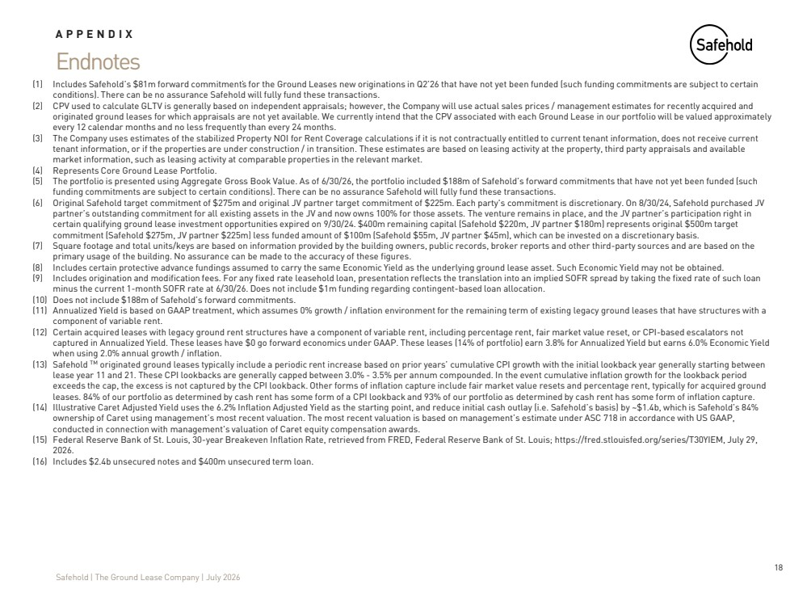 | 18 Safehold | The Ground Lease Company | July 2026 Endnotes APPENDIX (1) Includes Safehold’s $81m forward commitments for the Ground Leases new originations in Q2’26 that have not yet been funded (such funding commitments are subject to certain conditions). There can be no assurance Safehold will fully fund these transactions. (2) CPV used to calculate GLTV is generally based on independent appraisals; however, the Company will use actual sales prices / management estimates for recently acquired and originated ground leases for which appraisals are not yet available. We currently intend that the CPV associated with each Ground Lease in our portfolio will be valued approximately every 12 calendar months and no less frequently than every 24 months. (3) The Company uses estimates of the stabilized Property NOI for Rent Coverage calculations if it is not contractually entitled to current tenant information, does not receive current tenant information, or if the properties are under construction / in transition. These estimates are based on leasing activity at the property, third party appraisals and available market information, such as leasing activity at comparable properties in the relevant market. (4) Represents Core Ground Lease Portfolio. (5) The portfolio is presented using Aggregate Gross Book Value. As of 6/30/26, the portfolio included $188m of Safehold’s forward commitments that have not yet been funded (such funding commitments are subject to certain conditions). There can be no assurance Safehold will fully fund these transactions. (6) Original Safehold target commitment of $275m and original JV partner target commitment of $225m. Each party's commitment is discretionary. On 8/30/24, Safehold purchased JV partner’s outstanding commitment for all existing assets in the JV and now owns 100% for those assets. The venture remains in place, and the JV partner’s participation right in certain qualifying ground lease investment opportunities expired on 9/30/24. $400m remaining capital (Safehold $220m, JV partner $180m) represents original $500m target commitment (Safehold $275m, JV partner $225m) less funded amount of $100m (Safehold $55m, JV partner $45m), which can be invested on a discretionary basis. (7) Square footage and total units/keys are based on information provided by the building owners, public records, broker reports and other third-party sources and are based on the primary usage of the building. No assurance can be made to the accuracy of these figures. (8) Includes certain protective advance fundings assumed to carry the same Economic Yield as the underlying ground lease asset. Such Economic Yield may not be obtained. (9) Includes origination and modification fees. For any fixed rate leasehold loan, presentation reflects the translation into an implied SOFR spread by taking the fixed rate of such loan minus the current 1-month SOFR rate at 6/30/26. Does not include $1m funding regarding contingent-based loan allocation. (10) Does not include $188m of Safehold’s forward commitments. (11) Annualized Yield is based on GAAP treatment, which assumes 0% growth / inflation environment for the remaining term of existing legacy ground leases that have structures with a component of variable rent. (12) Certain acquired leases with legacy ground rent structures have a component of variable rent, including percentage rent, fair market value reset, or CPI-based escalators not captured in Annualized Yield. These leases have $0 go forward economics under GAAP. These leases (14% of portfolio) earn 3.8% for Annualized Yield but earns 6.0% Economic Yield when using 2.0% annual growth / inflation. (13) Safehold originated ground leases typically include a periodic rent increase based on prior years’ cumulative CPI growth with the initial lookback year generally starting between lease year 11 and 21. These CPI lookbacks are generally capped between 3.0% - 3.5% per annum compounded. In the event cumulative inflation growth for the lookback period exceeds the cap, the excess is not captured by the CPI lookback. Other forms of inflation capture include fair market value resets and percentage rent, typically for acquired ground leases. 84% of our portfolio as determined by cash rent has some form of a CPI lookback and 93% of our portfolio as determined by cash rent has some form of inflation capture. (14) Illustrative Caret Adjusted Yield uses the 6.2% Inflation Adjusted Yield as the starting point, and reduce initial cash outlay (i.e. Safehold’s basis) by ~$1.4b, which is Safehold’s 84% ownership of Caret using management’s most recent valuation. The most recent valuation is based on management’s estimate under ASC 718 in accordance with US GAAP, conducted in connection with management's valuation of Caret equity compensation awards. (15) Federal Reserve Bank of St. Louis, 30-year Breakeven Inflation Rate, retrieved from FRED, Federal Reserve Bank of St. Louis; https://fred.stlouisfed.org/series/T30YIEM, July 29, 2026. (16) Includes $2.4b unsecured notes and $400m unsecured term loan.
 | 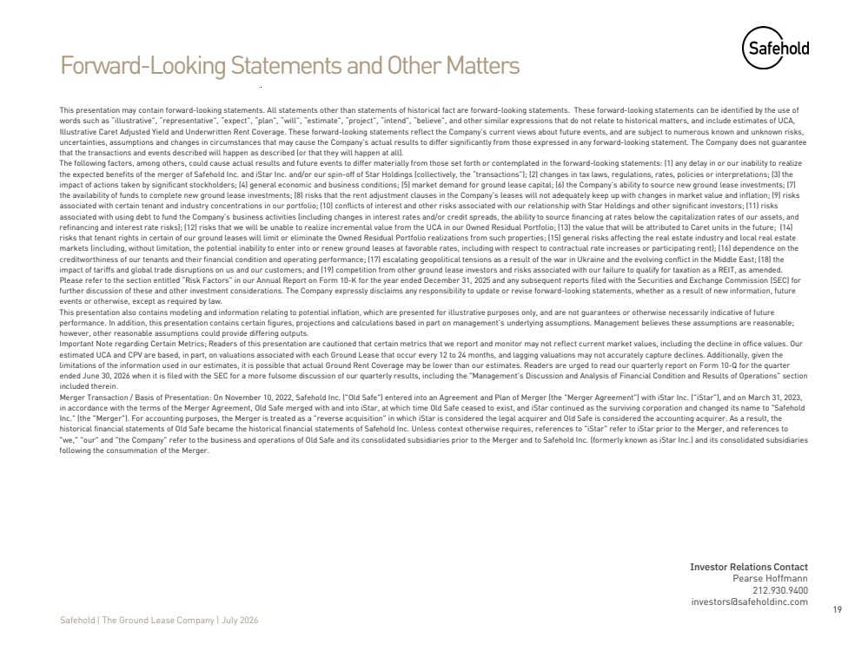 | 19 Safehold | The Ground Lease Company | July 2026 Forward-Looking Statements and Other Matters This presentation may contain forward-looking statements. All statements other than statements of historical fact are forward-looking statements. These forward-looking statements can be identified by the use of words such as “illustrative”, “representative”, “expect”, “plan”, “will”, “estimate”, “project”, “intend”, “believe”, and other similar expressions that do not relate to historical matters, and include estimates of UCA, Illustrative Caret Adjusted Yield and Underwritten Rent Coverage. These forward-looking statements reflect the Company’s current views about future events, and are subject to numerous known and unknown risks, uncertainties, assumptions and changes in circumstances that may cause the Company’s actual results to differ significantly from those expressed in any forward-looking statement. The Company does not guarantee that the transactions and events described will happen as described (or that they will happen at all). The following factors, among others, could cause actual results and future events to differ materially from those set forth or contemplated in the forward-looking statements: (1) any delay in or our inability to realize the expected benefits of the merger of Safehold Inc. and iStar Inc. and/or our spin-off of Star Holdings (collectively, the “transactions”); (2) changes in tax laws, regulations, rates, policies or interpretations; (3) the impact of actions taken by significant stockholders; (4) general economic and business conditions; (5) market demand for ground lease capital; (6) the Company’s ability to source new ground lease investments; (7) the availability of funds to complete new ground lease investments; (8) risks that the rent adjustment clauses in the Company's leases will not adequately keep up with changes in market value and inflation; (9) risks associated with certain tenant and industry concentrations in our portfolio; (10) conflicts of interest and other risks associated with our relationship with Star Holdings and other significant investors; (11) risks associated with using debt to fund the Company’s business activities (including changes in interest rates and/or credit spreads, the ability to source financing at rates below the capitalization rates of our assets, and refinancing and interest rate risks); (12) risks that we will be unable to realize incremental value from the UCA in our Owned Residual Portfolio; (13) the value that will be attributed to Caret units in the future; (14) risks that tenant rights in certain of our ground leases will limit or eliminate the Owned Residual Portfolio realizations from such properties; (15) general risks affecting the real estate industry and local real estate markets (including, without limitation, the potential inability to enter into or renew ground leases at favorable rates, including with respect to contractual rate increases or participating rent); (16) dependence on the creditworthiness of our tenants and their financial condition and operating performance; (17) escalating geopolitical tensions as a result of the war in Ukraine and the evolving conflict in the Middle East; (18) the impact of tariffs and global trade disruptions on us and our customers; and (19) competition from other ground lease investors and risks associated with our failure to qualify for taxation as a REIT, as amended. Please refer to the section entitled “Risk Factors” in our Annual Report on Form 10-K for the year ended December 31, 2025 and any subsequent reports filed with the Securities and Exchange Commission (SEC) for further discussion of these and other investment considerations. The Company expressly disclaims any responsibility to update or revise forward-looking statements, whether as a result of new information, future events or otherwise, except as required by law. This presentation also contains modeling and information relating to potential inflation, which are presented for illustrative purposes only, and are not guarantees or otherwise necessarily indicative of future performance. In addition, this presentation contains certain figures, projections and calculations based in part on management’s underlying assumptions. Management believes these assumptions are reasonable; however, other reasonable assumptions could provide differing outputs. Important Note regarding Certain Metrics; Readers of this presentation are cautioned that certain metrics that we report and monitor may not reflect current market values, including the decline in office values. Our estimated UCA and CPV are based, in part, on valuations associated with each Ground Lease that occur every 12 to 24 months, and lagging valuations may not accurately capture declines. Additionally, given the limitations of the information used in our estimates, it is possible that actual Ground Rent Coverage may be lower than our estimates. Readers are urged to read our quarterly report on Form 10-Q for the quarter ended June 30, 2026 when it is filed with the SEC for a more fulsome discussion of our quarterly results, including the "Management's Discussion and Analysis of Financial Condition and Results of Operations" section included therein. Merger Transaction / Basis of Presentation: On November 10, 2022, Safehold Inc. ("Old Safe") entered into an Agreement and Plan of Merger (the "Merger Agreement") with iStar Inc. ("iStar"), and on March 31, 2023, in accordance with the terms of the Merger Agreement, Old Safe merged with and into iStar, at which time Old Safe ceased to exist, and iStar continued as the surviving corporation and changed its name to "Safehold Inc." (the "Merger"). For accounting purposes, the Merger is treated as a "reverse acquisition" in which iStar is considered the legal acquirer and Old Safe is considered the accounting acquirer. As a result, the historical financial statements of Old Safe became the historical financial statements of Safehold Inc. Unless context otherwise requires, references to "iStar" refer to iStar prior to the Merger, and references to "we," "our" and "the Company" refer to the business and operations of Old Safe and its consolidated subsidiaries prior to the Merger and to Safehold Inc. (formerly known as iStar Inc.) and its consolidated subsidiaries following the consummation of the Merger. Investor Relations Contact Pearse Hoffmann 212.930.9400 investors@safeholdinc.com

