Table of Contents

UNITED STATES

SECURITIES AND EXCHANGE COMMISSION
Washington, D.C. 20549

_______________________________________________________________________________

FORM 10-K

(Mark One)

☒

ANNUAL REPORT PURSUANT TO SECTION 13 OR 15(d) OF THE SECURITIES EXCHANGE ACT OF 1934

For the fiscal year ended

December 31, 2019

OR

☐

TRANSITION REPORT PURSUANT TO SECTION 13 OR 15(d) OF THE SECURITIES EXCHANGE ACT OF 1934

For the transition period from

to

Commission File No. 001-38122

_______________________________________________________________________________

Safehold Inc.

(Exact name of registrant as specified in its charter)

Maryland

30-0971238

(State or other jurisdiction of

incorporation or organization)

(I.R.S. Employer

Identification Number)

1114 Avenue of the Americas

, 39th Floor

New York , NY

10036

(Address of principal executive offices)

(Zip code)

Registrant's telephone number, including area code: (212) 930-9400

_______________________________________________________________________________

Securities registered pursuant to Section 12(b) of the Act:

 | Title of each class: |  | Trading Symbol(s) |  |  | Name of Exchange on which registered:
 | Common Stock, $0.01 par value |  | SAFE |  |  | New York Stock Exchange
Indicate by check mark if the registrant is a well-known seasoned issuer, as defined in Rule 405 of the Securities Act. Yes ☒ No o
Indicate by check mark if the registrant is not required to file reports pursuant to Section 13 or Section 15(d) of the Act. Yes o |  |  |  |  | No ☒

Indicate by check mark whether the registrant: (i) has filed all reports required to be filed by Section 13 or 15(d) of the Securities Exchange Act of 1934 during the preceding twelve months (or for such shorter period that the registrant was required to file such reports); and (ii) has been subject to such filing requirements for the past 90 days. Yes ☒ No o

Indicate by check mark whether the registrant has submitted electronically every Interactive Data File required to be submitted pursuant to Rule 405 of Regulation S-T during the preceding 12 months (or for such shorter period that the registrant was required to submit such files). Yes ☒ No o

Table of Contents

Indicate by check mark whether the registrant is a large accelerated filer, an accelerated filer, a non-accelerated filer, smaller reporting company, or an emerging growth company. See definitions of "large accelerated filer," "accelerated filer," "smaller reporting company," and "emerging growth company" in Rule 12b-2 of the Exchange Act.

Large accelerated filer | Accelerated filer | Non-accelerated filer | Smaller reporting company | Emerging growth company
o | ☒ | o | ☒ | ☒
Indicate by check mark whether the registrant is a shell company (as defined in Rule 12b-2 of the Act). Yes ☐ |  |  | No ☒

If an emerging growth company, indicate by check mark if the registrant has elected not to use the extended transition period for complying with any new or revised financial accounting standards provided pursuant to Section 13(a) of the Exchange Act. ☒

As of June 30, 2019, the aggregate market value of Safehold Inc. common stock, $0.01 par value per share, held by non-affiliates of the registrant was approximately $282.0 million, based upon the closing price of $30.20 on the New York Stock Exchange composite tape on such date.

As of February 12, 2020, there were 47,781,786 shares of common stock outstanding.

DOCUMENTS INCORPORATED BY REFERENCE

- Portions of the registrant's definitive proxy statement for the registrant's 2020 Annual Meeting, to be filed within 120 days after the close of the registrant's fiscal year, are incorporated by reference into Part III of this Annual Report on Form 10-K.

Table of Contents

 |  |  |  |  |  |  |  |  |  |  |  |  |  |  |  |  |  | TABLE OF CONTENTS
 |  |  |  |  |  |  |  |  |  |  |  |  |  |  |  |  |  |  |  |  |  |  |  |  | Page
PART I |  |  |  |  |  |  |  |  |  |  |  |  |  |  |  |  |  |  |  |  |  |  |  |  |  | 1
Item 1. |  |  |  |  |  | Business |  |  |  |  |  |  |  |  |  |  |  |  |  |  |  |  |  |  |  | 1
Item 1a. |  |  |  |  |  | Risk Factors |  |  |  |  |  |  |  |  |  |  |  |  |  |  |  |  |  |  | 8
Item 1b. |  |  |  |  |  | Unresolved Staff Comments |  |  |  |  |  |  |  |  |  |  |  |  |  |  |  |  |  |  | 28
Item 2. |  |  |  |  |  | Properties |  |  |  |  |  |  |  |  |  |  |  |  |  |  |  |  |  |  | 28
Item 3. |  |  |  |  |  | Legal Proceedings |  |  |  |  |  |  |  |  |  |  |  |  |  |  |  |  |  |  | 28
Item 4. |  |  |  |  |  | Mine Safety Disclosures |  |  |  |  |  |  |  |  |  |  |  |  |  |  |  |  |  |  | 28
PART II |  |  |  |  |  |  |  |  |  |  |  |  |  |  |  |  |  |  |  |  |  |  |  |  | 29
Item 5. |  |  |  |  |  | Market for Registrant's Equity and Related Share Matters |  |  |  |  |  |  |  |  |  |  |  |  |  |  |  |  |  |  | 29
Item 6. |  |  |  |  |  | Selected Financial Data |  |  |  |  |  |  |  |  |  |  |  |  |  |  |  |  |  |  | 30
Item 7. |  |  |  |  |  | Management's Discussion and Analysis of Financial Condition and Results of Operations |  |  |  |  |  |  |  |  |  |  |  |  |  |  |  |  |  |  | 31
Item 7a. |  |  |  |  |  | Quantitative and Qualitative Disclosures about Market Risk |  |  |  |  |  |  |  |  |  |  |  |  |  |  |  |  |  |  | 40
Item 8. |  |  |  |  |  | Financial Statements and Supplemental Data |  |  |  |  |  |  |  |  |  |  |  |  |  |  |  |  |  |  | 41
Item 9. |  |  |  |  |  | Changes and Disagreements with Registered Public Accounting Firm on Accounting and Financial Disclosure |  |  |  |  |  |  |  |  |  |  |  |  |  |  |  |  |  |  | 71
Item 9a. |  |  |  |  |  | Controls and Procedures |  |  |  |  |  |  |  |  |  |  |  |  |  |  |  |  |  |  | 71
Item 9b. |  |  |  |  |  | Other Information |  |  |  |  |  |  |  |  |  |  |  |  |  |  |  |  |  |  | 71
PART III |  |  |  |  |  |  |  |  |  |  |  |  |  |  |  |  |  |  |  |  |  |  |  |  | 72
Item 10. |  |  |  |  |  | Directors, Executive Officers and Corporate Governance of the Registrant |  |  |  |  |  |  |  |  |  |  |  |  |  |  |  |  |  |  | 72
Item 11. |  |  |  |  |  | Executive Compensation |  |  |  |  |  |  |  |  |  |  |  |  |  |  |  |  |  |  | 72
Item 12. |  |  |  |  |  | Security Ownership of Certain Beneficial Owners and Management and Related Stockholder Matters |  |  |  |  |  |  |  |  |  |  |  |  |  |  |  |  |  |  | 72
Item 13. |  |  |  |  |  | Certain Relationships, Related Transactions and Director Independence |  |  |  |  |  |  |  |  |  |  |  |  |  |  |  |  |  |  | 72
Item 14. |  |  |  |  |  | Principal Registered Public Accounting Firm Fees and Services |  |  |  |  |  |  |  |  |  |  |  |  |  |  |  |  |  |  | 72
PART IV |  |  |  |  |  |  |  |  |  |  |  |  |  |  |  |  |  |  |  |  |  |  |  |  | 73
Item 15. |  |  |  |  |  | Exhibits, Financial Statement Schedules and Reports on Form 8-K |  |  |  |  |  |  |  |  |  |  |  |  |  |  |  |  |  |  | 73
Item 16. |  |  |  |  |  | Form 10-K Summary |  |  |  |  |  |  |  |  |  |  |  |  |  |  |  |  |  |  | 74
SIGNATURES

Table of Contents

PART I

Item 1. Business

Explanatory Note for Purposes of the "Safe Harbor Provisions" of Section 21E of the Securities Exchange Act of 1934, as amended

Certain statements in this report, other than purely historical information, including estimates, projections, statements relating to our business plans, objectives and expected operating results, and the assumptions upon which those statements are based, are "forward-looking statements" within the meaning of the Private Securities Litigation Reform Act of 1995, Section 27A of the Securities Act of 1933, as amended (the "Securities Act"), and Section 21E of the Securities Exchange Act of 1934, as amended (the "Exchange Act"). Forward-looking statements are included with respect to, among other things, our current business plan, business strategy, portfolio management, prospects and liquidity. These forward-looking statements generally are identified by the words "believe," "project," "expect," "anticipate," "estimate," "intend," "strategy," "plan," "may," "should," "will," "would," "will be," "will continue," "will likely result," and similar expressions. Forward-looking statements are based on current expectations and assumptions that are subject to risks and uncertainties which may cause actual results or outcomes to differ materially from those contained in the forward-looking statements. Important factors that we believe might cause such differences are discussed in the section entitled, "Risk Factors" in Part I, Item 1a of this Form 10-K or otherwise accompany the forward-looking statements contained in this Form 10-K. We undertake no obligation to update or revise publicly any forward-looking statements, whether as a result of new information, future events or otherwise. In assessing all forward-looking statements, readers are urged to read carefully all cautionary statements contained in this Form 10-K.

Business

We are a publicly-traded company that originates and acquires ground leases in order to generate attractive long-term risk-adjusted returns. We believe that our business has characteristics comparable to a high-grade, fixed income investment business, but with certain unique advantages. Relative to alternative fixed income investments generally, our ground leases typically benefit from built-in growth derived from contractual rent increases, and the opportunity to realize value from residual rights to acquire the buildings and other improvements on our land at no additional cost to us. We believe that these features offer us the opportunity to realize superior risk-adjusted total returns when compared to certain alternative highly-rated investments.

Ground leases generally represent the ownership of land underlying commercial real estate properties, which are leased on a long-term basis (base terms are typically 30 to 99 years, often with tenant renewal options) by the land owner (landlord) to a tenant that owns and operates the building on top of the land ("Ground Lease"), or what we refer to as a SafeholdTM. The property is generally leased on a triple net basis with the tenant generally responsible for taxes, maintenance and insurance as well as all operating costs and capital expenditures. Ground Leases typically provide that at the end of the lease term or upon tenant default and the termination of the Ground Lease upon such default, the land, building and all improvements revert to the landlord. We seek to become the industry leader in Ground Leases by demonstrating the value of the product to real estate investors, owners, operators and developers and expanding their use throughout major metropolitan areas.

We have a diverse portfolio of properties located in major metropolitan areas. All of the properties in our portfolio are subject to long-term leases consisting of Ground Leases and one master lease (covering five properties) that provide for contractual periodic rent escalations or percentage rent participations in gross revenues generated at the relevant properties.

We have chosen to focus on Ground Leases because we believe they meet an important need in the real estate capital markets for our customers. We also believe Ground Leases offer a unique combination of safety, income growth and the potential for capital appreciation for investors for the following reasons:

High Quality Long-Term Cash Flow: We believe that a Ground Lease represents a safe position in a property's capital structure. The combined property value subject to a Ground Lease typically significantly exceeds the Ground Lease landlord's investment in the Ground Lease; therefore, even if the landlord takes over the property following a tenant default or upon expiration of the Ground Lease, the landlord is reasonably likely to recover substantially all of its Ground Lease investment, and possibly amounts in excess of its investment, depending upon prevailing market conditions. Additionally, the typical structure of a Ground Lease provides the landlord with a residual right to regain possession of its land and take ownership of the buildings and improvements thereon upon a tenant default. The landlord's residual right provides a strong incentive for a Ground Lease tenant or its leasehold lender to make the required Ground Lease rent payments.

1

Table of Contents

Income Growth: Ground Leases typically provide growing income streams through contractual base rent escalators that may compound over the duration of the lease. These rent escalators may be based on fixed increases, a Consumer Price Index ("CPI") or a combination thereof, and may also include a participation in the gross revenues of the property. We believe that this growth in the lease rate over time can mitigate the effects of inflation and capture anticipated increases in land values over time, as well as serving as a basis for growing our dividend.

Opportunity for Capital Appreciation: The opportunity for capital appreciation comes in two forms. First, as the ground rent grows over time, the value of the Ground Lease should grow under market conditions in which capitalization rates remain flat. Second, our residual right to regain possession of the land underlying the Ground Lease and take title to the buildings and other improvements thereon for no additional consideration creates additional potential value to our shareholders.

We generally target Ground Lease investments in which the initial cost of the Ground Lease represents 30% to 45% of the combined value of the land and buildings and improvements thereon (the "Combined Property Value") as if the Ground Lease did not exist. If the initial cost of a Ground Lease is equal to 35% of the Combined Property Value, the remaining 65% of the Combined Property Value represents potential excess value over the amount of our investment that would be turned over to us upon the reversion of the property, assuming no intervening change in the Combined Property Value. In our view, there is a strong correlation between inflation and commercial real estate values over time, which supports our belief that the value of our owned residual portfolio should increase over time as inflation increases, although our ability to recognize value in certain cases may be limited by the rights of our tenants under some of our Ground Leases, including tenant rights to purchase our land in certain circumstances and the right of one tenant to demolish improvements prior to the expiration of the lease. See "Risk Factors" for a discussion of these tenant rights.

Owned Residual Portfolio: We believe that the residual right is a unique feature distinguishing Ground Leases from other fixed income investments and property types. We track the unrealized appreciation in the value of our owned residual portfolio over our basis because we believe it provides relevant information with regard to the three key investment characteristics of our Ground Leases: (1) the safety of our position in a tenant's capital structure; (2) the quality of the long-term cash flows generated by our portfolio rent that increases over time; and (3) increases and decreases in the Combined Property Value of the portfolio that reverts to us pursuant to such residual rights.

We believe that, similar to a loan to value metric, tracking changes in the value of our owned residual portfolio is useful as an indicator of the quality of our cash flows and the safety of our position in a tenant's capital structure, which, in turn, support the Company's objective to pay and grow dividends over time. Observing changes in our owned residual portfolio value also helps us monitor changes in the value of the real estate portfolio that reverts to us under the terms of the leases, either at the expiration or earlier termination of the lease. The value may be realized by us at the relevant time by entering into a new lease reflecting then current market terms and values, selling the building, selling the building with the land, or operating the building directly and leasing the spaces to tenants at prevailing market rates.

We have engaged an independent valuation firm to prepare: (a) initial reports of the Combined Property Value associated with our Ground Lease portfolio; and (b) periodic updates of such reports, which we use, in part, to determine the current estimated value of our owned residual portfolio. We calculate this estimated value by subtracting our original aggregate cost basis in the Ground Leases from the aggregate Combined Property Value determined by the valuation firm.

The table below shows the current estimated unrealized capital appreciation in our owned residual portfolio ("UCA") as of December 31, 2019 and 2018 ($ in millions):⁽¹⁾

 |  | December 31, 2019 |  |  |  | December 31, 2018
 | Combined Property Value⁽²⁾ | $ | 7,538 |  | $ | 2,757
 | Ground Lease Cost⁽²⁾ |  | 2,708 |  |  | 948
 | Unrealized Capital Appreciation in Our Owned Residual Portfolio |  | 4,830 |  |  | 1,809
 | _______________________________________________________________________________
- Please review our Current Report on Form 8-K filed on February 13, 2020 for a discussion of the valuation methodology used and important limitations and qualifications of the calculation of UCA. See "Risk Factors" for a discussion of certain tenant rights that may limit our ability to realize value from the UCA, including tenant rights to purchase our land in certain circumstances and the right of one tenant to demolish improvements prior to the expiration of the lease.
- Combined Property Value includes our 54.8% percentage interest in our unconsolidated venture and $416.0 million and $254.9 million related to transactions with remaining unfunded commitments as of December 31, 2019 and 2018, respectively. Ground Lease Cost includes our 54.8% percentage interest in our unconsolidated venture and $81.3 million and $64.0 million of unfunded commitments as of December 31, 2019 and 2018, respectively. As of December 31, 2019, our gross book value as a percentage of Combined Property Value was 38%.

Market Opportunity: We believe that there is a significant market opportunity for a dedicated provider of Ground Lease capital like us. We believe that the market for existing Ground Leases is fragmented with ownership comprised primarily of high

2

Table of Contents

net worth individuals, pension funds, life insurance companies, estates and endowments. However, while we intend to pursue acquisitions of existing Ground Leases, our investment thesis is predicated, in part, on what we believe is an untapped market opportunity to expand the use of Ground Leases to a broader component of the approximately $7.0 trillion institutional commercial property market in the U.S. We intend to capture this market opportunity by utilizing multiple sourcing and origination channels, including manufacturing new Ground Leases with third-party owners and developers of commercial real estate and originating Ground Leases to provide capital for development and redevelopment. We further believe that Ground Leases generally represent an attractive source of capital for our tenants and may allow them to generate superior returns on their invested equity as compared to utilizing alternative sources of capital. We draw on the extensive investment origination and sourcing platform of iStar, the parent company of SFTY Manager, LLC (our "Manager"), to actively promote the benefits of the Ground Lease structure to prospective Ground Lease tenants.

We are a Maryland corporation and completed our initial public offering in June 2017. Our common stock is listed on the New York Stock Exchange under the symbol "SAFE." We elected to be taxed as a real estate investment trust ("REIT") for U.S. federal income tax purposes, commencing with the tax year ended December 31, 2017. We are structured as an Umbrella Partnership REIT ("UPREIT"). As such, all of our properties are owned through a subsidiary partnership, Safehold Operating Partnership LP (the "Operating Partnership"). As of December 31, 2019, we owned 100% of the limited partner interests and a subsidiary of ours owned 100% of the general partner interests, in the Operating Partnership. The UPREIT structure may afford us certain benefits as we seek to acquire properties from third parties who may want to defer taxes by contributing their Ground Leases to us.

Investment Strategy

Our primary investment objective is to construct a diversified portfolio of Ground Leases that will generate attractive high-quality risk-adjusted returns and support stable and growing distributions to our stockholders. We have identified several channels for pursuing Ground Lease investment opportunities which include:

- Create a Ground Lease with a Third Party. We seek to pursue opportunities where a third party acquiror or existing owner of a commercial property may be interested in utilizing a Ground Lease structure to facilitate its options with respect to its interests in the property. We will create the Ground Lease by splitting ownership of the property into an ownership interest and Ground Lease on the land, and a separate leasehold interest of the building and improvements thereon. We will acquire the ownership interest and Ground Lease on the land from the third party.

- Acquire Existing Ground Leases. We seek to acquire existing Ground Leases that are marketed for sale and actively solicit potential sellers and related property brokers of existing Ground Leases to engage in off-market transactions. Our structure as an UPREIT gives us the ability to acquire Ground Leases from owners, particularly estates and high net worth individuals, using Operating Partnership units that may provide the seller with tax advantages, as well as liquidity, portfolio diversification and professional management.

- Originate Ground Leases to Provide Capital For Development or Value-Add Redevelopment or Repositioning. We seek opportunities where we can purchase land and simultaneously lease it pursuant to a new Ground Lease to a tenant who plans to develop a new, or significantly improve an existing, commercial property on the land.

- Acquire a Commercial Real Estate Property to Create a Ground Lease. We seek in select instances, in partnership with our Manager, to acquire commercial real estate properties that have the potential to be converted into an ownership structure that includes a Ground Lease retained by us and a leasehold interest that may be acquired by our Manager or sold to a third party.

- Finance Third Party Ground Leases. Combining our capital resources with our Manager's relationships and Ground Lease expertise, we seek opportunities to originate Ground Lease investments in conjunction with our Manager's origination of a leasehold financing with the same customer.

We generally intend to target Ground Leases that meet some or all of the following investment criteria:

- Properties located in major metropolitan areas;

- Average remaining initial lease terms of 30 to 99 years;

- Periodic contractual rent escalators or percentage rent participations;

- Value of approximately 30% to 45% of the Combined Property Value at the commencement of the lease or the acquisition date;

- Ground Rent Coverage, defined as the ratio of the Property's NOI to the annualized rental payment due us, of approximately 2.0x to 4.5x for the initial 12-month period of the lease. Property NOI is defined as the trailing twelve month net operating income of the building and improvements being operated at the property without giving effect to any rent paid or payable under our Ground Lease, and for this purpose we use estimates of the stabilized Property NOI if we don't receive current

3

Table of Contents

tenant information. For properties under construction or in transition, in each case we use estimates based on leasing activity at the property and available market information, including leasing activity at comparable properties in the relevant market;

- First year cash return on asset of between 3.0% and 4.0% and effective yields between 5.0% and 5.5%;

- Properties that we believe are well located in markets with high barriers to entry and that have durable cash flow; and

- Transaction sizes ranging from $20 million to $500 million.

For the year ended December 31, 2019, our two largest tenants by revenues, the tenants of our 1111 Pennsylvania Avenue Ground Lease and our Park Hotels Portfolio Ground Lease, accounted for approximately 17.3% and 14.9%, respectively, of our total revenues.

Policies with Respect to Other Activities

Our investment, disposition, financing and corporate governance policies (including conflicts of interests policies) are managed under the ultimate supervision of our board of directors. We can amend, revise or eliminate these policies at any time without a vote of its shareholders. We intend to originate and manage investments in a manner consistent with the requirements of the Internal Revenue Code of 1986, as amended (the "Code") for us to qualify as a REIT.

Investment Policies

Investment in Real Estate or Interests in Real Estate

We conduct substantially all of our investment activities through our Operating Partnership and its affiliates. Our primary investment objective is to enhance stockholder value by increasing earnings, cash flow from our operations and the valuation of our investment portfolio.

We pursue our primary investment objective primarily through the ownership, directly or indirectly, by our Operating Partnership of our Ground Lease investments. Future investment activities will not be limited to any geographic area or to a specified percentage of our assets. While we may diversify in terms of property type, geography, tenant and lease term, we do not have any limit on the amount or percentage of our assets that may be invested in any one of the foregoing categories. We intend to engage in such future investment activities in a manner that is consistent with our qualification and maintenance of our qualification as a REIT for U.S. federal income tax purposes. We do not have a specific policy to acquire assets primarily for capital gain or primarily for income. In addition, we may purchase, lease and/or finance Ground Lease assets for long-term investment, or sell such assets, in whole or in part, when circumstances warrant.

We may also participate with third parties in ventures or other types of co-ownership if we determine that doing so would be the most effective means of raising capital. We will not, however, enter into a venture or other partnership arrangement to make an investment that would not otherwise meet our investment policies. We also may acquire real estate or interests in real estate in exchange for the issuance of common stock, Operating Partnership units, preferred stock or options to purchase stock.

Investments may be subject to existing mortgage financing and other indebtedness or to new indebtedness which may be incurred in connection with acquiring or refinancing these investments, and we may in the future have corporate level indebtedness through credit facilities and debt securities. Principal of and interest on our debt will have a priority over any dividends and any liquidation amounts with respect to our common stock. Investments are also subject to our policy not to be treated as an investment company under the 1940 Act.

Investments in Real Estate Mortgages

Our current portfolio consists primarily of, and our business objectives emphasize, equity investments in real estate. We may also finance Ground Lease transactions in the future and invest in mortgages or deeds of trust. Debt investments run the risk that one or more borrowers may default under the debt and the collateral securing the debt may not be sufficient to enable us to recoup our full investment. See "Risk Factors—Risks Related to Our Portfolio and Our Business—Loans that we make to Ground Lease owners will be subject to delinquency, foreclosure and loss, which could result in losses to us."

4

Table of Contents

Investments in Securities of or Interests in Persons Primarily Engaged in Real Estate Activities and Other Issuers

Subject to our qualification as a REIT, we may invest in securities of other REITs, other entities engaged in real estate activities or securities of other issuers, including for the purpose of exercising control over such entities. We do not currently have any policy limiting the types of entities in which we may invest or the proportion of assets to be so invested, whether through acquisition of an entity's common stock, limited liability or partnership interests, interests in another REIT or entry into a joint venture. We intend to invest primarily in entities that own real estate and provide Ground Lease capital. We have no current plans to make material investments in entities that are not engaged in real estate activities. Our business objectives are to enhance stockholder value by increasing earnings, cash flow from operations, acquire and originate target investments and provide cash distributions and long-term capital appreciation to our stockholders through increases in the value of our company. We have not established a specific policy regarding the relative priority of the foregoing objectives.

Investment in Other Securities

Other than as described above, we do not intend to invest in any additional securities such as loans, bonds, preferred stock or common stock.

Disposition Policies

We may from time to time dispose of investments if, based upon our Manager's and our board's periodic review of our portfolio, we determine such action would be in our best interest. In addition, we may elect to enter into ventures or other types of co-ownership with respect to properties that we own, either in connection with acquiring interests in other properties (as discussed above in "—Investment Policies—Investment in Real Estate or Interests in Real Estate") or from investors to raise equity capital.

Financing Policies

We utilize and expect to continue to utilize leverage. Our current strategy is to generally target overall leverage at an amount that is approximately 25% of the aggregate Combined Property Value of our portfolio, but not to exceed an overall ratio of 2:1 relative to our total equity. However, our organizational documents do not limit the amount of indebtedness that we may incur. We anticipate that our Manager, under the supervision of our board of directors, will consider a number of factors in evaluating our level of indebtedness from time to time, as well as the amount of such indebtedness that will be either fixed or floating rate. Our board of directors may from time to time modify our leverage policies in light of the then-current economic conditions, relative costs of debt and equity capital, market values of our properties, general market conditions for debt and equity issuances, fluctuations in the market price of our common stock, growth and acquisition opportunities and other factors, including the restrictive covenants under our debt obligations.

To the extent our board of directors determines to obtain additional capital, we may, without stockholder approval, borrow funds or issue debt or equity securities, including additional Operating Partnership units, retain earnings (subject to the distribution requirements applicable to REITs under the Code) or pursue a combination of these methods. As long as our Operating Partnership is in existence, the proceeds of all equity capital raised by us will be contributed to our Operating Partnership in exchange for additional interests in our Operating Partnership, which will dilute the ownership interests of the then existing limited partners in our Operating Partnership.

Hedging Strategy

We may enter into hedging transactions with respect to one or more of our assets or liabilities. Hedging transactions could take a variety of forms, including interest rate swap agreements, interest rate cap agreements, options, futures contracts, forward rate agreements or similar financial instruments. We intend to structure hedging transactions in a manner that does not jeopardize our qualification as a REIT.

Conflict of Interest Policies

Conflicts of interest may exist or could arise in the future with iStar and its affiliates, including our Manager, our executive officers and/or directors who are also officers and/or directors of iStar, and any limited partner of our Operating Partnership. Conflicts may include, without limitation: conflicts arising from the enforcement of agreements between us and iStar or our Manager; conflicts in the amount of time that officers and employees of our Manager will spend on our affairs versus iStar's other affairs; and conflicts in future transactions that we may pursue with iStar. iStar is our largest shareholder and owned approximately 65.2% of our common stock as of December 31, 2019. In addition, two directors of iStar serve on our board of directors, including Jay Sugarman, who is the chief executive officer of iStar and our chief executive officer. Our Manager is a wholly-owned subsidiary of iStar. As a result of the foregoing relationships, iStar has significant influence over us.

We have entered into an exclusivity agreement with iStar pursuant to which iStar (including iStar's Net Lease Venture II equity method investment) has agreed that it will not acquire, originate, invest in, or provide financing for a third party's acquisition

5

Table of Contents

of, a Ground Lease unless it has first offered that opportunity to us. The exclusivity agreement does not apply to opportunities that include only an incidental interest in Ground Leases or opportunities to manufacture or otherwise create a Ground Lease from a property that has been owned by iStar's first net lease venture (Net Lease Venture) for at least three years after the closing of our initial public offering. The Net Lease Venture invested in single tenant properties leased to corporate entities under triple net leases. iStar owns a 51.9% interest in, and manages the day to day operations of, the Net Lease Venture and several of its executives whose time is substantially devoted to the venture own a 0.6% equity interest in the venture and are entitled to participate in promote payments made to iStar. The exclusivity agreement will remain in effect during the term of the management agreement. The exclusivity agreement will automatically terminate upon any termination of the management agreement and will not otherwise be terminable; provided, however, that if iStar terminates the management agreement for convenience, it will continue to be bound by the exclusivity agreement for 12 months after the termination. We do not generally expect to enter into ventures with iStar, but if we do so, the terms and conditions of our venture investment will be subject to the approval of a majority of disinterested directors of our board of directors.

Our directors and executive officers have duties to us under applicable Maryland law in connection with their management of our company. At the same time, we have fiduciary duties, as a general partner, to our Operating Partnership and to the limited partners under Delaware law (the jurisdiction of the Operating Partnership's organization) in connection with the management of our Operating Partnership. Our duties as a general partner to our Operating Partnership and its partners may come into conflict with the duties of our directors and executive officers to our company. Unless otherwise provided for in the relevant partnership agreement, Delaware law generally requires a general partner of a Delaware limited partnership to adhere to fiduciary duty standards under which it owes its limited partners the highest duties of loyalty and care and which generally prohibits such general partner from taking any action or engaging in any transaction as to which it has a conflict of interest. The limited partners of our Operating Partnership have agreed that in the event of such a conflict, we will fulfill our fiduciary duties to such limited partners by acting in the best interests of our company.

Additionally, the Operating Partnership agreement expressly limits our liability by providing that neither the general partner of the Operating Partnership, nor any of its directors or officers, will be liable or accountable in damages to our Operating Partnership, the limited partners or assignees for errors in judgment, mistakes of fact or law or for any act or omission if we, or such director or officer, acted in good faith. In addition, our Operating Partnership is required to indemnify us, our affiliates and each of our respective executive officers, directors and employees and any person we may designate from time to time in our sole and absolute discretion, including present and former members, managers, stockholders, directors, limited partners, general partners, officers or controlling persons of our predecessor, to the fullest extent permitted by applicable law against any and all losses, claims, damages, liabilities (whether joint or several), expenses (including, without limitation, attorneys' fees and other legal fees and expenses), judgments, fines, settlements and other amounts arising from any and all claims, demands, actions, suits or proceedings, civil, criminal, administrative or investigative, that relate to the operations of the Operating Partnership, provided that our Operating Partnership will not indemnify such person for: (i) willful misconduct or a knowing violation of the law; (ii) any transaction for which such person received an improper personal benefit in violation or breach of any provision of the Operating Partnership agreement; or (iii) in the case of a criminal proceeding, the person had reasonable cause to believe the act or omission was unlawful.

The provisions of Delaware law that allow the common law fiduciary duties of a general partner to be modified by an operating partnership agreement have not been resolved in a court of law, and we have not obtained an opinion of counsel covering the provisions set forth in the Operating Partnership agreement that purport to waive or restrict our fiduciary duties that would be in effect under common law were it not for the Operating Partnership agreement.

Our charter and bylaws do not restrict any of our directors, executive officers, stockholders or affiliates from having a pecuniary interest in an investment or transaction that we have an interest in or from conducting, for their own account, business activities of the type we conduct. We have, however, adopted certain policies designed to eliminate or minimize certain potential conflicts of interest. Specifically, we adopted a code of business conduct and ethics that prohibits conflicts of interest between our executive officers, employees and directors on the one hand, and our company on the other hand, except in compliance with the policy. Our code of business conduct and ethics states that a conflict of interest exists when a person's private interest interferes with our interest. For example, a conflict of interest will arise when any of our employees, executive officers or directors or any immediate family member of such employee, executive officer or director receives improper personal benefits as a result of his or her position with us. Our code of business conduct and ethics also limits our employees, executive officers and directors from engaging in any activity that is competitive with the business activities and operations of our company, except as disclosed by us from time to time in our public filings. In addition, our code of business conduct and ethics also restricts the ability of our employees, executive officers and directors to participate in a joint venture, partnership or other business arrangement with us, except in compliance with the policy. Waivers of our code of business conduct and ethics will be required to be disclosed in accordance with New York Stock Exchange ("NYSE") and Securities and Exchange Commission ("SEC") requirements. In addition, we have adopted corporate governance guidelines to assist our board of directors in the exercise of its responsibilities and to serve our interests and those of our stockholders. However, we cannot assure you these policies or provisions of law will always succeed

6

Table of Contents

in eliminating the influence of such conflicts. If they are not successful, decisions could be made that might fail to reflect the best interest of all stockholders.

Competition

We compete with numerous commercial developers, real estate companies (including other REITs), financial institutions (such as banks and insurance companies) and other investors (such as pension funds, investment funds, private companies and individuals) for investment opportunities and tenants. This competition may result in higher costs for properties, lower returns and impact our ability to grow. Some of these competitors have greater financial and other resources and access to more attractive capital than we do. However, due to our focus on Ground Leases located throughout the U.S., and because some of our competitors are locally and/or regionally focused, we do not always encounter the same competitors in each market.

Regulation

General

Our properties are subject to various laws, ordinances and regulations. We believe that we are in compliance in all material respects with the necessary permits and approvals to conduct our business.

Environmental Matters

Under various federal, state and local environmental laws, statutes, ordinances, rules and regulations, as an owner of real property, we may be liable for the costs of removal or remediation of certain hazardous or toxic substances at, on, in or under the properties we own as well as certain other potential costs relating to hazardous or toxic substances. These liabilities may include government fines and penalties and damages for injuries to persons and adjacent property. These laws may impose liability without regard to whether we knew of, or were responsible for, the presence or disposal of those substances. This liability may be imposed on us in connection with the activities of an operator of, or tenant at, the property. The cost of any required remediation, removal, fines or personal or property damages, and our liability therefor, could be significant and could exceed the value of the property and/have a material adverse effect on us. In addition, the presence of those substances, or the failure to properly dispose of or remove those substances, may adversely affect our ability to sell or rent the affected property or to borrow using such property as collateral, which, in turn, would reduce our revenues and ability to satisfy our debt service obligations and to make distributions to our stockholders.

A property can also be adversely affected either through physical contamination or by virtue of an adverse effect upon value attributable to the migration of hazardous or toxic substances, or other contaminants that have or may have emanated from other properties.

Although our tenants are primarily responsible for any environmental damages and claims related to the leased properties, a tenant's bankruptcy or inability to satisfy its obligations for these types of damages or claims could require us to satisfy such liabilities. In addition, we may be held directly liable for any such damages or claims irrespective of the provisions of any lease.

From time to time, in connection with the conduct of our business, we authorize the preparation of environmental reports with respect to our properties. There can be no assurance that these environmental reports will reveal all environmental conditions at the properties in which we have an interest or that the following will not expose us to material liability in the future:

- the discovery of previously unknown environmental conditions;

- changes in law;

- activities of prior owners or tenants;

- activities of current tenants; or

- activities relating to properties in the vicinity of our properties.

Changes in laws increasing the potential liability for environmental conditions existing on properties or increasing the restrictions on discharges or other conditions may result in significant unanticipated expenditures or may otherwise adversely affect the operations of the tenants of our properties, which could materially and adversely affect us.

Emerging Growth Company Status

We are an "emerging growth company," as defined in the Jumpstart Our Business Startups Act of 2012 (the "JOBS Act"), and we are eligible to take advantage of certain exemptions from various reporting requirements that are applicable to other publicly-traded companies that are not "emerging growth companies," including not being required to comply with the auditor attestation requirements of Section 404 of the Sarbanes-Oxley Act of 2002 (the "Sarbanes-Oxley Act"). We have elected to utilize the exemption for auditor attestation requirements.

7

Table of Contents

In addition, the JOBS Act provides that an "emerging growth company" can take advantage of the extended transition period provided in the Securities Act, for complying with new or revised accounting standards. In other words, an emerging growth company can delay the adoption of certain accounting standards until those standards would otherwise apply to private companies. However, we have chosen to "opt out" of this extended transition period, and, as a result, we will comply with new or revised accounting standards on the relevant dates on which adoption of such standards is required for all public companies that are not emerging growth companies. Our decision to opt out of the extended transition period for complying with new or revised accounting standards is irrevocable.

We will remain an "emerging growth company" until the earliest to occur of: (i) the last day of the fiscal year during which our total annual revenue equals or exceeds $1.07 billion (subject to adjustment for inflation); (ii) the last day of the fiscal year following the fifth anniversary of our initial public offering; (iii) the date on which we have, during the previous three-year period, issued more than $1.0 billion in non-convertible debt; or (iv) the date on which we are deemed to be a "large accelerated filer" under the Exchange Act.

Code of Conduct

The Company has adopted a code of conduct that sets forth the principles of conduct and ethics to be followed by our directors, officers, Manager and employees of our Manager who perform services for us (the "Code of Conduct"). The purpose of the Code of Conduct is to promote honest and ethical conduct, compliance with applicable governmental rules and regulations, full, fair, accurate, timely and understandable disclosure in periodic reports, prompt internal reporting of violations of the Code of Conduct and a culture of honesty and accountability. A copy of the Code of Conduct has been provided to each of our directors, officers, the Manager and relevant employees, who are required to acknowledge that they have received and will comply with the Code of Conduct. A copy of the Company's Code of Conduct has been previously filed with the SEC and is incorporated by reference in this Annual Report on Form 10-K as Exhibit 14.1. The Code of Conduct is also available on the Company's website at www.safeholdinc.com. The Company will disclose to shareholders material changes to its Code of Conduct, or any waivers for directors or executive officers, if any, within four business days of any such event. As of December 31, 2019, there have been no amendments to the Code of Conduct and the Company has not granted any waivers from any provision of the Code of Conduct to any directors or executive officers.

Employees

We have no employees, as our Manager provides all services to us.

Additional Information

We maintain a website at www.safeholdinc.com. The information on our website is not incorporated by reference in this report, and our web address is included only as an inactive textual reference. In addition to this Annual Report on Form 10-K, we file quarterly and special reports, proxy statements and other information with the SEC. Through our website, we make available free of charge our annual proxy statement, annual reports to stockholders, annual reports on Form 10-K, quarterly reports on Form 10-Q, current reports on Form 8-K, and amendments to those reports filed or furnished pursuant to Section 13(a) or 15(d) of the Exchange Act as soon as reasonably practicable after we electronically file such material with, or furnish it to, the SEC. These documents also may be accessed through the SEC's electronic data gathering, analysis and retrieval system via electronic means, including on the SEC's homepage, which can be found at www.sec.gov.

Item 1a. Risk Factors

In addition to the other information in this report, you should consider carefully the following risk factors in evaluating an investment in the Company's securities. Any of these risks or the occurrence of any one or more of the uncertainties described below could have a material adverse effect on the Company's business, financial condition, results of operations, cash flows, ability to service our indebtedness, ability to pay distributions and the market price of the Company's common stock. The risks set forth below speak only as of the date of this report and the Company disclaims any duty to update them except as required by law. For purposes of these risk factors, the terms "our Company," "we," "our" and "us" refer to Safehold Inc. and its consolidated subsidiaries, unless the context indicates otherwise.

Risks Related to Our Portfolio and Our Business

Our expectations as to the size of the market for Ground Lease transactions and the availability of investment opportunities may prove to be incorrect.

We believe we are the first public company that invests primarily in Ground Lease assets and the achievement of our investment objectives depends, in part, on our ability to continue to grow our portfolio. We cannot assure you that the size of the market for Ground Leases will meet our estimates. Potential tenants may prefer to own the land underlying the improvements they

8

Table of Contents

intend to develop, rehabilitate or own. Negative publicity about the experience of tenants with non-Safehold Ground Leases may also discourage potential tenants. In addition, as and when interest rates increase, there may be less activity generally in real estate transactions, including leasing, development and financing, and less financing available for potential tenants to finance their leasehold interests.

If potential tenants are unable to secure financing for their leasehold interests, their appetite for Ground Leases may diminish, which could materially and adversely affect our growth prospects.

In addition, if our current tenants are unable to secure financing to continue to operate their businesses and pay us rent, we could be materially and adversely affected.

A potential tenant's interest in entering into a Ground Lease transaction as opposed to alternative financing, such as mortgage financing, will depend in part on such tenant's ability to secure financing for a leasehold interest on attractive terms. If leasehold financing is not available on terms that are at least as favorable as available mortgage financing, we expect that potential tenants will be less likely to pursue Ground Lease transactions with us, which may materially adversely affect the market for our leases and our ability to grow and meet our investment objectives.

Additionally, many of our tenants rely on external sources of financing to operate their businesses. The U.S. may experience significant liquidity disruptions, resulting in the unavailability of financing for many businesses. If our current tenants are unable to secure financing necessary to continue to operate their businesses, they may be unable to meet their rent obligations to us or be forced to declare bankruptcy and reject their leases.

Unfavorable market and economic conditions in the U.S. and globally, in the specific markets or submarkets where our properties are located or in the markets and industries in which our tenants conduct business, could materially and adversely affect the market value of our properties, the financial performance of our tenants, the availability of attractive investment and financing opportunities, the demand for Ground Leases and our ability to sell, recapitalize or refinance our properties.

Unfavorable market and economic conditions in the U.S. and globally, especially in the markets or submarkets where our properties are located or in the markets and industries in which our tenants conduct business, may significantly affect the market value of our properties, the financial performance of our tenants, the availability of attractive investment and financing opportunities, the demand for Ground Leases and our ability to strategically dispose, recapitalize or refinance our properties on economically favorable terms or at all. Our ability to originate Ground Lease transactions, lease our properties on favorable terms, obtain financing and re-let leasehold improvements after Ground Lease expirations or earlier terminations is dependent upon overall economic conditions, which are adversely affected by, among other things, job losses and unemployment levels, recession, market volatility and uncertainty about the future. We expect that any declines in our lease-related revenues would cause us to have less cash available to meet our operating requirements, including debt service, and to make distributions to our stockholders. Our business may be affected by the volatility and illiquidity in the financial and credit markets, a general global economic recession and other market or economic challenges experienced by the real estate industry or the U.S. economy as a whole. Factors that may affect our lease-related revenues, the Property NOI related to our properties and/or the market value of our properties include the following, among others:

- downturns in global, national, regional and local economic conditions;

- declines in the financial position or liquidity of our tenants due to bankruptcy, competition, operational failures or other reasons, which may result in tenant defaults under our Ground Leases;

- the inability or unwillingness of potential tenants to enter into Ground Leases; and

- changes in the values of our leases.

Our operating performance and the market value of our properties are subject to risks associated with real estate assets and the real estate industry, which could materially and adversely affect us.

Real estate investments are subject to various risks and fluctuations and cycles in value and demand, many of which are beyond our control. Certain events may adversely affect our operating results and decrease cash available for distributions to our stockholders, as well as the market value of our properties. These events include, but are not limited to:

- adverse changes in international, national, regional or local economic and demographic conditions;

- vacancies or our inability to enter into Ground Lease transactions or re-let a property on favorable terms, including possible market pressures to offer tenants various incentives to sign or renew their leases;

- increases in market rental rates that we are unable to capture because our leases are long-term and any rent escalations under our leases may often be fixed;

- increases in inflation that exceed any rent adjustment clauses;

- adverse changes in the financial position or liquidity of tenants and buyers of properties;

9

Table of Contents

- decreases in market rental rates at the end of our leases;

- our inability to collect rent from tenants;

- competition from other real estate investors with significant capital, including real estate operating companies, other publicly traded REITs, institutional investment funds, banks, insurance companies and individuals;

- fluctuations in interest rates, which could adversely affect our ability, or the ability of buyers and lessees of our land, to obtain financing on favorable terms or at all;

- civil disturbances, hurricanes and other natural disasters, or terrorist acts or acts of war, which may result in uninsured or underinsured losses; and

- changes in, and changes in enforcement of, laws, regulations and governmental policies, including, without limitation, health, safety, environmental, zoning and tax laws and governmental fiscal policies.

In addition, periods of economic slowdown or recession, rising interest rates or declining demand for real estate, or the public perception that any of these events may occur, could result in a general decline in attractive investment opportunities or an increased incidence of defaults under our existing leases. As a result of the foregoing, there can be no assurance that we can achieve our investment objectives.

The rental payments under our leases may not keep up with changes in market value and inflation.

Approximately 4.6% of the total revenues under our Ground Leases in 2019 represented percentage rent participations in tenant operating revenues, primarily from tenants involved in hotel operations. In addition, the leases at most of our other properties provide for rental payments that are CPI-Linked or fixed with future CPI adjustments. These percentage rent participations and CPI adjustments may not keep up fully with changes in inflation. They may also not keep up with increases in lease payments at a fair market value. As a result, we may not capture the full value of the land underlying our leases. Future leases that we enter into may contain similar or other limitations on rent increases, which may limit the appreciation in value of our land and our net asset value.

Multi-tenanted leasehold improvements and improvements leased to subtenants expose us to additional risks.

Land that is ground leased to a tenant that will operate a multi-tenant building or that will lease the building to a subtenant will involve risks not typically encountered in properties that are ground leased to, and occupied by, a single tenant. Leasing land to such building operators could expose us to the risks that a sufficient number of suitable tenants may not be found by our Ground Lease tenant or that the tenants and subtenants fail to satisfy their obligations and as a result, the property does not operate profitably enough to pay rent under our Ground Lease. Multi-tenant properties and subleased properties are also subject to tenant turnover and fluctuation in occupancy and rental rates, which could affect our Ground Lease tenant's ability to pay rent to us, and may lower our percentage rents, if any.

We are the tenant of a Ground Lease underlying a majority of our Doubletree Seattle Airport property.

The sum of our cash base rental income in place for our Doubletree Seattle Airport property as of December 31, 2019 and total percentage cash rental income during the year ended December 31, 2019 for such property totaled an aggregate of $5.7 million, or approximately 10.6% of the cash income of our entire portfolio. A majority of the land underlying our Doubletree Seattle Airport property is owned by a third party and is ground leased to us. We are obligated to pay the third-party owner of the Ground Lease $0.4 million, subject to adjustment for changes in the CPI, per year through 2044; however, we pass this cost on to our tenant under the terms of our master lease. If the underlying Ground Lease is not renewed by the landlord on or before its expiration in 2044, our lease of the Doubletree Seattle Airport hotel to our tenant would also terminate which would result in the loss to us of the rental income from this hotel as well as any UCA that had not been realized by that time.

As an owner primarily of land, our depreciation expenses are expected to be limited for financial and tax reporting purposes, with the result that we will be highly dependent on external capital sources to fund our growth.

As an owner of land, we expect to record limited depreciation expenses for either financial reporting or tax reporting purposes. As a result, we will not have significant depreciation expenses that will reduce our net taxable income and the payment ratio of our distributions to our cash available for distribution to our stockholders or other metrics is likely to be higher than at many other REITs. This also means that we will be highly dependent on external capital sources to fund our growth. If capital markets are experiencing disruption or are otherwise unfavorable, we may not have access to capital on attractive terms, or at all, which could prevent us from achieving our investment objectives.

10

Table of Contents

Lease defaults, terminations or landlord-tenant disputes may reduce our revenue from our lease investments.

The creditworthiness of our tenants could be negatively impacted as a result of challenging economic conditions or otherwise, which could result in their inability to meet the terms of their leases with us. Lease defaults or terminations by one or more tenants may reduce our revenues unless a default is cured or a suitable replacement tenant is found promptly. In addition, disputes may arise between us and a tenant that result in the tenant withholding rent payments, possibly for an extended period. These disputes may lead to litigation or other legal procedures to secure payment of the rent withheld or possession of the building and improvements thereon. Upon a lease default, we may have limited or no recourse against a guarantor. Neither tenants nor any guarantors may have the ability to satisfy any judgments we may obtain in full or at all. We may also have duties to mitigate our losses and we may not be successful in that regard. Any of these situations may result in extended periods during which there is a significant decline in revenues or no revenues generated by a property.

Counterparty and geographic concentration may expose us to financial credit risk.

Concentrations of credit risks arise when we derive a significant percentage of our revenues from a particular tenant or credit party, or a number of our tenants are engaged in similar business activities, or activities in the same geographic region, or have similar economic features, such that their ability to meet their contractual obligations, including those to us under our leases, could be similarly affected by changes in economic conditions. For the year ended December 31, 2019, our two largest tenants by revenues, the tenants of our 1111 Pennsylvania Avenue Ground Lease and our Park Hotels Portfolio Ground Lease, accounted for approximately 17.3% and 14.9%, respectively, of our total revenues. In addition, as of December 31, 2019, our portfolio had the following regional geographic concentrations: Northeast-47%, West-23%, Mid Atlantic-12%, Southwest-8%, Southeast-7% and Central-3%. To the extent we have a significant concentration of operating lease income from any tenant, credit party, business or geography, we could be materially and adversely affected.

Hotel industry concentration exposes us to the financial risks of a downturn in the hotel industry generally, and the hotel operations at our specific properties.

Some of our tenants operate hotels at the leased properties. For the year ended December 31, 2019, 19.6% of our total revenues came from hotel properties. The master lease relating to the Park Hotels Portfolio and certain other leases provide for percentage rent participations in operating revenues at the hotels located on the properties. Although these leases also provide for a fixed rent or a minimum rent (in addition to our right to receive percentage rent), declines in the operating revenues of these hotels, or a decline in the hotel industry generally, could materially reduce the percentage rent that we receive. The performance of the hotel industry has historically been closely linked to the performance of the general economy and, specifically, growth in U.S. gross domestic product. It is also sensitive to business and personal discretionary spending levels. Declines in corporate budgets and consumer demand due to adverse general economic conditions, risks affecting or reducing travel patterns, lower consumer confidence or terrorist activity can lower the revenues and profitability of our tenants participating in the hotel industry. As a result of our current concentration, we are particularly susceptible to adverse developments in the hotel industry.

Percentage rent payable under our master lease relating to the Park Hotels Portfolio is calculated on an aggregate portfolio-wide basis.

Our master lease relating to the five assets constituting the Park Hotels Portfolio obligates the tenant to pay us percentage rent equal to 7.5% of the positive difference between the aggregate annual operating revenues of the five hotels in the Park Hotels Portfolio for any year and the aggregate base revenues of the five hotels specified in the master lease of approximately $81.4 million. Accordingly, to the extent the aggregate operating revenues of the five hotels for any year do not exceed $81.4 million we will not be entitled to any percentage rent from any of those hotels. As a result, a deterioration in the operating performance at any of the hotels in the Park Hotels Portfolio would adversely affect our ability to earn percentage rent under any of the remaining hotels in the Park Hotels Portfolio, and it is possible that poor operating performance at one or more hotels in the Park Hotels Portfolio could reduce or eliminate percentage rent for any annual period notwithstanding stable or improving operating performance at other hotels included in the Park Hotels Portfolio.

We are subject to the risk of bankruptcy of our tenants.

The bankruptcy or insolvency of a tenant may materially and adversely affect the income produced by our properties or could force us to "take back" a property as a result of a default or a rejection of the lease by a tenant in bankruptcy, any of which could materially and adversely affect us. If any tenant becomes a debtor in a case under federal bankruptcy law, we cannot evict the tenant and assume ownership of the building and improvements thereon solely because of the bankruptcy if the tenant continues to comply with the terms of our lease. In addition, the bankruptcy court might permit the tenant to reject and terminate its lease with us. Our claim against the tenant for unpaid and future rent would be subject to a statutory cap that might be substantially less than the rent actually owed to us under the lease. Our claim for unpaid rent will be a general unsecured claim that would likely not be paid in full. We may also be unable to re-lease a terminated or rejected space or re-lease it on comparable or more favorable terms.

11

Table of Contents

It is also possible that, if a tenant were to become subject to bankruptcy proceedings, a bankruptcy court could re-characterize the lease transactions as secured lending transactions depending on its interpretation of the terms of the lease, including, among other factors, the length of the lease relative to the useful life of the leased property. If a lease were judicially recharacterized as a secured lending transaction, we would not be treated as the owner of the property subject to the lease and could lose the legal as well as economic attributes of the owners of the property, which could have a material adverse effect on us.

In addition, one of our current leases is a multiple property master lease, and we may acquire additional master leases in the future. Bankruptcy laws afford certain protections to a tenant that may also affect the master lease structure. Subject to certain restrictions, a tenant under a master lease generally is required to assume or reject the master lease as a whole, rather than making the decision on a property-by-property basis. This prevents the tenant from assuming only the better performing properties and terminating the master lease with respect to the poorer performing properties. If these tenants are considering filing for bankruptcy protection, we may find it necessary to agree to amend their master leases to remove certain underperforming properties rather than risk the tenant rejecting the entire master lease in bankruptcy. Whether or not a bankruptcy court will require a master lease to be assumed or rejected as a whole depends upon a "facts and circumstances" analysis. A bankruptcy court will consider a number of factors, including the parties' intent, the nature and purpose of the relevant documents, whether there was separate and distinct consideration for each property included in the master lease, the provisions contained in the relevant documents and applicable state law. If a bankruptcy court allows a master lease to be rejected in part, certain underperforming leases related to properties we own could be rejected by the tenant in bankruptcy, thereby adversely affecting payments derived from the properties. As a result, the bankruptcy of a tenant subject to a master lease could materially and adversely affect us.

We may be unable to renew Ground Leases or re-lease the land on favorable terms or at all at the end of our Ground Leases.

Above-market lease rates at some of the properties in our portfolio at the time of any Ground Lease renewal or re-lease may force us to renew some expiring leases or re-lease properties at lower rates. We cannot assure you existing tenants will exercise any extension options or that our expiring leases will be renewed or that our properties will be re-leased at lease rates equal to or above their then weighted average lease rates.

The tenant under our Ground Lease relating to the One Ally Center property has the right to demolish the building before the expiration of the lease.

Prior to the expiration of the Ground Lease relating to the One Ally Center property, the tenant has the right to demolish the building and improvements on the property, although it cannot do so during the last five years of the lease without our prior consent. Rent under our Ground Lease must continue to be paid through the end of the lease, even if the tenant demolishes the building and any improvements on the property. If the tenant elects to demolish the building and any improvements on the property, it will be more difficult for us to re-let the property, taking more time for us to find a replacement tenant willing to develop the property. Accordingly, no assurance can be given as to the commencement date of any future lease or the attractiveness of the future lease terms.

Our master lease relating to the Park Hotels Portfolio and our Ground Lease relating to the Lock Up Self Storage Facility provide the tenants with the right to purchase our hotel properties or land, as the case may be, in certain circumstances.

Our master lease gives the tenant the right to purchase one or more of the hotels at fair market value if the hotel suffers a major casualty or condemnation event, as defined under the master lease. The Lock Up Self Storage Facility lease gives the tenant the right to purchase our interest in the underlying land at fair market value as of the expiration of the lease in 2037. Additionally, we may enter into leases in the future that provide the tenants with purchase options. If a tenant exercises a purchase option, we would lose the right to future lease payments from the property. Furthermore, the purchase price we are entitled to receive may be less than the price we paid for the related property and we may not be able to reinvest the purchase price we receive in comparable investments that produce similar or better returns.

The tenants under certain of our Ground Leases have certain preemptive rights should we decide to sell the Ground Leases.

The tenants under certain of our Ground Leases have a right of first offer or a right of first refusal to purchase the land underlying the Ground Lease should we decide to sell the land together with the Ground Lease to a third party. The existence of such preemptive rights could limit third-party offers for the Ground Lease, inhibit our ability to sell a Ground Lease or adversely affect the timing of any sale of any such Ground Lease and affect our ability to obtain the highest price possible in the event that we decide to market or sell the Ground Lease.

We typically agree to grant certain mortgagee protections to a permitted leasehold mortgagee, and there can be no assurance that we will not be materially and adversely affected by the exercise of such protections.

We typically permit tenants to obtain mortgage financing secured by their leasehold interest, and in connection with that financing, we permit the tenant to assign the lease and the tenant's rights under the lease to the mortgagee as collateral. We also

12

Table of Contents

typically agree to grant certain mortgagee protections to a permitted leasehold mortgagee, including, without limitation, the right to receive notices and cure tenant defaults under the lease, the right to require us to enter into a new lease with a successor tenant on the same terms as the existing lease and the right to consent to certain actions. We may grant a leasehold mortgagee more time to cure certain non-monetary defaults than would be afforded to the tenant under the lease. We may also agree to defer certain remedies while the leasehold mortgagee is endeavoring to cure a default, such as terminating or giving notice of termination of the lease and bringing a proceeding and dispossessing the tenant or subtenants. In addition, some leasehold mortgage lenders may insist, should a casualty, loss or condemnation occur, upon using insurance proceeds to reduce the tenant's debt to it rather than restoring or repairing the casualty, loss or condemnation, although the tenant would likely not be able to generate sufficient revenues from the resulting property to pay ground rent to us. As of December 31, 2019, many of the tenants at our properties had leasehold mortgage financing in place. There can be no assurance that we will not be materially and adversely affected by a leasehold mortgagee's exercise of such mortgagee protections.

We rely on Property NOI as reported to us by our tenants.

We rely on Property NOI as reported to us by our tenants, or as otherwise publicly available, to, among other things, calculate Ground Rent Coverage and evaluate the security of the rent owed to us pursuant to a Ground Lease and the safety of our investment in a Ground Lease. We seek to invest in Ground Leases that we believe will generate secure rental payments, with Ground Rent Coverage of 2.0x to 4.5x. Similarly, we seek safety in our Ground Lease investments by typically limiting our investment in a Ground Lease to 30% to 45% of our estimate of the Combined Property Value as of the commencement of the lease or as of our acquisition of the Ground Lease. In evaluating Ground Rent Coverages and estimating Combined Property Values, we rely, to a significant degree, on Property NOI as reported to us by our tenants, or as otherwise publicly available, without independent investigation or verification on our part. Our tenants do not, nor do we expect that future tenants will, provide us with full financial statements prepared in accordance with GAAP, and the financial information provided to us by our tenants has not been, nor do we expect that future information will be, audited or reviewed by an independent registered public accounting firm. Our leases generally do not specify the detail upon which such financial information must be prepared. Our leases also generally do not require our approval for rent concessions or abatements given by our tenants to their subtenants, nor do our leases generally require our tenants to advise us of such concessions or abatements. Additionally, we do not independently investigate or verify the information supplied to us by our tenants, or that is otherwise publicly available, but rather assume the accuracy and completeness of such information and the appropriateness of the accounting methodology or principles, assumptions, estimates and judgments made by our tenants in preparing the information provided to us, or that is otherwise publicly available. Accordingly, no assurance can be given that the information provided to us by our tenants, or that is otherwise publicly available, is accurate or complete, which could materially and adversely affect our underwriting decisions. Tenants may also restrict our ability to disclose publicly their Property NOI. For example, we are prohibited from publicly disclosing the Property NOI at One Ally Center pursuant to a confidentiality agreement with the tenant. In addition, with respect to properties under development or renovation, Ground Rent Coverage reflects our estimated annual rent coverage at the expected stabilization or completion of renovation at the applicable property. There can be no assurance our estimates will prove to be correct.

13

Table of Contents

There can be no assurance that we will realize any incremental value from the UCA in our owned residual portfolio or that the market price of our common stock will reflect any value attributable thereto.

At the end of a Ground Lease, we regain possession of the land, pursuant to the typical terms of a Ground Lease, and generally take title to the building and any improvements thereon, without the payment of any additional consideration by us. Since we target Ground Leases where the initial cost of the Ground Lease represents between 30% and 45% of the Combined Property Value, we regard the difference between the initial Ground Lease value and the Combined Property Value as UCA in our owned residual portfolio that we may realize at the end of the lease through a releasing or sale transaction, or perhaps by operating the property directly. To the extent we choose to operate a property directly after the expiration or other termination of a Ground Lease, we will be subject to additional risks associated with leasing commercial real estate, including responsibility for property operating costs, such as taxes, insurance and maintenance, that previously were paid for by our tenant pursuant the Ground Lease. Though we estimate Combined Property Value using one or more valuation methodologies that we consider appropriate, there can be no assurance that this estimate or the amount of any UCA in our owned residual portfolio is accurate at the time we invest in a Ground Lease. Even if we estimate that a UCA exists initially, we will generally not be able to realize that appreciation through a near term transaction, as the property is leased to a tenant pursuant to a long-term lease. While the value of commercial real estate as a broad class has generally increased over extended periods of time and is believed by some to exhibit a positive correlation with rates of inflation, the value of a particular commercial real estate asset is primarily a function of its location, overall quality and the terms of relevant leases. Since our leases are typically long-term (base terms ranging from 30 to 99 years), it is possible that the UCA in our owned residual portfolio will increase in value, but over long periods of time. However, the Combined Property Value of a particular property at the end of a Ground Lease will be highly dependent on its unique attributes and there can be no assurance that it will exceed the amount of our initial investment in the Ground Lease. Moreover, no assurance can be given that the market price of our common stock will include any value attributable to the UCA in our owned residual portfolio. In addition, our ability to recognize value through reversion rights may be limited by the rights of our tenants under some of our Ground Leases, including tenant rights to purchase the properties under certain circumstances and the right of the One Ally Center tenant to demolish the improvements prior to the expiration of the Ground Lease. See "—The tenant under our Ground Lease relating to the One Ally Center property has the right to demolish the building before the expiration of the lease." Moreover, the market price of our common stock may not reflect any value ascribed to the UCA in our owned residual portfolio, as it is difficult and highly speculative to estimate the value of a commercial real estate portfolio that may be realized at a distant point in time.

Our estimates of Ground Rent Coverage for properties in development or transition, or for which we do not receive current tenant financial information, may prove to be incorrect.

We target investments in Ground Leases for which the ratio of the net operating income of the buildings and other improvements operated on the land to the annual base rent due under the Ground Lease is in the range of 2.0x to 4.5x. Certain of the Ground Leases in our portfolio, including the Ground Leases at 425 Park Avenue and 135 West 50th Street in New York City, relate to properties that are under development or in transition. In such cases, our underwriting and monitoring of the property during development or transition is based on our estimate of the initial net operating income of the building at an assumed stabilization date. Similarly, we use estimates of Property NOI in cases where our tenant is not required to report the actual amount to us on a current basis. Our estimates are based on leasing activity at the building and available market information, including leasing activity at comparable properties in the market. Estimates are inherently uncertain. While we intend to use assumptions that we believe are reasonable when making estimates, our assumptions may prove to be incorrect. No assurance can be given regarding the accuracy of our estimates and assumptions and it is possible that the actual Ground Rent Coverage of these assets may be materially lower than our estimates.

We use our estimates of Combined Property Value when underwriting investments and monitoring our portfolio, which are based on various assumptions and information supplied to us by our tenants; accordingly, such estimated values may not be indicative of actual values.

We intend to target investments in Ground Leases in which the initial cost of our Ground Lease represents between 30% and 45% of the Combined Property Value. When underwriting a potential investment and monitoring our portfolio, our estimate of Combined Property Value is based on expected lease terms, information supplied to us by our prospective tenant or tenant and numerous assumptions made by us. We do not independently investigate or verify the information provided to us by our tenants and no assurance can be given that the information is accurate. See "— We rely on Property NOI as reported to us by our tenants." The use of different information or assumptions could result in valuations that are materially lower than those used in our underwriting and portfolio monitoring processes.

Our estimates of Combined Property Values represent our opinion and may not accurately reflect the current market value of the properties relating to our Ground Leases. Such estimates are based on numerous estimates and assumptions and not on contractual sale terms or third-party appraisals and, therefore, are inherently uncertain, and no assurance can be given regarding the accuracy or appropriateness of such estimates and assumptions. The application of alternative estimates or assumptions could result in valuations, by us or others, that are materially lower than those used in our underwriting and portfolio monitoring processes.

14

Table of Contents

Ground Leases with developers expose us to risks associated with property development and redevelopment that could materially and adversely affect us.

One of our business strategies is to enter into Ground Leases with developers looking to construct or rehabilitate a building. In Ground Lease transactions with developers, rent may not commence until construction is completed. In such cases, we would be subject to risks that the developer will be unable to complete the project and have it begin paying rent to us. Risks associated with development transactions include, without limitation: (i) the availability and pricing of financing for the developer on favorable terms or at all; (ii) the availability and timely receipt by the developer of zoning and other regulatory approvals; (iii) the potential for the fluctuation of occupancy rates and rents, which could affect any percentage rents that we may receive; (iv) development, repositioning and redevelopment costs may be higher than anticipated by the developer, which may cause the developer to abandon the project; and (v) cost overruns and untimely completion of construction (including due to risks beyond the developer's control, such as weather or labor conditions, or material shortages). In addition, if our tenant has obtained leasehold financing to complete construction, and the construction lender forecloses on the mortgage following a default, there is a risk that the mortgagee or a new tenant may not have necessary or sufficient development experience to complete the project or to do so to the same standards as the original developer. These risks could result in substantial unanticipated delays or expenses and could prevent the initiation or the completion of development, repositioning or redevelopment activities, any of which could materially and adversely affect us.

We may directly own one or more commercial properties before we are able to execute a Ground Lease transaction, which will expose us to the risks of ownership of operating properties and require us to bear the costs of owning and operating the properties.

Certain of our business and growth strategies involve creating Ground Leases from existing commercial properties by separating a property into an ownership interest in land that is ground leased to a tenant and an ownership interest in the buildings and improvements thereon that is retained by the original owner of the property or acquired by a third party. In pursuing such transactions, there may be instances where we take ownership of the commercial property for a period of time prior to the separation of the fee and leasehold interests. For example, if a proposed Ground Lease tenant fails to complete a Ground Lease transaction with us, we may nonetheless maintain or take ownership of the commercial property while we pursue an alternative transaction.

The ownership and operation of commercial properties will expose us to risks, including, without limitation, the risks described above under "—Our operating performance and the market value of our properties are subject to risks associated with real estate assets and the real estate industry, which could materially and adversely affect us."

Upon taking ownership of a commercial property, we may be required to contribute ownership of the commercial property to a taxable REIT subsidiary ("TRS"), which would subsequently seek to sell a leasehold interest in such commercial property. Any gain from the sale of such leasehold interest would be subject to corporate income tax. See "—Tax Risks Related to Ownership of Our Shares—Our TRSs are subject to special rules that may result in increased taxes."

Loans that we make to Ground Lease owners will be subject to delinquency, foreclosure and loss, which could result in losses to us.

Certain of our business and growth strategies involve financing the acquisition of Ground Leases by third parties. The ability of a borrower to repay a loan secured by a Ground Lease typically is dependent primarily upon the successful operation of the commercial property by our borrower's tenant, rather than upon the existence of independent income or assets of our borrower. If the net operating income of such commercial property is reduced, and our borrower's tenant fails to pay the contractual rent to our borrower, our borrower's ability to repay our loan may be impaired.

Loan defaults by one or more borrowers may reduce our revenues unless the default is cured. If a default is not cured, we will bear a risk of loss of principal to the extent of any deficiency between the value of the Ground Lease loan collateral and the principal and accrued interest of the loan. Upon a lease default, we may have limited or no recourse against a guarantor. Neither the borrower nor any guarantors may have the ability to satisfy any judgments we may obtain in full or at all.

In the event of the bankruptcy of a Ground Lease loan borrower, the loan to that borrower will be deemed to be secured only to the extent of the value of the underlying collateral at the time of bankruptcy (as determined by the bankruptcy court), and the lien securing the loan will be subject to the avoidance powers of the bankruptcy trustee or debtor-in-possession to the extent the lien is unenforceable under state law if, for example, the bankruptcy trustee or debtor in possession determined that we did not properly perfect our lien. Foreclosure of a secured loan can be an expensive and lengthy process.

Competition may adversely affect our ability to acquire and originate investments.

We compete with commercial developers, other REITs, real estate companies, financial institutions, such as banks and insurance companies, funds, and other investors, such as pension funds, private companies and individuals, for investment

15

Table of Contents

opportunities. Our competitors include both competitors seeking to originate or acquire Ground Lease transactions or acquire properties in their entirety and competitors offering debt financing as an alternative to a Ground Lease. Some of our competitors have greater financial and other resources and access to capital than we do. Due to our focus on Ground Leases throughout the U.S., and because most competitors are often locally and/or regionally focused, we do not always encounter the same competitors in each market.

As an owner of real property, we could become subject to liability for environmental contamination, regardless of whether we caused such contamination.

Under various federal, state and local environmental laws, statutes, ordinances, rules and regulations, as an owner of real property, we may be liable for the costs of removal or remediation of certain hazardous or toxic substances at, on, in or under the properties we own as well as certain other potential costs relating to hazardous or toxic substances. These liabilities may include government fines and penalties and damages for injuries to persons and adjacent property. These laws may impose liability without regard to whether we knew of, or were responsible for, the presence or disposal of those substances. This liability may be imposed on us in connection with the activities of an operator of, or tenant at, the property. The cost of any required remediation, removal, fines or personal or property damages, and our liability therefor, could be significant and could exceed the value of the property and have a material adverse effect on us. In addition, the presence of those substances, or the failure to properly dispose of or remove those substances, may adversely affect our ability to sell or rent the affected property or to borrow using such property as collateral, which, in turn, would reduce our revenues and ability to satisfy our debt service obligations and to make distributions to our stockholders.

A property can also be adversely affected either through physical contamination or by virtue of an adverse effect upon value attributable to the migration of hazardous or toxic substances, or other contaminants that have or may have emanated from other properties.

Although our tenants are primarily responsible for any environmental damages and claims related to the properties, a tenant's bankruptcy or inability to satisfy its obligations for these types of damages or claims could require us to satisfy such liabilities. In addition, we may be held directly liable for any such damages or claims irrespective of the provisions of any lease.

Our tenants may fail to maintain required insurance, and certain potential losses may not be fully covered by insurance.

Our leases generally require the tenant to maintain all insurance on the property, and the failure of the tenant to maintain the proper insurance could adversely impact our interest in a property in the event of a loss. Furthermore, there are certain types of losses, such as losses resulting from wars, terrorism or certain acts of God, that generally are not insured because they are either uninsurable or not economically insurable. Should an uninsured loss or a loss in excess of insured limits occur, we could lose capital invested in a Ground Lease as well as the anticipated future revenues from a Ground Lease, while remaining obligated for any indebtedness we may have incurred related to the Ground Lease. Any loss of these types could materially and adversely affect us.

We may acquire investments through tax deferred contribution transactions, which could result in stockholder dilution and limit our ability to sell such assets.

We may acquire investments in exchange for Operating Partnership units in tax deferred contribution transactions. Generally, these units will be redeemable, at the option of the holder, for cash equal to the market value of an equal number of shares of our common stock at the time of redemption or, at our election, exchangeable for shares of our common stock on a one-for-one basis. The issuance and subsequent redemption or exchange of such units may result in stockholder dilution. Additionally, this acquisition structure may require us to protect the contributors' ability to defer recognition of taxable gain by limiting our ability to dispose of the contributed properties and/or requiring us to maintain a minimum amount of nonrecourse partnership liabilities encumbering the contributed property. These restrictions could limit our ability to sell or refinance an asset at a time, or on terms, that would be favorable absent such restrictions.

Our business is highly dependent on information systems and communication systems; systems failures and other operational disruptions could significantly affect our business.

Our business is highly dependent on communication and information systems which may interfere with or depend on systems operated by third parties, including market counterparties, tenants and service providers. Any failure or interruption of these systems could cause delays or other problems in our activities, including in our investment activities.

Additionally, we rely heavily on financial, accounting and other data processing systems and operational risks arising from mistakes made in the closing of transactions, from transactions not being properly booked, evaluated or accounted for or other similar disruption in our operations may cause us to suffer financial loss, the disruption of our business, liability to third parties, regulatory intervention and reputational damage.

16

Table of Contents

Cybersecurity risk and cyber incidents may adversely affect our business by causing a disruption to our operations, a compromise or corruption of our confidential information and/or damage to our business relationships.

A cyber incident is considered to be any adverse event that threatens the confidentiality, integrity or availability of our information resources. These incidents may be an intentional attack or unintentional event and could involve gaining unauthorized access to our or our Manager's information systems for purposes of misappropriating assets, stealing confidential information, corrupting data or causing operational disruption. The result of these incidents may include disrupted operations, misstated or unreliable financial data, liability for stolen assets or information, increased cybersecurity protection and insurance cost, litigation and damage to our business relationships. As reliance on technology has increased, so have the risks posed to both our and our Manager's information systems and those provided by third-party service providers. Our Manager has implemented processes, procedures and internal controls to help mitigate cybersecurity risks and cyber intrusions, but these measures, as well as our increased awareness of the nature and extent of a risk of a cyber incident, do not guarantee that we will not be materially and adversely affected by such an incident.

Changes in accounting rules, assumptions and/or judgments could materially and adversely affect us.

Accounting rules for certain aspects of our anticipated operations are highly complex and involve significant judgment and assumptions. These complexities could lead to a delay in the preparation of our financial statements and the public reporting of this information. Furthermore, changes in accounting rules or in our accounting assumptions and/or judgments, such as asset impairments, could materially and adversely affect us.

If there are deficiencies in our disclosure controls and procedures or internal control over financial reporting, we may be unable to accurately present our financial statements, which could materially and adversely affect us.

As a publicly-traded company, we are required to report our financial statements on a consolidated basis. Effective internal controls are necessary for us to accurately report our financial results. Section 404 of the Sarbanes-Oxley Act will require us to evaluate and report on our internal control over financial reporting. However, for as long as we are an "emerging growth company" under the JOBS Act, our independent registered public accounting firm will not be required to attest to the effectiveness of our internal control over financial reporting pursuant to Section 404(b) of the Sarbanes-Oxley Act. We could be an "emerging growth company" for up to five years. An independent assessment of the effectiveness of our internal controls could detect problems that our management's assessment might not. There can be no guarantee that our internal control over financial reporting will be effective in accomplishing all control objectives all of the time. Furthermore, as we grow our business, our internal controls will become more complex, and we may require significantly more resources to ensure our internal controls remain effective. Deficiencies, including any material weakness, in our internal control over financial reporting which may occur could result in misstatements of our results of operations that could require a restatement, failing to meet our public company reporting obligations and causing investors to lose confidence in our reported financial information, which could materially and adversely affect us.

Risks Related to Our Relationship with Our Manager

Termination of the management agreement would be difficult and costly.

Termination of the management agreement without cause will be difficult and costly. Our management agreement provides that until June 30, 2023, we may not terminate the agreement except for certain cause events. Thereafter, the agreement may be terminated upon the affirmative vote of at least two-thirds of our independent directors, based upon unsatisfactory long-term performance by our Manager that is materially detrimental to us and our subsidiaries taken as a whole. The agreement may also be terminated beginning with the seventh annual renewal term after the initial term upon a finding by at least two-thirds of our independent directors that the management fee payable to our Manager is not fair, subject to our Manager's right to prevent any termination due to unfair fees by accepting a reduction of the management fee agreed to by at least two-thirds of our independent directors. We must provide our Manager 180 days' written notice of any termination. Additionally, upon such a termination, or if we are in default of the management agreement and our Manager terminates the management agreement, the management agreement provides that we will pay our Manager a termination fee equal to three times the average annual management fee earned by our Manager during the last completed fiscal year immediately preceding the effective date of termination. These provisions increase the cost to us of terminating the management agreement, adversely affect our ability to terminate the management agreement without cause and may inhibit change of control transactions that may be in the interests of our non-iStar stockholders.

Our Manager's liability is limited under the management agreement, and we have agreed to indemnify our Manager against certain liabilities. As a result, we could experience poor performance or losses for which our Manager would not be liable.

Pursuant to the management agreement, our Manager does not assume any responsibility other than to render the services called for thereunder and is not responsible for any action of our board of directors in following or declining to follow its advice or recommendations. Under the terms of the management agreement, our Manager, its officers, stockholders, members, managers,

17

Table of Contents

directors, personnel, any person or entity controlling or controlled by our Manager (including iStar) and any of their officers, stockholders, members, managers, directors, employees, consultants and personnel, and any person providing advisory services to our Manager are not liable to us, any subsidiary of ours, our directors, our stockholders or any subsidiary's stockholders or partners for acts or omissions performed in accordance with and pursuant to the management agreement, except because of acts constituting bad faith, willful misconduct, gross negligence, or reckless disregard of their duties under the management agreement. In addition, we have agreed to indemnify our Manager, its officers, stockholders, members, managers, directors, personnel, any person or entity controlling or controlled by our Manager and any of their officers, stockholders, members, managers, directors, employees, consultants and personnel, and any person providing advisory services to our Manager with respect to all expenses, losses, damages, liabilities, demands, charges and claims arising from acts of our Manager not constituting bad faith, willful misconduct, gross negligence, or reckless disregard of duties, performed in accordance with and pursuant to the management agreement.

Because we depend upon our Manager and, through our Manager, iStar to conduct our operations, any adverse events or developments affecting our Manager or iStar or any adverse changes in our relationship with our Manager could hinder our operating performance and ability to achieve our investment objectives.

We depend on our Manager to manage our assets and operations. Any adverse events or developments affecting our Manager or its parent, iStar, or any adverse changes in our relationship with our Manager, could hinder our operating performance and ability to achieve our investment objectives.

We depend on our Manager to conduct all of our operations and provide all of our personnel and as we grow, we expect our reimbursement obligations to our Manager to increase.

Our management agreement obligates us to reimburse our Manager for costs incurred by it on our behalf to operate our business, including our allocable share of the compensation and related costs of certain Manager personnel and, at our Manager's option, rent, utilities and other overhead. We experienced significant growth in 2019 and intend to continue our efforts to grow materially. As we grow, we expect that our expenses will also grow and that our Manager will elect to seek reimbursement in the future of additional expenses, including, without limitation, rent, overhead and certain personnel costs, which may be material in amount.

We depend on our Manager and our Manager's key personnel with long-standing business relationships. The loss of our Manager or our Manager's key personnel could threaten our ability to operate our business successfully.

Our future success depends, to a significant extent, upon the continued services of our Manager's management team. In particular, the Ground Lease experience of the management team and the extent and nature of the relationships they have developed within the real estate industry and with financial institutions are critically important to the success of our business. The loss of services of one or more members of our Manager's management team, whether as a result of their departure from iStar or iStar's unilateral decision to no longer make them available to our Manager, could threaten our ability to operate our business successfully. Additionally, the management agreement does not require our Manager to devote all of its resources or for its personnel to devote all of their business time to managing our affairs or for iStar to allocate any specific officers or employees to our Manager for our benefit, and we don't expect any of the officers or employees of our Manager or iStar to be dedicated exclusively to us. The ability of our Manager, iStar and their officers and employees to engage in other business activities may reduce the time our Manager spends managing us.

Transactions between iStar and us were negotiated between related parties and their terms may not be as favorable to us as if they had been negotiated with an unaffiliated third party.

Transactions between iStar and us, including our management agreement (refer to 13) and certain other transactions (refer to Note 11 and Note 13) were negotiated between related parties and their terms may not be as favorable to us as if they had been negotiated with an unaffiliated third party. In addition, we may choose not to enforce, or to enforce less vigorously, our rights under agreements with iStar because of our desire to maintain our ongoing relationship with iStar and our Manager.

iStar has significant influence over us. Certain other investors may have influence through their significant ownership interests or their representation on our board of directors.

As of December 31, 2019, iStar serves (through a subsidiary) as our Manager pursuant to a management agreement, and owned approximately 65.2% of the outstanding shares of our common stock. We entered into a Stockholder Agreement with iStar, pursuant to which iStar agreed to limit its aggregate voting power in us to 41.9% and iStar agreed to certain standstill provisions. Two directors of iStar also serve on our board of directors, including Jay Sugarman, who is the chief executive officer of iStar and our chief executive officer.

Two institutional investors that invested in us prior to our initial public offering own approximately 8.6% of our outstanding common stock. In addition, one of the institutional investors designated one member of our board of directors.

As a result of the foregoing relationships, iStar has, and the institutional investors together with iStar collectively have, significant influence over the outcome of voting matters presented to our stockholders, and, in addition, iStar and one institutional investor will have influence over our affairs through their representation on our board of directors.

18

Table of Contents

There are various potential conflicts of interest in our relationship with iStar and its affiliates, including our Manager, and our executive officers and/or directors who are also officers and/or directors of iStar, which could result in decisions that are not in the best interest of our stockholders.

Conflicts of interest may exist or could arise in the future with iStar and its affiliates, including our Manager, our executive officers and/or directors who are also directors or officers of iStar, and any limited partner of our Operating Partnership. Conflicts may include, without limitation: conflicts arising from the enforcement of agreements between us and iStar or our Manager; conflicts in the amount of time that officers and employees of our Manager will spend on our affairs versus iStar's other affairs; conflicts in future transactions that we may pursue with iStar; and conflicts in pursuing transactions that could be structured as either a Ground Lease or as another type of transaction that is within iStar's investment focus. Transactions between iStar and us would be subject to the approval of a majority of our independent directors; however, there can be no assurance that such approval will be successful in achieving terms and conditions as favorable to us as would be available from a third party. Two directors of iStar also serve on our board of directors, including Jay Sugarman, who is the chief executive officer of iStar and our chief executive officer. Our Manager is a wholly-owned subsidiary of iStar. As a result of the foregoing relationships and iStar's significant ownership of our common stock and partnership interests, iStar has significant influence over us. Additionally, although we entered into an exclusivity agreement with iStar, the agreement contains exceptions to iStar's exclusivity for opportunities that include only an incidental interest in Ground Leases and opportunities to manufacture or otherwise create a Ground Lease from a property that has been owned by iStar's Net Lease Venture for at least three years after our initial public offering. Accordingly, the exclusivity agreement will not prevent iStar from pursuing certain Ground Lease opportunities directly or through the aforementioned Net Lease Venture.

Conflicts of interest may exist or could arise in the future with investors and us in connection with the enforcement of the stockholders and registration rights agreements between us and the investors, and with iStar's Net Lease Venture and us in connection with future investment opportunities.

Our directors and executive officers have duties to our company under applicable Maryland law, and our executive officers and our directors who are also directors or officers of iStar also have duties to iStar under applicable Maryland law. Those duties may come in conflict from time to time. At the same time, we, as the general partner of our Operating Partnership, have fiduciary duties and obligations to our Operating Partnership and its other partners under Delaware law. Our Operating Partnership agreement provides that in the event of a conflict in the duties owed by our directors and executive officers to our company and the fiduciary duties owed by us, in our capacity as general partner of our Operating Partnership, to those limited partners, we will fulfill our fiduciary duties to those limited partners by acting in the best interests of our company.

The manner of determining the management fee may not provide sufficient incentive to our Manager to maximize risk-adjusted returns on our investment portfolio since it is based on our total equity (as defined in the management agreement) and not on other measures of performance.

Our Manager is entitled to receive a management fee that is based on the amount of our total equity (as defined in the management agreement) at the end of each quarter, regardless of our performance. Our total equity for the purposes of calculating the management fee is not the same as, and could be greater than, the amount of total equity shown on our balance sheet. The possibility exists that significant management fees could be payable to our Manager for a given quarter despite the fact that we could experience a net loss during that quarter. Our Manager's entitlement to such significant nonperformance-based compensation may not provide sufficient incentive to our Manager to devote its time and effort to source and maximize risk-adjusted returns on our investment portfolio.

Our Manager manages our portfolio pursuant to our investment guidelines and our board of directors will not approve each investment decision made by our Manager, which may result in our Manager making riskier investments on our behalf than would be specifically approved by our board of directors.

Our Manager is required to manage our business affairs in conformity with the policies and the investment guidelines approved by our board of directors. While our directors periodically review our policies, investment guidelines and our investment portfolio, they do not review all of our proposed investments, which may result in our Manager making riskier investments on our behalf than would be specifically approved by our board of directors. In addition, in conducting periodic reviews, our directors may rely primarily on information provided to them by our Manager. Furthermore, our Manager may enter into complicated transactions that may be difficult or impossible to unwind by the time they are reviewed by our directors. Our Manager has great latitude within the broad investment guidelines in determining its investment process and the types of assets it may decide are proper investments for us, which could result in investment returns that are substantially below expectations or that result in losses. Our Manager may change its investment process without stockholder approval at any time. Decisions made and investments entered into by our Manager may not fully reflect your best interests.

19

Table of Contents

Financing and Investment Risks

Our debt obligations will reduce cash available for distribution to our stockholders and may expose us to the risk of default under those debt obligations and may include covenants that prohibit or otherwise restrict our ability to make distributions to our stockholders.

Payments of principal and interest on borrowings may leave us with insufficient cash resources to fund investment activities or to make distributions currently contemplated or necessary for us to qualify or maintain our qualification as a REIT. If interest rates, and therefore, the costs of our debt rise faster and by greater amounts than any rent escalations and percentage rents under our leases, we may not generate sufficient cash to pay amounts due under our borrowings. Our level of debt, the costs of our debt relative to the cash flows from operations and the limitations imposed on us by our debt agreements could have significant adverse consequences, including, without limitation, the following:

- our cash flow may be insufficient to meet our required principal and interest payments;

- we may be unable to borrow additional funds as needed on favorable terms, or at all;

- we may be unable to refinance our indebtedness at maturity or the refinancing terms may be less favorable than the terms of our original indebtedness;

- increases in interest rates could materially increase our interest expense on outstanding variable debt or future fixed rate debt;

- we may be forced to dispose of one or more of our assets, possibly on disadvantageous terms;

- our 2017 Revolver prohibits us from paying distributions if there is a default thereunder, subject to limited exceptions relating to the maintenance of our REIT qualification;

- certain defaults under some of our mortgages, such as a failure of a tenant to pay required taxes, may be triggered by the actions or omissions of our tenants who have substantial control over the activities conducted on the properties subject to our Ground Leases, which may be difficult for us to address in a timely manner to avoid such defaults becoming an event of default under certain of our mortgages (refer to Note 8);

- we may default on our obligations or violate restrictive covenants, in which case the lenders or mortgagees may accelerate our debt obligations, repossess on the properties, if any, that secure their loans and/or take control of our properties, if any, that secure their loans and collect rents and other property income; and

- our default under debt agreements could result in a default or acceleration of other indebtedness with cross-default or cross acceleration provisions.

High interest rates and/or unavailability of debt financing for real estate transactions may make it difficult for us to finance or refinance investments, which could reduce the number of properties we can acquire or originate, our operating results, cash flows and the amount of cash distributions we can make to our stockholders.

If debt is unavailable at reasonable rates, we may not be able to finance the purchase or origination of Ground Lease investments. If debt is unavailable at rates lower than the capitalization rates on our investments, our operating results could be reduced. If we incur secured debt, we may be unable to refinance the investments when the debt becomes due, or to refinance the debt on favorable terms. If interest rates are higher when we refinance our investments, our operating results and cash flows could be reduced. This, in turn, could reduce cash available for distribution to our stockholders and may hinder our ability to raise more capital by issuing more stock or by borrowing more money.

Our degree of leverage and the lack of a limitation on the amount of indebtedness in our organizational documents we may incur could materially and adversely affect us.

Our organizational documents do not contain any limitation on the amount of indebtedness we may incur. A high ratio of debt-to-earnings or other metrics could be viewed negatively by investors. In addition, our degree of leverage could affect our ability to obtain additional financing for working capital, acquisitions, distributions or other general corporate purposes. Our degree of leverage could also make us more vulnerable to a downturn in business or the economy generally. If we become highly leveraged in the future, the resulting increase in debt service requirements could cause us to default on our obligations.

20

Table of Contents

If we use interest rate derivatives and fail to hedge interest rates effectively, such failure could have a material and adverse effect on us.

Subject to our qualification as a REIT, we may seek to manage our exposure to interest rate volatility by using interest rate hedging arrangements that involve risk, such as the risk that counterparties may fail to honor their obligations under these arrangements, and that these arrangements may not be effective in reducing our exposure to interest rate changes. Moreover, there can be no assurance that our hedging arrangements will qualify for hedge accounting or that our hedging activities will have the desired beneficial impact on our results of operations and cash flows. Should we desire to terminate a hedging arrangement, there could be significant costs and cash requirements involved to fulfill our initial obligation under the hedging arrangement.

When a hedging arrangement is required under the terms of a mortgage loan, it is often a condition that the hedge counterparty maintains a specified credit rating. If the credit rating of a counterparty were downgraded and we were unable to renegotiate the credit rating condition with the lender or find an alternative counterparty with acceptable credit rating, we would be in default under the loan and the lender could seize that property securing the loan through foreclosure.

Joint venture investments could be adversely affected by our lack of sole decision-making authority, our reliance on partners' or co-venturers' financial position and liquidity and disputes between us and our co-venturers.

We hold our Ground Lease at 425 Park Avenue through a subsidiary REIT owned by us and a third party, and we may co-invest in the future with third parties through partnerships, joint ventures or other entities, including subsidiary REITs. Under our stockholder's agreement with an institutional investor that invested in us prior to our initial public offering, we have agreed that it will have the right to participate as a co-investor in real estate investments for which we are seeking joint venture partners. In a joint venture, we may not be in a position to exercise sole decision-making authority regarding material decisions concerning the property, partnership, joint venture or other entity. Investments in partnerships, joint ventures or other entities may, under certain circumstances, involve risks not present were a third party not involved, including the possibility that partners or co-venturers might become bankrupt or fail to fund their share of required capital contributions as a result of their challenged financial position and liquidity or otherwise. Partners or co-venturers may have economic or other business interests or goals which are inconsistent with our business interests or goals, and may be in a position to take actions contrary to our policies or objectives, and they may have competing interests that could create conflict of interest issues. Such investments may also have the potential risk of impasses on decisions, such as a sale, because neither we nor the partner or co-venturer would have full control over the partnership or joint venture. In addition, prior consent of our partners or co-venturers may be required for a sale or transfer to a third party of our interests in the partnership or joint venture, which would restrict our ability to dispose of our interest in the partnership or joint venture. If we become a limited partner or non-managing member in any partnership or limited liability company and such entity takes or expects to take actions that could jeopardize our qualification as a REIT or require us to pay tax, we may be forced to dispose of our interest in such entity at an unfavorable price or time. In addition, where we have acquired a Ground Lease through a subsidiary REIT, such subsidiary REIT's failure to qualify as a REIT could adversely impact our ability to continue to qualify as a REIT. See "—Tax Risks Related to Ownership of Our Shares—Our failure to remain qualified as a REIT would subject us to U.S. federal income tax and applicable state and local taxes, which would reduce the amount of cash available for distribution to our stockholders." Disputes between us and partners or co-venturers may result in litigation or arbitration that would increase our expenses and prevent our executive officers and/or directors from focusing their time and effort on our business. Consequently, actions by or disputes with partners or co-venturers might result in subjecting properties owned by the partnership or joint venture to additional risk. In addition, we may in certain circumstances be liable for the actions of our partners or co-venturers. Our partnerships or joint ventures may be subject to debt and we could be forced to fund our partners' or co-venturers' share of such debt if they fail to make the required payments in order to preserve our investment. In addition, in any weakened credit market, the refinancing of such debt may require equity capital calls.

Changes in the method for determining LIBOR or a replacement of LIBOR may affect the value of the financial obligations to be held or issued by us that are linked to LIBOR and could affect our results of operations or financial condition.

In July 2017, the U.K. Financial Conduct Authority announced that it intends to stop persuading or compelling banks to submit LIBOR rates after 2021. We are unable to predict the effect of any changes, any establishment of alternative reference rates or any other reforms to LIBOR or any replacement of LIBOR that may be enacted in the United Kingdom or elsewhere. Such changes, reforms or replacements relating to LIBOR could have an adverse impact on the market for or value of any LIBOR-linked securities, loans, derivatives and other financial obligations or extensions of credit held by or due to us or on our overall financial condition or results of operations.

21

Table of Contents

Risks Related to Our Organization and Structure

We are a holding company with no direct operations and will rely on funds received from our Operating Partnership to pay our obligations and make distributions to our stockholders.

We are a holding company and will conduct substantially all of our operations through our Operating Partnership. We will not have, apart from an interest in our Operating Partnership, any independent operations. As a result, we will rely on distributions from our Operating Partnership to make any distributions we declare on shares of our common stock. We will also rely on distributions from our Operating Partnership to meet any of our obligations. In addition, because we are a holding company, claims of stockholders are structurally subordinated to all existing and future creditors and preferred equity holders of our Operating Partnership and its subsidiaries, and holders of equity interests in our subsidiaries, such as joint venture partners and holder of CARET Units, will be entitled to share in liquidation proceeds to the extent of their interests therein. Therefore, in the event of a bankruptcy, insolvency, liquidation or reorganization of our Operating Partnership or its subsidiaries, assets of our Operating Partnership or the applicable subsidiary will be available to satisfy our claims to us as an equity owner therein only after all of their liabilities and preferred equity have been paid in full and only to the extent of the Operating Partnership's interests in the subsidiaries.

The concentration of our voting power may adversely affect the ability of investors to influence our policies.

As of December 31, 2019, iStar owned approximately 65.2% of the outstanding shares of our common stock. We entered into a Stockholder's Agreement with iStar, pursuant to which iStar agreed to limit its aggregate voting power in us to 41.9% and iStar agreed to certain standstill provisions. Consequently, iStar has the ability to influence the outcome of matters presented to our stockholders, including the election of our board of directors and approval of significant corporate transactions, including business combinations, consolidations and mergers. Two directors of iStar also serve on our board of directors, including Jay Sugarman, who is the chief executive officer of iStar and our chief executive officer. Our directors, executive officers and iStar could exercise influence in a manner that is not in the best interest of our other stockholders. The concentration of voting power in iStar might also have the effect of delaying, deferring or preventing a change of control that our other stockholders may view as beneficial.

Certain provisions of Maryland law could inhibit changes in control of our company.

Certain "business combination" and "control share acquisition" provisions of the Maryland General Corporation Law, or the MGCL, may have the effect of deterring a third party from making a proposal to acquire us or of impeding a change in control under circumstances that otherwise could provide the holders of our common stock with the opportunity to realize a premium over the then-prevailing market price of our common stock. Pursuant to the MGCL, our board of directors has by resolution exempted business combinations between us and any other person. Our bylaws contain a provision exempting from the control share acquisition statute any and all acquisitions by any person of shares of our stock. However, there can be no assurance that these exemptions will not be amended or eliminated at any time in the future. Our charter and bylaws and Maryland law also contain other provisions that may delay, defer or prevent a transaction or a change of control that might involve a premium price for our common stock or that our stockholders otherwise believe to be in their best interest.

Certain provisions in the partnership agreement of our Operating Partnership may delay, defer or prevent unsolicited acquisitions of us.

Provisions in the partnership agreement of our Operating Partnership may delay, defer or prevent unsolicited acquisitions of us or changes of our control. These provisions could discourage third parties from making proposals involving an unsolicited acquisition of us or change of our control, although some stockholders might consider such proposals, if made, desirable. These provisions include, among others:

- redemption rights of qualifying parties;

- transfer restrictions on Operating Partnership units;

- our ability, as general partner, in some cases, to amend the partnership agreement and to cause the Operating Partnership to issue units with terms that could delay, defer or prevent a merger or other change of control of us or our Operating Partnership without the consent of the limited partners; and

- the right of the limited partners to consent to transfers of the general partnership interest and mergers or other transactions involving us under specified circumstances.

The partnership agreement of our Operating Partnership and Delaware law also contain other provisions that may delay, defer or prevent a transaction or a change of control that might involve a premium price for our common stock or that our stockholders otherwise believe to be in their best interest.

22

Table of Contents

Our charter contains stock ownership limits, which may delay, defer or prevent a change of control.

In order for us to qualify as a REIT, no more than 50% in value of our outstanding capital stock may be owned, directly or indirectly, by five or fewer individuals during the last half of any calendar year, and at least 100 persons must beneficially own our stock during at least 335 days of a taxable year of 12 months, or during a proportionate portion of a shorter taxable year. "Individuals" for this purpose include natural persons, private foundations, some employee benefit plans and trusts and some charitable trusts. To assist us in complying with these limitations, among other purposes, our charter generally prohibits any person from directly or indirectly owning more than 9.8% in value or number of shares, whichever is more restrictive, of the outstanding shares of all classes and series of our capital stock or more than 9.8% in value or number of shares, whichever is more restrictive, of the outstanding shares of our common stock. These ownership limitations could have the effect of discouraging a takeover or other transaction in which holders of our common stock might receive a premium for their shares over the then prevailing market price or which holders might believe to be otherwise in their best interests.

Our charter's constructive ownership rules are complex and may cause the outstanding shares owned by a group of related individuals or entities to be deemed to be constructively owned by one individual or entity. As a result, the acquisition of less than these percentages of the outstanding shares by an individual or entity could cause that individual or entity to own constructively in excess of these percentages of the outstanding shares and thus violate the share ownership limits. Our charter also provides that any attempt to own or transfer shares of our common stock or preferred stock (if and when issued) in excess of the stock ownership limits without the consent of our board of directors or in a manner that would cause us to be "closely held" under Section 856(h) of the Code (without regard to whether the shares are held during the last half of a taxable year) will result in the shares being automatically transferred to a trustee for a charitable trust or, if the transfer to the charitable trust is not automatically effective to prevent a violation of the share ownership limits or the restrictions on ownership and transfer of our shares, any such transfer of our shares will be null and void.

Our bylaws designate the Circuit Court for Baltimore City, Maryland as the sole and exclusive forum for some litigation, which could limit the ability of stockholders to obtain a favorable judicial forum for disputes with our company.

Our bylaws provide that, unless we consent in writing to the selection of an alternative forum, the sole and exclusive forum for: (a) any derivative action or proceeding brought on our behalf;

- any action asserting a claim of breach of any duty owed by us or by any director or officer or other employee to us or to our stockholders; (c) any action asserting a claim against us or any director or officer or other employee arising pursuant to any provision of the Maryland General Corporation Law or our charter or bylaws; or (d) any action asserting a claim against us or any director or officer or other employee that is governed by the internal affairs doctrine shall be the Circuit Court for Baltimore City, Maryland, or, if that Court does not have jurisdiction, the United States District Court for the District of Maryland, Baltimore Division. This forum selection provision may limit the ability of stockholders of our company to obtain a judicial forum that they find favorable for disputes with our company or our directors, officers, employees, if any, or other stockholders.

Our board of directors may change our strategies, policies or procedures without stockholder consent, which may subject us to different and more significant risks in the future.

Our investment, financing, leverage and distribution policies and our policies with respect to all other activities, including growth, debt, capitalization and operations, are determined by our board of directors. These policies may be amended or revised at any time and from time to time at the discretion of the board of directors without notice to or a vote of our stockholders. Additionally, our charter provides that the board of directors may revoke or otherwise terminate our REIT election without the approval of our stockholders if the board determines that it is no longer in our best interest to continue to qualify as a REIT. Any such decision could result in us conducting operational matters, making investments or pursuing different business or growth strategies than those contemplated in this prospectus. Under these circumstances, we may expose ourselves to different and more significant risks in the future, which could have a material adverse effect on our business and growth. In addition, the board of directors may change our policies with respect to conflicts of interest, provided that such changes are consistent with applicable legal requirements.

Our rights and the rights of our stockholders to take action against our directors and executive officers are limited, which could limit stockholders recourse in the event of actions not in the stockholders best interest.

Our charter limits the liability of our present directors and executive officers to us and our stockholders for money damages to the maximum extent permitted under Maryland law. Under current Maryland law, our present directors and executive officers will not have any liability to us or our stockholders for money damages other than liability resulting from: (i) actual receipt of an improper benefit or profit in money, property or services; or (ii) active and deliberate dishonesty by the director or executive officer that was established by a final judgment and is material to the cause of action. As a result, we and our stockholders have limited rights against our present and former directors and executive officers, which could limit your recourse in the event of actions not in your best interest.

23

Table of Contents

Conflicts of interest exist or could arise in the future between the interests of our stockholders and the interests of holders of Operating Partnership units, which may impede business decisions that could benefit our stockholders.

Conflicts of interest exist or could arise in the future as a result of the relationships between us and our affiliates, on the one hand, and our Operating Partnership or any partner thereof, on the other. Our directors and executive officers have duties to us under applicable Maryland law in connection with their management of our company. At the same time, we, as the general partner of our Operating Partnership, have fiduciary duties and obligations to our Operating Partnership and its limited partners under Delaware law and the partnership agreement of our Operating Partnership in connection with the management of our Operating Partnership. Our fiduciary duties and obligations as general partner to our Operating Partnership and its partners may come into conflict with the duties of our directors and executive officers to our company. Our Operating Partnership agreement provides that in the event of a conflict in the duties owed by us to our stockholders and the fiduciary duties owed by us, in our capacity as general partner of our Operating Partnership, to those limited partners, we will fulfill our fiduciary duties to those limited partners by acting in the best interests of our company.

Additionally, the partnership agreement provides that we and our directors and executive officers will not be liable or accountable to our Operating Partnership for losses sustained, liabilities incurred or benefits not derived if we or such director or executive officer acted in good faith. The partnership agreement also provides that we will not be liable to the Operating Partnership or any partner for monetary damages for losses sustained, liabilities incurred or benefits not derived by the Operating Partnership or any limited partner, except for liability for our intentional harm or gross negligence. Moreover, the partnership agreement provides that our Operating Partnership is required to indemnify us and our directors and executive officers and authorizes our Operating Partnership to indemnify present and former members, managers, stockholders, directors, limited partners, general partners, officers or controlling persons of our predecessor and authorizes us to indemnify members, partners, employees and agents of us or our predecessor, in each case for actions taken by them in those capacities from and against any and all claims that relate to the operations of our Operating Partnership, except: (i) if the act or omission of the person was material to the matter giving rise to the action and either was committed in bad faith or was the result of active and deliberate dishonesty; (ii) for any transaction for which the person received an improper personal benefit, in money, property or services or otherwise, in violation or breach of any provision of the partnership agreement; or (iii) in the case of a criminal proceeding, if the person had reasonable cause to believe that the act or omission was unlawful. No reported decision of a Delaware appellate court has interpreted provisions similar to the provisions of the partnership agreement of our Operating Partnership that modify and reduce our fiduciary duties or obligations as the general partner or reduce or eliminate our liability for money damages to the Operating Partnership and its partners, and we have not obtained an opinion of counsel as to the enforceability of the provisions set forth in the partnership agreement that purport to modify or reduce the fiduciary duties that would be in effect were it not for the partnership agreement.

We could increase or decrease the number of authorized shares of stock, classify and reclassify unissued stock and issue stock without stockholder approval, which could prevent a change in our control and negatively affect the market price of our common stock.

Our board of directors, without stockholder approval, has the power under our charter to amend our charter from time to time to increase or decrease the aggregate number of shares of stock or the number of shares of stock of any class or series that we are authorized to issue, to authorize us to issue authorized but unissued shares of our common stock or preferred stock and to classify or reclassify any unissued shares of our common stock or preferred stock into one or more classes or series of stock and set the terms of such newly classified or reclassified shares. As a result, we may issue series or classes of common stock or preferred stock with preferences, distributions, powers and rights, voting or otherwise, that are senior to the rights of holders of our common stock. Any such issuance could dilute our existing common stockholders' interests. Although our board of directors has no such intention at the present time, it could establish a class or series of preferred stock that could, depending on the terms of such series, delay, defer or prevent a transaction or a change of control that might involve a premium price for our common stock or that our stockholders otherwise believe to be in their best interest.

Our Operating Partnership may issue additional Operating Partnership units without the consent of our stockholders, which could have a dilutive effect on our stockholders.

Our Operating Partnership may issue additional Operating Partnership units without the consent of our stockholders, which would reduce our ownership percentage in our Operating Partnership and may have a dilutive effect on the amount of distributions made to us by our Operating Partnership and, therefore, the amount of distributions we may make to our stockholders. Any such issuances, or the perception of such issuances, could materially and adversely affect the market price of our common stock.

Risks Related to Our Common Stock

Cash available for distribution may not be sufficient to make distributions to our stockholders at expected levels, or at all.

We intend to make distributions to holders of shares of our common stock and holders of Operating Partnership units. We intend to maintain our current distribution rate unless our actual or anticipated results of operations, cash flows or financial position,

24

Table of Contents

economic or market conditions or other factors differ materially from our current estimates. However, any future distributions will be made at the discretion of our board of directors and will depend on a number of factors, including our actual or anticipated results of operations, cash flows and financial position, our qualification as a REIT, prohibitions and other restrictions in our financing agreements, economic and market conditions, applicable law, and other factors as our board of directors may deem relevant from time to time. Our 2017 Revolver prohibits us from paying distributions if there is a default thereunder, subject to limited exceptions relating to the maintenance of our REIT qualification. If sufficient cash is not available for distribution from our operations, we may have to fund distributions from working capital or borrow funds or issue equity for such distribution, or eliminate or otherwise reduce the amount of such distribution. We currently expect that our operating cash flow will cover our distribution for the foreseeable future. We currently have no intention to make distributions using shares of our common stock. We cannot assure you that our estimated distributions will be achieved or sustained. Accordingly, any distributions we make in the future could differ materially from our current expectations. If we fail to meet the market's expectations with regard to future operating results and cash distributions, the market price of our common stock could be adversely affected.

Increases in market interest rates may result in a decline in the market price of our common stock.

One of the factors that will influence the market price of our common stock will be the distribution yield on the common stock (as a percentage of the market price of our common stock) relative to market interest rates. An increase in market interest rates, which are currently at low levels relative to historical rates, may lead prospective purchasers of shares of our common stock to expect a higher distribution yield and higher interest rates would likely increase our borrowing costs and potentially decrease our cash available for distribution. Thus, higher market interest rates could cause the market price of our common stock to decline.

The number of shares and Operating Partnership units available for future sale could adversely affect the market price of our common stock.

We cannot predict whether future issuances of shares of our common stock or Operating Partnership units or the availability of shares for resale in the open market will decrease the market price of our common stock. We pay management fees to our Manager in cash or in shares of our common stock at the discretion of our independent directors valued at the greater of: (i) the volume weighted average market price of our common stock during the quarter for which the fee is being calculated; and (ii) the initial public offering price of $20.00 per share of our common stock. Although our Manager is restricted from selling such shares for two years from the date such shares are issued, these restrictions will terminate upon termination of the management agreement, and the restrictions will not apply to distributions of shares to iStar in contemplation of a further distribution of such shares to iStar's stockholders. Under the terms of registration rights agreements, iStar received rights to have shares of common stock issued from time to time registered for resale under the Securities Act. We may also issue shares of common stock or Operating Partnership units in connection with future property, portfolio or business acquisitions. Issuances or resales of substantial amounts of shares of our common stock (including shares of our common stock issued pursuant to our management agreement or our equity incentive plan) or Operating Partnership units, or upon exchange of Operating Partnership units, or the perception that such issuances or resales might occur could adversely affect the market price of our common stock. This potential adverse effect may be increased by the large number of shares of our common stock that are or will be owned by iStar to the extent that any of them resells, or there is a perception that any of them may resell, a significant portion of its holdings. In addition, future issuances of shares of our common stock may be dilutive to holders of shares of our common stock.

Issuances of certain securities, such as CARET Units, preferred stock and Operating Partnership units, would entitle the holders thereof to cash distributions and issuances of debt securities and preferred stock would rank senior to shares of our common stock upon our liquidation, all of which could limit distributions to our common stockholders and result in conflicts of interest.

CARET Units generally entitle holders to a share of cash distributions in respect of the capital appreciation above our investment basis on our Ground Lease assets received upon the sale of a Ground Lease, the sale of a combined property and certain non-recourse mortgage debt refinancings of a Ground Lease. The number of authorized CARET Units is a fixed amount. We have established an equity incentive plan providing for grants of CARET Units to our directors, officers and employees of our Manager and other eligible participants representing up to 15% of all distributions made to holders of CARET Units. Such grants are subject to stock price hurdles (all of which have been satisfied as of December 31, 2019) and time-based service conditions. We own the remaining 85% of the CARET Units, and we may choose to sell a portion of them to third parties in the future, which would reduce our current percentage interest (and indirectly the interest of our stockholders) in cash distributions in respect of CARET Units. Additionally, issuances of additional shares of our common stock will reduce an individual stockholder's indirect interest in CARET Units, while the interests of CARET Unit holders are fixed. Conflicts of interest could arise between the interests of holders of CARET Units and holders of our common stock with respect to decisions of whether to issue additional common stock and to extend, sell, hold or refinance a Ground Lease or combined property in the future.

25

Table of Contents

In the future, we may issue debt or equity securities. Upon liquidation, holders of our debt securities and other loans and shares of our preferred stock will receive a distribution of our available assets before holders of shares of our common stock. Our preferred stock, if issued, would also likely have a preference on periodic distribution payments, which could limit our ability to make distributions to holders of shares of our common stock. We are not required to offer any debt or equity securities to existing stockholders on a preemptive basis. Therefore, shares of our common stock that we issue in the future, directly or through convertible or exchangeable securities (including Operating Partnership units), warrants or options, will dilute the holdings of our then-existing common stockholders and such issuances or the perception of such issuances may reduce the market price of our common stock. Because our decision to issue or sell CARET Units, debt or equity securities or otherwise incur debt in the future will depend on market conditions and other factors beyond our control, we cannot predict or estimate the amount, timing, nature or impact of our future capital raising efforts. Thus, holders of shares of our common stock bear the risk that our future issuances or sales of CARET Units, debt or equity securities or our incurrence of other borrowings may materially and adversely affect the market price of shares of our common stock and dilute their economic interests or other attributes of ownership in us.

Tax Risks Related to Ownership of Our Shares

Our failure to remain qualified as a REIT would subject us to U.S. federal income tax and applicable state and local taxes, which would reduce the amount of cash available for distribution to our stockholders.

We believe we have been organized and operated and intend to continue to operate in a manner that will enable us to qualify as a REIT for U.S. federal income tax purposes commencing with our taxable year ended December 31, 2017. We have not requested and do not intend to request a ruling from the Internal Revenue Service, or the IRS, that we qualify as a REIT. Qualification as a REIT involves the application of highly technical and complex Code provisions and Treasury Regulations promulgated thereunder for which there are limited judicial and administrative interpretations. The complexity of these provisions and of applicable Treasury Regulations is greater in the case of a REIT that, like us, holds its assets through entities treated as partnerships for U.S. federal income tax purposes. To qualify as a REIT, we must meet, on an ongoing basis, various tests regarding the nature and diversification of our assets and our income, the ownership of our outstanding shares, and the amount of our distributions. Our ability to satisfy these asset tests depends upon the characterization and fair market values of our assets, some of which are not susceptible to a precise determination, and for which we will not obtain independent appraisals. Our compliance with the REIT income and quarterly asset requirements also depends upon our ability to manage successfully the composition of our income and assets on an ongoing basis. In connection with such requirements, for so long as iStar or any other stockholder, either individually or together in the aggregate, holds 10% or more of the shares of our common stock, we will be deemed to own any tenant in which, iStar, such stockholder or iStar and such stockholder together own, at any time during a taxable year, a 10% or greater interest, applying certain constructive ownership rules, which could cause us to receive rental income from a related party tenant. We have put in place, together with iStar, procedures to diligence whether we will directly or indirectly receive rental income of a related party tenant, including as a result of our constructive ownership of a tenant due to ownership of such tenant by iStar. However, due to the broad nature of the attribution rules of the Code, we cannot be certain that in all cases we will be able to timely determine whether we are receiving related party rental income in an amount that would cause us to fail the REIT gross income tests. To the extent we fail to satisfy a REIT gross income test as a result of receiving related party tenant income we could fail to qualify as a REIT or be subject to a penalty tax which could be significant in amount. See—"Certain U.S. Federal Income Tax Considerations—Requirements for Qualification—General—Failure to Satisfy the Gross Income Tests." Moreover, new legislation, court decisions or administrative guidance, in each case possibly with retroactive effect, may make it more difficult or impossible for us to qualify as a REIT. Thus, while we believe we have been organized and operated and intend to continue to operate so that we will qualify as a REIT, given the highly complex nature of the rules governing REITs, the ongoing importance of factual determinations, and the possibility of future changes in our circumstances, no assurance can be given that we have qualified or will continue to so qualify for any particular year. These considerations also might restrict the types of assets that we can acquire or services that we can directly provide to our tenants in the future.

If we fail to qualify as a REIT in any taxable year, and we do not qualify for certain statutory relief provisions, we would be required to pay U.S. federal income tax on our taxable income at regular corporate rates, and distributions to our stockholders would not be deductible by us in determining our taxable income. In such a case, we might need to borrow money, sell assets, or reduce or even cease making distributions in order to pay our taxes. Our payment of income tax would reduce significantly the amount of cash available for distribution to our stockholders. Furthermore, if we fail to qualify or maintain our qualification as a REIT, we no longer would be required to distribute substantially all of our net taxable income to our stockholders. In addition, unless we were eligible for certain statutory relief provisions, we could not re-elect to qualify as a REIT until the fifth calendar year following the year in which we failed to qualify. In addition, if we are treated as a "successor" of iStar (within the meaning of Treasury Regulations Section 1.856-8(c)(2)) and iStar's REIT status were terminated or revoked, we would be prohibited from electing to be taxed as a REIT until the fifth calendar year following the year in which iStar Inc.'s qualification was lost.

26

Table of Contents

Complying with the REIT requirements may cause us to forego and/or liquidate otherwise attractive investments.

To qualify as a REIT, we must satisfy various gross income tests and quarterly asset tests described in greater detail in "Certain U.S. Federal Income Tax Considerations—Requirements for Qualification—General—Gross Income Tests" and "—Asset Tests."

To meet these tests, we may be required to take or forego taking actions that we otherwise would consider advantageous. For instance, in order to satisfy the gross income or asset tests applicable to REITs under the Code, we may be required to forego investments that we otherwise would make. Furthermore, we may be required to liquidate from our portfolio otherwise attractive investments. In addition, we may be required to make distributions to stockholders at disadvantageous times or when we do not have funds readily available for distribution. These actions could have the effect of reducing our income and cash available for distribution to our stockholders. Thus, compliance with the REIT requirements may hinder our investment performance.

The REIT distribution requirements could require us to borrow funds, issue equity or sell assets during unfavorable market conditions or subject us to tax, which may affect our ability to seize strategic opportunities, satisfy debt obligations and make distributions to our stockholders.

In order to qualify as a REIT, we must distribute to our stockholders, on an annual basis, at least 90% of our REIT taxable income, determined without regard to the deduction for dividends paid and excluding net capital gains. In addition, we will be subject to U.S. federal income tax at regular corporate rates to the extent that we distribute less than 100% of our net taxable income (including net capital gains) and will be subject to a 4% nondeductible excise tax on the amount by which our distributions in any calendar year are less than a minimum amount specified under U.S. federal income tax laws. We intend to distribute our net taxable income to our stockholders in a manner intended to satisfy the REIT 90% distribution requirement and to eliminate U.S. federal income tax and the 4% nondeductible excise tax.

Our taxable income may exceed our net income as determined by GAAP because, for example, realized capital losses will be deducted in determining our GAAP net income, but may not be deductible in computing our taxable income. In addition, we may incur nondeductible capital expenditures or be required to make debt or amortization payments. Also, certain Ground Lease transactions we enter into may be determined to have a financing component, which may result in a timing difference between the receipt of cash and the recognition of income for U.S. federal income tax purposes. In addition, we may be required to take certain amounts into income no later than the time such amounts are reflected on our financial statements. As a result of the foregoing, we may generate less cash flow than taxable income in a particular year and we may incur U.S. federal income tax and the 4% nondeductible excise tax on that income if we do not distribute such income to stockholders in that year. In that event, we may be required to use cash reserves, incur debt, issue equity or liquidate assets at rates or times that we regard as unfavorable or make a taxable distribution of our shares in order to satisfy the REIT 90% distribution requirement and to eliminate U.S. federal income tax and the 4% nondeductible excise tax in that year.

Even if we qualify as a REIT, we may incur tax liabilities that reduce our cash flow.

Even if we qualify as a REIT, we may be subject to certain U.S. federal, state and local taxes on our income and assets, including taxes on any undistributed income, taxes on income from some activities conducted as a result of a foreclosure, and state or local income, franchise, property and transfer taxes. In order to meet the REIT qualification requirements, or to avoid the imposition of a 100% tax that applies to certain gains derived by a REIT from sales of inventory or property held primarily for sale to customers in the ordinary course of business, we may hold some of our assets through taxable C corporations, including TRSs. Such subsidiary corporations will be subject to U.S. federal, state and local corporate income taxes, which would decrease the cash available for distribution to our stockholders.

Any TRSs that we form will be subject to special rules that may result in increased taxes.

We may conduct certain activities or invest in assets through one or more TRSs. A TRS may generally engage in any business, including the provision of customary or non-customary services to tenants of its parent REIT. A TRS is subject to U.S. federal income tax as a regular C corporation.

No more than 20% of the value of a REIT's total assets may consist of stock or securities of one or more TRSs. This requirement limits the extent to which we can conduct our activities through TRSs. In addition, as a REIT, we must pay a 100% penalty tax on certain payments that we receive if the economic arrangements between us and any of our TRSs are not comparable to similar arrangements between unrelated parties. We intend to structure transactions with any TRS on terms that we believe are arm's length to avoid incurring the 100% excise tax described above; however, the IRS may successfully assert that the economic arrangements of any of our inter-company transactions are not comparable to similar arrangements between unrelated parties.

Complying with REIT requirements may limit our ability to hedge effectively and may cause us to incur tax liabilities.

27

Table of Contents

The REIT provisions of the Code may limit our ability to hedge our assets and operations. Income from hedging transactions that relate to risks other than real estate related interest rate risk and foreign currency exposure or that do not meet certain criteria will generally constitute non-qualifying income for purposes of both the REIT 75% and 95% gross income tests. As a result of these rules, we may have to limit our use of hedging techniques that might otherwise be advantageous or implement those hedges through a TRS. This could increase the cost of our hedging activities because our TRS would be subject to tax on gains or expose us to greater risks associated with changes in interest rates than we would otherwise want to bear. In addition, losses in our TRS will generally not provide any tax benefit, except for being carried forward against future taxable income in the TRS.

Legislative or regulatory tax changes related to REITs could materially and adversely affect us.

The U.S. federal income tax laws and regulations governing REITs and their stockholders, as well as the administrative interpretations of those laws and regulations, are constantly under review and may be changed at any time, possibly with retroactive effect. No assurance can be given as to whether, when, or in what form, the U.S. federal income tax laws applicable to us and our stockholders may be enacted. Changes to the U.S. federal income tax laws and interpretations of U.S. federal tax laws could adversely affect an investment in our common stock.

Stockholders are urged to consult with their tax advisors regarding any legislative, regulatory or administrative developments on an investment in our common stock.

Item 1b. Unresolved Staff Comments

None.

Item 2. Properties

Our principal executive offices are located at 1114 Avenue of the Americas, New York, New York, 10036. Our telephone number is (212) 930-9400. Our website address is www.safeholdinc.com. The information on, or otherwise accessible through, our website does not constitute a part of this prospectus.

See "Item 1. Business—Portfolio Overview" for a discussion of properties held by us for investment purposes and Item 8—"Financial Statements and Supplemental Data—Schedule III," for a detailed listing of such properties.

Item 3. Legal Proceedings

We are not currently a party to any pending legal proceedings that we believe could have a material adverse effect on our business or financial condition. However, we may be subject to various claims and legal actions arising in the ordinary course of business from time to time.

Item 4. Mine Safety Disclosures

Not applicable.

28

Table of Contents

PART II

Item 5. Market for Registrant's Equity and Related Share Matters

Our common stock trades on the NYSE under the symbol "SAFE." Computershare is the transfer agent and registrar for our common stock. We had 13 holders of record of common stock as of February 12, 2020. This figure does not represent the actual number of beneficial owners of our common stock because shares of our common stock are frequently held in “street name” by securities dealers and others for the benefit of beneficial owners who may vote the shares and who would report dividends paid by us in their taxable income.

Unregistered Sales of Equity Securities

In addition to previously reported unregistered sales of equity securities, in October 2019, we issued 64,101 shares of our common stock to our Manager as payment for the management fee for the three months ended September 30, 2019. These shares were not registered under the Securities Act.

Issuer Purchases of Equity Securities

We did not purchase any shares of our common stock during the three months ended December 31, 2019.

The following table sets forth information with respect to purchases of our common stock made by iStar during the three months ended December 31, 2019. The purchases were made in open market transactions on an opportunistic basis and not as part of a publicly announced plan. The amounts do not reflect shares of our common stock issued to iStar, in its capacity as our Manager, in lieu of cash management fees.

 |  |  |  |  | Maximum Dollar Value of Shares
 | Total Number of Shares | Average Price Paid per |  | Total Number of Shares Purchased as | that May Yet be Purchased Under the
 | Purchased |  | Share | Part of a Publicly Announced Plan | Plans
October 1 to October 31, 2019 | 142,311 | $ | 33.85 | N/A | N/A
November 1 to November 30, 2019 | — | $ | — | N/A | N/A
December 1 to December 31, 2019 | — | $ | — | N/A | N/A

Disclosure of Equity Compensation Plan Information

In connection with our initial public offering, we adopted a 2017 equity incentive plan (the "2017 Plan") to provide equity incentive opportunities to members of our Manager’s management team and employees who perform services for us, our independent directors, advisers, consultants and other personnel. Our equity incentive plan provides for grants of stock options, shares of restricted common stock, phantom shares, dividend equivalent rights and other equity-based awards up to an aggregate of 907,500 (representing 5% of the issued and outstanding shares of our common stock as of the closing of our initial public offering).

On each of June 27, 2017, June 28, 2018 and May 9, 2019, we issued 40,000 fully-vested shares to our directors who are not employees of the Manager or iStar in consideration for their annual services as directors. In the first quarter 2019, we granted 25,000 restricted stock units with a fair value of $0.5 million, or $19.15 per share, to an employee of the Manager, representing the right to receive 25,000 shares of our common stock on January 5, 2022, if the employee is employed by the Manager on that date.

29

Table of Contents

The following table presents certain information about our equity compensation plan as of December 31, 2019:

 |  |  |  |  |  |  | (c)
 |  | (a) |  |  | (b) |  | Number of securities
 |  | (a) |  |  |  |  | remaining available for
 |  | Number of securities to |  |  | Weighted-average |  | future issuance under
 |  | be issued upon exercise |  |  | exercise price of |  | equity compensation plans
Plans Category |  | of outstanding options, |  |  | outstanding options, |  | (excluding securities
Plans Category |  | warrants and rights |  |  | warrants and rights |  | reflected in column (a))
Equity incentive plans approved by shareholders⁽¹⁾ |  |  | — |  | — |  | 762,500
Equity incentive plans not approved by shareholders |  |  | — |  | — |  | —

_______________________________________________________________________________

- Composed of the 2017 Plan.

In the third quarter 2018, we adopted an equity incentive plan providing for grants of interests (called "CARET Units") in a subsidiary of the Operating Partnership intended to constitute profits interests within the meaning of relevant Internal Revenue Service guidance. Our shareholders approved the plan in the second quarter of 2019. Grants under the plan are subject to graduated vesting based on time and hurdles of our common stock price ranging from $25.00 to $35.00. Once a particular stock price hurdle is met, a portion of the awards become vested, but remain subject to being forfeited, in part, if additional time-based service conditions are not satisfied. The awards generally entitle plan participants to cash distributions of up to 15%, in the aggregate, of the capital appreciation above our investment basis on our Ground Lease assets received upon the sale of a Ground Lease, the sale of a combined property and certain non-recourse mortgage debt refinancings of a Ground Lease. We own the remaining 85% of the CARET Units. As of December 31, 2019, all stock price hurdles ($25.00, $27.50, $30.00, $32.50 and $35.00) were achieved. As a result, 25% of each outstanding award is now fully vested and the remaining 75% of each award will become vested upon satisfaction of continuing service conditions. Awards with an aggregate fair value of $1.5 million at the time of plan adoption were available to be granted under this plan, of which $1.4 million was granted to our independent directors and employees of the Manager in the third quarter 2018. During the year ended December 31, 2019, we recognized $0.4 million in expense from the equity plan.

Item 6. Selected Financial Data

This item is not applicable due to our "smaller reporting company" filing status.

30

Table of Contents

Item 7. Management's Discussion and Analysis of Financial Condition and Results of Operations

This discussion summarizes the significant factors affecting our consolidated operating results, financial condition and liquidity during the two-year period ended December 31, 2019. This discussion should be read in conjunction with our consolidated financial statements and related notes for the two-year period ended December 31, 2019 included elsewhere in this Annual Report on Form 10-K. These historical financial statements may not be indicative of our future performance.

Executive Overview

We acquire, manage and capitalize Ground Leases and report our business as a single reportable segment. We believe owning a portfolio of Ground Leases affords our investors the opportunity for safe, growing income. Safety is derived from a Ground Lease's senior position in the commercial real estate capital structure. Growth is realized through long-term leases with contractual periodic increases in rent. Capital appreciation is realized though appreciation in the value of the land over time and through our typical rights as landlord to acquire the commercial buildings on our land at the end of a Ground Lease, which may yield substantial value to us. The diversification by geographic location, property type and sponsor in our portfolio further reduces risk and enhances potential upside. Under our Ground Leases we are typically not responsible for any operating or capital expenses over the life of the lease, making the management of our portfolio relatively simple, with limited working capital needs.

We believe institutional owners of commercial real estate increasingly understand that the structure of our SafeholdTM Ground Lease allows owners of high quality properties to generate higher returns with less risk. We experienced significant customer demand for our SafeholdTM Ground Leases during the year ended December 31, 2019, and we expect that increased customer experience and market recognition should generate greater demand for SafeholdTM Ground Leases from building owners and acquirers going forward.

31

Table of Contents

Our Portfolio

Our portfolio of properties is diversified by property type and region. Our portfolio is comprised of Ground Leases and a master lease (relating to five hotel assets that we refer to as our “Park Hotels Portfolio”) that has many of the characteristics of a Ground Lease, including length of lease term, percentage rent participations, triple net terms and strong Ground Rent Coverage (which was 4.0x as of December 31, 2019 on a weighted average basis).

Below is an overview of the top 10 assets in our portfolio as of December 31, 2019 (based on gross book value):⁽¹⁾

 | Property |  |  |  |  |  | Lease Expiration / As |  | Rent Escalation |  | % of Gross
 | Name |  | Property Type |  | Location |  | Extended |  | Structure |  | Book Value
425 | Park Avenue⁽²⁾ |  | Office |  | New York, NY |  | 2090 / 2090 |  | Fixed with Inflation Adjustments |  | 12.9%
135 | West 50th Street |  | Office |  | New York, NY |  | 2123 / 2123 |  | Fixed with Inflation Adjustments |  | 10.9%
195 | Broadway |  | Office |  | New York, NY |  | 2118 / 2118 |  | Fixed with Inflation Adjustments |  | 10.5%
Park Hotels Portfolio⁽³⁾ |  |  | Hotel |  | Various |  | 2025 / 2035 |  | % Rent |  | 8.4%
Alohilani |  |  | Hotel |  | Honolulu, HI |  | 2118 / 2118 |  | Fixed with Inflation Adjustments |  | 7.5%
685 | Third Avenue |  | Office |  | New York, NY |  | 2123 / 2123 |  | Fixed with Inflation Adjustments |  | 6.9%
1111 Pennsylvania Avenue |  |  | Office |  | Washington, DC |  | 2117 / 2117 |  | Fixed with Inflation Adjustments |  | 5.7%
Domain Tower |  |  | Office |  | Austin, TX |  | 2118 / 2118 |  | Fixed with Inflation Adjustments |  | 3.0%
Hollywood Blvd - South |  |  | Multi-family |  | Los Angeles, CA |  | 2104 / 2104 |  | Inflation-Linked |  | 2.8%
One Ally Center |  |  | Office |  | Detroit, MI |  | 2114 / 2174 |  | Fixed with Inflation Adjustments |  | 2.7%

_______________________________________________________________________________

- Gross book value represents the historical purchase price plus accrued interest on sales-type leases.

- Gross book value for this property represents our pro rata share of the gross book value of our unconsolidated venture (refer to Note 6).

- The Park Hotels Portfolio consists of five properties and is subject to a single master lease. A majority of the land underlying one of these properties is owned by a third party and is ground leased to us through 2044 subject to changes in the CPI; however, our tenant at the property pays this cost directly to the third party.

32

Table of Contents

The following charts show certain statistics of our portfolio as of December 31, 2019, excluding unfunded commitments:
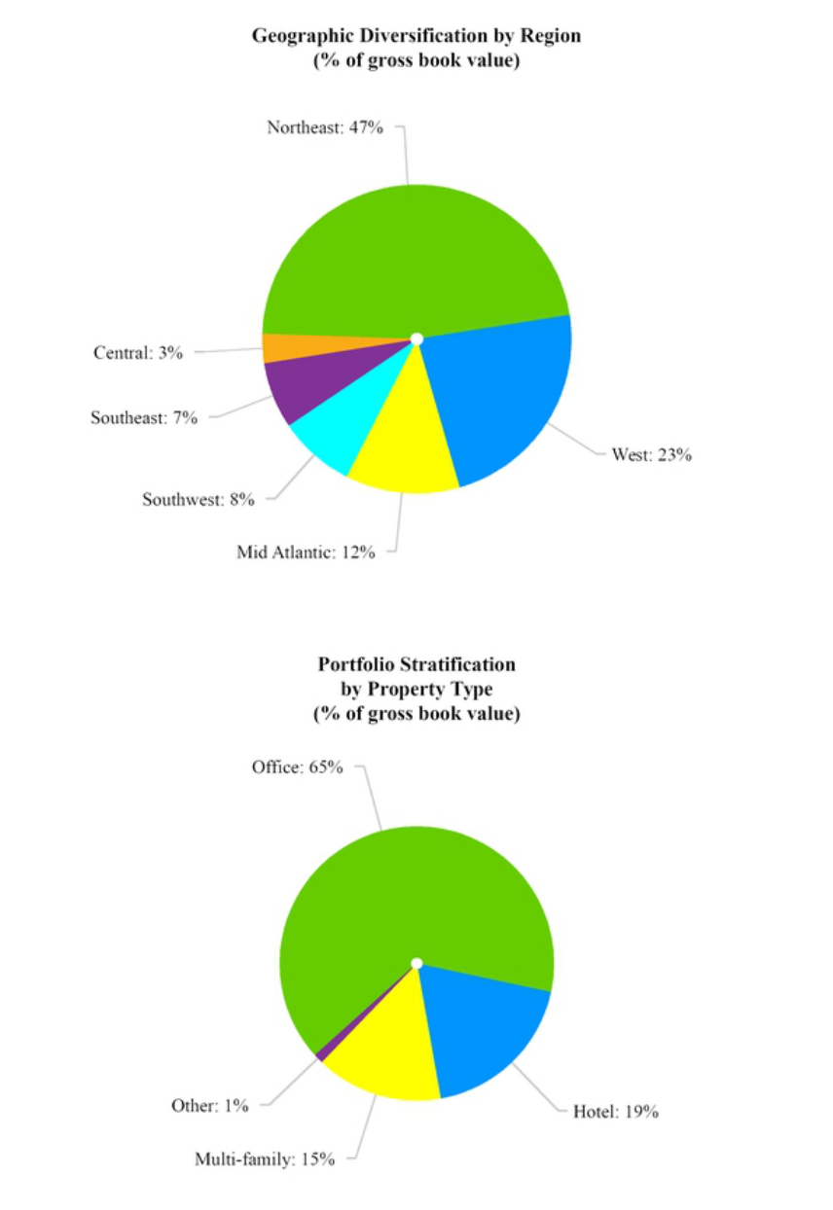

33

Table of Contents

Unfunded Commitments

In October 2017, we entered into a commitment to acquire land subject to a Ground Lease on which a luxury multi-family project is currently being constructed in San Jose, California. Pursuant to the purchase agreement, we will acquire the Ground Lease on November 1, 2020 from iStar for $34.0 million. iStar committed to provide a $80.5 million construction loan to the ground lessee.

In August 2018, we entered into an aggregate $30.0 million commitment to acquire land for $12.5 million and provide a $17.5 million leasehold improvement allowance for the Ground Lease tenant's construction of a multi-family property in Washington, DC. We acquired the land in June 2019 and will fund the leasehold improvement allowance upon the completion of certain conditions.

In January 2019, we acquired land for $13.0 million and simultaneously structured and entered into a Ground Lease as part of the Ground Lease tenant's acquisition of an existing office building located in Washington, DC that is to be converted into a multi-family building. We committed to provide the Ground Lease tenant a $10.5 million leasehold improvement allowance that will be funded upon the completion of certain conditions.

In June 2019, we acquired land for $8.1 million and simultaneously structured and entered into a Ground Lease as part of the Ground Lease tenant's development of a to-be-built multi-family community located outside of Orlando, FL. We committed to provide the Ground Lease tenant a $21.4 million leasehold improvement allowance that will be funded upon the completion of certain conditions. As of December 31, 2019, $2.1 million of the leasehold improvement allowance had been funded.

Results of Operations for the Year Ended December 31, 2019 compared to the Year Ended December 31, 2018

 | For the Years Ended December 31,
 | 2019 |  |  |  | 2018 |  |  | $ Change
 |  |  |  |  | (in thousands)
Revenues:
Operating lease income | $ | 72,071 |  | $ | 47,400 |  | $ | 24,671
Interest income from sales-type leases |  | 18,531 |  |  | — |  |  | 18,531
Other income |  | 2,794 |  |  | 2,324 |  |  | 470
Total revenues |  | 93,396 |  |  | 49,724 |  |  | 43,672
Costs and expenses:
Interest expense |  | 29,868 |  |  | 15,389 |  |  | 14,479
Real estate expense |  | 2,673 |  |  | 1,600 |  |  | 1,073
Depreciation and amortization |  | 9,379 |  |  | 9,142 |  |  | 237
General and administrative |  | 14,435 |  |  | 10,662 |  |  | 3,773
Other expense |  | 899 |  |  | 995 |  |  | (96)
Total costs and expenses |  | 57,254 |  |  | 37,788 |  |  | 19,466
Loss on early extinguishment of debt |  | (2,011) |  |  | — |  |  | (2,011)
Earnings (losses) from equity method investments |  | (403) |  |  | — |  |  | (403)
Net income | $ | 33,728 |  | $ | 11,936 |  | $ | 21,792

Operating lease income increased to $72.1 million during the year ended December 31, 2019 from $47.4 million for the same period in 2018. The increase in 2019 was primarily due to the origination and acquisition of Ground Leases classified as operating leases.

Interest income from sales-type leases (refer to Note 3) was $18.5 million for the year ended December 31, 2019. On January 1, 2019, we adopted new accounting standards (refer to Note 3) and, as a result, now classify certain of our Ground Leases as sales-type leases. Under sales-type leases, we accrue interest income under the effective interest method as opposed to recognition of operating lease income under the straight-line rent method for our Ground Leases that do not qualify as sales-type leases. We expect a majority of our newly originated Ground Leases will be classified as sales-type leases.

Other income for the year ended December 31, 2019 was $2.8 million and consists primarily of $2.4 million of interest income earned on our cash balances and $0.4 million of other income relating to a Ground Lease in which we are the lessee but

34

Table of Contents

our tenant at the property pays this expense directly under the terms of a master lease (refer to Note 3). Other income for the year ended December 31, 2018 was $2.3 million and consists of $1.5 million received by us in connection with the termination of a contract for the purchase of the leased fee interest in a property due to the exercise by another entity of a pre-existing pre-emptive right to acquire such property and $0.8 million of interest income earned on our cash balances

During the year ended December 31, 2019, we incurred interest expense from our secured financings of $29.9 million compared to $15.4 million in 2018. The increase in 2019 was primarily the result of additional borrowings to fund our growing investment portfolio.

Real estate expense was $2.7 million and $1.6 million during the years ended December 31, 2019 and 2018, respectively. Real estate expenses consisted primarily of the amortization of an operating lease right-of-use asset in 2019 and a below market lease asset in 2018 at one of our hotel properties, property taxes, property appraisal fees and insurance expense in both periods. In addition, during the year ended December 31, 2019, we also recorded $0.4 million of real estate expense relating to a Ground Lease in which we are the lessee but our tenant at the property pays this expense directly under the terms of a master lease (refer to Note 3).

Depreciation and amortization was $9.4 million and $9.1 million during the years ended December 31, 2019 and 2018, respectively, and primarily relates to our ownership of the Park Hotels Portfolio and our ownership of the Buckler multi-family property.

General and administrative includes management fees (which our Manager waived through June 30, 2018), stock-based compensation, costs of operating as a public company and an allocation of expenses to us from our Manager (which our Manager waived through June 30, 2018). Although we paid no management fee or expense reimbursements to our Manager through June 30, 2018, we are required under GAAP to record such expenses as non-cash capital contributions from iStar. The following table presents our general and administrative expenses for the years ended December 31, 2019 and 2018 ($ in thousands):

For the Years Ended

December 31,

 | 2019 |  |  |  | 2018
Management fees | $ | 7,461 |  | $ | 3,643
Public company and other costs |  | 3,247 |  |  | 4,676
Expense reimbursements to the Manager |  | 2,144 |  |  | 1,470
Stock-based compensation |  | 1,583 |  |  | 873
Total general and administrative expenses | $ | 14,435 |  | $ | 10,662

During the year ended December 31, 2019, other expense consists primarily of investment pursuit costs, fees related to our derivative transactions and state and local taxes. During the year ended December 31, 2018, other expense consists primarily of costs related to an unsuccessful acquisition (but for which we received a $1.5 million termination fee - see Other Income section above), investment pursuit costs and fees related to our derivative transactions.

During the year ended December 31, 2019, loss on early extinguishment of debt resulted from the refinancing of two mortgages on existing Ground Leases.

During the year ended December 31, 2019, losses from equity method investments resulted from our share of costs attributable to transaction structuring activities from a venture that we entered into with an existing shareholder that acquired the existing Ground Lease at 425 Park Avenue in New York City, partially offset by rental income from the venture upon its acquisition in November 2019 (refer to Note 6).

Liquidity and Capital Resources

Liquidity is a measure of our ability to meet potential cash requirements, including to pay interest and repay borrowings, fund and maintain our assets and operations, complete acquisitions and originations of investments, make distributions to our stockholders and meet other general business needs. In order to qualify as a REIT, we are required under the Internal Revenue Code of 1986 to distribute to our stockholders, on an annual basis, at least 90% of our REIT taxable income, determined without regard to the deduction for dividends paid and excluding net capital gains. We expect to make quarterly cash distributions to our stockholders sufficient to meet REIT qualification requirements.

35

Table of Contents

As of December 31, 2019, we had $22.7 million of unrestricted cash, $359.0 million of undrawn capacity and the ability to borrow an additional $118.2 million on our 2017 Revolver, subject to the conditions set forth in the applicable loan agreement (refer to Note 8 for more information on our 2017 Revolver), without pledging any additional assets to the facility. We refer to this $140.9 million of unrestricted cash and additional borrowing capacity as our "equity" liquidity which can be used for general corporate purposes or leveraged (a maximum of 2:1 in the case of our 2017 Revolver) to acquire new Ground Lease assets. Our primary sources of cash to date have been proceeds from equity offerings and private placements (refer to Note 11), proceeds from our initial capitalization by iStar and two institutional investors (refer to Note 11) and borrowings from our debt facilities. Our primary uses of cash to date have been the acquisition/origination of Ground Leases, repayments on our debt facilities and distributions to our shareholders.

We expect our future liquidity requirements to include debt service, distributions to our shareholders, working capital, acquisitions and originations of Ground Lease investments, including in respect of the unfunded commitments described above, debt maturities and payments of fees under our management agreement to the extent we do not elect to pay the fees in common stock. Our primary sources of liquidity going forward will generally consist of cash on hand and cash flows from operations, new financings, unused borrowing capacity under our 2017 Revolver (subject to the conditions set forth in the applicable loan agreement) and common and/or preferred equity issuances.

Contractual Obligations—The following table outlines the contractual obligations related to our long-term debt obligations and certain other commitments as of December 31, 2019 (refer to Note 8 and Note 9 to the consolidated financial statements).

 |  |  |  |  |  |  |  | Amounts Due By Period
 |  |  |  |  |  |  |  | 1 - 3 |  |  | 3 - 5 |  |  | 5 - 10 |  |  | After 10
 |  | Total |  | Less Than 1 Year |  |  |  | Years |  |  | Years |  |  | Years |  |  | Years
 |  |  |  |  |  |  |  | (in thousands)
Long-Term Debt Obligations⁽¹⁾:
Mortgages | $ | 1,230,143 |  | $ | — |  | $ | — |  | $ | — |  | $ | 316,193 |  | $ | 913,950
2017 Revolver |  | 166,000 |  |  | — |  |  | — |  |  | 166,000 |  |  | — |  |  | —
Total principal maturities |  | 1,396,143 |  |  | — |  |  | — |  |  | 166,000 |  |  | 316,193 |  |  | 913,950
Interest Payable⁽²⁾ |  | 1,731,597 |  |  | 45,889 |  |  | 92,763 |  |  | 90,332 |  |  | 195,981 |  |  | 1,306,632
Purchase Commitments⁽³⁾ |  | 81,270 |  |  | 70,770 |  |  | 10,500 |  |  | — |  |  | — |  |  | —
Total⁽⁴⁾ | $ | 3,209,010 |  | $ | 116,659 |  | $ | 103,263 |  | $ | 256,332 |  | $ | 512,174 |  | $ | 2,220,582

_______________________________________________________________________________
- Assumes the extended maturity date for all debt obligations.

- Variable-rate debt assumes one-month LIBOR of 1.76%. Interest payable does not include interest that may be payable under our derivatives.

- Refer to Note 9 of the consolidated financial statements.

- We are also obligated to pay the third-party owner of a property that is ground leased to us $0.4 million, subject to adjustment for changes in the CPI, per year through 2044; however, our tenant pays this expense directly under the terms of a master lease through 2035.

Mortgages—Mortgages consist of asset specific non-recourse borrowings that are secured by our Ground Leases. As of December 31, 2019, our mortgages are full term interest only, bear interest at a weighted average interest rate of 4.06% (our combined weighted average interest rate of our consolidated mortgage debt and the mortgage debt of our unconsolidated venture, applying our percentage interest in the venture, was 4.00%) and have maturities between April 2027 and November 2069.

2017 Revolver—In June 2017, we entered into a recourse senior secured revolving credit facility with an initial maximum aggregate principal amount of up to $300.0 million (the "2017 Revolver") that has since been increased to $525.0 million. The 2017 Revolver provides an accordion feature to increase, subject to certain conditions, the maximum availability up to $1.0 billion. The 2017 Revolver has an initial maturity of November 2022 with two 12-month extension options exercisable by us, subject to certain conditions, and bears interest at an annual rate of applicable LIBOR plus 1.30%. An undrawn credit facility commitment fee ranges from 0.15% to 0.25%, based on utilization each quarter. The 2017 Revolver allows us to leverage Ground Leases up to a maximum 67%. As of December 31, 2019, there was $359.0 million of undrawn capacity on the 2017 Revolver and we had the ability to draw an additional $118.2 million without pledging any additional assets to the facility.

36

Table of Contents

Debt Covenants—We are subject to financial covenants under the 2017 Revolver, including maintaining: (i) a limitation on total consolidated leverage of not more than 70%, or 75% for no more than 180 days, of our total consolidated assets; (ii) a consolidated fixed charge coverage ratio of at least 1.40x; (iii) a consolidated tangible net worth of at least $632.8 million plus 75% of future issuances of net equity after September 30, 2019; (iv) a consolidated secured leverage ratio of not more than 70%, or 75% for no more than 180 days, of our total consolidated assets; and (v) a secured recourse debt ratio of not more than 5.0% of our total consolidated assets. In addition, we may make distributions without restriction as to amount so long as after giving effect to the dividend we remain in compliance with the financial covenants and no event of default has occurred and is continuing.
Our other debt obligations contain no significant maintenance or ongoing financial covenants. As of December 31, 2019, we were in compliance with all of our financial covenants.

Off-Balance Sheet Arrangements—We are not dependent on the use of any off-balance sheet financing arrangements for liquidity.

Critical Accounting Estimates

Basis of Presentation—The preparation of these consolidated financial statements in conformity with generally accepted accounting principles in the United States of America ("GAAP") requires management to make estimates and assumptions that affect the reported amounts of assets and liabilities and disclosure of contingent assets and liabilities at the dates of the financial statements and the reported amounts of revenues and expenses during the reporting periods.

Real estate—Real estate assets are recorded at cost less accumulated depreciation and amortization, as follows:

Capitalization and depreciation—Certain improvements and replacements are capitalized when they extend the useful life of the asset. Repair and maintenance costs are expensed as incurred. Depreciation is computed using the straight-line method over the estimated useful life, which is generally 40 years for facilities, the shorter of the remaining lease term or expected life for tenant improvements and the remaining useful life of the facility for facility improvements.

Purchase price allocation—Upon acquisition of real estate, we determine whether the transaction is a business combination, which is accounted for under the acquisition method, or an acquisition of assets. For both types of transactions, we recognize and measure identifiable assets acquired, liabilities assumed and any noncontrolling interest in the acquiree based on their relative fair values. For business combinations, we recognize and measure goodwill or gain from a bargain purchase, if applicable, and expense acquisition-related costs in the periods in which the costs are incurred. For acquisitions of assets, acquisition-related costs are capitalized and recorded in "Real estate, net," "Real estate-related intangible assets, net" and "Real estate-related intangible liabilities, net" on our consolidated balance sheets. If we acquire real estate and simultaneously enter into a lease of the real estate, the acquisition will be accounted for as an asset acquisition.

We account for our acquisition of properties by recording the purchase price of tangible and intangible assets acquired and liabilities assumed based on their estimated fair values. The value of the tangible assets, consisting of land, buildings, building improvements and tenant improvements is determined as if these assets are vacant. Intangible assets may include the value of lease incentive assets, above-market leases, below-market Ground Lease assets and in-place leases, which are each recorded at their estimated fair values and included in "Real estate-related intangible assets, net" on our consolidated balance sheets. Intangible liabilities may include the value of below-market leases, which are recorded at their estimated fair values and included in "Real estate-related intangible liabilities, net" on our consolidated balance sheets. In-place leases are amortized over the remaining non-cancelable term of the lease and the amortization expense is included in "Depreciation and amortization" in our consolidated statements of operations. Lease incentive assets and above-market (or below-market) lease value are amortized as a reduction of (or, increase to) operating lease income over the remaining non-cancelable term of each lease plus any renewal periods with fixed rental terms that are considered to be below-market. We may also engage in sale/leaseback transactions whereby we execute a net lease with the occupant simultaneously with the purchase of the asset.

Impairments—We review real estate assets for impairment in value whenever events or changes in circumstances indicate that the carrying amount of such assets may not be recoverable. The value of a long-lived asset held for use is impaired if management's estimate of the aggregate future cash flows (undiscounted and without interest charges) to be generated by the asset (taking into account the anticipated holding period of the asset) are less than its carrying value. Such estimate of cash flows considers factors such as expected future operating income trends, as well as the effects of demand, competition and other economic factors. To the extent impairment has occurred, the loss will be measured as the excess of the carrying amount of the asset over the estimated fair value of the asset and reflected as an adjustment to the basis of the asset. Impairments of real estate assets, if any, are recorded in "Impairment of assets" in our consolidated statements of operations.

37

Table of Contents

Net Investment in Sales-type Leases and Ground Lease Receivables—Net investment in sales-type leases and Ground Lease receivables are recognized when our Ground Leases qualify as sales-type leases. The net investment in sales-type leases is initially measured at the present value of the fixed and determinable lease payments, including any guaranteed or unguaranteed residual value of the asset at the end of the lease, discounted at the rate implicit in the lease. Acquisition-related costs are capitalized and recorded in "Net Investment in Sales-type Leases" and "Ground Lease Receivables" on our consolidated balance sheets. For newly originated or acquired Ground Leases, our estimate of residual value equals the fair value of the land at lease commencement. If a lease qualifies as a sales-type lease, it is further evaluated to determine whether the transaction is considered a sale leaseback transaction. When we acquire land and enter into a Ground Lease directly with the seller that qualifies as a sales-type lease, the lease does not qualify as a sale leaseback transaction and the lease is considered a financing receivable and is recognized in accordance with ASC 310 and included in "Ground Lease receivables" on our consolidated balance sheets.

Reserve for losses in net investment in sales-type leases and Ground Lease receivables— We evaluate our net investment in sales-type leases and Ground Lease receivables for impairment under ASC 310. As part of our process for monitoring the credit quality of our net investment in sales-type leases and Ground Lease receivables, we perform a quarterly assessment for each of our net investment in sales-type leases and Ground Lease receivables. We generally target Ground Lease investments in which the initial cost of the Ground Lease represents 30% to 45% of the Combined Property Value. As such, we believe our Ground Lease investments represent a safe position in a property's capital structure. This safety is derived from the typical structure of a Ground Lease under which the landlord has a residual right to regain possession of its land and take ownership of the buildings and improvements thereon upon a tenant default. The landlord's residual right provides a strong incentive for a Ground Lease tenant or its leasehold lender to make the required Ground Lease rent payments and, as such, we believe there is a low likelihood of default on our net investment in sales-type leases and Ground Lease receivables. We consider a net investment in sales-type lease or Ground Lease receivable to be impaired when, based upon current information and events, we believe that it is probable that we will be unable to collect all amounts due under the contractual terms of the Ground Lease. As of December 31, 2019, all of our net investment in sales-type leases and Ground Lease receivables were performing in accordance with the terms of the respective leases.

Any potential reserve for losses in net investment in sales-type leases and Ground Lease receivables will reflect management's estimate of losses inherent in the portfolio as of the balance sheet date. If we determine that the collateral fair value less costs to sell is less than the carrying value of a collateral-dependent receivable, we will record a reserve. The reserve, if applicable, will be increased (decreased) through "Reserve for losses on receivables" in our consolidated statements of operations and will be decreased by charge-offs. Our policy is to charge off a receivable when we determine, based on a variety of factors, that all commercially reasonable means of recovering the receivable balance have been exhausted. This may occur at different times, including when we receive cash or other assets in a pre-foreclosure sale or take control of the underlying collateral in full satisfaction of the receivable upon foreclosure or deed-in-lieu, or when we have otherwise ceased significant collection efforts. We consider circumstances such as the foregoing to be indicators that the final steps in the receivable collection process have occurred and that a receivable is uncollectible. At this point, a loss is confirmed and the receivable and related reserve will be charged off. We have one portfolio segment represented by acquiring, managing and capitalizing Ground Leases, whereby we utilize a uniform process for determining our reserve for losses on our net investment in sales-type leases and Ground Lease receivables.

Interest Income from Sales-type Leases—Interest income from sales-type leases is recognized under the effective interest method. The effective interest method produces a constant yield on the net investment in the sales-type lease and Ground Lease receivable over the term of the lease. Rent payments that are not fixed and determinable at lease inception, such as percentage rent and CPI adjustments, are not included in the effective interest method calculation and are recognized in "Interest income from sales-type leases" in our consolidated statements of operations in the period earned. A Ground Lease receivable is placed on non-accrual status if and when it becomes 90-days past due or we consider the Ground Lease receivable impaired.

Equity Investments in Ground Leases—Equity investments in Ground Leases are accounted for pursuant to the equity method of accounting if we can significantly influence the operating and financial policies of the investee. We have a 54.8% noncontrolling equity interest in a venture and have shared voting power with our partner. We determined the entity to be a voting interest entity and our equity interest is accounted for pursuant to the equity method of accounting. Our periodic share of earnings and losses in equity method investees are included in "Earnings (losses) from equity method investments" in our consolidated statements of operations. Equity investments are included in "Equity investments in Ground Leases" on our consolidated balance sheets.

Operating lease income—Operating lease income includes rent earned from leasing land and buildings owned by us to our tenants. Operating lease income is recognized on the straight-line method of accounting, generally from the later of the date the lessee takes possession of the space and it is ready for its intended use or the date of acquisition of the asset subject to existing leases. Accordingly, increases in contractual lease payments are recognized evenly over the term of the lease. The periodic difference

38

Table of Contents

between operating lease income recognized under this method and contractual lease payment terms is recorded as deferred operating lease income receivable and is included in ‘‘Deferred operating lease income receivable’’ on our consolidated balance sheets. We are also entitled to percentage rent, representing a portion of our lessee's gross revenues from the properties, pursuant to some of our leases and record percentage rent as operating lease income when earned. Operating lease income also includes the amortization of finite lived intangible assets and liabilities, which are amortized over the period during which the assets or liabilities are expected to contribute directly or indirectly to the future cash flows of the business acquired.

We estimate losses within operating lease income receivable and deferred operating lease income receivable balances as of the balance sheet date and incorporate a reserve based on management's evaluation of the credit risks associated with these receivables. As of December 31, 2019 and 2018, we did not have an allowance for doubtful accounts related to real estate tenant receivables or deferred operating lease income.

Fair Values—We are required to disclose fair value information with regard to our financial instruments, whether or not recognized in the consolidated balance sheets, for which it is practical to estimate fair value. The Financial Accounting Standards Board guidance defines fair value as the price that would be received to sell an asset or paid to transfer a liability in an orderly transaction between market participants on the measurement date. We determine the estimated fair values of financial assets and liabilities based on a hierarchy that distinguishes between market participant assumptions based on market data obtained from sources independent of us and our own assumptions about market participant assumptions. We determined the carrying values of our financial instruments including cash and cash equivalents; net investment in sales-type leases; Ground Lease receivables; restricted cash; deferred operating lease income receivable, net; deferred expenses and other assets, net; and accounts payable, accrued expenses, and other liabilities approximated their the fair values of the instruments. We determined the fair value of our debt obligations, net as of December 31, 2019 and 2018 was approximately $1.4 billion and $537.8 million, respectively.

New Accounting Pronouncements—For a discussion of the impact of new accounting pronouncements on our financial condition or results of operations, refer to Note 3 to the consolidated financial statements.

39

Table of Contents

Item 7a. Quantitative and Qualitative Disclosures about Market Risk

Market Risks

Our future income, cash flows and fair values relevant to financial instruments are dependent upon prevalent market prices and interest rates. Market risk refers to the risk of loss from adverse changes in market prices and interest rates. One of the principal market risks facing us is interest rate risk on our floating rate indebtedness.

Subject to qualifying and maintaining our qualification as a REIT for U.S. federal income tax purposes, we may mitigate the risk of interest rate volatility through the use of hedging instruments, such as interest rate swap agreements and interest rate cap agreements. Our primary objectives when undertaking hedging transactions will be to reduce our floating rate exposure and to fix a portion of the interest rate for anticipated financing and refinancing transactions. However, we can provide no assurances that our efforts to manage interest rate volatility will successfully mitigate the risks of such volatility on our portfolio. Our current portfolio is not subject to foreign currency risk.

Our objectives with respect to interest rate risk are to limit the impact of interest rate changes on operations and cash flows and to lower our overall borrowing costs. To achieve these objectives, we may borrow at fixed rates and may enter into hedging instruments such as interest rate swap agreements and interest rate cap agreements in order to mitigate our interest rate risk on a related floating rate financial instrument. We do not enter into derivative or interest rate transactions for speculative purposes.

As of December 31, 2019, we had $1.2 billion principal amount of fixed-rate debt outstanding and $166.0 million principal amount of floating-rate debt outstanding. In addition, as of December 31, 2019 we were party to derivative contracts to manage our interest rate risk.

The following table quantifies the potential changes in annual net income should interest rates increase or decrease by 10, 50 and 100 basis points, assuming no change in our interest earning assets, interest bearing liabilities, derivative contracts or the shape of the yield curve (i.e., relative interest rates). The base interest rate scenario assumes the one-month LIBOR rate of 1.76% as of December 31, 2019. Actual results could differ significantly from those estimated in the table.

Estimated Change In Net Income

($ in thousands)

Change in Interest Rates |  |  | Net Income (Loss)
-100 Basis Points |  | $ | 1,240
-50 Basis Points |  |  | 620
-10 Basis Points |  |  | 124
Base Interest Rate |  |  | —
+10 Basis Points |  |  | (124)
+ 50 Basis Points |  |  | (620)
+100 Basis Points |  |  | (1,240)

40

Table of Contents

Item 8. Financial Statements and Supplemental Data

Index to Financial Statements

 |  |  |  |  |  |  |  |  |  |  |  | Page
 | Report of Independent Registered Public Accounting Firm |  |  |  |  |  |  |  |  |  |  |  | 42
 | Financial Statements:
 |  |  | Consolidated Balance Sheets as of December 31, 2019 and 2018 |  |  |  |  |  |  |  |  |  | 43
 |  |  | Consolidated Statements of Operations for the years ended December 31, 2019 and 2018 |  |  |  |  |  |  |  |  | 44
 |  |  | Consolidated Statements of Comprehensive Income (Loss) for the years ended December 31, 2019 and 2018 |  |  |  |  |  |  |  |  |  | 45
 |  |  | Consolidated Statements of Changes in Equity for the years ended December 31, 2019 and 2018 |  |  |  |  |  |  |  |  | 46
 |  |  | Consolidated Statements of Cash Flows for the years ended December 31, 2019 and 2018 |  |  |  |  |  |  |  |  |  | 47
 | Notes to Consolidated Financial Statements |  |  |  |  |  |  |  |  |  |  | 48
 | Financial Statement Schedule:
 |  |  | Schedule III—Real Estate and Accumulated Depreciation as of December 31, 2019 with reconciliations for the years ended December 31, 2019 and 2018 |  |  |  |  |  |  |  |  |  | 69

All other schedules are omitted because they are not applicable or the required information is shown in the financial statements or notes thereto.

41

Report of Independent Registered Public Accounting Firm

To the shareholders and the Board of Directors of Safehold Inc.

Opinion on the Financial Statements

We have audited the accompanying consolidated balance sheets of Safehold Inc. and subsidiaries (the "Company") as of December 31, 2019 and 2018, the related consolidated statements of operations, comprehensive income (loss), changes in equity, and cash flows, for the years ended December 31, 2019 and 2018, and the related notes and the schedules listed in the Index at Item 15 (collectively referred to as the "financial statements"). In our opinion, the financial statements present fairly, in all material respects, the financial position of the Company as of December 31, 2019 and 2018, and the results of its operations and its cash flows for the years ended December 31, 2019 and 2018, in conformity with accounting principles generally accepted in the United States of America.

Change in Accounting Principle

As discussed in Note 3 to the financial statements, effective January 1, 2019, the Company adopted FASB Accounting Standards Updates 2016-02 and 2018-11, Leases, using the modified retrospective approach.

Basis for Opinion

These financial statements are the responsibility of the Company's management. Our responsibility is to express an opinion on the Company's financial statements based on our audits. We are a public accounting firm registered with the Public Company Accounting Oversight Board (United States) (PCAOB) and are required to be independent with respect to the Company in accordance with the U.S. federal securities laws and the applicable rules and regulations of the Securities and Exchange Commission and the PCAOB.

We conducted our audits in accordance with the standards of the PCAOB. Those standards require that we plan and perform the audit to obtain reasonable assurance about whether the financial statements are free of material misstatement, whether due to error or fraud. The Company is not required to have, nor were we engaged to perform, an audit of its internal control over financial reporting. As part of our audits, we are required to obtain an understanding of internal control over financial reporting but not for the purpose of expressing an opinion on the effectiveness of the Company’s internal control over financial reporting. Accordingly, we express no such opinion.

Our audits included performing procedures to assess the risks of material misstatement of the financial statements, whether due to error or fraud, and performing procedures that respond to those risks. Such procedures included examining, on a test basis, evidence regarding the amounts and disclosures in the financial statements. Our audits also included evaluating the accounting principles used and significant estimates made by management, as well as evaluating the overall presentation of the financial statements. We believe that our audits provide a reasonable basis for our opinion.

/s/ DELOITTE & TOUCHE LLP

New York, New York

February 13, 2020

We have served as the Company's auditor since 2018.

42

Safehold Inc.

Consolidated Balance Sheets

(In thousands, except per share data)

 |  |  |  | As of December 31,
 |  |  |  | 2019 |  |  | 2018
 | ASSETS
Real estate
Real estate, at cost |  |  | $ | 687,902 |  | $ | 669,923
Less: accumulated depreciation |  |  |  | (16,286) |  |  | (10,257)
Real estate, net |  |  |  | 671,616 |  |  | 659,666
Real estate-related intangible assets, net (refer to Note 4) |  |  |  | 242,837 |  |  | 262,531
Total real estate, net and real estate-related intangible assets, net |  |  |  | 914,453 |  |  | 922,197
Net investment in sales-type leases |  |  |  | 984,598 |  |  | —
Ground Lease receivables |  |  |  | 397,087 |  |  | —
Equity investments in Ground Leases |  |  |  | 127,524 |  |  | —
Cash and cash equivalents |  |  |  | 22,704 |  |  | 16,418
Restricted cash |  |  |  | 24,078 |  |  | 8,007
Deferred operating lease income receivable |  |  |  | 58,303 |  |  | 23,138
Deferred expenses and other assets, net |  |  |  | 37,814 |  |  | 9,983
Total assets |  |  | $ | 2,566,561 |  | $ | 979,743
LIABILITIES AND EQUITY
Liabilities:
Accounts payable, accrued expenses and other liabilities |  |  | $ | 43,008 |  | $ | 20,800
Real estate-related intangible liabilities, net (refer to Note 4) |  |  |  | 57,333 |  |  | 57,620
Debt obligations, net |  |  |  | 1,372,922 |  |  | 543,965
Total liabilities |  |  |  | 1,473,263 |  |  | 622,385
Commitments and contingencies (refer to Note 9)
Equity:
Safehold Inc. shareholders' equity:
Common stock, $0.01 par value, 400,000 shares authorized | , 47,782 a | nd 18,276 shares issued and outstanding as of December 31, 2019 and
2018, respectively |  |  |  | 478 |  |  | 183
Additional paid-in capital |  |  |  | 1,132,603 |  |  | 370,530
Accumulated deficit |  |  |  | (2,146) |  |  | (8,486)
Accumulated other comprehensive loss |  |  |  | (39,123) |  |  | (6,876)
Total Safehold Inc. shareholders' equity |  |  |  | 1,091,812 |  |  | 355,351
Noncontrolling interests |  |  |  | 1,486 |  |  | 2,007
Total equity |  |  |  | 1,093,298 |  |  | 357,358
Total liabilities and equity |  |  | $ | 2,566,561 |  | $ | 979,743

_______________________________________________________________________________
Note - Refer to Note 2 for details on the Company's consolidated variable interest entities ("VIEs").

The accompanying notes are an integral part of the consolidated financial statements.

43

Table of Contents
 |  |  | Safehold Inc.
 |  |  | Consolidated Statements of Operations
 |  |  | (In thousands, except per share data)
 |  |  |  | For the Years Ended December 31,
 |  |  | 2019 |  |  |  | 2018
 | Revenues:
 |  | Operating lease income | $ |  | 72,071 |  | $ | 47,400
 |  | Interest income from sales-type leases |  |  | 18,531 |  |  | —
 |  | Other income |  |  | 2,794 |  |  | 2,324
 |  | Total revenues |  |  | 93,396 |  |  | 49,724
 | Costs and expenses:
 |  | Interest expense |  |  | 29,868 |  |  | 15,389
 |  | Real estate expense |  |  | 2,673 |  |  | 1,600
 |  | Depreciation and amortization |  |  | 9,379 |  |  | 9,142
 |  | General and administrative |  |  | 14,435 |  |  | 10,662
 |  | Other expense |  |  | 899 |  |  | 995
 |  | Total costs and expenses |  |  | 57,254 |  |  | 37,788
 | Income from operations before other items |  |  |  | 36,142 |  |  | 11,936
 |  | Loss on early extinguishment of debt |  |  | (2,011) |  |  | —
 |  | Earnings (losses) from equity method investments |  |  | (403) |  |  | —
 | Net income |  |  |  | 33,728 |  |  | 11,936
 |  | Net income attributable to noncontrolling interests |  |  | (6,035) |  |  | (196)
 | Net income attributable to Safehold Inc. common shareholders |  |  | $ | 27,693 |  | $ | 11,740
 | Per common share data:
 | Net income attributable to Safehold Inc.
 |  | Basic and diluted | $ |  | 0.89 |  | $ | 0.64
 |  | Weighted average number of common shares:
 |  | Basic and diluted |  |  | 31,008 |  |  | 18,218

The accompanying notes are an integral part of the consolidated financial statements.

44

Table of Contents
 |  |  | Safehold Inc.
 |  | Consolidated Statements of Comprehensive Income (Loss)
 |  |  | (In thousands)
 |  |  |  |  | For the Years Ended December 31,
 |  |  |  |  | 2019 |  |  | 2018
 | Net income |  | $ |  | 33,728 |  | $ | 11,936
 | Other comprehensive income (loss):
 | Cumulative-effect adjustment for cash flow hedges |  |  |  | — |  |  | 41
 | Reclassification of (gains) losses on derivatives into earnings |  |  |  | 271 |  |  | (252)
 | Unrealized losses on derivatives |  |  |  | (32,518) |  |  | (6,745)
 | Other comprehensive loss |  |  |  | (32,247) |  |  | (6,956)
 | Comprehensive income |  |  |  | 1,481 |  |  | 4,980
 | Comprehensive (income) attributable to noncontrolling interests |  |  |  | (2,377) |  |  | (196)
 | Comprehensive income (loss) attributable to Safehold Inc. |  | $ |  | (896) |  | $ | 4,784

The accompanying notes are an integral part of the consolidated financial statements.

45

Table of Contents

Safehold Inc.

Consolidated Statements of Changes in Equity

(In thousands)

 |  | Common |  |  | Additional |  |  | Retained |  |  | Accumulated
 |  |  |  |  |  |  |  | Earnings / |  |  | Other |  |  | Noncontrolling |  |  | Total
 |  | Stock at |  |  | Paid-In |  |  | Accumulated |  |  | Comprehensive |  |  |  |  |  | Total
 |  | Par |  |  | Capital |  |  | (Deficit) |  |  | Income (Loss) |  |  | Interests |  |  | Equity
Balance as of December 31, 2018 | $ | 183 |  | $ | 370,530 |  | $ | (8,486) |  | $ | (6,876) |  | $ | 2,007 |  | $ | 357,358
Net income |  | — |  |  | — |  |  | 27,693 |  |  | — |  |  | 6,035 |  |  | 33,728
Issuance of common stock, net / amortization |  | 170 |  |  | 509,385 |  |  | — |  |  | — |  |  | 356 |  |  | 509,911
Investor Unit conversion (refer to Note 11) |  | 125 |  |  | 252,060 |  |  | — |  |  | (6,450) |  |  | (245,735) |  |  | —
Dividends declared ($0.618 per share) |  | — |  |  | — |  |  | (21,353) |  |  | — |  |  | — |  |  | (21,353)
Change in accumulated other comprehensive income (loss) |  | — |  |  | — |  |  | — |  |  | (28,589) |  |  | (3,658) |  |  | (32,247)
Contributions from noncontrolling interests |  | — |  |  | 628 |  |  | — |  |  | 2,792 |  |  | 245,426 |  |  | 248,846
Distributions to noncontrolling interests |  | — |  |  | — |  |  | — |  |  | — |  |  | (2,945) |  |  | (2,945)
Balance as of December 31, 2019 | $ | 478 |  | $ | 1,132,603 |  | $ | (2,146) |  | $ | (39,123) |  | $ | 1,486 |  | $ | 1,093,298
Balance as of December 31, 2017 | $ | 182 |  | $ | 364,919 |  | $ | (9,246) |  | $ | 80 |  | $ | — |  | $ | 355,935
Net income |  | — |  |  | — |  |  | 11,740 |  |  | — |  |  | 196 |  |  | 11,936
Contributions from iStar Inc. |  | — |  |  | 2,581 |  |  | — |  |  | — |  |  | — |  |  | 2,581
Offering costs |  | — |  |  | 1,347 |  |  | — |  |  | — |  |  | — |  |  | 1,347
Issuance of common stock to iStar Inc. (refer to Note 11) |  | 1 |  |  | 918 |  |  | — |  |  | — |  |  | — |  |  | 919
Issuance of common stock to directors/amortization |  | — |  |  | 765 |  |  | — |  |  | — |  |  | 108 |  |  | 873
Dividends declared ($0.60 per share) |  | — |  |  | — |  |  | (10,939) |  |  | — |  |  | — |  |  | (10,939)
Cumulative-effect adjustment for cash flow hedges |  | — |  |  | — |  |  | (41) |  |  | 41 |  |  | — |  |  | —
Change in accumulated other comprehensive income (loss) |  | — |  |  | — |  |  | — |  |  | (6,997) |  |  | — |  |  | (6,997)
Contributions from noncontrolling interests |  | — |  |  | — |  |  | — |  |  | — |  |  | 1,750 |  |  | 1,750
Distributions to noncontrolling interests |  | — |  |  | — |  |  | — |  |  | — |  |  | (47) |  |  | (47)
Balance as of December 31, 2018 | $ | 183 |  | $ | 370,530 |  | $ | (8,486) |  | $ | (6,876) |  | $ | 2,007 |  | $ | 357,358

The accompanying notes are an integral part of the consolidated financial statements.

46

Table of Contents
 |  | Safehold Inc.
 |  | Consolidated Statements of Cash Flows
 |  | (In thousands)
 |  |  | For the Years Ended December 31,
 |  |  | 2019 |  |  | 2018
 | Cash flows from operating activities:
 | Net income |  | $ | 33,728 |  | $ | 11,936
 | Adjustments to reconcile net income to cash flows from operating activities:
 | Depreciation and amortization |  |  | 9,379 |  |  | 9,142
 | Stock-based compensation expense |  |  | 1,582 |  |  | 873
 | Deferred operating lease income |  |  | (35,165) |  |  | (19,041)
 | Non-cash interest income from sales-type leases |  |  | (6,547) |  |  | —
 | Amortization of real estate-related intangibles, net |  |  | 2,509 |  |  | 2,518
 | Loss on early extinguishment of debt |  |  | 2,011 |  |  | —
 | Losses (earnings) from equity method investments |  |  | 403 |  |  | —
 | Amortization of premium, discount and deferred financing costs on debt obligations, net |  |  | 2,257 |  |  | 1,612
 | Non-cash management fees |  |  | 7,461 |  |  | 3,643
 | Other operating activities |  |  | 1,586 |  |  | 789
 | Changes in assets and liabilities:
 | Changes in deferred expenses and other assets, net |  |  | 301 |  |  | (1,163)
 | Changes in accounts payable, accrued expenses and other liabilities |  |  | (21,468) |  |  | 3,219
 | Cash flows (used in) provided by operating activities |  |  | (1,963) |  |  | 13,528
 | Cash flows from investing activities:
 | Acquisitions of real estate |  |  | (28,816) |  |  | (385,897)
 | Origination/acquisition of net investment in sales-type leases and ground lease receivables |  |  | (1,362,593) |  |  | —
 | Fundings on ground lease receivables |  |  | (2,089) |  |  | —
 | Contributions to equity investments in ground leases |  |  | (127,970) |  |  | —
 | Other investing activities |  |  | 693 |  |  | 1,392
 | Cash flows used in investing activities |  |  | (1,520,775) |  |  | (384,505)
 | Cash flows from financing activities:
 | Proceeds from issuance of common stock |  |  | 511,900 |  |  | —
 | Proceeds from debt obligations |  |  | 1,183,739 |  |  | 312,353
 | Repayments of debt obligations |  |  | (351,500) |  |  | (74,500)
 | Payments for debt prepayment or extinguishment costs |  |  | (1,358) |  |  | —
 | Payments for deferred financing costs |  |  | (18,468) |  |  | (2,289)
 | Payment of offering costs |  |  | (9,778) |  |  | (808)
 | Dividends paid to common shareholders |  |  | (16,622) |  |  | (10,927)
 | Distributions to noncontrolling interests |  |  | (2,945) |  |  | (47)
 | Contributions from noncontrolling interests |  |  | 250,000 |  |  | 1,750
 | Other financing activities |  |  | 127 |  |  | —
 | Cash flows provided by financing activities |  |  | 1,545,095 |  |  | 225,532
 | Changes in cash, cash equivalents and restricted cash |  |  | 22,357 |  |  | (145,445)
 | Cash, cash equivalents and restricted cash at beginning of period |  |  | 24,425 |  |  | 169,870
 | Cash, cash equivalents and restricted cash at end of period |  | $ | 46,782 |  | $ | 24,425
 | Supplemental disclosure of cash flow information:
 | Cash paid for interest |  | $ | 22,878 |  | $ | 12,817
 | Supplemental disclosure of non-cash investing and financing activity:
 | Origination of sales-type lease |  | $ | 10,194 |  | $ | —
 | Assumption of debt obligations |  |  | 10,194 |  |  | —
 | Investor Unit conversion (refer to Note 11) |  |  | 250,000 |  |  | —
 | Contribution from iStar Inc. |  |  | — |  |  | 2,581
 | Dividends declared to common shareholders |  |  | 7,478 |  |  | 2,741
 | Accrued offering costs |  |  | 250 |  |  | (709)
 | Accrued finance costs |  |  | 658 |  |  | 217

The accompanying notes are an integral part of the consolidated financial statements.

47

Table of Contents

Safehold Inc.

Notes to Consolidated Financial Statements

Note 1—Business and Organization

Business—Safehold Inc. (the "Company"), formerly known as Safety, Income & Growth Inc., operates its business through one reportable segment by acquiring, managing and capitalizing ground leases. Ground leases are long-term contracts between the landlord (the Company) and a tenant or leaseholder. The Company believes that it is the first publicly-traded company formed primarily to acquire, own, manage, finance and capitalize ground leases. Ground leases generally represent ownership of the land underlying commercial real estate projects that is net leased by the fee owner of the land to the owners/operators of the real estate projects built thereon ("Ground Leases"). Under Ground Leases the tenant is generally responsible for all property operating expenses, such as maintenance, real estate taxes and insurance and is also responsible for development costs and capital expenditures. Ground Leases are typically long-term (base terms ranging from 30 to 99 years, often with tenant renewal options) and have contractual base rent increases (either at a specified percentage or consumer price index ("CPI") based, or both) and sometimes include percentage rent participations.

The Company intends to target investments in long-term Ground Leases in which: (i) the cost of its Ground Lease represents 30% to 45% of the combined value of the land and buildings and improvements thereon as if there was no Ground Lease on the land ("Combined Property Value"); (ii) the ratio of property net operating income to the Ground Lease payment due the Company ("Ground Rent Coverage") is between 2.0x to 4.5x , and for this purpose the Company uses estimates of the stabilized property net operating income if it doesn't receive current tenant information and for properties under construction or in transition, in each case based on leasing activity at the property and available market information, including leasing activity at comparable properties in the relevant market; and (iii) the Ground Lease contains contractual rent escalation clauses or percentage rent that participates in gross revenues generated by the commercial real estate on the land. A Ground Lease lessor (the Company) typically has the right to regain possession of its land and take ownership of the buildings and improvements thereon upon tenant default and the termination of the Ground Lease on account of such default. The Company believes that the Ground Lease structure provides an opportunity for potential value accretion through the reversion to the Company, as the Ground Lease owner, of the buildings and improvements on the land at the expiration or earlier termination of the lease, for no additional consideration from the Company.

The Company is managed by SFTY Manager, LLC (the "Manager"), a wholly-owned subsidiary of iStar Inc. ("iStar"), the Company's largest shareholder, pursuant to a management agreement (refer to Note 13). The Company has no employees, as the Manager provides all services to it. The Company draws on the extensive investment origination and sourcing platform of its Manager to actively promote the benefits of the Ground Lease structure to prospective Ground Lease tenants.

Organization—The Company is a Maryland corporation and completed its initial public offering in June 2017. The Company's common stock is listed on the New York Stock Exchange under the symbol "SAFE." The Company's predecessor ("Original Safety" or the "Predecessor") was formed as a wholly-owned subsidiary of iStar on October 24, 2016. iStar contributed a pre-existing portfolio of Ground Leases to Original Safety and sought third party capital to grow its Ground Lease business. A second entity, SIGI Acquisition, Inc. ("SIGI"), was capitalized on April 14, 2017 by iStar and two institutional investors. On April 14, 2017, Original Safety merged with and into SIGI with SIGI surviving the merger and being renamed Safety, Income & Growth Inc. (which was subsequently renamed to Safehold Inc.). References herein to the Company refer to Original Safety before such merger and to the surviving company of such merger thereafter.

On June 27, 2017, the Company completed its initial public offering raising $205.0 million in gross proceeds and concurrently completed a $45.0 million private placement with iStar, its largest shareholder. The price per share paid in the initial public offering and the private placement was $20.00.

The Company elected to be taxed as a real estate investment trust ("REIT") for U.S. federal income tax purposes, commencing with the tax year ended December 31, 2017. The Company is structured as an Umbrella Partnership REIT ("UPREIT"). As such, all of the Company's properties are owned through a subsidiary partnership, Safehold Operating Partnership LP (the "Operating Partnership"). As of December 31, 2019, the Company owned 100% of the limited partner interests and a subsidiary of the Company owned 100% of the general partner interests, in the Operating Partnership. The UPREIT structure may afford the Company certain benefits as it seeks to acquire properties from third parties who may want to defer taxes by contributing their Ground Leases to the Company.

48

Table of Contents

Safehold Inc.

Notes to Consolidated Financial Statements (Continued)

Note 2—Basis of Presentation and Principles of Consolidation

Basis of Presentation—The accompanying audited consolidated financial statements have been prepared in conformity with generally accepted accounting principles in the United States of America ("GAAP") for complete financial statements. The preparation of financial statements in conformity with GAAP requires management to make estimates and assumptions that affect the reported amounts of assets and liabilities and disclosure of contingent assets and liabilities at the dates of the financial statements and the reported amounts of revenues and expenses during the reporting periods. Actual results could differ from those estimates.

Principles of Consolidation—The consolidated financial statements include the accounts and operations of the Company, its wholly-owned subsidiaries and VIEs for which the Company is the primary beneficiary. All intercompany balances and transactions have been eliminated in consolidation.

Consolidated VIEs—The Company consolidates VIEs for which it is considered the primary beneficiary. As of December 31, 2019, the total assets of these consolidated VIEs were $58.5 million and total liabilities were $29.6 million. The classifications of these assets are primarily within "Real estate, net," "Real estate-related intangible assets, net" and "Deferred operating lease income receivable" on the Company's consolidated balance sheets. The classifications of liabilities are primarily within "Debt obligations, net" and "Accounts payable, accrued expenses and other liabilities" on the Company's consolidated balance sheets. The liabilities of these VIEs are non-recourse to the Company and can only be satisfied from each VIE's respective assets. The Company has provided no financial support to VIEs that it was not previously contractually required to provide and did not have any unfunded commitments related to consolidated VIEs as of December 31, 2019.

Note 3—Summary of Significant Accounting Policies

The following paragraphs describe the impact on the Company's consolidated financial statements from the adoption of Accounting Standards Updates ("ASUs") on January 1, 2019.

ASU 2016-02 and ASU 2018-11—ASU 2016-02, Leases ("ASU 2016-02") resulted in the Company, as lessor, recognizing certain of its Ground Leases as sales-type leases and recording the Ground Leases as "Net investment in leases" on the Company's consolidated balance sheets (refer to Note 5). For the Company's Ground Leases which qualify as sales-type leases, the Company records interest income in "Interest income from sales-type leases" in the Company's consolidated statements of operations. The amount recorded as interest income from sales-type leases in any given period will likely be different than the straight-line ground lease income that would have been recorded under the superseded guidance.

ASU 2016-02 also required the recognition of lease assets and lease liabilities by the Company as lessee for those leases classified as operating or finance leases, both measured at the present value of the lease payments (refer to Note 7). As of December 31, 2018, the Company was party to a Ground Lease and obligated to pay the owner of the property $0.4 million, subject to adjustment for changes in the CPI, per year through 2044; however, the Company's tenant at the property pays this expense directly under the terms of a master lease. As lessee under the Ground Lease, the Company recognizes a single lease cost, calculated on a straight-line basis, in "Real estate expense" and an offsetting amount in "Other income" in the Company's consolidated statements of operations. In addition, the Company reclassified a below-market lease asset acquired as part of a business combination from "Real estate-related intangible assets, net" (refer to note 4) to "Deferred expenses and other assets, net" (refer to Note 7) on the Company's consolidated balance sheets.

Management elected the practical expedient package that allowed the Company: (a) to not reassess whether any expired or existing contracts entered into prior to January 1, 2019 are or contain leases; (b) to not reassess the lease classification for any expired or existing leases entered into prior to January 1, 2019; and (c) to not reassess initial direct costs for any expired or existing leases entered into prior to January 1, 2019.

ASU 2018-11, Leases amended ASU 2016-02 so that: (i) entities could elect to not recast the comparative periods presented when transitioning to ASC 842 by allowing entities to change their initial application to the beginning of the period of adoption with a cumulative effect adjustment to equity; and (ii) provided lessors with a practical expedient to not separate non-lease components from the associated lease component of the contractual payments if certain conditions are met. Management elected both of these provisions.

49

Table of Contents

Safehold Inc.

Notes to Consolidated Financial Statements (Continued)

ASU 2018-16—ASU 2018-16, Derivatives and Hedging: Inclusion of the Secured Overnight Financing Rate ("SOFR") Overnight Index Swap ("OIS") Rate as a Benchmark Interest Rate for Hedge Accounting Purposes expands the list of U.S. benchmark interest rates permitted in the application of hedge accounting by adding the OIS rate based on SOFR as an eligible benchmark interest rate. The adoption of ASU 2018-16 did not have a material impact on the Company's consolidated financial statements.

Significant Accounting Policies

Real estate—Real estate assets are recorded at cost less accumulated depreciation and amortization, as follows:

Capitalization and depreciation—Certain improvements and replacements are capitalized when they extend the useful life of the asset. Repair and maintenance costs are expensed as incurred. Depreciation is computed using the straight-line method over the estimated useful life, which is generally 40 years for facilities, the shorter of the remaining lease term or expected life for tenant improvements and the remaining useful life of the facility for facility improvements.

Purchase price allocation—Upon acquisition of real estate, the Company determines whether the transaction is a business combination, which is accounted for under the acquisition method, or an acquisition of assets. For both types of transactions, the Company recognizes and measures identifiable assets acquired, liabilities assumed and any noncontrolling interest in the acquiree based on their relative fair values. For business combinations, the Company recognizes and measures goodwill or gain from a bargain purchase, if applicable, and expenses acquisition-related costs in the periods in which the costs are incurred. For acquisitions of assets, acquisition-related costs are capitalized and recorded in "Real estate, net," "Real estate-related intangible assets, net" and "Real estate-related intangible liabilities, net" on the Company's consolidated balance sheets. If the Company acquires real estate and simultaneously enters into a new lease of the real estate the acquisition will be accounted for as an asset acquisition.

The Company accounts for its acquisition of properties by recording the purchase price of tangible and intangible assets and liabilities acquired based on their estimated fair values. The value of the tangible assets, consisting of land, buildings, building improvements and tenant improvements is determined as if these assets are vacant. Intangible assets may include the value of lease incentive assets, above-market leases, below-market Ground Lease assets and in-place leases, which are each recorded at their estimated fair values and included in "Real estate-related intangible assets, net" or "Real estate-related intangible liabilities, net" on the Company's consolidated balance sheets. Intangible liabilities may include the value of below-market leases, which are recorded at their estimated fair values and included in "Real estate-related intangible liabilities, net" on the Company's consolidated balance sheets. In-place leases are amortized over the remaining non-cancelable term of the lease and the amortization expense is included in "Depreciation and amortization" in the Company's consolidated statements of operations. Lease incentive assets and above-market (or below-market) lease value are amortized as a reduction of (or, increase to) operating lease income over the remaining non-cancelable term of each lease. Below-market Ground Lease assets are amortized to real estate expense over the remaining non-cancelable term of the lease. The Company may also engage in sale/leaseback transactions whereby the Company executes a net lease with the occupant simultaneously with the purchase of the asset.

Impairments—The Company reviews real estate assets for impairment in value whenever events or changes in circumstances indicate that the carrying amount of such assets may not be recoverable. The value of a long-lived asset held for use is impaired if management's estimate of the aggregate future cash flows (undiscounted and without interest charges) to be generated by the asset (taking into account the anticipated holding period of the asset) are less than its carrying value. Such estimate of cash flows considers factors such as expected future operating income trends, as well as the effects of demand, competition and other economic factors. To the extent impairment has occurred, the loss will be measured as the excess of the carrying amount of the asset over the estimated fair value of the asset and reflected as an adjustment to the basis of the asset. Impairments of real estate assets, if any, are recorded in "Impairment of assets" in the Company's consolidated statements of operations. The Company did not record any impairments for the periods presented.

Net Investment in Sales-type Leases and Ground Lease Receivables—Net investment in sales-type leases and Ground Lease receivables are recognized when the Company's Ground Leases qualify as sales-type leases. The net investment in sales-type leases is initially measured at the present value of the fixed and determinable lease payments, including any guaranteed or unguaranteed residual value of the asset at the end of the lease, discounted at the rate implicit in the lease. Acquisition-related costs are capitalized and recorded in "Net Investment in Sales-type Leases" and "Ground Lease Receivables" on the Company's consolidated balance sheets. For newly originated or acquired Ground Leases, the Company's estimate of residual value equals the fair value of the land at lease commencement. If a lease qualifies as a sales-type lease, it is further evaluated to determine

50

Table of Contents

Safehold Inc.

Notes to Consolidated Financial Statements (Continued)

whether the transaction is considered a sale leaseback transaction. When the Company acquires land and enters into a Ground Lease directly with the seller that qualifies as a sales-type lease, the lease does not qualify as a sale leaseback transaction and the lease is considered a financing receivable and is recognized in accordance with ASC 310 and included in "Ground Lease receivables" on the Company's consolidated balance sheets (refer to Note 5).

Reserve for losses in net investment in sales-type leases and Ground Lease receivables— The Company evaluates its net investment in sales-type leases and Ground Lease receivables for impairment under ASC 310. As part of the Company's process for monitoring the credit quality of its net investment in sales-type leases and Ground Lease receivables, it performs a quarterly assessment for each of its net investment in sales-type leases and Ground Lease receivables. The Company generally targets Ground Lease investments in which the initial cost of the Ground Lease represents 30% to 45% of the Combined Property Value. As such, the Company believes its Ground Lease investments represent a safe position in a property's capital structure. This safety is derived from the typical structure of a Ground Lease under which the landlord has a residual right to regain possession of its land and take ownership of the buildings and improvements thereon upon a tenant default. The landlord's residual right provides a strong incentive for a Ground Lease tenant or its leasehold lender to make the required Ground Lease rent payments and, as such, the Company believes there is a low likelihood of default on its net investment in sales-type leases and Ground Lease receivables. The Company considers a net investment in sales-type lease or Ground Lease receivable to be impaired when, based upon current information and events, it believes that it is probable that the Company will be unable to collect all amounts due under the contractual terms of the Ground Lease. As of December 31, 2019, all of the Company's net investment in sales-type leases and Ground Lease receivables were performing in accordance with the terms of the respective leases.

Any potential reserve for losses in net investment in sales-type leases and Ground Lease receivables will reflect management's estimate of losses inherent in the portfolio as of the balance sheet date. If the Company determines that the collateral fair value less costs to sell is less than the carrying value of a collateral-dependent receivable, the Company will record a reserve. The reserve, if applicable, will be increased (decreased) through "Reserve for losses on receivables" in the Company's consolidated statements of operations and will be decreased by charge-offs. The Company's policy is to charge off a receivable when it determines, based on a variety of factors, that all commercially reasonable means of recovering the receivable balance have been exhausted. This may occur at different times, including when the Company receives cash or other assets in a pre-foreclosure sale or takes control of the underlying collateral in full satisfaction of the receivable upon foreclosure or deed-in-lieu, or when the Company has otherwise ceased significant collection efforts. The Company considers circumstances such as the foregoing to be indicators that the final steps in the receivable collection process have occurred and that a receivable is uncollectible. At this point, a loss is confirmed and the receivable and related reserve will be charged off. The Company has one portfolio segment represented by acquiring, managing and capitalizing Ground Leases, whereby it utilizes a uniform process for determining its reserve for losses on net investment in sales-type leases and Ground Lease receivables.

Interest Income from Sales-type Leases—Interest income from sales-type leases is recognized under the effective interest method. The effective interest method produces a constant yield on the net investment in the sales-type lease and Ground Lease receivable over the term of the lease. Rent payments that are not fixed and determinable at lease inception, such as percentage rent and CPI adjustments, are not included in the effective interest method calculation and are recognized in "Interest income from sales-type leases" in the Company's consolidated statements of operations in the period earned. A Ground Lease receivable is placed on non-accrual status if and when it becomes 90-days past due or if the Company considers the Ground Lease receivable impaired.

Equity Investments in Ground Leases—Equity investments in Ground Leases are accounted for pursuant to the equity method of accounting if the Company can significantly influence the operating and financial policies of the investee. The Company has a 54.8% equity interest in a venture (refer to Note 6) and has shared voting power with its partner. The Company determined the entity to be a voting interest entity and its equity interest is accounted for pursuant to the equity method of accounting. The Company's periodic share of earnings and losses in equity method investees are included in "Earnings (losses) from equity method investments" in the Company's consolidated statements of operations. Equity investments are included in "Equity investments in Ground Leases" on the Company's consolidated balance sheets.

The Company periodically reviews equity method investments for impairment in value whenever events or changes in circumstances indicate that the carrying amount of such investments may not be recoverable. The Company will record an impairment charge to the extent that the estimated fair value of an investment is less than its carrying value and the Company determines the impairment is other-than-temporary. Impairment charges, if applicable, are recorded in "Earnings (losses) from equity method investments" in the Company's consolidated statements of operations.

51

Table of Contents

Safehold Inc.

Notes to Consolidated Financial Statements (Continued)

Cash and cash equivalents—Cash and cash equivalents include cash held in banks or invested in money market funds, if applicable, with original maturity terms of less than 90 days.

Restricted Cash—Restricted cash was $24.1 million and $8.0 million as of December 31, 2019 and 2018, respectively, and primarily includes cash balances required to be maintained under certain of the Company's derivative transactions.

The following table provides a reconciliation of the cash and cash equivalents and restricted cash reported in the Company's consolidated balance sheets that total to the same amount as reported in the Company's consolidated statements of cash flows (in thousands):

 |  | December 31, 2019 |  |  | December 31, 2018 |  |  | December 31, 2017
Cash and cash equivalents | $ | 22,704 |  | $ | 16,418 |  | $ | 168,214
Restricted cash |  | 24,078 |  |  | 8,007 |  |  | 1,656
Total cash, cash equivalents and restricted cash reported in the | $ | 46,782 |  | $ | 24,425 |  | $ | 169,870
consolidated statements of cash flows | $ | 46,782 |  | $ | 24,425 |  | $ | 169,870

Operating lease income—Operating lease income includes rent earned from operating leases of land and buildings owned by the Company to its tenants. Operating lease income is recognized on the straight-line method of accounting, generally from the later of the date the lessee takes possession of the space and it is ready for its intended use or the date of acquisition of the asset subject to existing leases. Accordingly, increases in contractual lease payments are recognized evenly over the term of the lease. The periodic difference between operating lease income recognized under this method and contractual lease payment terms is recorded as deferred operating lease income receivable and is included in ‘‘Deferred operating lease income receivable, net’’ on the Company's consolidated balance sheets. The Company is also entitled to percentage rent, representing a portion of the Company's lessee's gross revenues from the properties, pursuant to some of its leases and records percentage rent as operating lease income when earned. During the years ended December 31, 2019 and 2018, the Company recorded $4.3 million and $3.6 million, respectively, of percentage rent from operating leases. Operating lease income also includes the amortization of finite lived intangible assets and liabilities, which are amortized over the period during which the assets or liabilities are expected to contribute directly or indirectly to the future cash flows of the business acquired.

The Company estimates losses within operating lease income receivable and deferred operating lease income receivable balances as of the balance sheet date and incorporates a reserve based on management's evaluation of the credit risks associated with these receivables. As of December 31, 2019 and 2018, we did not have an allowance for doubtful accounts related to real estate tenant receivables or deferred operating lease income.

Other income—Other income primarily includes interest income from the Company's cash balances, non-recurring fees in connection with the termination of a purchase contract and other ancillary income.

Earnings per share—The Company has one class of common stock. Earnings per share ("EPS") is calculated by dividing net income (loss) attributable to common stockholders by the weighted average number of common shares outstanding.

Deferred expenses and other assets—Deferred expenses and other assets includes operating lease right-of-use assets, purchase deposits, deferred financing fees associated with the 2017 Revolver (refer to Note 8), derivative assets, deferred costs, leasing costs such as brokerage, legal and other costs which are amortized over the life of the respective leases and presented as an operating activity in the Company's consolidated statements of cash flows. Amortization of leasing costs is included in "Depreciation and amortization" in the Company's consolidated statements of operations.

Deferred financing fees—Deferred financing fees associated with the Company's mortgages are recorded in ‘‘Debt obligations, net’’ on the Company's consolidated balance sheets. The amortization of deferred financing fees is included in ‘‘Interest expense’’ in the Company’s consolidated statements of operations.

Stock-based compensation—The Company adopted an equity incentive plan (refer to Note 11) to provide equity incentive opportunities to members of the Manager’s management team and employees who perform services for the Company, the Company's

52

Table of Contents

Safehold Inc.

Notes to Consolidated Financial Statements (Continued)

independent directors, advisers, consultants and other personnel (the "2017 Equity Incentive Plan"). The 2017 Equity Incentive Plan provides for grants of stock options, shares of restricted common stock, phantom shares, dividend equivalent rights and other equity-based awards, including long-term incentive plan units. The Company accounts for stock-based compensation awards using the fair value method, which requires an estimate of fair value of the award at the time of grant. Grants under the 2017 Equity Incentive Plan are recognized as compensation costs ratably over the applicable vesting period and recorded in "General and administrative" in the Company's consolidated statements of operations. Dividends will accrue as and when dividends are declared by the Company on shares of its common stock, but will not be paid unless and until the restricted stock units vest and are settled.

During the third quarter 2018, the Company adopted an equity incentive plan providing for grants of interests (called "CARET Units") in a subsidiary of the Operating Partnership intended to constitute profits interests within the meaning of relevant Internal Revenue Service guidance. The Company's shareholders approved the plan in the second quarter of 2019. Grants under the plan are subject to graduated vesting based on time and hurdles of the Company's common stock price (refer to Note 11). Expense from CARET Units is recorded in "General and administrative" in the Company's consolidated statements of operations and "Noncontrolling interests" on the Company's consolidated balance sheet.

Income taxes—The Company operates its business in a manner consistent with its election to be taxed as a REIT. As such, the consolidated financial statements of the Company have been prepared consistent with the Company's qualification as a REIT for the periods presented. The Company elected to be taxed as a REIT under sections 856 through 859 of the Internal Revenue Code of 1986, as amended (the "Code") beginning with its taxable year ended December 31, 2017. The Company will be subject to federal and state income taxation at corporate rates on its net taxable income; the Company, however, may claim a deduction for the amount of dividends paid to its stockholders. Amounts distributed as dividends by the Company will be subject to taxation at the stockholder level only. While the Company must distribute at least 90% of its net taxable income to qualify as a REIT, the Company intends to distribute all of its net taxable income, if any, and eliminate federal and state taxes on undistributed net taxable income. Certain states may impose minimum franchise taxes. In addition, the Company is allowed certain other non-cash deductions or adjustments, such as depreciation expense, when computing its net taxable income and distribution requirement. These deductions permit the Company to reduce its dividend payout requirement under federal tax laws. The Company's tax years from 2017 through 2018 remain subject to examination by major tax jurisdictions. The Company formed a taxable REIT subsidiary ("TRS") during the year ended December 31, 2018. The TRS had no activity during the periods presented, and accordingly, no provision for income taxes was required. During the year ended December 31, 2019, the Company paid $0.1 million in taxes.

Derivative instruments and hedging activity—The Company's use of derivative financial instruments is associated with debt issuances and primarily limited to the utilization of interest rate swaps, interest rate caps or other instruments to manage interest rate risk exposure. The Company does not enter into derivatives for trading purposes. Refer to Note 10 for more information on the Company's derivative activity.

Variable interest entities—The Company evaluates its investments and other contractual arrangements to determine if they constitute variable interests in a VIE. A VIE is an entity where a controlling financial interest is achieved through means other than voting rights. A VIE is consolidated by the primary beneficiary, which is the party that has the power to direct matters that most significantly impact the activities of the VIE and has the obligation to absorb losses or the right to receive benefits of the VIE that could potentially be significant to the VIE. This overall consolidation assessment includes a review of, among other factors, which interests create or absorb variability, contractual terms, the key decision making powers, their impact on the VIE's economic performance, and related party relationships. Where qualitative assessment is not conclusive, the Company performs a quantitative analysis. The Company reassesses its evaluation of the primary beneficiary of a VIE on an ongoing basis and assesses its evaluation of an entity as a VIE upon certain reconsideration events.

Fair Values—The Company is required to disclose fair value information with regard to its financial instruments, whether or not recognized in the consolidated balance sheets, for which it is practical to estimate fair value. The Financial Accounting Standards Board ("FASB") guidance defines fair value as the price that would be received to sell an asset or paid to transfer a liability in an orderly transaction between market participants on the measurement date. The Company determines the estimated fair values of financial assets and liabilities based on a hierarchy that distinguishes between market participant assumptions based on market data obtained from sources independent of the Company and the Company’s own assumptions about market participant assumptions. The Company determined the carrying values of its cash and cash equivalents; net investment in sales-type leases; Ground Lease receivables; restricted cash; operating lease income receivable; deferred operating lease income receivable, net; deferred expenses and other assets, net; and accounts payable, accrued expenses, and other liabilities approximated their fair values.

53

Table of Contents

Safehold Inc.

Notes to Consolidated Financial Statements (Continued)

The Company determined the fair value of its debt obligations, net as of December 31, 2019 and 2018 was approximately $1.4 billion and $537.8 million, respectively, and is classified as Level 3 within the fair value hierarchy.

Other—The Company is an "emerging growth company" as defined in the Jumpstart Our Business Startups Act of 2012 (the "JOBS Act") and is eligible to take advantage of certain exemptions from various reporting requirements that are applicable to other publicly-traded companies that are not "emerging growth companies," including not being required to comply with the auditor attestation requirements of Section 404 of the Sarbanes-Oxley Act of 2002. The Company has elected to utilize the exemption for auditor attestation requirements.

In addition, the JOBS Act provides that an "emerging growth company" can take advantage of the extended transition period provided in the Securities Act of 1933, as amended, for complying with new or revised accounting standards. In other words, an emerging growth company can delay the adoption of certain accounting standards until those standards would otherwise apply to private companies. However, the Company has chosen to "opt out" of this extended transition period, and as a result, it will comply with new or revised accounting standards on the relevant dates on which adoption of such standards is required for all public companies that are not emerging growth companies. The Company's decision to opt out of the extended transition period for complying with new or revised accounting standards is irrevocable.

The Company will remain an "emerging growth company" until the earliest to occur of: (i) the last day of the fiscal year during which our total annual revenue equals or exceeds $1.07 billion (subject to adjustment for inflation); (ii) the last day of the fiscal year following the fifth anniversary of the Company's initial public offering; (iii) the date on which the Company has, during the previous three-year period, issued more than $1.0 billion in non-convertible debt; or (iv) the date on which the Company is deemed to be a "large accelerated filer" under the Securities Exchange Act of 1934, as amended.

New Accounting Pronouncements—In June 2016, the FASB issued ASU 2016-13, Financial Instruments—Credit Losses: Measurement of Credit Losses on Financial Instruments ("ASU 2016-13") which was issued to provide financial statement users with more decision-useful information about the expected credit losses on financial instruments held by a reporting entity. This amendment replaces the incurred loss impairment methodology in current GAAP with a methodology that reflects expected credit losses and requires consideration of a broader range of reasonable and supportable information to inform credit loss estimates. For public entities such as the Company that qualify as smaller reporting companies, ASU 2016-13 is effective for interim and annual reporting periods beginning after December 15, 2022. Early adoption was permitted for interim and annual reporting periods beginning after December 15, 2018. Management is currently evaluating the impact of ASU 2016-13 on the Company’s consolidated financial statements.

In May 2019, the FASB issued ASU 2019-04, Codification Improvements to Topic 326, Financial Instruments—Credit Losses, Topic 815, Derivatives and Hedging, and Topic 825, Financial Instruments ("ASU 2019-04") to clarify certain accounting topics from previously issued ASUs, including ASU 2016-13. ASU 2019-04 addresses certain aspects of ASU 2016-13, including but not limited to, accrued interest receivable, loan recoveries, interest rate projections for variable-rate financial instruments and expected prepayments. ASU 2019-04 provides alternatives that allow entities to measure credit losses on accrued interest separate from credit losses on the principal portion of a loan, clarifies that entities should include expected recoveries in the measurement of credit losses, allows entities to consider future interest rates when measuring credit losses and can elect to adjust effective interest rates used to discount expected cash flows for expected loan prepayments. ASU 2019-04 is effective upon the adoption of ASU 2016-13. Management is currently evaluating the impact of ASU 2019-04 on the Company’s consolidated financial statements.

54

Table of Contents

Safehold Inc.

Notes to Consolidated Financial Statements (Continued)

Note 4—Real Estate and Real Estate-Related Intangibles
The Company's real estate assets consist of the following ($ in thousands):
 |  | As of
 |  | December 31, 2019 |  |  | December 31, 2018
Land and land improvements, at cost | $ | 494,670 |  | $ | 477,527
Buildings and improvements, at cost |  | 193,232 |  |  | 192,396
Less: accumulated depreciation |  | (16,286) |  |  | (10,257)
Total real estate, net | $ | 671,616 |  | $ | 659,666
Real estate-related intangible assets, net |  | 242,837 |  |  | 262,531
Total real estate, net and real estate-related intangible assets, net | $ | 914,453 |  | $ | 922,197

Real estate-related intangible assets, net consist of the following items ($ |  |  | in thousands):
 |  |  |  |  |  | As of December 31, 2019
 |  | Gross |  |  |  | Accumulated |  |  | Carrying
 |  | Intangible |  |  |  | Depreciation |  |  | Value
Above-market lease assets, net⁽¹⁾ | $ |  | 203,288 |  | $ | (6,183) |  | $ | 197,105
In-place lease assets, net⁽²⁾ |  |  | 53,626 |  |  | (8,629) |  |  | 44,997
Other intangible assets, net |  |  | 750 |  |  | (15) |  |  | 735
Total | $ |  | 257,664 |  | $ | (14,827) |  | $ | 242,837
 |  |  |  |  |  | As of December 31, 2018
 |  | Gross |  |  |  | Accumulated |  |  | Carrying
 |  | Intangible |  |  |  | Depreciation |  |  | Value
Above-market lease assets, net⁽¹⁾ | $ |  | 193,249 |  | $ | (3,040) |  | $ | 190,209
In-place lease assets, net⁽²⁾ |  |  | 52,071 |  |  | (5,288) |  |  | 46,783
Below-market lease asset, net⁽³⁾ |  |  | 26,484 |  |  | (1,688) |  |  | 24,796
Other intangible assets, net |  |  | 750 |  |  | (7) |  |  | 743
Total |  | $ | 272,554 |  | $ | (10,023) |  | $ | 262,531

_______________________________________________________________________________
- Above-market lease assets are recognized during business combinations and asset acquisitions when the present value of market rate rental cash flows over the term of a lease is less than the present value of the contractual in-place rental cash flows. Above-market lease assets are amortized over the non-cancelable term of the leases.
- In-place lease assets are recognized during business combinations and asset acquisitions and are estimated based on the value associated with the costs avoided in originating leases comparable to the acquired in-place leases as well as the value associated with lost rental revenue during the assumed lease-up period. In-place lease assets are amortized over the non-cancelable term of the leases.
- Below-market lease asset, net resulted from the acquisition of the initial portfolio from iStar and relates to a property that is majority-owned by a third party and is ground leased to the Company. The Company is obligated to pay the owner of the property $0.4 million, subject to adjustment for changes in the CPI, per year through 2044; however, the Company's tenant at the property pays this expense directly under the terms of a master lease. The below-market lease asset is amortized over the term of the lease. Effective with the adoption of ASU 2016-02 on January 1, 2019, below-market lease asset, net was reclassified to "Deferred expenses and other assets, net" on the Company's consolidated balance sheet (refer to Note 3).

55

Table of Contents

Safehold Inc.

Notes to Consolidated Financial Statements (Continued)

The amortization of real estate-related intangible assets had the following impact on the Company's consolidated statements of operations for the years ended December 31, 2019 and 2018 ($ in thousands):

 |  | Income Statement |  |  | For the Years Ended December 31,
Intangible asset |  | Location |  |  | 2019 |  |  | 2018
Above-market lease assets (decrease to income) |  | Operating lease income |  | $ | 3,144 |  | $ | 2,142
In-place lease assets (decrease to income) |  | Depreciation and amortization |  |  | 3,342 |  |  | 3,134
Below-market lease asset (decrease to income) |  | Real estate expense |  |  | — |  |  | 989
Other intangible assets (decrease to income) |  | Operating lease income |  |  | 8 |  |  | 7

The estimated expense from the amortization of real estate-related intangible assets for each of the five succeeding fiscal years is as follows ($ in thousands) ⁽¹⁾:

Year |  |  | Amount
2020 |  | $ | 6,665
2021 |  |  | 6,665
2022 |  |  | 6,665
2023 |  |  | 6,665
2024 |  |  | 6,665
_______________________________________________________________________________

- As of December 31, 2019, the weighted average amortization period for the Company's real estate-related intangible assets was approximately 80.3 years.

Real estate-related intangible liabilities, net consist of the following items ($ in thousands):

 |  |  |  |  | As of December 31, 2019
 |  | Gross |  |  | Accumulated |  |  | Carrying
 |  | Intangible |  |  | Depreciation |  |  | Value
Below-market lease liabilities⁽¹⁾ | $ | 59,015 |  | $ | (1,682) |  | $ | 57,333
 |  |  |  |  | As of December 31, 2018
 |  | Gross |  |  | Accumulated |  |  | Carrying
 |  | Intangible |  |  | Depreciation |  |  | Value
Below-market lease liabilities⁽¹⁾ | $ | 58,660 |  | $ | (1,040) |  | $ | 57,620
_______________________________________________________________________________
- Below-market lease liabilities are recognized during business combinations and asset acquisitions when the present value of market rate rental cash flows over the term of a lease exceeds the present value of the contractual in-place rental cash flows. Below-market lease liabilities are amortized over the term of the leases.

The amortization of real estate-related intangible liabilities had the following impact on the Company's consolidated statements of operations for the years ended December 31, 2019 and 2018 ($ in thousands):

 |  | Income Statement |  |  | For the Years Ended December 31,
Intangible liability |  | Location |  |  | 2019 |  |  | 2018
Below-market lease liabilities (increase to income) |  | Operating lease income |  | $ | 642 |  | $ | 621

56

Table of Contents

Safehold Inc.

Notes to Consolidated Financial Statements (Continued)

Future Minimum Operating Lease Payments—Future minimum lease payments to be collected under non-cancelable operating leases, excluding lease payments that are not fixed and determinable, in effect as of December 31, 2019, are as follows by year ($ in thousands):

 |  |  | Inflation- |  |  | Fixed Bumps with |  |  | Fixed |  |  | Percentage |  |  | Fixed Bumps with
Year |  |  | Linked |  | Inflation Adjustments |  |  |  | Bumps |  |  | Rent |  |  | Percentage Rent |  |  | Total
2020 |  | $ | 5,357 |  | $ | 17,708 |  | $ | 2,117 |  | $ | 10,519 |  | $ | 356 |  | $ | 36,057
2021 |  |  | 5,357 |  |  | 18,037 |  |  | 2,155 |  |  | 10,519 |  |  | 356 |  |  | 36,424
2022 |  |  | 5,357 |  |  | 18,384 |  |  | 2,185 |  |  | 10,519 |  |  | 356 |  |  | 36,801
2023 |  |  | 5,357 |  |  | 18,833 |  |  | 2,213 |  |  | 10,519 |  |  | 281 |  |  | 37,203
2024 |  |  | 5,357 |  |  | 19,193 |  |  | 2,248 |  |  | 10,519 |  |  | 51 |  |  | 37,368
Thereafter |  |  | 418,055 |  |  | 4,765,352 |  |  | 440,167 |  |  | 18,896 |  |  | 179 |  |  | 5,642,649

Note 5—Net Investment in Sales-type Leases and Ground Lease Receivables

On January 1, 2019, the Company adopted ASU 2016-02 and ASU 2018-11. As a result of the adoption of ASU 2016-02, the Company, as lessor, classifies certain Ground Leases entered into or acquired subsequent to December 31, 2018 as sales-type leases and records the leases within "Net investment in sales-type leases" on the Company's consolidated balance sheets and records interest income in "Interest income from sales-type leases" in the Company's consolidated statements of operations (refer to Note 3). In addition, during the year ended December 31, 2019, the Company entered into transactions whereby it acquired land and entered into Ground Leases directly with the seller. The Ground Leases qualified as sales-type leases and, as such, did not qualify for sale leaseback accounting and are accounted for as financing receivables in accordance with ASC 310 and are included in "Ground Lease receivables" on the Company's consolidated balance sheets (refer to Note 3). The Company records interest income from Ground Lease receivables in "Interest income from sales-type leases" in the Company's consolidated statements of operations.

57

Table of Contents

Safehold Inc.

Notes to Consolidated Financial Statements (Continued)

The following table presents a rollforward of the Company's net investment in sales-type leases and Ground Lease receivables for the year ended December 31, 2019 ($ in thousands):

 | Net Investment in Sales-type |  |  |  | Ground Lease
 |  | Leases |  |  | Receivables |  |  | Total
Beginning balance⁽¹⁾ | $ | — |  | $ | — |  | $ | —
Origination/acquisition⁽²⁾ |  | 979,057 |  |  | 396,081 |  |  | 1,375,138
Accretion (amortization) |  | 5,541 |  |  | 1,006 |  |  | 6,547
Ending balance | $ | 984,598 |  | $ | 397,087 |  | $ | 1,381,685

_______________________________________________________________________________
- The Company elected a provision provided by ASU 2018-11 that allowed entities to not recast the comparative periods presented when transitioning to ASC 842 by allowing entities to change their initial application to the beginning of the period of adoption. As a result, the Company did not have any adjustments to its financial statements as of or prior to December 31, 2018.
- The net investment in sales-type leases is initially measured at the present value of the fixed and determinable lease payments, including any guaranteed or unguaranteed residual value of the asset at the end of the lease, discounted at the rate implicit in the lease. For newly originated or acquired Ground Leases, the Company's estimate of residual value equals the fair value of the land at lease commencement. As of December 31, 2019, the Company's weighted average accrual rate for its net investment in sales-type leases and Ground Lease receivables was 5.6% and 5.4%, respectively. As of December 31, 2019, the weighted average remaining life of the Company's six Ground Lease receivables was 102.5 years.

Future Minimum Lease Payments under Sales-type Leases—Future minimum lease payments to be collected under sales-type leases accounted for under ASC 842, excluding lease payments that are not fixed and determinable, in effect as of December 31, 2019, are as follows by year ($ in thousands):

 |  | Fixed Bumps with |  |  | Fixed Bumps with
 |  | Inflation Adjustments |  |  | Percentage Rent |  |  | Total
2020 | $ | 33,967 |  | $ | 532 |  | $ | 34,499
2021 |  | 34,663 |  |  | 532 |  |  | 35,195
2022 |  | 35,642 |  |  | 537 |  |  | 36,179
2023 |  | 36,720 |  |  | 586 |  |  | 37,306
2024 |  | 38,759 |  |  | 586 |  |  | 39,345
Thereafter |  | 11,016,998 |  |  | 101,834 |  |  | 11,118,832
Total undiscounted cash flows |  | 11,196,749 |  |  | 104,607 |  |  | 11,301,356
Unguaranteed estimated residual value |  |  |  |  |  |  |  | 979,057
Present value discount |  |  |  |  |  |  |  | (11,295,815)
Net investment in sales-type leases as of December 31, 2019 |  |  |  |  |  |  | $ | 984,598

During the year ended December 31, 2019, the Company recognized interest income from sales-type leases in its consolidated statements of operations as follows ($ in thousands):

 |  | Net Investment in Sales- |  |  | Ground
 |  | type Leases |  |  | Lease Receivables |  |  | Total
Cash | $ | 10,086 |  | $ | 1,898 |  | $ | 11,984
Non-cash |  | 5,541 |  |  | 1,006 |  |  | 6,547
Total interest income from sales-type leases | $ | 15,627 |  | $ | 2,904 |  | $ | 18,531

Note 6—Equity Investments in Ground Leases

In August 2019, the Company formed a venture with a sovereign wealth fund that is an existing shareholder of the Company to acquire the existing Ground Lease at 425 Park Avenue in New York City. The Company has a 54.8% noncontrolling equity interest in the new venture and iStar is the manager of the venture. The venture acquired the Ground Lease in November

58

Table of Contents

Safehold Inc.

Notes to Consolidated Financial Statements (Continued)

2019 and during the year ended December 31, 2019, the Company recorded $0.4 million in losses from the venture, reflecting our share of costs attributable to transaction structuring activities, partially offset by rental income from the venture. As of December 31, 2019, the Company's investment in the venture was $127.5 million.

Note 7—Deferred Expenses and Other Assets, Net and Accounts Payable, Accrued Expenses and Other Liabilities

Deferred expenses and other assets, net, consist of the following items ($ in thousands):
 |  | As of
 |  | December 31, 2019 |  |  | December 31, 2018
Operating lease right-of-use asset⁽¹⁾ | $ | 29,659 |  | $ | —
Interest rate hedge assets |  | 7 |  |  | 2,991
Other assets |  | 1,432 |  |  | 2,416
Deferred finance costs, net⁽²⁾ |  | 4,668 |  |  | 2,295
Purchase deposits |  | 1,575 |  |  | 1,800
Leasing costs, net |  | 473 |  |  | 481
Deferred expenses and other assets, net | $ | 37,814 |  | $ | 9,983
_______________________________________________________________________________
- Operating lease right-of-use asset relates to a property that is majority-owned by a third party and is ground leased to the Company. The Company is obligated to pay the owner of the property $0.4 million, subject to adjustment for changes in the CPI, per year through 2044; however, the Company's ground lease tenant at the property pays this expense directly under the terms of a master lease. Operating lease right-of-use asset is amortized on a straight-line basis over the term of the lease and is recorded in "Real estate expense" in the Company's consolidated statements of operations (refer to Note 3). For the year ended December 31, 2019, the Company recognized $0.4 million in "Real estate expense" and $0.4 million in "Other income" from its operating lease right-of-use asset. The related operating lease liability (see table below) equals the present value of the minimum rental payments due under the lease discounted at the Company's incremental secured borrowing rate for a similar asset estimated to be 5.5%. Effective with the adoption of ASU 2016-02 on January 1, 2019, the Company reclassified $24.8 million relating to a below-market lease asset acquired as part of a business combination (refer to Note 4) from "Real estate-related intangible assets, net" to "Deferred expenses and other assets, net" on the Company's consolidated balance sheets.

- Accumulated amortization of deferred finance costs was $3.4 million and $1.7 million as of December 31, 2019 and 2018, respectively.

Accounts payable, accrued expenses and other liabilities consist of the following items ($ in thousands):

 |  | As of
 |  | December 31, 2019 |  |  | December 31, 2018
Interest rate hedge liabilities | $ | 13,672 |  | $ | 10,092
Accrued expenses⁽¹⁾ |  | 2,746 |  |  | 3,596
Dividends declared and payable |  | 7,472 |  |  | 2,741
Operating lease liability |  | 5,852 |  |  | —
Other liabilities⁽²⁾ |  | 4,975 |  |  | 1,788
Interest payable |  | 5,801 |  |  | 1,663
Management fee payable |  | 2,490 |  |  | 920
Accounts payable, accrued expenses and other liabilities | $ | 43,008 |  | $ | 20,800
_______________________________________________________________________________
- As of December 31, 2019 and 2018, accrued expenses primarily includes accrued legal expenses, accrued audit expenses and deferred finance costs.

- As of December 31, 2019 and 2018, other liabilities includes $0.6 million and $0.4 million, respectively, due to the Manager for allocated payroll costs and costs it paid on the Company's behalf.

59

Table of Contents

Safehold Inc.

Notes to Consolidated Financial Statements (Continued)

Note 8—Debt Obligations, net
The Company's outstanding debt obligations consist of the following ($ in thousands):
 |  | As of |  |  |  |  | Interest |  | Scheduled
 |  | December 31, 2019 |  |  | December 31, 2018 |  | Rate⁽¹⁾ |  | Maturity Date⁽²⁾
Secured credit financing:
 |  |  |  |  |  |  |  |  | April 2027 to November
Mortgages | $ | 1,230,143 |  | $ | 377,193 | 4.06% |  |  | 2069
 |  |  |  |  |  |  | One-Month LIBOR plus
2017 Revolver |  | 166,000 |  |  | 169,500 | 1.30% |  |  | November 2024
Total secured credit financing⁽³⁾ |  | 1,396,143 |  |  | 546,693
Total debt obligations |  | 1,396,143 |  |  | 546,693
Debt premium, discount and deferred financing costs, net |  | (23,221) |  |  | (2,728)
Total debt obligations, net | $ | 1,372,922 |  | $ | 543,965

_______________________________________________________________________________
- Represents the weighted average interest rate of consolidated mortgage debt in effect over the life of the mortgage debt and excludes the effect of debt premium, discount and deferred financing costs. As of December 31, 2019, the weighted average cash interest rate for the Company's consolidated mortgage debt, based on interest rates in effect at that date, was 3.26%. The difference between the weighted average interest rate and the weighted average cash interest rate is recorded to interest payable within "Accounts payable, accrued expenses, and other liabilities" on the Company's consolidated balance sheets. As of December 31, 2019, the Company's combined weighted average interest rate and combined weighted average cash interest rate of the Company's consolidated mortgage debt and the mortgage debt of the Company's unconsolidated venture (applying the Company's percentage interest in the venture - refer to Note 6) were 4.00% and 3.13%, respectively.

- Represents the extended maturity date for all debt obligations.

- As of December 31, 2019, $1.97 billion of real estate, at cost, net investment in sales-type leases and Ground Lease receivables served as collateral for the Company's debt obligations.

Mortgages—Mortgages consist of asset specific non-recourse borrowings that are secured by the Company's Ground Leases. As of December 31, 2019, the Company's mortgages are full term interest only, bear interest at a weighted average interest rate of 4.06% and have maturities between April 2027 and November 2069. In July 2019, the Company refinanced two mortgages on existing Ground Leases and incurred $2.0 million in losses on early extinguishment of debt.

2017 Revolver—In June 2017, the Company entered into a recourse senior secured revolving credit facility with an initial maximum aggregate principal amount of up to $300.0 million (the "2017 Revolver") that has since been increased to $525.0 million. The 2017 Revolver provides an accordion feature to increase, subject to certain conditions, the maximum availability up to $1.0 billion. The 2017 Revolver has an initial maturity of November 2022 with two 12-month extension options exercisable by the Company, subject to certain conditions, and bears interest at an annual rate of applicable LIBOR plus 1.30%. An undrawn credit facility commitment fee ranges from 0.15% to 0.25%, based on utilization each quarter. The 2017 Revolver allows the Company to leverage Ground Leases up to a maximum of 67.0%. As of December 31, 2019, there was $359.0 million of undrawn capacity on the 2017 Revolver and the Company had the ability to draw an additional $118.2 million without pledging any additional assets to the facility.

Debt Covenants—The Company is subject to financial covenants under the 2017 Revolver, including maintaining: (i) a limitation on total consolidated leverage of not more than 70%, or 75% for no more than 180 days, of the Company's total consolidated assets; (ii) a consolidated fixed charge coverage ratio of at least 1.40x; (iii) a consolidated tangible net worth of at least $632.8 million plus 75% of future issuances of net equity after September 30, 2019; (iv) a consolidated secured leverage ratio of not more than 70%, or 75% for no more than 180 days, of the Company's total consolidated assets; and (v) a secured recourse debt ratio of not more than 5.0% of the Company's total consolidated assets (exclusive of amounts drawn on this facility). Additionally, the 2017 Revolver previously restricted the Company's ability to pay distributions to its shareholders. Prior to November 2019, the Company was permitted to make annual distributions up to an amount equal to 110% of the Company's adjusted funds from operations, as calculated in accordance with the 2017 Revolver. In November 2019, the 2017 Revolver was amended to eliminate the restrictions on the Company's ability to pay distributions to its shareholders so long as there is no event of default. In addition, the Company may make distributions without restriction as to amount so long as after giving effect to the dividend the Company remains in compliance with the financial covenants and no event of default has occurred and is continuing. The Company's mortgages contain no significant maintenance or ongoing financial covenants. As of December 31, 2019, the Company was in compliance with all of its financial covenants.

60

Table of Contents

Safehold Inc.

Notes to Consolidated Financial Statements (Continued)

Future Scheduled Maturities—As of December 31, 2019, future scheduled maturities of outstanding debt obligations, assuming all extensions that can be exercised at the Company's option, are as follows ($ in thousands):

 |  | Total
2020 | $ | —
2021 |  | —
2022 |  | —
2023 |  | —
2024 |  | 166,000
Thereafter⁽¹⁾ |  | 1,230,143
Total principal maturities |  | 1,396,143
Debt premium, discount and deferred financing costs, net |  | (23,221)
Total debt obligations, net | $ | 1,372,922
______________________________________________________________________________
- As of December 31, 2019, the Company's weighted average maturity for its consolidated mortgage debt was 30.7 years.

Note 9—Commitments and Contingencies

Unfunded Commitments—In October 2017, the Company entered into a purchase agreement to acquire land subject to a Ground Lease on which a luxury multi-family project is currently being constructed in San Jose, California. Pursuant to the purchase agreement, the Company will acquire the Ground Lease on November 1, 2020 from iStar for $34.0 million. iStar committed to provide a $80.5 million construction loan to the ground lessee.

In August 2018, the Company entered into an aggregate $30.0 million commitment to acquire land for $12.5 million and provide a $17.5 million leasehold improvement allowance for the Ground Lease tenant's construction of a multi-family property in Washington, DC. The Company acquired the land in June 2019 and will fund the leasehold improvement allowance upon the completion of certain conditions.

In January 2019, the Company acquired land for $13.0 million and simultaneously structured and entered into a Ground Lease as part of the Ground Lease tenant's acquisition of an existing office building located in Washington, DC that is to be converted into a multi-family building. The Company committed to provide the Ground Lease tenant a $10.5 million leasehold improvement allowance that will be funded upon the completion of certain conditions.

In June 2019, the Company acquired land for $8.1 million and simultaneously structured and entered into a Ground Lease as part of the Ground Lease tenant's development of a to-be-built multi-family community located outside of Orlando, FL. The Company committed to provide the Ground Lease tenant a $21.4 million leasehold improvement allowance that will be funded upon the completion of certain conditions. As of December 31, 2019, $2.1 million of the leasehold improvement allowance had been funded.

Legal Proceedings—The Company evaluates developments in legal proceedings that could require a liability to be accrued and/or disclosed. Based on its current knowledge, and after consultation with legal counsel, the Company believes it is not a party to, nor are any of its properties the subject of, any pending legal proceeding that would have a material adverse effect on the Company’s consolidated financial statements.

Note 10—Risk Management and Derivatives

In the normal course of its ongoing business operations, the Company encounters credit risk. Credit risk is the risk of default on the Company’s leases that result from a tenant’s inability or unwillingness to make contractually required payments.

Risk concentrations—Concentrations of credit risks arise when the Company has multiple leases with a particular tenant or credit party, or a number of the Company’s tenants are engaged in similar business activities, or activities in the same geographic region, or have similar economic features, such that their ability to meet contractual obligations, including those to the Company, could be similarly affected by changes in economic conditions.

61

Table of Contents

Safehold Inc.

Notes to Consolidated Financial Statements (Continued)

Although the Company’s Ground Leases are geographically diverse and the tenants operate in a variety of industries and property types, to the extent the Company has a significant concentration of operating lease income from any tenant, the inability of that tenant to make its payment could have a material adverse effect on the Company. During the year ended December 31, 2019, the Company’s two largest tenants by revenues accounted for approximately 17.3% and 14.9%, respectively, of the Company’s revenues.

The gross carrying value of five hotels leased by the Company under a master lease guaranteed by Park Intermediate Holdings LLC represented 8.6% of the Company’s total assets as of December 31, 2019. Park Intermediate Holdings LLC is a subsidiary of Park Hotels & Resorts Inc., which is a public reporting company. According to Park Hotels & Resorts Inc.’s public Securities and Exchange Commission filings, Park Hotels & Resorts Inc. conducts substantially all of its business and holds substantially all of its assets through Park Intermediate Holdings LLC. For detailed financial information regarding Park Hotels & Resorts Inc., please refer to its financial statements, which are publicly available on the website of the Securities and Exchange Commission at http://www.sec.gov.

Derivative instruments and hedging activity—The Company's use of derivative financial instruments is associated with debt issuances and primarily limited to the utilization of interest rate swaps, interest rate caps or other instruments to manage interest rate risk exposure. The Company does not enter into derivatives for trading purposes.

The Company recognizes derivatives as either assets or liabilities on the Company's consolidated balance sheets at fair value. Interest rate hedge assets are recorded in "Deferred expenses and other assets, net" and interest rate hedge liabilities are recorded in "Accounts payable, accrued expenses and other liabilities" on the Company's consolidated balance sheets. If certain conditions are met, a derivative may be specifically designated as a hedge of the exposure to changes in the fair value of a recognized asset or liability, a hedge of a forecasted transaction or the variability of cash flows to be received or paid related to a recognized asset or liability.

For the Company's derivatives designated and qualifying as cash flow hedges, changes in the fair value of the derivatives are reported as a component of accumulated other comprehensive income (loss) and subsequently reclassified into interest expense in the same periods during which the hedged transaction affects earnings. Amounts reported in accumulated other comprehensive income related to derivatives will be reclassified to interest expense as interest payments are made on the Company’s debt. The Company is hedging its exposure to the variability in future cash flows for forecasted transactions over a maximum period of 30 months (excluding forecasted transactions related to the payment of variable interest on existing financial instruments).

For the Company's derivatives not designated as hedges, the changes in the fair value of the derivatives are reported in "Interest expense" in the Company's consolidated statements of operations. Derivatives not designated as hedges are not speculative and are used to manage the Company’s exposure to interest rate movements and other identified risks but do not meet the strict hedge accounting requirements.

62

Table of Contents

Safehold Inc.

Notes to Consolidated Financial Statements (Continued)

The table below presents the Company's derivatives as well as their classification on the consolidated balance sheets as of December 31, 2019 and 2018 ($ in thousands):⁽¹⁾

 |  |  | December 31, 2019 |  |  | December 31, 2018 |  | Balance Sheet
Derivative Type |  |  | Fair Value⁽²⁾ |  |  |  |  | Location
Assets
Interest rate swaps |  | $ | 7 |  | $ | 2,987 |  | Deferred expenses and other assets, net
Interest rate cap⁽³⁾ |  |  | — |  |  | 4 |  | Deferred expenses and other assets, net
 |  | $ | 7 |  | $ | 2,991
Liabilities
Interest rate swaps |  | $ | 13,672 |  | $ | 10,092 |  | Accounts payable, accrued expenses and other liabilities
 |  | $ | 13,672 |  | $ | 10,092

____________________________________________________________________________

- For the years ended December 31, 2019 and 2018, the Company recorded $32.5 million and $6.7 million, respectively, of unrealized losses in accumulated other comprehensive income (loss).

- The fair value of the Company's derivatives are based upon widely accepted valuation techniques utilized by a third-party specialist using observable inputs such as interest rates and contractual cash flow and are classified as Level 2 within the fair value hierarchy. Over the next 12 months, the Company expects that $1.4 million related to cash flow hedges will be reclassified from "Accumulated other comprehensive income (loss)" as an increase to interest expense.
- This derivative is not designated in a hedging relationship.

Credit Risk-Related Contingent Features—The Company reports derivative instruments on a gross basis in its consolidated financial statements. The Company has agreements with each of its derivative counterparties that contain a provision whereby if the Company either defaults or is capable of being declared in default on any of its indebtedness, then the Company could also be declared in default on its derivative obligations. In connection with its interest rate derivatives which were in a liability position as of December 31, 2019 and 2018, the Company posted collateral of $20.1 million and $8.0 million, respectively, which is included in "Restricted cash" on the Company's consolidated balance sheets. As of December 31, 2019 and 2018, the Company would not have been required to post any additional collateral to settle these contracts had the Company been declared in default on its derivative obligations.

The tables below present the effect of the Company's derivative financial instruments in the consolidated statements of operations and the consolidated statements of comprehensive income (loss) for the years ended December 31, 2019 and 2018 ($ in thousands):

 |  |  |  |  |  |  |  | Amount of Gain (Loss) Recognized |  |  | Amount of Gain (Loss) Reclassified
 |  |  |  | Location of Gain (Loss) |  |  |  |  |  |  |  | from Accumulated Other
Derivatives Designated in Hedging Relationships |  |  |  |  |  |  |  |  | in Accumulated Other |  |  | Comprehensive Income into
 |  |  |  | Recognized in Income |  |  |  |  | Comprehensive Income |  |  | Earnings
For the Year Ended December 31, 2019
Interest rate swaps |  |  |  | Interest expense |  |  | $ |  | (32,518) |  | $ | (271)
For the Year Ended December 31, 2018
Interest rate swaps |  |  |  | Interest expense |  |  | $ |  | (6,745) |  | $ | 252
 |  |  |  | Location of Gain or |  |  |  |  | Amount of Gain or (Loss)
Derivatives not Designated in Hedging Relationships |  |  |  | (Loss) Recognized in
Derivatives not Designated in Hedging Relationships |  |  |  | Income |  |  |  |  | Recognized in Income
For the Year Ended December 31, 2019
Interest rate cap |  |  |  | Interest expense |  |  | $ |  | (4)
For the Year Ended December 31, 2018
Interest rate cap |  |  |  | Interest expense |  |  | $ |  | (13)

63

Table of Contents

Safehold Inc.

Notes to Consolidated Financial Statements (Continued)

Note 11—Equity

Common Stock—On April 14, 2017, two institutional investors acquired 2,875,000 shares of the Company's common stock for $57.5 million and iStar acquired 2,775,000 shares of the Company's common stock for $55.5 million.

On June 27, 2017, the Company sold 10,250,000 shares of its common stock in its initial public offering for proceeds of $205.0 million. Concurrently with the initial public offering, the Company sold $45.0 million in shares, or 2,250,000 shares, of its common stock to iStar in a private placement.

On January 2, 2019, the Company received $250.0 million of proceeds from iStar for its purchase of 12,500,000 newly designated limited partnership units ("Investor Units") in the Operating Partnership at a purchase price of $20.00 per unit. In May 2019, after approval of the Company's shareholders, the Investor Units were exchanged for shares of the Company's common stock on a one-for-one basis. Following the exchange, the Investor Units were retired. Each Investor Unit received distributions equivalent to distributions declared and paid on one share of the Company's common stock. The Investor Units had no voting rights. They had limited protective consent rights over certain matters such as amendments to the terms of the Investor Units that would adversely affect the Investor Units.

On August 12, 2019, the Company sold 3,450,000 shares of its common stock in a public offering for gross proceeds of $96.6 million. Concurrently with the public offering, the Company sold $168.0 million in shares, or 6,000,000 shares, of its common stock to iStar in a private placement. The Company incurred approximately $4.4 million of offering costs in connection with these transactions which were recorded as a reduction to additional paid-in capital.

On November 22, 2019, the Company sold 3,450,000 shares of its common stock in a public offering for gross proceeds of $117.3 million. Concurrently with the public offering, the Company sold $130.0 million in shares, or 3,823,529 shares, of its common stock to iStar in a private placement. The Company incurred approximately $5.0 million of offering costs in connection with these transactions which were recorded as a reduction to additional paid-in capital.

Through December 31, 2019, iStar purchased 3.4 million shares of the Company's common stock for $73.4 million, at an average cost of $21.61 per share, pursuant to 10b5-1 plans (the “10b5-1 Plans") in accordance with Rules 10b5-1 and 10b-18 under the Securities and Exchange Act of 1934, as amended, under which it could buy shares of the Company's common stock in the open market. In addition, iStar purchased an additional 133,524 shares of the Company's common stock in private and open market transactions for $2.2 million, for an average cost of $16.39 per share. As of December 31, 2019, iStar owned 65.2% of the Company's common stock; however, its discretionary voting power is limited to 41.9% as a result of limitations on its voting power contained in a stockholder's agreement entered into in connection with its purchase of the Investor Units.

Equity Plans—During the third quarter 2018, the Company adopted an equity incentive plan providing for CARET Units in a subsidiary of the Operating Partnership intended to constitute profits interests within the meaning of relevant Internal Revenue Service guidance. The Company's shareholders approved the plan in the second quarter of 2019. Grants under the plan are subject to graduated vesting based on time and hurdles of the Company's common stock price ranging from $25.00 to $35.00. Once a particular stock price hurdle is met, a portion of the awards become vested, but remain subject to being forfeited, in part, if additional time-based service conditions are not satisfied. The awards generally entitle plan participants to cash distributions of up to 15%, in the aggregate, of the capital appreciation above the Company's investment basis on its Ground Lease assets received upon the sale of a Ground Lease, the sale of a combined property and certain non-recourse mortgage debt refinancings of a Ground Lease. The Company owns the remaining 85% of the CARET Units. As of December 31, 2019, all stock price hurdles ($25.00, $27.50, $30.00, $32.50 and $35.00) were achieved. As a result, 25% of each outstanding award is now fully vested while the remaining 75% of each award will become vested upon satisfaction of continuing service conditions. Awards with an aggregate fair value of $1.5 million at the time of plan adoption were available to be granted under this plan, of which $1.4 million was granted to the Company's independent directors and employees of the Manager in 2018, which will be recognized over a period of four years. During the years ended December 31, 2019 and 2018, the Company recognized $0.4 million and $0.1 million, respectively, in expense from CARET Units and it is recorded in "General and administrative" in the Company's consolidated statements of operations and "Noncontrolling interests" on the Company's consolidated balance sheet.

The Company adopted the 2017 Equity Incentive Plan to provide equity incentive opportunities to members of the Manager's management team and employees who perform services for the Company, the Company's independent directors, advisers, consultants and other personnel. The 2017 Equity Incentive Plan provides for grants of stock options, shares of restricted common

64

Table of Contents

Safehold Inc.

Notes to Consolidated Financial Statements (Continued)

stock, phantom shares, dividend equivalent rights and other equity-based awards, including long-term incentive plan units. On each of June 28, 2018 and May 9, 2019, the Company issued 40,000 fully-vested shares under the 2017 Equity Incentive Plan at $19.13 and $27.19 per share, respectively, to its directors who are not employees of the Manager or iStar in consideration for their annual services as directors with aggregate grant date fair values of $0.8 million and $1.1 million, respectively. In the first quarter 2019, the Company granted 25,000 restricted stock units with a fair value of $0.5 million, or $19.15 per share, under the 2017 Equity Incentive Plan to an employee of the Manager, representing the right to receive 25,000 shares of the Company's common stock on January 5, 2022, if the employee is employed by the Manager on that date. Dividends will accrue as and when dividends are declared by the Company on shares of its common stock, but will not be paid unless and until the restricted stock units vest and are settled. As of December 31, 2019, there was $0.3 million of total unrecognized compensation cost related to the unvested restricted stock units. As of December 31, 2019, an aggregate of 762,500 shares remain available for issuance pursuant to future awards under the 2017 Equity Incentive Plan. During the years ended December 31, 2019 and 2018, the Company recognized $1.2 million and $0.8 million, respectively, in stock-based compensation expense related to the 2017 Equity Incentive Plan, which is classified within "General and administrative" in the Company's consolidated statements of operations.

Accumulated Other Comprehensive Income (Loss)—Accumulated other comprehensive income (loss) consists of net unrealized gains (losses) on the Company's derivative transactions.

Noncontrolling Interests—Noncontrolling interests include third-party equity interests in ventures that are consolidated in the Company's consolidated financial statements and CARET Units that have been granted to employees of the Company's Manager.

Dividends—The Company elected to be taxed as a REIT beginning with its taxable year ended December 31, 2017. To qualify as a REIT, the Company must annually distribute, at a minimum, an amount equal to 90% of its taxable income, excluding net capital gains, and must distribute 100% of its taxable income (including net capital gains) to eliminate corporate federal income taxes payable by the REIT. Because taxable income differs from cash flow from operations due to non-cash revenues and expenses (such as depreciation and other items), in certain circumstances, the Company may generate operating cash flow in excess of its dividends, or alternatively, may need to make dividend payments in excess of operating cash flows. During the year ended December 31, 2019, the Company declared cash dividends on its common stock of $21.4 million, or $0.618 per share. Dividends paid in 2019 consisted of ordinary income of $0.0699 per share and a return of capital of $0.5421 per share for tax reporting purposes. In addition, during the year ended December 31, 2019, the Company declared cash distributions to iStar for its Investor Units of $1.9 million, or $0.15 per Investor Unit. During the year ended December 31, 2018, the Company declared cash dividends on its common stock of $10.9 million, or $0.60 per share. Dividends paid in 2018 consisted of ordinary income of $0.1153 per share and a return of capital of $0.4847 per share for tax reporting purposes.

Note 12—Earnings Per Share

EPS is calculated by dividing net income (loss) attributable to common stockholders by the weighted average number of shares outstanding for the period. The following tables present a reconciliation of net income used in the basic and diluted EPS calculations ($ in thousands, except for per share data):

 | For the Years Ended December 31,
 | 2019 |  |  |  |  | 2018
Net income | $ | 33,728 |  |  |  | $ | 11,936
Net (income) attributable to noncontrolling interests |  | (6,035) |  |  |  |  | (196)
Net income attributable to Safehold Inc. common shareholders for basic earnings per share | $ | 27,693 |  |  |  | $ | 11,740
 | For the Years Ended December 31,
 | 2019 |  |  |  |  | 2018
Earnings allocable to common shares:

Numerator for basic and diluted earnings per share:

Net income attributable to Safehold Inc. common shareholders - basic and diluted $ 27,693 $ 11,740

65

Table of Contents

Safehold Inc.

Notes to Consolidated Financial Statements (Continued)

 |  | For the Years Ended December 31,
 |  | 2019 |  |  | 2018
Denominator for basic and diluted earnings per share:⁽¹⁾
Weighted average common shares outstanding for basic and diluted earnings per common share |  | 31,008 |  |  | 18,218
Basic and diluted earnings per common share:
Net income attributable to Safehold Inc. common shareholders | $ | 0.89 |  | $ | 0.64

_______________________________________________________________________________

- During the year ended December 31, 2019, 4,383,562 of Investor Units (refer to Note 11) were anti-dilutive.

Note 13—Related Party Transactions

The Company is externally managed by an affiliate of iStar, the Company's largest shareholder. iStar has been an active real estate investor for over 20 years and has executed transactions with an aggregate value of over $40.0 billion. iStar has an extensive network for sourcing investments, which includes relationships with brokers, corporate tenants and developers that it has established over its long operating history. As of September 30, 2019, iStar had total assets of approximately $5.6 billion and 157 employees.

Management Agreement

A summary of the terms of the management agreement is below:

Manager | SFTY Manager, LLC, a wholly-owned subsidiary of iStar Inc.
Management Fee | Annual fee of 1.0% of total equity (up to $1.5 billion)
 | Annual fee of 1.25% of total equity (for incremental equity of $1.5 billion to $3.0 billion)
 | Annual fee of 1.375% of total equity (for incremental equity of $3.0 billion to $5.0 billion) and
 | Annual fee of 1.5% of total equity (for incremental equity over $5.0 billion)
Management Fee Consideration | At the discretion of the Company's independent directors, payment will be made in cash or in shares of the Company's common stock
 | (valued at the greater of: (i) the volume weighted average market price during a specified pricing period; or (ii) the initial public
 | offering price of $20.00 per share)
Lock-up | Restriction from selling common stock received for management fees for two years from the date of such issuance (restriction will
 | terminate in the event of and effective with the termination of the management agreement)
Management Fee Waiver | No management fee was paid to the Manager during the first year (through June 30, 2018)
Incentive Fee | None
Term⁽¹⁾ | Non-terminable through June 30, 2023, except for cause.
 | Automatic annual renewals thereafter, subject to non-renewal upon certain findings by the Company's independent directors and
 | payment of termination fee.
Termination Fee | 3x prior year's management fee

_______________________________________________________________________________

- The management agreement was extended by one year to June 30, 2023 in January 2020.

For the years ended December 31, 2019 and 2018, the Company recorded $7.5 million and $3.6 million, respectively, in management fees to the Manager. These management fees are recorded in "General and administrative" in the Company's consolidated statements of operations. Prior to June 30, 2018, no management fees were paid to the Manager because such fees were waived during the first year of the agreement. The fees were accounted for as a non-cash capital contribution from iStar despite iStar not receiving any compensation for its services during the first year of the agreement.

66

Table of Contents

Safehold Inc.

Notes to Consolidated Financial Statements (Continued)

Expense Reimbursements

The Company pays, or reimburses the Manager for, certain of the Company's operating expenses as well as the costs of personnel performing certain legal, accounting, finance, due diligence tasks and other services, in each case except those specifically required to be borne or elected not to be charged by the Manager under the management agreement.

For the years ended December 31, 2019 and 2018, the Company was allocated $2.1 million and $1.5 million, respectively, in expenses from the Manager. These expenses are recorded in "General and administrative" in the Company's consolidated statements of operations. Prior to June 30, 2018, in accordance with the provisions of the management agreement, the reimbursement of expenses was waived by the Manager and, accordingly, these expenses were accounted for as a non-cash capital contribution from iStar despite iStar not receiving any reimbursement for these allocated expenses during the first year of the agreement.

Acquisitions

iStar has participated in certain of the Company's investment transactions, as the Company's tenant or either as a seller of land or by providing financing to the Company's Ground Lease tenants. Following is a list of transactions in which the Company and iStar have participated for the periods presented. These transactions were approved by the Company’s independent directors in accordance with the Company's policy with respect to transactions in which iStar is also a participant.

In October 2019, the Company acquired land and simultaneously structured and entered into a Ground Lease as part of the Ground Lease tenant's acquisition of an existing multi-family property located in Sarasota, FL. The Company acquired the land and the Company's Ground Lease tenant acquired the leasehold from a venture in which iStar has a 50% ownership interest. In addition, iStar provided a $22.0 million loan to the Company's Ground Lease tenant for the acquisition of the leasehold. iStar subsequently sold the loan at par to a third party.

In August 2019, the Company and iStar closed on the acquisition of a 310,000 square foot Class-A office building located in Austin, TX. iStar acquired the leasehold interest and the Company simultaneously acquired the fee interest and entered into a new 99-year Ground Lease with iStar.

In February 2019, the Company and iStar closed on the acquisition of a 420,000 square foot office building located in Jersey City, NJ. iStar acquired the leasehold interest and the Company simultaneously acquired the fee interest and entered into a new 98-year Ground Lease with iStar.

In January 2019, the Company acquired land and simultaneously structured and entered into a Ground Lease as part of the Ground Lease tenant's acquisition of an existing office building located in Washington, DC that is to be converted into a multi-family building. The Ground Lease has a term of 99 years. The Company also committed to provide the Ground Lease tenant a $10.5 million leasehold improvement allowance that will be funded upon the completion of certain conditions. In addition, iStar provided a $13.3 million loan to the ground lessee with an initial term of 21 months for the acquisition of the property.

In May 2018, the Company acquired land and simultaneously structured and entered into a Ground Lease as part of the Ground Lease tenant's acquisition of two multi-tenant office buildings located in Atlanta, GA. iStar provided a $19.9 million loan to the ground lessee for the acquisition of the property and the loan was repaid in December 2019.

In August 2017, the Company acquired land and simultaneously structured and entered into a Ground Lease in Atlanta, GA and accounted for the transaction as an asset acquisition. The Ground Lease has a term of 99 years. In addition, the ground lessee constructed a 185-space parking deck adjacent to the building engineered to accommodate future development of the site. The Company has a right of first refusal to provide funding for up to 30.0% of the construction cost of an additional 160,000 square feet of development on terms consistent with the Ground Lease. iStar committed to provide a $24.0 million construction loan to the ground lessee for the renovation of the property. The loan was repaid in August 2019.

67

Table of Contents

Safehold Inc.

Notes to Consolidated Financial Statements (Continued)

Note 14—Quarterly Financial Information (Unaudited)

The following table sets forth the selected quarterly financial data for the Company ($ in thousands, except per share amounts).

 |  |  |  |  | For the Quarters Ended
 | December 31, |  |  |  | September 30, |  |  | June 30, |  |  | March 31,
2019:
Revenue | $ | 29,586 |  | $ | 22,310 |  | $ | 19,680 |  | $ | 21,820
Net income |  | 11,168 |  |  | 5,481 |  |  | 5,942 |  |  | 11,137
Net income attributable to Safehold Inc. |  | 11,119 |  |  | 5,432 |  |  | 4,523 |  |  | 6,619
Earnings per common share data:⁽¹⁾
Net income attributable to Safehold Inc.
Basic | $ | 11,119 |  | $ | 5,432 |  | $ | 4,523 |  | $ | 6,619
Diluted | $ | 11,119 |  | $ | 5,432 |  | $ | 4,523 |  | $ | 11,090
Earnings per share
Basic | $ | 0.25 |  | $ | 0.15 |  | $ | 0.18 |  | $ | 0.36
Diluted | $ | 0.25 |  | $ | 0.15 |  | $ | 0.18 |  | $ | 0.36
Weighted average number of common shares
Basic |  | 43,651 |  |  | 36,111 |  |  | 25,640 |  |  | 18,296
Diluted |  | 43,651 |  |  | 36,111 |  |  | 25,640 |  |  | 30,657
 |  |  |  |  | For the Quarters Ended
 | December 31, |  |  |  | September 30, |  |  | June 30, |  |  | March 31,
2018:
Revenue | $ | 14,813 |  | $ | 11,644 |  | $ | 11,574 |  | $ | 11,693
Net income |  | 4,362 |  |  | 2,069 |  |  | 1,762 |  |  | 3,743
Net income attributable to Safehold Inc. |  | 4,308 |  |  | 2,009 |  |  | 1,703 |  |  | 3,720
Earnings per common share data:⁽¹⁾
Net income attributable to Safehold Inc.
Basic and diluted | $ | 4,308 |  | $ | 2,009 |  | $ | 1,703 |  | $ | 3,720
Earnings per share
Basic and diluted | $ | 0.24 |  | $ | 0.11 |  | $ | 0.09 |  | $ | 0.20
Weighted average number of common shares
Basic and diluted |  | 18,261 |  |  | 18,230 |  |  | 18,191 |  |  | 18,190
_______________________________________________________________________________

- Basic and diluted EPS are computed independently based on the weighted-average shares of common stock and stock equivalents outstanding for each period. Accordingly, the sum of the quarterly EPS amounts may not agree to the total for the year.

68

Safehold Inc.

Schedule III—Real Estate and Accumulated Depreciation

As of December 31, 2019

($ in thousands)

 |  |  |  |  |  |  |  |  |  |  |  | Cost |  |  |  | Gross Amount Carried
 |  |  |  |  |  | Initial Cost to Company |  |  |  |  |  |  |  |  |  |  |  | at Close of Period
 |  |  |  |  |  |  |  |  |  |  |  | Capitalized |  |  |  |  |  |  |  |  |  |  |  |  |  |  |  | Depreciable
Location |  |  | Encumbrances |  |  | Land |  |  | Building and |  |  | Subsequent to |  |  | Land |  |  | Building and |  |  | Total(1) |  |  | Accumulated |  | Date |  | Life
Location |  |  | Encumbrances |  |  | Land |  |  | Improvements |  |  | Acquisition |  |  | Land |  |  | Improvements |  |  | Total(1) |  |  | Depreciation |  | Acquired |  | (Years)
Detroit, MI |  | $ | 31,961 | (2) | $ | 29,086 |  | $ | — |  | $ | — |  | $ | 29,086 | $ |  | — |  | $ | 29,086 |  | $ | — | 2017 |  |  | N/A
Dallas, TX |  |  | 3,736 | (2) |  | 1,954 |  |  | — |  |  | — |  |  | 1,954 |  |  | — |  |  | 1,954 |  |  | — | 2017 |  |  | N/A
Dallas, TX |  |  | 4,151 | (2) |  | 2,751 |  |  | — |  |  | — |  |  | 2,751 |  |  | — |  |  | 2,751 |  |  | — | 2017 |  |  | N/A
Atlanta, GA |  |  | 7,577 | (2) |  | 4,097 |  |  | — |  |  | — |  |  | 4,097 |  |  | — |  |  | 4,097 |  |  | — | 2017 |  |  | N/A
Milwaukee, WI |  |  | 3,633 | (2) |  | 4,638 |  |  | 51,323 |  |  | — |  |  | 4,638 |  |  | 51,323 |  |  | 55,961 |  |  | 3,500 | 2017 |  | 40
Washington, DC |  |  | 5,190 | (2) |  | 1,484 |  |  | — |  |  | — |  |  | 1,484 |  |  | — |  |  | 1,484 |  |  | — | 2017 |  |  | N/A
Minneapolis, MN |  |  | 1,452 | (2) |  | 716 |  |  | — |  |  | — |  |  | 716 |  |  | — |  |  | 716 |  |  | — | 2017 |  |  | N/A
Durango, CO |  |  | 16,604 | (2) |  | 1,415 |  |  | 17,080 |  |  | — |  |  | 1,415 |  |  | 17,080 |  |  | 18,495 |  |  | 1,480 | 2017 |  | 35
Rohnert Park, CA |  |  | 19,300 | (2) |  | 5,869 |  |  | 13,752 |  |  | — |  |  | 5,869 |  |  | 13,752 |  |  | 19,621 |  |  | 1,480 | 2017 |  | 32
Salt Lake City, UT |  |  | 55,312 | (2) |  | 8,573 |  |  | 40,583 |  |  | — |  |  | 8,573 |  |  | 40,583 |  |  | 49,156 |  |  | 3,240 | 2017 |  | 34
San Diego, CA |  |  | 38,084 | (2) |  | 5,077 |  |  | 24,096 |  |  | — |  |  | 5,077 |  |  | 24,096 |  |  | 29,173 |  |  | 2,032 | 2017 |  | 33
Seattle, WA |  |  | 40,000 | (2) |  | 7,813 |  |  | 45,562 |  |  | — |  |  | 7,813 |  |  | 45,562 |  |  | 53,375 |  |  | 4,530 | 2017 |  | 30
Los Angeles, CA |  |  | 57,936 | (2) |  | 68,140 |  |  | — |  |  | — |  |  | 68,140 |  |  | — |  |  | 68,140 |  |  | — | 2017 |  |  | N/A
Los Angeles, CA |  |  | 62,764 | (2) |  | 72,836 |  |  | — |  |  | — |  |  | 72,836 |  |  | — |  |  | 72,836 |  |  | — | 2017 |  |  | N/A
Atlanta, GA |  |  | — | (4) |  | 6,300 |  |  | — |  |  | — |  |  | 6,300 |  |  | — |  |  | 6,300 |  |  | — | 2017 |  |  | N/A
Washington, DC |  |  | 23,100 | (2) |  | 27,354 |  |  | — |  |  | — |  |  | 27,354 |  |  | — |  |  | 27,354 |  |  | — | 2018 |  |  | N/A
Orlando, FL |  |  | 7,800 | (2) |  | 6,626 |  |  | — |  |  | — |  |  | 6,626 |  |  | — |  |  | 6,626 |  |  | — | 2018 |  |  | N/A
Atlanta, GA |  |  | 18,000 | (2) |  | 11,449 |  |  | — |  |  | — |  |  | 11,449 |  |  | — |  |  | 11,449 |  |  | — | 2018 |  |  | N/A
Raleigh-Durham, |  |  | 11,940 |  |  | 4,502 |  |  | — |  |  | — |  |  | 4,502 |  |  | — |  |  | 4,502 |  |  | — | 2018 |  |  | N/A
NC |  |  | 11,940 | (2) |  | 4,502 |  |  |  |  |  |  |  |  | 4,502 |  |  |  |  |  | 4,502 |  |  | — |  |  |  | N/A
Atlanta, GA |  |  | 9,882 | (2) |  | 8,478 |  |  | — |  |  | — |  |  | 8,478 |  |  | — |  |  | 8,478 |  |  | — | 2018 |  |  | N/A
San Diego, CA |  |  | — | (4) |  | 8,168 |  |  | — |  |  | — |  |  | 8,168 |  |  | — |  |  | 8,168 |  |  | — | 2018 |  |  | N/A
Washington, DC |  |  | 10,000 | (2) |  | 15,217 |  |  | — |  |  | — |  |  | 15,217 |  |  | — |  |  | 15,217 |  |  | — | 2018 |  |  | N/A
Phoenix, AZ |  |  | — | (4) |  | 5,996 |  |  | — |  |  | — |  |  | 5,996 |  |  | — |  |  | 5,996 |  |  | — | 2018 |  |  | N/A
Washington, DC |  |  | — | (4) |  | 21,478 |  |  | — |  |  | — |  |  | 21,478 |  |  | — |  |  | 21,478 |  |  | — | 2018 |  |  | N/A
Miami, FL |  |  | 6,000 | (2) |  | 3,735 |  |  | — |  |  | — |  |  | 3,735 |  |  | — |  |  | 3,735 |  |  | — | 2018 |  |  | N/A
Miami, FL |  |  | 2,471 | (2) |  | 9,170 |  |  | — |  |  | — |  |  | 9,170 |  |  | — |  |  | 9,170 |  |  | — | 2018 |  |  | N/A
Washington, DC |  |  | 95,000 | (2) |  | 121,100 |  |  | — |  |  | — |  |  | 121,100 |  |  | — |  |  | 121,100 |  |  | — | 2018 |  |  | N/A
Nashville, TN |  |  | 17,500 | (2) |  | 13,505 |  |  | — |  |  | — |  |  | 13,505 |  |  | — |  |  | 13,505 |  |  | — | 2018 |  |  | N/A
Portland, OR |  |  | — | — |  | 3,641 |  |  | — |  |  | — |  |  | 3,641 |  |  | — |  |  | 3,641 |  |  | — | 2019 |  |  | N/A
San Antonio, TX |  |  | 10,000 | (2) |  | 2,103 |  |  | 836 |  |  | — |  |  | 2,103 |  |  | 836 |  |  | 2,939 |  |  | 24 | 2019 |  | 40
Riverside, CA |  |  | — | (4) |  | 11,399 |  |  | — |  |  | — |  |  | 11,399 |  |  | — |  |  | 11,399 |  |  | — | 2019 |  |  | N/A
Total |  | $ | 559,393 |  | $ | 494,670 |  | $ | 193,232 |  | $ | — |  | $ | 494,670 |  | $ | 193,232 |  | $ | 687,902 |  | $ | 16,286
_______________________________________________________________________________
- The aggregate cost for Federal income tax purposes was approximately $963.1 million at December 31, 2019.

- Pledged as collateral under mortgages.

- These properties have land improvements with depreciable lives from 7 to 12 years.

- Pledged as collateral under the 2017 Revolver.

(3)

(3)

(3)

(3)

(3)

(3)

69

Safehold Inc.

Schedule III—Real Estate and Accumulated Depreciation (Continued)

As of December 31, 2019

($ in thousands)

The following table reconciles real estate for the years ended December 31, 2019 and 2018:

 |  | For the Years Ended December 31,
 |  | 2019 |  |  | 2018
Beginning balance | $ | 669,923 |  | $ | 413,145
Acquisitions |  | 17,979 |  |  | 256,778
Ending balance | $ | 687,902 |  | $ | 669,923

The following table reconciles accumulated depreciation for the years ended December 31, 2019 and 2018:

 | For the Years Ended December 31,
 | 2019 |  |  |  | 2018
Beginning balance | $ | 10,257 |  | $ | 4,253
Additions |  | 6,029 |  |  | 6,004
Ending balance | $ | 16,286 |  | $ | 10,257
 |  |  |  |  | 70

Table of Contents

Item 9. Changes and Disagreements with Registered Public Accounting Firm on Accounting and Financial Disclosure

None.

Item 9a. Controls and Procedures

Evaluation of Disclosure Controls and Procedures—The Company has established and maintains disclosure controls and procedures that are designed to ensure that information required to be disclosed in the Company's Exchange Act reports is recorded, processed, summarized and reported within the time periods specified in the SEC's rules and forms, and that such information is accumulated and communicated to the Company's management, including its Chief Executive Officer and Chief Accounting Officer, who is currently performing the functions of the Company's principal financial officer, as appropriate, to allow timely decisions regarding required disclosure. The Company has formed a disclosure committee that is responsible for considering the materiality of information and determining the disclosure obligations of the Company on a timely basis. Both the Chief Executive Officer and the Chief Accounting Officer, who is currently performing the functions of the Company's principal financial officer, are members of the disclosure committee.

Based upon their evaluation as of December 31, 2019, the Chief Executive Officer and Chief Accounting Officer, who is currently performing the functions of the Company's principal financial officer, concluded that the Company's disclosure controls and procedures (as such term is defined in Rules 13a-15(e) under the Securities and Exchange Act of 1934, as amended (the "Exchange Act")) are effective.

Management's Report on Internal Control Over Financial Reporting—Management is responsible for establishing and maintaining adequate internal control over financial reporting, as defined in Exchange Act Rule 13a-15(f). Under the supervision and with the participation of the disclosure committee and other members of management, including the Chief Executive Officer and Chief Accounting Officer, who is currently performing the functions of the Company's principal financial officer, management carried out its evaluation of the effectiveness of the Company's internal control over financial reporting based on the framework in Internal Control—Integrated Framework issued in 2013 by the Committee of Sponsoring Organizations of the Treadway Commission.

Based on management's assessment under the framework in Internal Control—Integrated Framework, management has concluded that its internal control over financial reporting was effective as of December 31, 2019.

Changes in Internal Controls Over Financial Reporting—There have been no changes during the last fiscal quarter in the Company's internal controls identified in connection with the evaluation required by paragraph (d) of Exchange Act Rules 13a-15 or 15d-15 that have materially affected, or are reasonably likely to materially affect, the Company's internal control over financial reporting.

Item 9b. Other Information

None.

71

Table of Contents

PART III

Item 10. Directors, Executive Officers and Corporate Governance of the Registrant

Portions of the Company's definitive proxy statement for the 2020 annual meeting of shareholders to be filed within 120 days after the close of the Company's fiscal year are incorporated herein by reference.

Item 11. Executive Compensation

Portions of the Company's definitive proxy statement for the 2020 annual meeting of shareholders to be filed within 120 days after the close of the Company's fiscal year are incorporated herein by reference.

Item 12. Security Ownership of Certain Beneficial Owners and Management and Related Stockholder Matters

Portions of the Company's definitive proxy statement for the 2020 annual meeting of shareholders to be filed within 120 days after the close of the Company's fiscal year are incorporated herein by reference.

Item 13. Certain Relationships, Related Transactions and Director Independence

Portions of the Company's definitive proxy statement for the 2020 annual meeting of shareholders to be filed within 120 days after the close of the Company's fiscal year are incorporated herein by reference.

Item 14. Principal Registered Public Accounting Firm Fees and Services

Portions of the Company's definitive proxy statement for the 2020 annual meeting of shareholders to be filed within 120 days after the close of the Company's fiscal year are incorporated herein by reference.

72

Table of Contents

PART IV

Item 15. Exhibits, Financial Statement Schedule and Reports on Form 8-K

- and (c) Financial statements and schedule—see Index to Financial Statements and Schedule included in Item 8.

- Exhibits—see index on following page.

 |  |  |  |  |  |  |  |  |  |  | INDEX TO EXHIBITS
Exhibit |  |  |  |  |  |  |  |  |  |  | Document Description
Number
1.1 |  |  | Investor Unit Purchase Agreement among iStar, SAFE and SAFE OP, dated January 2, 2019 (incorporated by reference to Exhibit 1.1 of our Current Report on Form 8-K, filed January 3,
 |  |  | 2019)
3.1 |  |  | Articles of Amendment and Restatement of Safety, Income and Growth, Inc., dated as of June 27, 2017 (incorporated by reference to Exhibit 3.1 to our Current Report on Form 8-K, filed July
 |  | 3, 2017)
3.2 |  |  | Articles of Amendment, dated February 22, 2019 (incorporated by reference to Exhibit 3(i) to our Current Report on Form 8-K, filed February 26, 2019.
3.3 |  |  | Bylaws of Safety, Income and Growth, Inc., dated as of June 27, 2017 (incorporated by reference to Exhibit 3.2 to our Current Report on Form 8-K, filed July 3, 2017).
4.1* |  |  | Description of Common Stock.
4.2 |  |  | Specimen Common Stock Certificate of Safety, Income and Growth, Inc. (incorporated by reference to Exhibit 4.1 to our Registration Statement on Form S-11 (File No. 333-217224), filed
 |  |  | June 16, 2017)
10.1 |  |  | First Amended and Restated Limited Partnership Agreement of Safety Income and Growth Operating Partnership LP, dated as of June 27, 2017, among Safety, Income and Growth, Inc. and
 |  |  | SIGOP GenPar LLC (incorporated by reference to Exhibit 10.1 to our Current Report on Form 8-K, filed July 3, 2017)
10.2 |  |  | Equity Incentive Plan (incorporated by reference to Exhibit 10.2 to our Annual Report on Form 10-K for the year ended December 31, 2017, filed on February 20, 2018)
10.3 |  |  | Form of Indemnification Agreement (incorporated by reference to Exhibit 10.3 to our Registration Statement on Form S-11 (File No. 333-217224), filed May 8, 2017)
10.4 |  |  | Amended and Restated Management Agreement, dated as of January 2, 2019, among Safety, Income and Growth, Inc., Safety Income and Growth Operating Partnership LP and SFTY
 |  |  | Manager LLC (incorporated by reference to Exhibit 10.2 to our Current Report on Form 8-K, filed January 3, 2019)
10.5 |  |  | Exclusivity and Expense Reimbursement Agreement, dated as of June 27, 2017, between Safety, Income and Growth, Inc. and iStar Inc. (incorporated by reference to Exhibit 10.3 to our
 |  |  | Current Report on Form 8-K, filed July 3, 2017)
10.6 |  |  | Amended and Restated Credit Agreement, dated as of November 6, 2019, among Safehold Inc., as borrower, Safehold OP GenPar LLC, Safehold Operating Partnership LP and certain of its
 |  |  | subsidiaries from time to time party thereto, as guarantors, Bank of America, N.A., as administrative agent, Bank of America, N.A., JPMorgan Chase Bank, N.A. and Barclays Bank PLC, as
 |  |  | L/C issuers and the other lenders party thereto (incorporated by reference to Exhibit 10.1 to our Current Report on Form 8-K, filed November 12, 2019).
10.7 |  |  | Amended and Restated Registration Rights Agreement, between Safety, Income and Growth, Inc. and iStar Inc. (incorporated by reference to Exhibit 10.3 to our Current Report on Form 8-K,
 |  |  | filed January 3, 2019)
10.8 |  |  | Stockholder's Agreement, between Safety, Income and Growth, Inc. and SFTY Venture LLC (incorporated by reference to Exhibit 10.9 to our Registration Statement on Form S-11 (File No.
 |  |  | 333-217224), filed May 8, 2017)
10.9 |  |  | Stockholder's Agreement, between Safety, Income and Growth, Inc. and SFTY VII-B, LLC (incorporated by reference to Exhibit 10.10 to our Registration Statement on Form S-11 (File No.
 |  |  | 333-217224), filed May 8, 2017)
10.10 |  |  | Registration Rights Agreement, among Safety, Income and Growth, Inc., SFTY Venture LLC and SFTY VII-B, LLC (incorporated by reference to Exhibit 10.11 to our Registration Statement
 |  |  | on Form S-11 (File No. 333-217224), filed May 8, 2017)
10.11 |  |  | Loan Agreement, dated March 30, 2017, among Barclays Bank PLC, JP Morgan Chase National Association and Bank of America, N.A., the company and the company subsidiaries named
 |  |  | therein as borrower (incorporated by reference to Exhibit 10.12 to our Registration Statement on Form S-11 (File No. 333-217224), filed April 10, 2017)
10.12 |  |  | Stockholder's Agreement between iStar and SAFE, dated January 2, 2019 (Incorporated by reference to Exhibit 1.1 of our Current Report on Form 8-K, filed January 3, 2019)
10.13 |  |  | CARET Performance Incentive Plan (Incorporated by reference to Annex B to our definitive annual proxy statement filed on April 15, 2019.
 |  | 73

Table of Contents
10.14 |  |  | First Amendment to Amended and Restated Management Agreement, dated as of January 14, 2020, among Safehold Inc., SFTY Manager LLC, Safehold Operating Partnership LP and iStar
 |  |  | Inc. (incorporated by reference to Exhibit 10.1 to our Current Report on Form 8-K filed January 15, 2020).
 | 10.15* |  | Second Amendment to Amended and Restated Management Agreement, dated as of February 12, 2020, among Safehold Inc., SFTY Manager LLC, Safehold Operating Partnership LP and
 |  |  | iStar Inc.
10.16 |  |  | First Amendment to Exclusivity Agreement, dated as of January 14, 2020, between Safehold Inc. and iStar Inc. (incorporated by reference to Exhibit 10.2 to our Current Report on Form 8-K
 |  |  | filed January 15, 2020).
 | 10.17 |  | First Amendment to Stockholder's Agreement, dated as of January 14, 2020, between Safehold Inc. and iStar Inc. (incorporated by reference to Exhibit 10.3 to our Current Report on Form 8-K
 |  |  | filed January 15, 2020).
14.1 |  |  | Code of Conduct (incorporated by reference to Exhibit 14.1 to our Annual Report on Form 10-K for the year ended December 31, 2017, filed on February 20, 2018)
 | 21.1* |  | Subsidiaries of the Company
23.1* |  |  | Consent of Deloitte & Touche LLP.
 | 31.0* |  | Certifications pursuant to Section 302 of the Sarbanes-Oxley Act.
 | 32.0* |  | Certifications pursuant to Section 906 of the Sarbanes-Oxley Act.
 | 100* |  | Inline XBRL-related documents

  - Interactive data file

* Filed herewith.

- In accordance with Rule 406T of Regulation S-T, the Inline XBRL related information in Exhibit 101 is deemed not filed or part of a registration statement or prospectus for purposes of sections 11 or 12 of the Securities Act of 1933, is deemed not filed for purposes of section 18 of the Exchange Act of 1934 and otherwise is not subject to liability under these sections.

Item 16. Form 10-K Summary

None.

74

Table of Contents

SIGNATURES

Pursuant to the requirements of Section 13 or 15(d) of the Securities Exchange Act of 1934, as amended, the Registrant has duly caused this report to be signed on its behalf by the undersigned, thereunto duly authorized.

Safehold Inc.

Registrant

Date: February 13, 2020 /s/ JAY SUGARMAN

Jay Sugarman

Chairman of the Board of Directors and Chief

Executive Officer (principal executive officer)

Safehold Inc.

Registrant

Date: February 13, 2020 /s/ GARETT ROSENBLUM

Garett Rosenblum

Chief Accounting Officer (principal financial and accounting officer)

Pursuant to the requirements of the Securities Exchange Act of 1934, as amended, this report has been signed below by the following persons on behalf of the registrant and in the capacities and on the dates indicated.

Date: February 13, 2020 |  | /s/ JAY SUGARMAN
 |  | Jay Sugarman
 |  | Chairman of the Board of Directors
 |  | Chief Executive Officer
Date: February 13, 2020 |  | /s/ DEAN S. ADLER
 |  | Dean S. Adler
 |  | Director
Date: February 13, 2020 |  | /s/ ROBIN JOSEPHS
 |  | Robin Josephs
 |  | Director
Date: February 13, 2020 |  | /s/ JAY S. NYDICK
 |  | Jay S. Nydick
 |  | Director
Date: February 13, 2020 |  | /s/ STEFAN M. SELIG
 |  | Stefan M. Selig
 |  | Director
 | 75

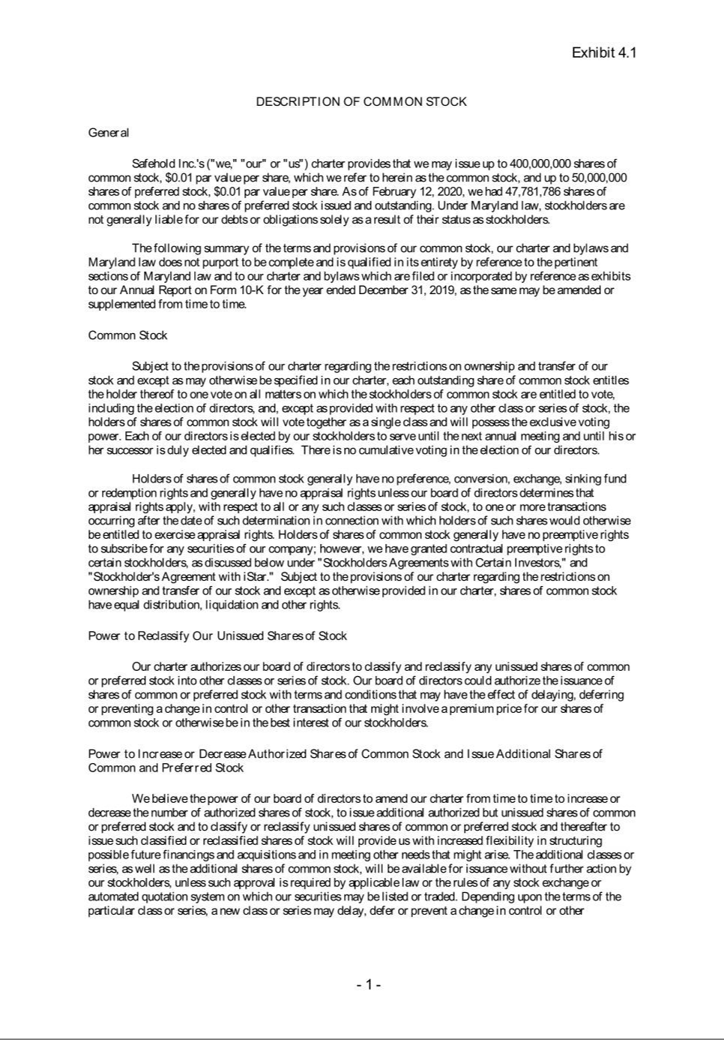

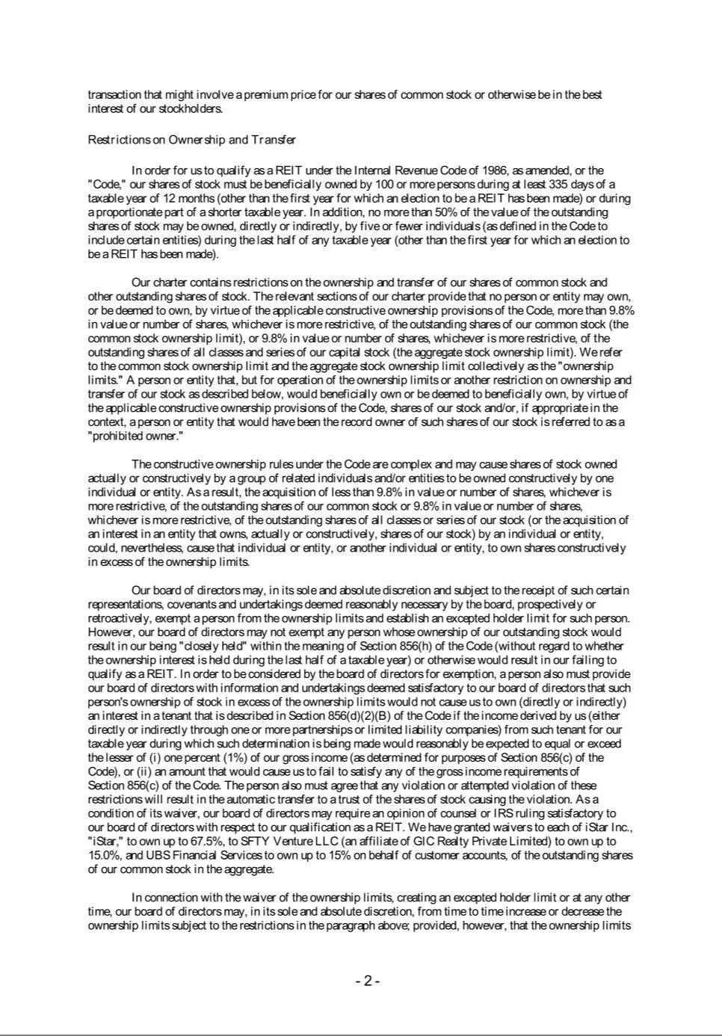

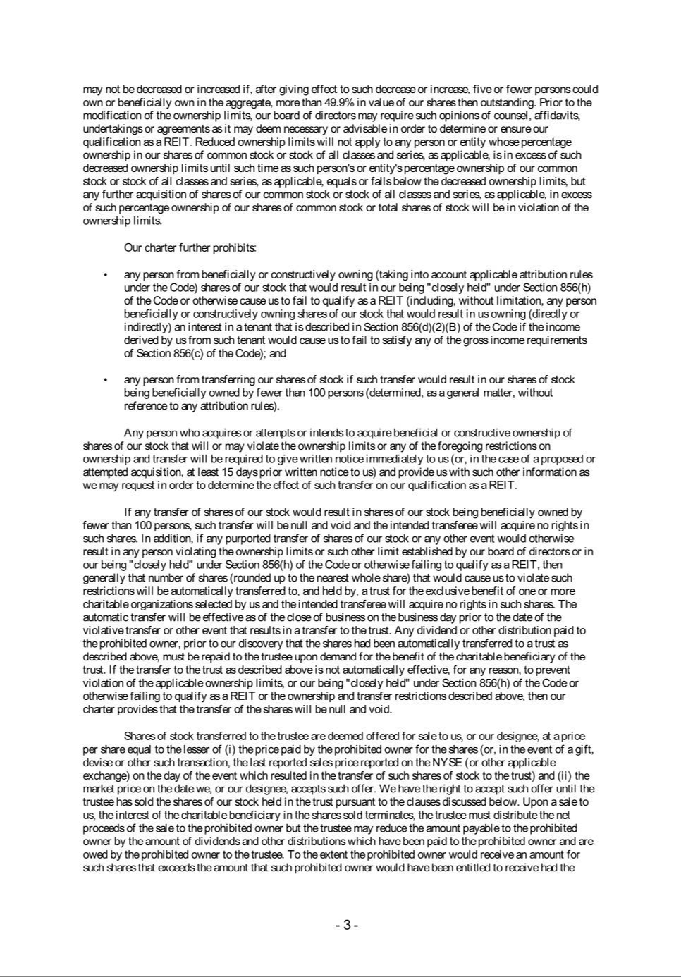

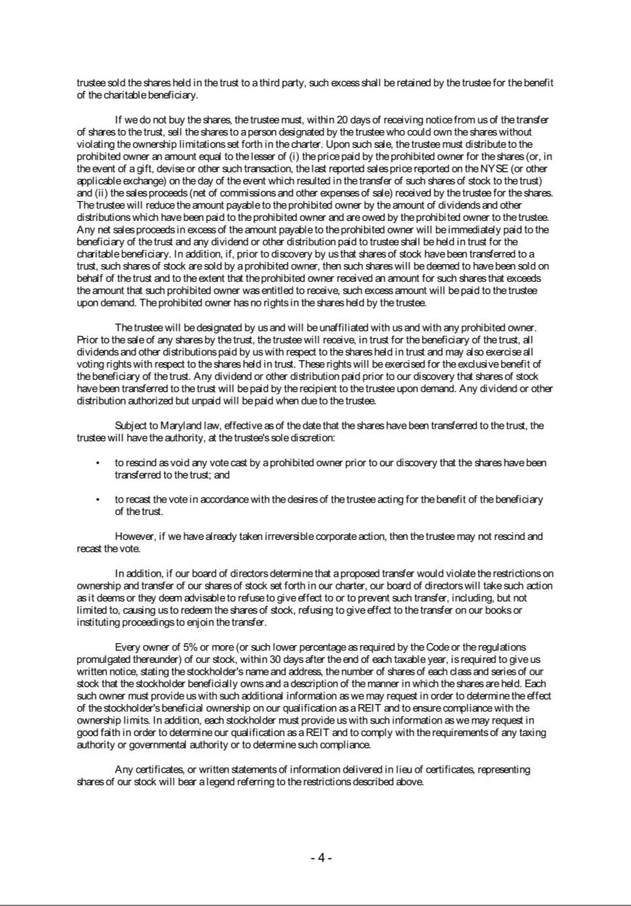

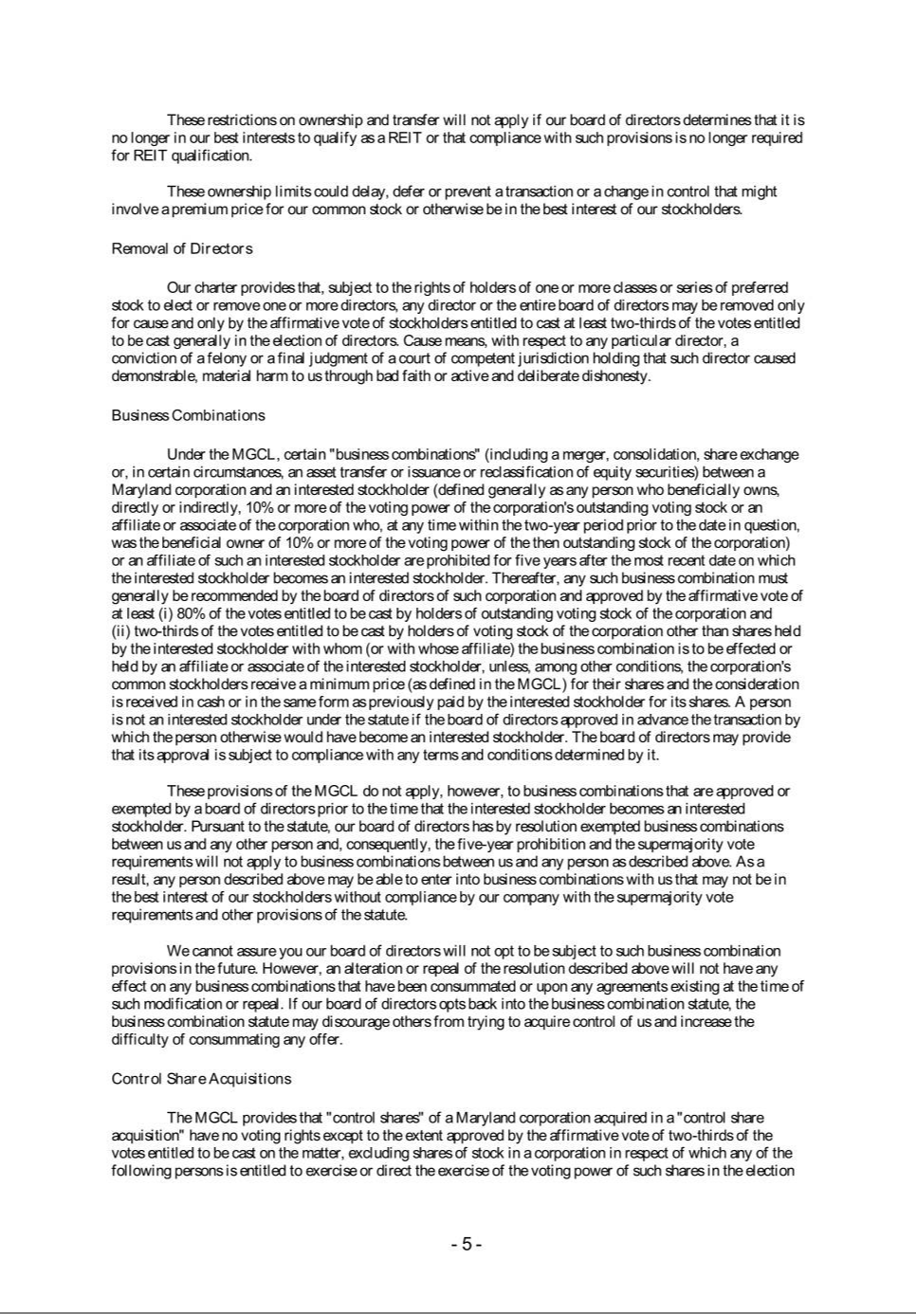

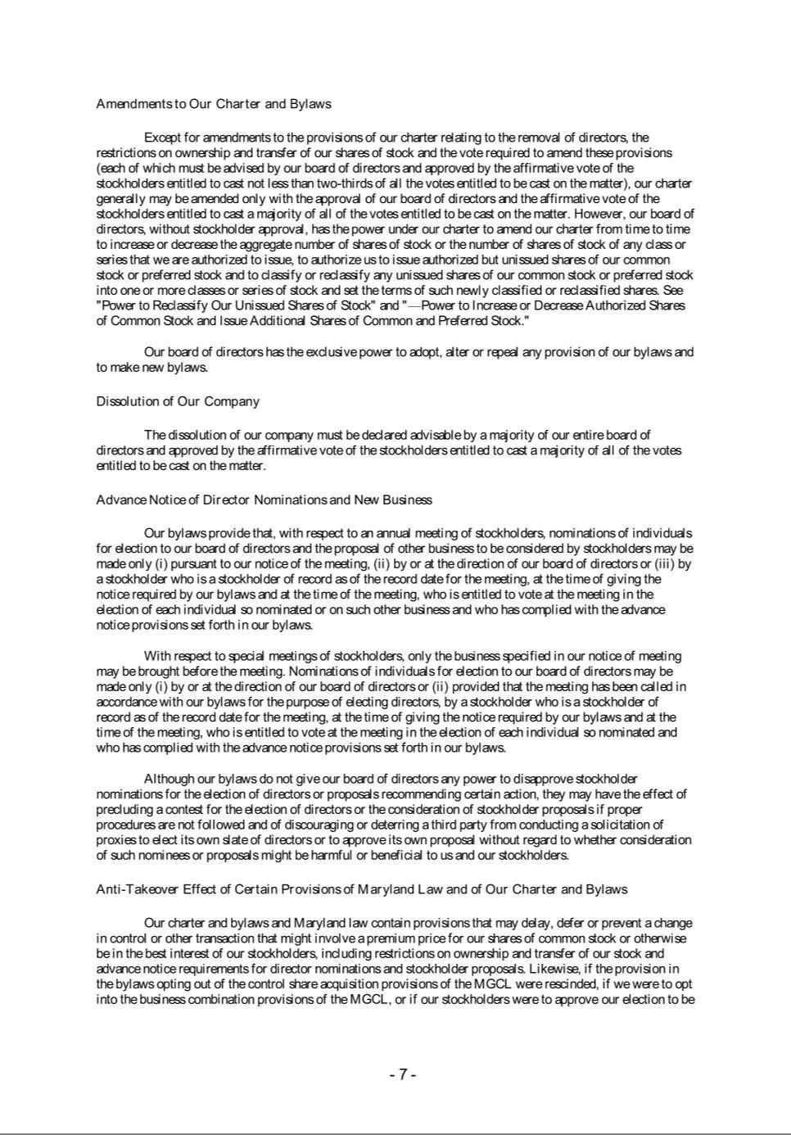

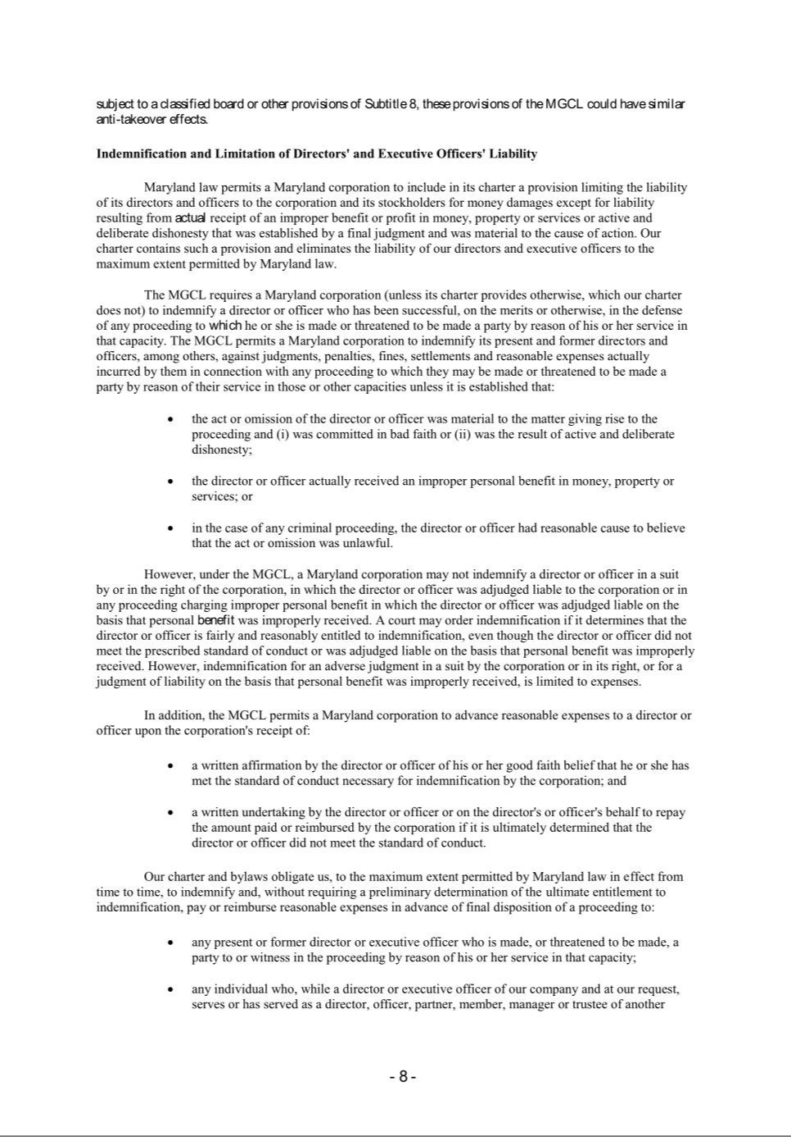

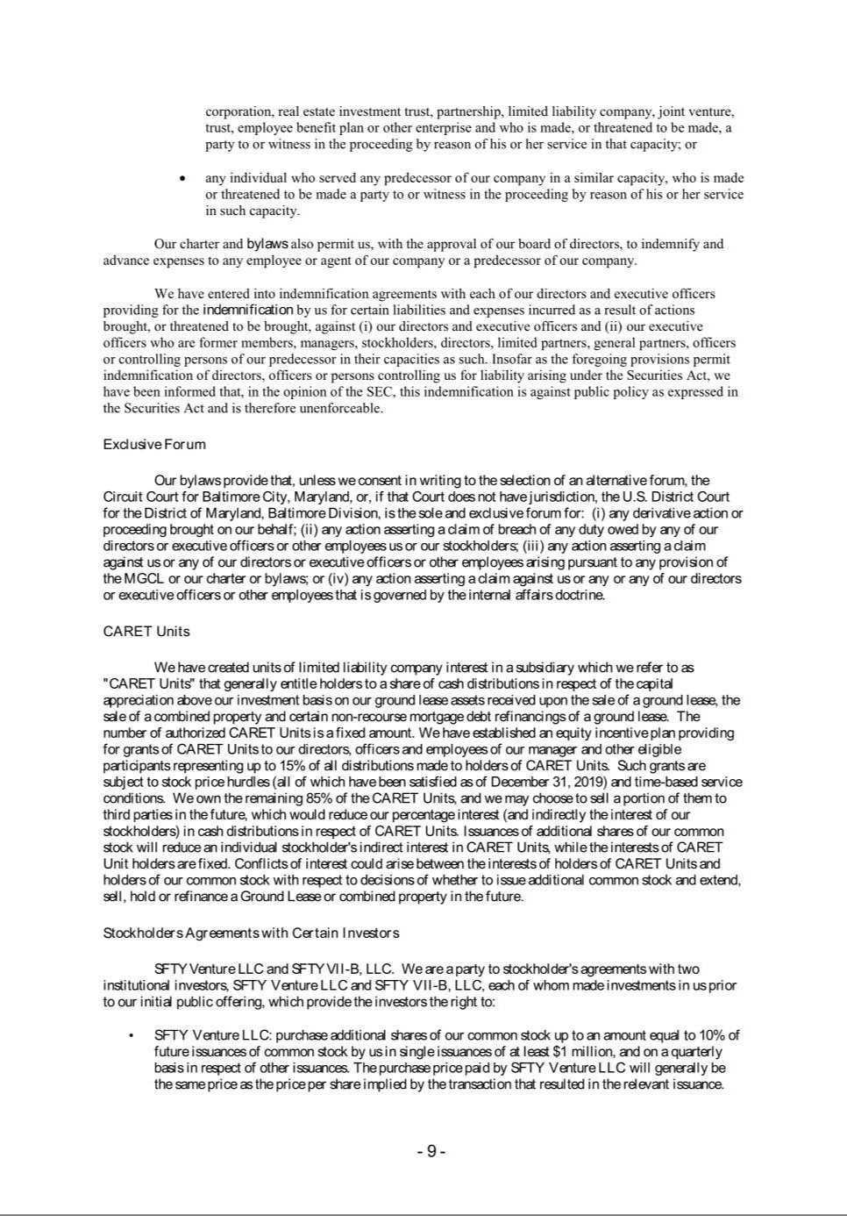

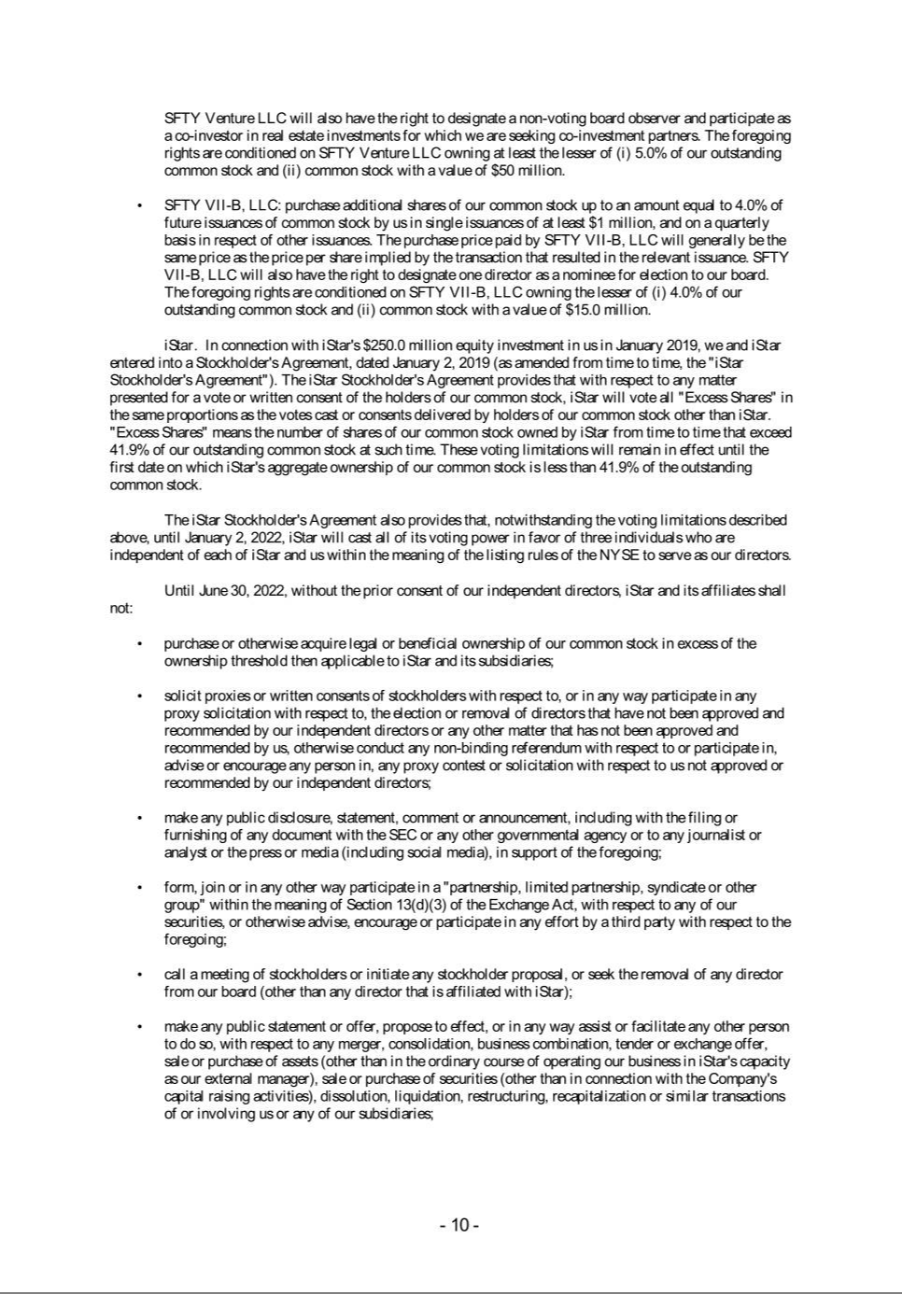

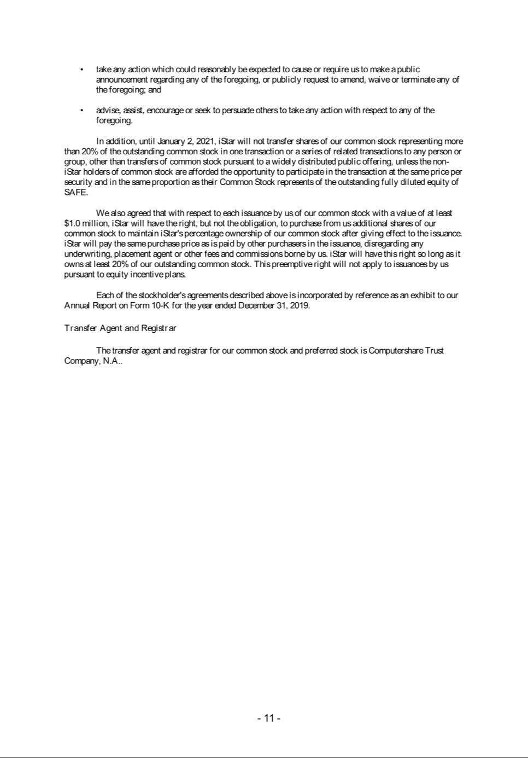

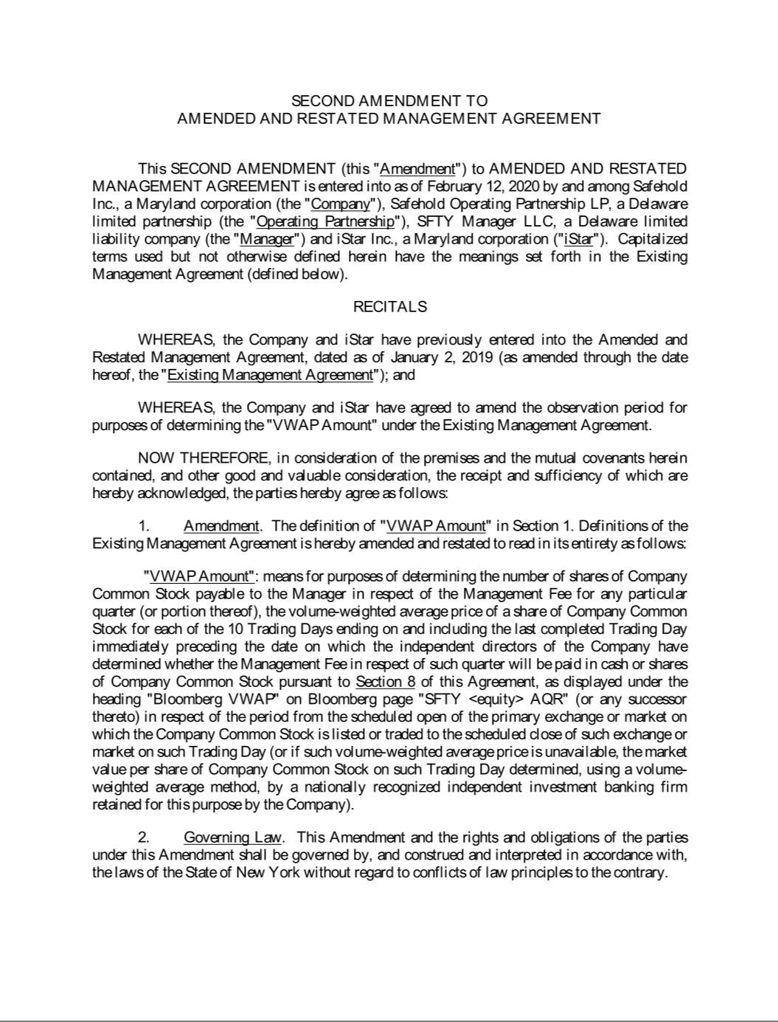

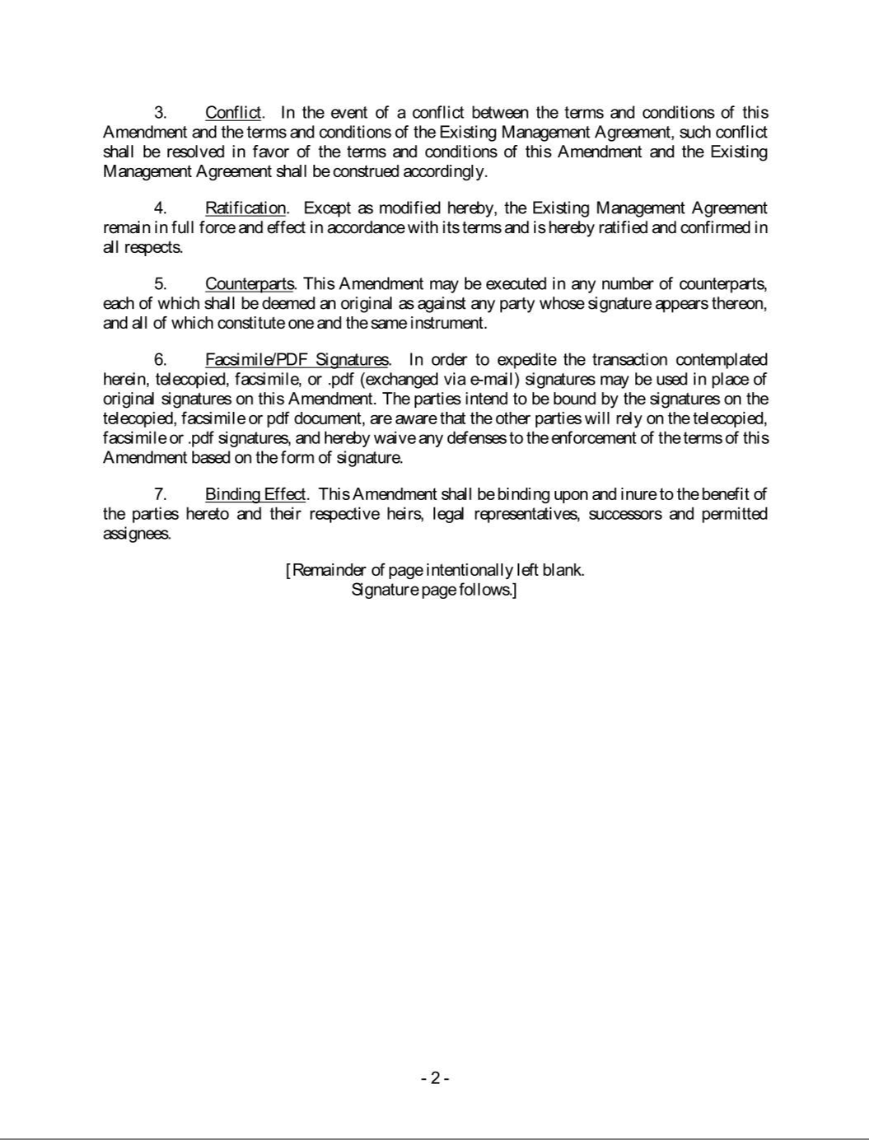

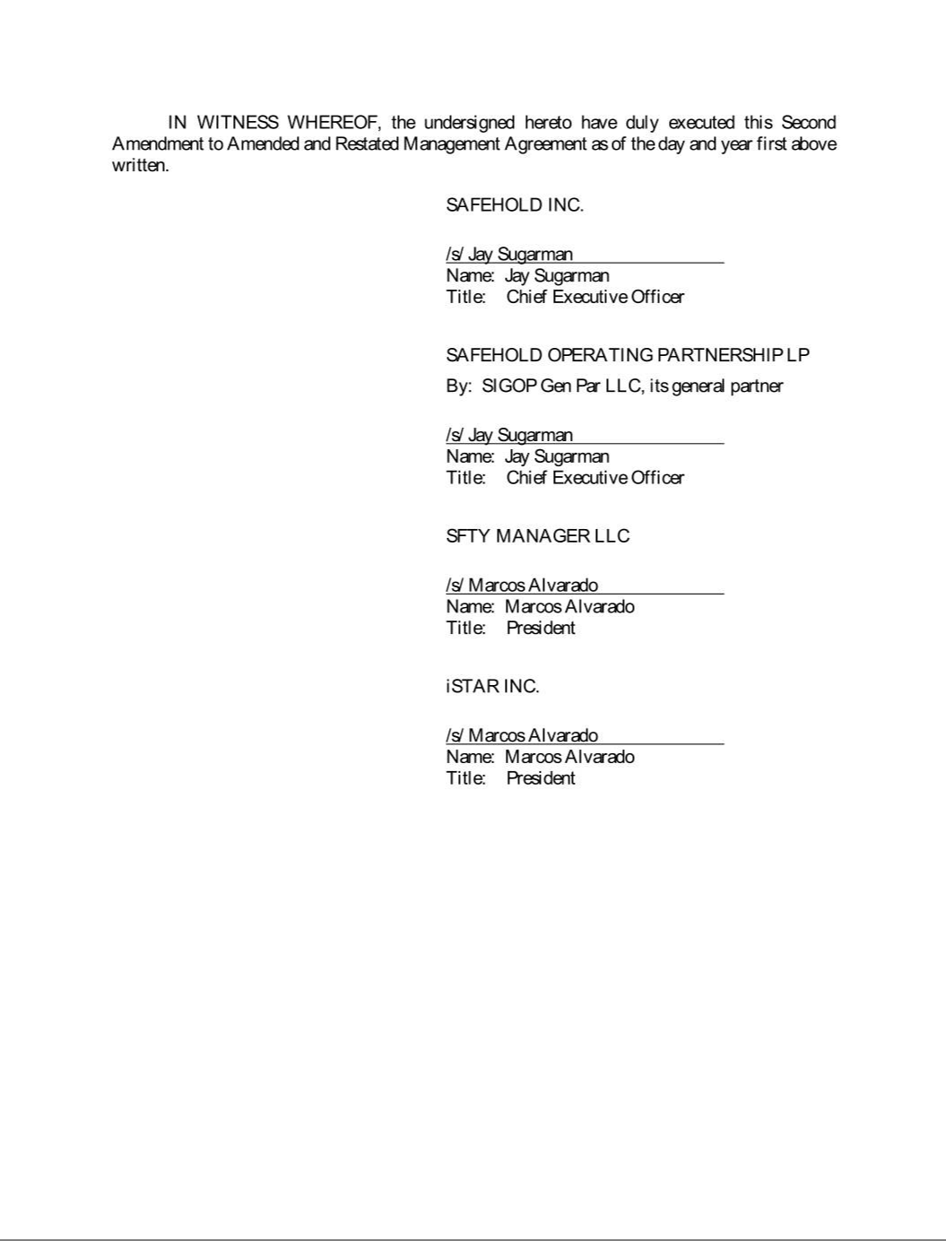

Exhibit 21.1

 | List of Subsidiaries
 | Subsidiary | State of Formation
1007 South Congress North Unit Ground Owner LLC |  | Delaware
101 | Marietta Street NW GL Venture LLC | Delaware
106 | Ridge Street Ground Owner LLC | Delaware
10721 Domain Dr Ground Owner LLC |  | Delaware
1100 First Street Ground Owner LLC |  | Delaware
110-114 Ridge Street Ground Owner LLC |  | Delaware
1111 Pennsylvania Ave Ground Owner LLC |  | Delaware
1201-31 Lafayette Ground Owner LLC (fka as 730 Third Ave Ground Owner LLC) |  | Delaware
1221 Division Street Ground Owner LLC |  | Delaware
1225 19th Street Ground Owner LLC |  | Delaware
135 | West 50th Street Equity Member LLC | Delaware
135 | West 50th Street Ground Owner LLC | Delaware
1325 Wilson Ground Owner LLC |  | Delaware
195 Broadway Ground Owner LLC |  | Delaware
20 Hawley Street Ground Owner LLC |  | Delaware
221 | American Boulevard - Bloomington LLC | Delaware
2490 Kalakaua Ave Ground Owner LLC |  | Delaware
301 G Street Ground Owner LLC |  | Delaware
301 | Washington Street Landlord LLC | Delaware
3333 Old Milton Alpharetta LLC |  | Delaware
340 E Paces Ferry Rd NE Ground Owner LLC |  | Delaware
3500 NW 24th St. Ground Owner LLC |  | Delaware
3549 Iowa Ave Ground Owner LLC |  | Delaware
3630 NW 25th St. Ground Owner LLC |  | Delaware
3665 Rio Road Ground Owner LLC |  | Delaware
3945 Connecticut Ave NW Ground Owner LLC |  | Delaware
3945 Connecticut Ave NW Lender LLC |  | Delaware
401 | W Michigan Street - Milwaukee LLC | Delaware
4050 Rocky Circle Ground Owner LLC |  | Delaware
425 Park Ave Ground Owner LLC |  | Delaware
425 Park Ave Equity Member LLC |  | Delaware
425 Park Ave REIT LLC |  | Delaware
425 Park Ave Safehold Member LLC |  | Delaware
500 Woodward LLC |  | Delaware
515 | 22nd Street NW Ground Owner LLC | Delaware
515 | 22nd Street NW Lender LLC | Delaware
520 SW 11th Ave Ground Owner LLC |  | Delaware
5601 Democracy Drive Ground Owner LLC |  | Delaware
570 Washington Ground Owner LLC |  | Delaware
62 Hundred Hollywood N GenPar LLC |  | Delaware

62 Hundred Hollywood North LP | Delaware
62 Hundred Hollywood S GenPar LLC | Delaware
62 Hundred Hollywood South LP | Delaware
685 Third Avenue Equity Member LLC | Delaware
685 Third Avenue Ground Owner LLC | Delaware
7640 Warren Ground Owner LLC | Delaware
920 S Terrace Ground Owner LLC | Delaware
CARET Management Holdings LLC | Delaware
CARET Services TRS Inc. | Delaware
CARET Ventures LLC | Delaware
CTL I Maryland LLC | Delaware
East Houston Ground Owner LLC | Delaware
East Houston Retail Owner LLC | Delaware
GA Santa Clara GenPar LLC | Delaware
GA Santa Clara Ground Owner LP | Delaware
Glenridge Point Ground Owner LLC | Delaware
Hubble Drive Lanham LLC | Delaware
iStar CTL Manager LLC | Delaware
iStar Dallas GL GenPar LLC | Delaware
iStar Dallas GL LP | Delaware
iStar North Old Atlanta Road LLC | Delaware
iStar Woodward LLC | Delaware
Lighthouse GenPar LLC | Delaware
Lighthouse Ground Owner LP | Delaware
Madison Arizona Ground Owner LLC | Delaware
One Palm Apartment Owner LLC | Delaware
One Palm Commercial and Hotel Owner LLC | Delaware
Pershing Point GL Venture LLC | Delaware
Promenade Ground Owner LLC | Delaware
Red Lion GP LLC | Delaware
Regency Lakeview GL GenPar LLC | Delaware
Regency Lakeview GL LP | Delaware
Regency Lakeview GL Venture LLC | Delaware
RLH GenPar II LLC | Delaware
RLH Partnership II LP | Delaware
RLH Partnership, L.P. | Delaware
SAFE Pershing Partner LLC | Delaware
SAFE Regency Partner LLC | Delaware
Safehold 101 Marietta NW Member LLC | Delaware
Safehold Finco 1 LLC | Delaware
Safehold Finco 2 LLC | Delaware
Safehold Inc. | Maryland
Safehold Lender LLC | Delaware
Safehold Operating Partnership LP | Delaware
Safehold OP GenPar LLC | Delaware
SFI I, LLC | Delaware

West Ninth GenPar LLC | Delaware
West Ninth Ground Owner LP | Delaware
West Vue Ground Owner LLC | Delaware

Exhibit 23.1

CONSENT OF INDEPENDENT REGISTERED PUBLIC ACCOUNTING FIRM

We consent to the incorporation by reference in Registration Statement No. 333-226048 on Form S-3 and Registration Statement No. 333-219012 on Form S-8 of our report dated February 13, 2020, relating to the financial statements and financial statement schedules of Safehold Inc. (which report expresses an unqualified opinion relating to the adoption of a new accounting standard), appearing in this Annual Report on Form 10-K of Safehold Inc. for the year ended December 31, 2019.

/s/ Deloitte & Touche LLP

New York, NY

February 13, 2020

Exhibit 31.0

CERTIFICATION

I, Jay Sugarman, certify that:

- I have reviewed this annual report on Form 10-K of Safehold Inc.;

- Based on my knowledge, this report does not contain any untrue statement of a material fact or omit to state a material fact necessary to make the statements made, in light of the circumstances under which such statements were made, not misleading with respect to the period covered by this report;

- Based on my knowledge, the financial statements, and other financial information included in this report, fairly present in all material respects the financial condition, results of operations and cash flows of the registrant as of, and for, the periods presented in this report;

- The registrant's other certifying officer and I are responsible for establishing and maintaining disclosure controls and procedures (as defined in Exchange Act Rules 13a-15(e) and 15d-15(e)) and internal control over financial reporting (as defined in Exchange Act Rules 13a-15(f) and 15d-15(f)) for the registrant and have:

  - Designed such disclosure controls and procedures, or caused such disclosure controls and procedures to be designed under our supervision, to ensure that material information relating to the registrant, including its consolidated subsidiaries, is made known to us by others within those entities, particularly during the period in which this report is being prepared;

  - Designed such internal control over financial reporting, or caused such internal control over financial reporting to be designed under our supervision, to provide reasonable assurance regarding the reliability of financial reporting and the preparation of financial statements for external purposes in accordance with generally accepted accounting principles;

  - Evaluated the effectiveness of the registrant's disclosure controls and procedures and presented in this report our conclusions about the effectiveness of the disclosure controls and procedures, as of the end of the period covered by this report based on such evaluation; and

  - Disclosed in this report any change in the registrant's internal control over financial reporting that occurred during the registrant's most recent fiscal quarter (the registrant's fourth fiscal quarter in the case of an annual report) that has materially affected, or is reasonably likely to materially affect, the registrant's internal control over financial reporting; and

- The registrant's other certifying officer and I have disclosed, based on our most recent evaluation of internal control over financial reporting, to the registrant's auditors and the audit committee of the registrant's board of directors (or persons performing the equivalent functions):

  - All significant deficiencies and material weaknesses in the design or operation of internal control over financial reporting which are reasonably likely to adversely affect the registrant's ability to record, process, summarize and report financial information; and

  - Any fraud, whether or not material, that involves management or other employees who have a significant role in the registrant's internal control over financial reporting.

Date:February 13, 2020 | By: | /s/ JAY SUGARMAN
 |  | Name: | Jay Sugarman
 |  | Title: | Chief Executive Officer

CERTIFICATION

I, Garett Rosenblum, certify that:

- I have reviewed this annual report on Form 10-K of Safehold Inc.;

- Based on my knowledge, this report does not contain any untrue statement of a material fact or omit to state a material fact necessary to make the statements made, in light of the circumstances under which such statements were made, not misleading with respect to the period covered by this report;

- Based on my knowledge, the financial statements, and other financial information included in this report, fairly present in all material respects the financial condition, results of operations and cash flows of the registrant as of, and for, the periods presented in this report;

- The registrant's other certifying officer and I are responsible for establishing and maintaining disclosure controls and procedures (as defined in Exchange Act Rules 13a-15(e) and 15d-15(e)) and internal control over financial reporting (as defined in Exchange Act Rules 13a-15(f) and 15d-15(f)) for the registrant and have:

  - Designed such disclosure controls and procedures, or caused such disclosure controls and procedures to be designed under our supervision, to ensure that material information relating to the registrant, including its consolidated subsidiaries, is made known to us by others within those entities, particularly during the period in which this report is being prepared;

  - Designed such internal control over financial reporting, or caused such internal control over financial reporting to be designed under our supervision, to provide reasonable assurance regarding the reliability of financial reporting and the preparation of financial statements for external purposes in accordance with generally accepted accounting principles;

  - Evaluated the effectiveness of the registrant's disclosure controls and procedures and presented in this report our conclusions about the effectiveness of the disclosure controls and procedures, as of the end of the period covered by this report based on such evaluation; and

  - Disclosed in this report any change in the registrant's internal control over financial reporting that occurred during the registrant's most recent fiscal quarter (the registrant's fourth fiscal quarter in the case of an annual report) that has materially affected, or is reasonably likely to materially affect, the registrant's internal control over financial reporting; and

- The registrant's other certifying officer and I have disclosed, based on our most recent evaluation of internal control over financial reporting, to the registrant's auditors and the audit committee of the registrant's board of directors (or persons performing the equivalent functions):

  - All significant deficiencies and material weaknesses in the design or operation of internal control over financial reporting which are reasonably likely to adversely affect the registrant's ability to record, process, summarize and report financial information; and

  - Any fraud, whether or not material, that involves management or other employees who have a significant role in the registrant's internal control over financial reporting.

Date:February 13, 2020 | By: | /s/ GARETT ROSENBLUM
 |  | Name: | Garett Rosenblum
 |  | Title: | Chief Accounting Officer (principal
 |  | Title: | financial officer)

Exhibit 32.0

Certification of Chief Executive Officer

Pursuant to Section 906 of The Sarbanes-Oxley Act of 2002

The undersigned, the Chief Executive Officer of Safehold Inc. (the "Company"), hereby certifies on the date hereof, pursuant to 18 U.S.C. 1350, as adopted pursuant to Section 906 of The Sarbanes-Oxley Act of 2002, that the Annual Report on Form 10-K for the year ended December 31, 2019 (the "Form 10-K"), filed concurrently herewith by the Company, fully complies with the requirements of Section 13(a) or 15(d) of the Securities Exchange Act of 1934, as amended, and that the information contained in the Form 10-K fairly presents, in all material respects, the financial condition and results of operations of the Company.

Date:February 13, 2020 | By: | /s/ JAY SUGARMAN
 |  | Name: | Jay Sugarman
 |  | Title: | Chief Executive Officer

Certification of Principal Financial Officer

Pursuant to Section 906 of The Sarbanes-Oxley Act of 2002

The undersigned, the principal financial officer of Safehold Inc. (the "Company"), hereby certifies on the date hereof, pursuant to 18 U.S.C. 1350, as adopted pursuant to Section 906 of The Sarbanes-Oxley Act of 2002, that the Annual Report on Form 10-K for the year ended December 31, 2019 (the "Form 10-K"), filed concurrently herewith by the Company, fully complies with the requirements of Section 13(a) or 15(d) of the Securities Exchange Act of 1934, as amended, and that the information contained in the Form 10-K fairly presents, in all material respects, the financial condition and results of operations of the Company.

Date:February 13, 2020 | By: | /s/ GARETT ROSENBLUM
 |  | Name: | Garett Rosenblum
 |  | Title: | Chief Accounting Officer (principal
 |  | Title: | financial officer)

