UNITED STATES
SECURITIES AND EXCHANGE COMMISSION
Washington, D.C. 20549
SCHEDULE 14A
Proxy Statement Pursuant to Section 14(a) of
the Securities Exchange Act of 1934
(Amendment No. )
Filed by the Registrant ☒
Filed by a Party other than the Registrant ☐
Check the appropriate box:
☐ | Preliminary Proxy Statement
☐ | Confidential, for Use of the Commission Only (as permitted by Rule 14a-6(e)(2))
☐ | Definitive Proxy Statement
☒ | Definitive Additional Materials
☐ | Soliciting Material under §240.14a-12
​
SAFEHOLD INC.
(Name of Registrant as Specified In Its Charter)
​
​
​
(Name of Person(s) Filing Proxy Statement, if other than the Registrant)
​
Payment of Filing Fee (Check all boxes that apply):
☒ | No fee required.
☐ | Fee paid previously with preliminary materials.
☐ | Fee computed on table in exhibit required by Item 25(b) per Exchange Act Rules 14a6(i)(1) and 0-11

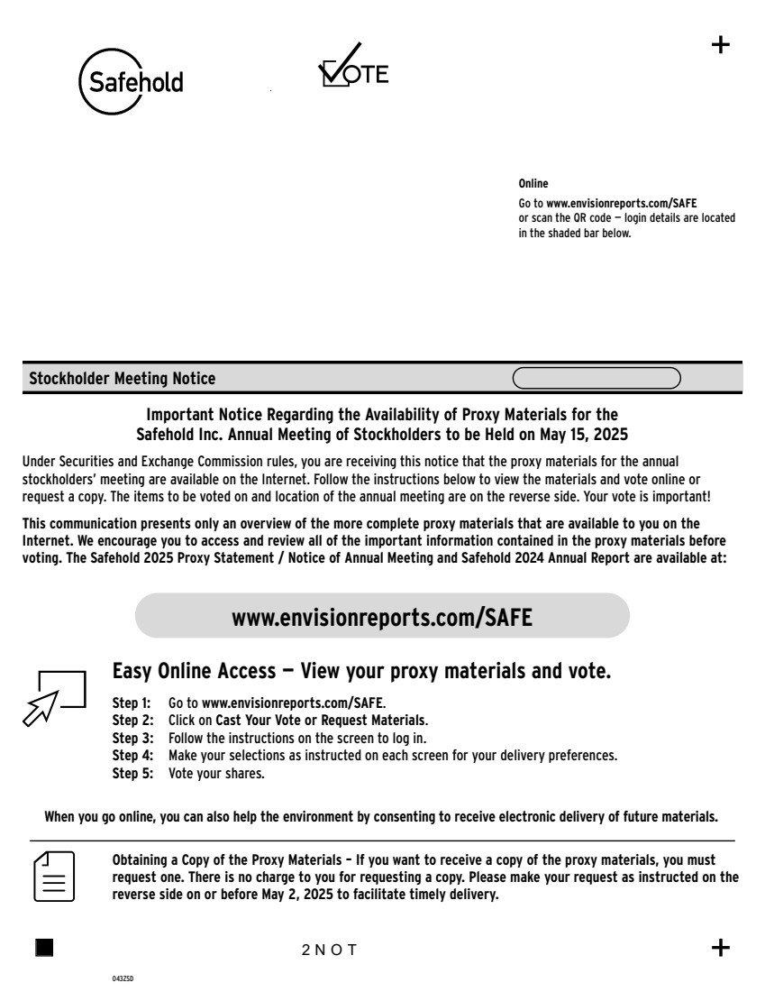 | Step 1: Go to www.envisionreports.com/SAFE. Step 2: Click on Cast Your Vote or Request Materials. Step 3: Follow the instructions on the screen to log in. www.envisionreports.com/SAFE Online Go to www.envisionreports.com/SAFE or scan the QR code — login details are located in the shaded bar below. Stockholder Meeting Notice 043ZSD Important Notice Regarding the Availability of Proxy Materials for the Safehold Inc. Annual Meeting of Stockholders to be Held on May 15, 2025 Under Securities and Exchange Commission rules, you are receiving this notice that the proxy materials for the annual stockholders’ meeting are available on the Internet. Follow the instructions below to view the materials and vote online or request a copy. The items to be voted on and location of the annual meeting are on the reverse side. Your vote is important! This communication presents only an overview of the more complete proxy materials that are available to you on the Internet. We encourage you to access and review all of the important information contained in the proxy materials before voting. The Safehold 2025 Proxy Statement / Notice of Annual Meeting and Safehold 2024 Annual Report are available at: Obtaining a Copy of the Proxy Materials – If you want to receive a copy of the proxy materials, you must request one. There is no charge to you for requesting a copy. Please make your request as instructed on the reverse side on or before May 2, 2025 to facilitate timely delivery. 2NOT Easy Online Access — View your proxy materials and vote. When you go online, you can also help the environment by consenting to receive electronic delivery of future materials. Step 4: Make your selections as instructed on each screen for your delivery preferences. Step 5: Vote your shares.
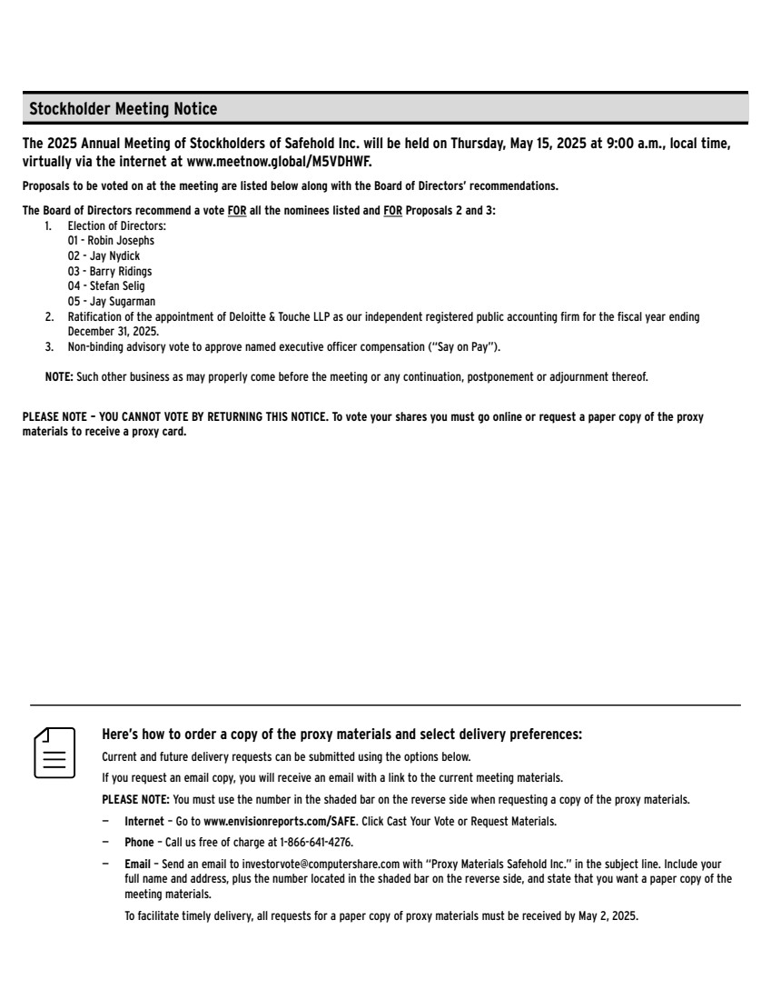 | Here’s how to order a copy of the proxy materials and select delivery preferences: Current and future delivery requests can be submitted using the options below. If you request an email copy, you will receive an email with a link to the current meeting materials. PLEASE NOTE: You must use the number in the shaded bar on the reverse side when requesting a copy of the proxy materials. — Internet – Go to www.envisionreports.com/SAFE. Click Cast Your Vote or Request Materials. — Phone – Call us free of charge at 1-866-641-4276. — Email – Send an email to investorvote@computershare.com with “Proxy Materials Safehold Inc.” in the subject line. Include your full name and address, plus the number located in the shaded bar on the reverse side, and state that you want a paper copy of the meeting materials. To facilitate timely delivery, all requests for a paper copy of proxy materials must be received by May 2, 2025. The 2025 Annual Meeting of Stockholders of Safehold Inc. will be held on Thursday, May 15, 2025 at 9:00 a.m., local time, virtually via the internet at www.meetnow.global/M5VDHWF. Proposals to be voted on at the meeting are listed below along with the Board of Directors’ recommendations. The Board of Directors recommend a vote FOR all the nominees listed and FOR Proposals 2 and 3: 1. Election of Directors: 01 - Robin Josephs 02 - Jay Nydick 03 - Barry Ridings 04 - Stefan Selig 05 - Jay Sugarman 2. Ratification of the appointment of Deloitte & Touche LLP as our independent registered public accounting firm for the fiscal year ending December 31, 2025. 3. Non-binding advisory vote to approve named executive officer compensation (“Say on Pay”). NOTE: Such other business as may properly come before the meeting or any continuation, postponement or adjournment thereof. PLEASE NOTE – YOU CANNOT VOTE BY RETURNING THIS NOTICE. To vote your shares you must go online or request a paper copy of the proxy materials to receive a proxy card. Stockholder Meeting Notice

