UNITED STATES

SECURITIES AND EXCHANGE COMMISSION

Washington, D.C. 20549
_______________________________________________________________________________
FORM 8-K

CURRENT REPORT

Pursuant to Section 13 or 15(d) of the Securities Exchange Act of 1934

Date of Report (Date of earliest event reported): August 5, 2025

_______________________________________________________________________________

Safehold Inc.

(Exact name of registrant as specified in its charter)

Maryland

001-15371

95-6881527

(State or other jurisdiction of

incorporation)

(Commission File

Number)

(IRS Employer

Identification Number)

1114 Avenue of the Americas

39th Floor

New York , NY

(Address of principal executive offices)

10036

(Zip Code)

Registrant’s telephone number, including area code: (212) 930-9400

_______________________________________________________________________________

N/A

(Former name or former address, if changed since last report.)

Check the appropriate box below if the Form 8-K filing is intended to simultaneously satisfy the filing obligation of the registrant under any of the following provisions (see

General Instruction A.2. below):

- Written communications pursuant to Rule 425 under the Securities Act (17 CFR 230.425)

- Soliciting material pursuant to Rule 14a-12 under the Exchange Act (17 CFR 240.14a-12)

- Pre-commencement communications pursuant to Rule 14d-2(b) under the Exchange Act (17 CFR 240.14d-2(b))

- Pre-commencement communications pursuant to Rule 13e-4(c) under the Exchange Act (17 CFR 240.13e-4(c))

Indicate by check mark whether the registrant is an emerging growth company as defined in Rule 405 of the Securities Act of 1933 (§230.405 of this chapter) or Rule 12b-2 of the Securities Exchange Act of 1934 (§240.12b-2 of this chapter).

Emerging growth company ☐

If an emerging growth company, indicate by check mark if the registrant has elected not to use the extended transition period for complying with any new or revised financial accounting standards provided pursuant to Section 13(a) of the Exchange Act. ☐

Securities registered pursuant to Section 12(b) of the Act:

 | Title of each class |  | Trading Symbol(s) |  | Name of each exchange on which registered
 | Common Stock |  | SAFE |  | NYSE

Item 2.02 Results of Operations and Financial Condition.

On August 5, 2025, Safehold Inc. issued an earnings release and made available on its website an earnings presentation for the quarter ended June 30, 2025. A copy of the earnings release and earnings presentation are attached as Exhibit 99.1 and Exhibit 99.2, respectively, hereto and incorporated herein by reference.

The information in this Current Report, including the exhibits hereto, is being furnished and shall not be deemed “filed” for purposes of Section 18 of the Securities Exchange Act of 1934, as amended, or otherwise subject to the liabilities of that Section. The information in this Current Report shall not be incorporated by reference into any registration statement or other document pursuant to the Securities Act of 1933, as amended, unless it is specifically incorporated by reference therein.

Item 7.01 Regulation FD Disclosure.

On August 5, 2025, Safehold Inc. made available on its website an earnings presentation for the quarter ended June 30, 2025. A copy of the earnings presentation is attached as Exhibit 99.2 hereto and incorporated by reference.

The earnings presentation, including Exhibit 99.2 hereto, is being furnished and shall not be deemed “filed” for purposes of Section 18 of the Securities Exchange Act of 1934, as amended, or otherwise subject to the liabilities of that Section. The information in this Current Report shall not be incorporated by reference into any registration statement or other document pursuant to the Securities Act of 1933, as amended, unless it is specifically incorporated by reference therein.

Item 9.01 Financial Statements and Exhibits.

Exhibit 99.1 Earnings Release.

Exhibit 99.2 Earnings Presentation.

Exhibit 104 Inline XBRL for the cover page of this Current Report on Form 8-K.

SIGNATURE

Pursuant to the requirements of the Securities Exchange Act of 1934, the registrant has duly caused this report to be signed on its behalf by the undersigned, thereunto duly authorized.

 |  | Safehold Inc.
Date: August 5, 2025 | By: |  | /s/ BRETT ASNAS
 |  |  | Brett Asnas
 |  |  | Chief Financial Officer

Exhibit 99.1
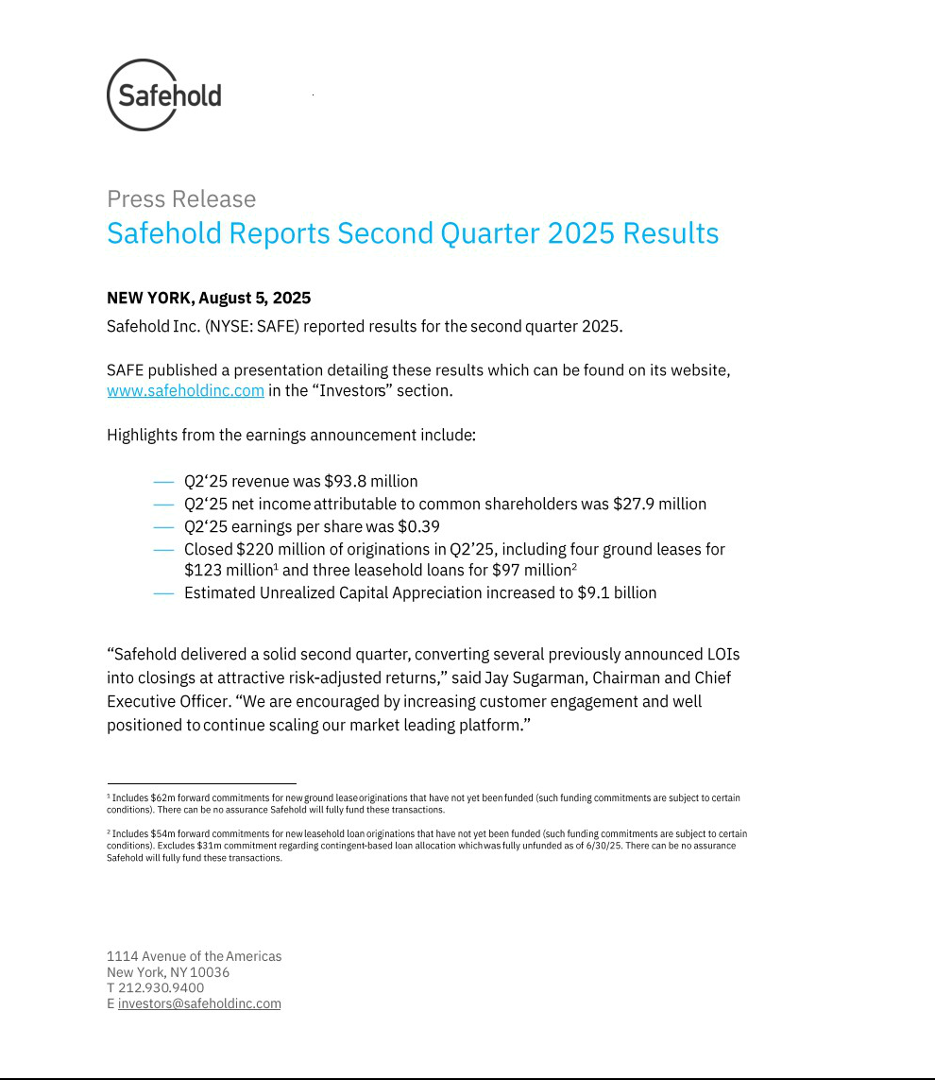

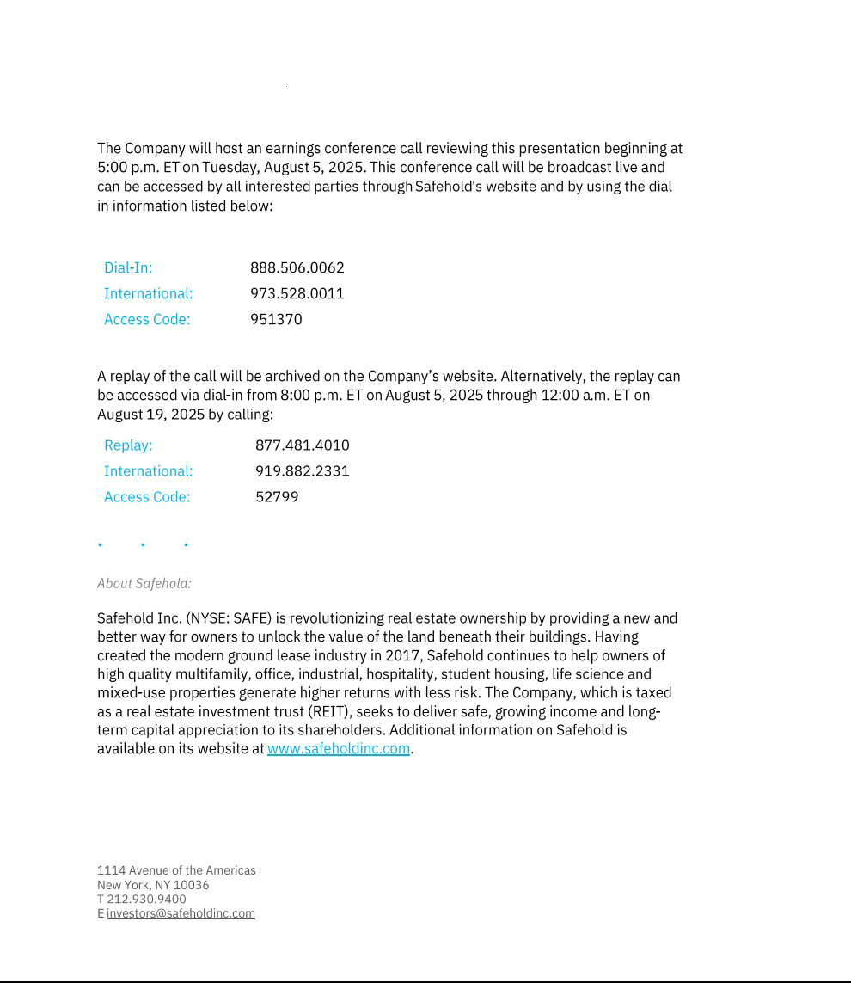

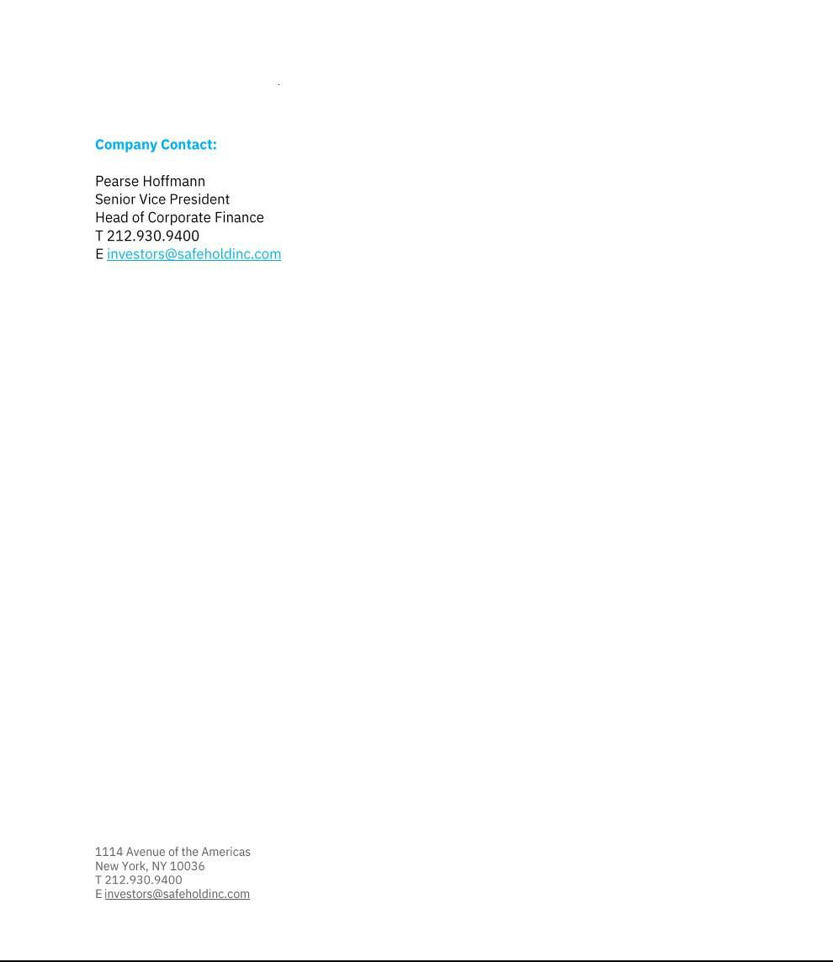

Exhibit 99.2


